**Name:** Kushal Kanti Ghosh

**Class:** BCSE-III

**Roll:** 28

**Section:** A1

**Assignment:** 1

**Assignment Deadline:** 24/1/2018

**Problem Statement:** Design and implement an error detection module

**Purpose:**

During transmission, signals suffer from noise that can introduce errors in the bits travelling from sender to receiver. To make sure whether the receiver’s information matches with the sender’s information, we use error detection. The main principle is to use error-detecting codes which are additional data (redundancy) added to original data to help us detect error.

**Diagram:**

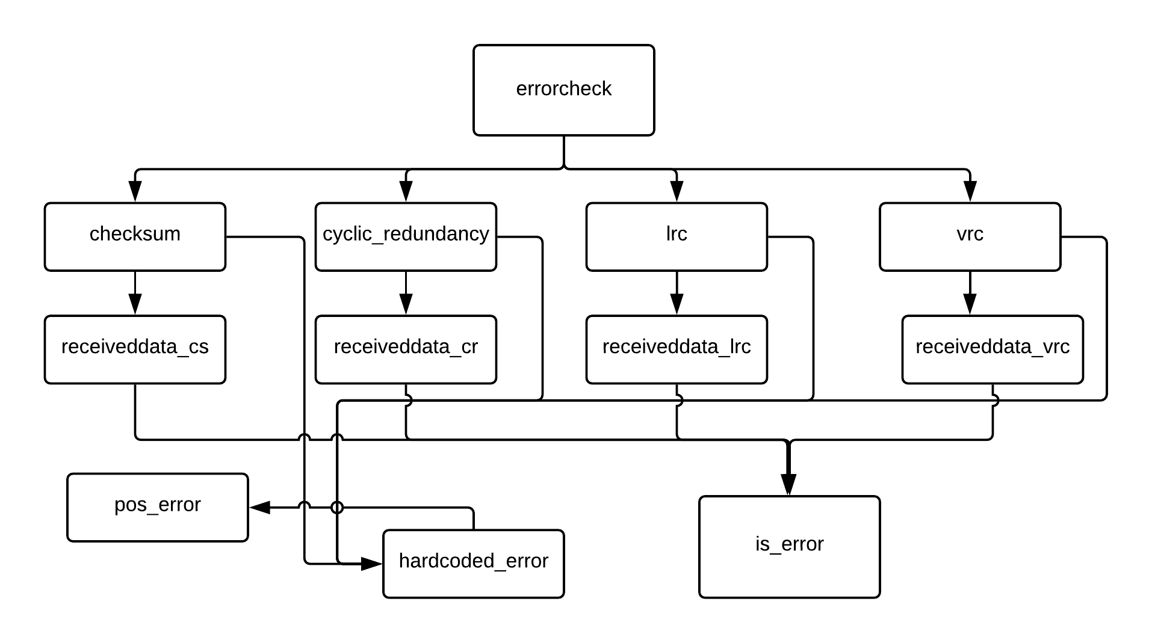

**Input / Output format:**

Input is a text file consisting of 0 and 1.

Output is:

for each error detection technique, for each frame, error is detected or not (“error” or “noerror”) .

**Code snippet and method description:**

**def** generaterror**(**string**):**

#print(string)

bound**=**len**(**string**)**

numerror**=**randint**(**0**,**bound**//**2**)** #number of error bit

**for** _ **in** range**(**numerror**):**

bit**=**randint**(**0**,**bound**-**1**)**

**if** string**[**bit**]==**'1'**:**

string**=**string**[:**bit**]+**'0'**+**string**[**bit**+**1**:]**

**else:**

string**=**string**[:**bit**]+**'1'**+**string**[**bit**+**1**:]**

#print(string)

#print()

**return string**

This method introduces error ar random positions of a given codeword by flipping random bits.

**def** pos_error**(**string**,**bit**):**

**if** string**[**bit**]==**'1'**:**

string**=**string**[:**bit**]+**'0'**+**string**[**bit**+**1**:]**

**else:**

string**=**string**[:**bit**]+**'1'**+**string**[**bit**+**1**:]**

**return** string

This method injects error at a given poisition.

**def** hardcodederror**(**string**,**error**):**

**for** pos **in** error**:**

string**=**pos_error**(**string**,**pos**)**

**return** string

This method takes the codeword and a list of positions in which error will be injected as input, and gives the erroneous codeword as output.

**Checksum Error detection technique:**

**def** wrap**(**chksumbin**,**framesize**):**

chksumbin**=**chksumbin**.**split**(**"b"**)**

chksumbin**=**chksumbin**[-**1**]**

**while** len**(**chksumbin**)>**framesize **:**

temp**=**chksumbin**[:-**framesize**]**

chksumbin**=**chksumbin**[-**framesize**:]**

chksum**=**int**(**temp**,**2**)+**int**(**chksumbin**,**2**)**

chksumbin**=**bin**(**chksum**)[**2**:]**

**return** chksumbin

Input: checksum (binary string) and framesize. Output: checksum wrapped into framesize

**def** onescomplement**(**string**):**

string**=**string**.**replace**(**'0'**,**'x'**)**

string**=**string**.**replace**(**'1'**,**'0'**)**

string**=**string**.**replace**(**'x'**,**'1'**)**

**return** string

Complement (1’s) a binary string.

**def** receivedata_chksum**(**receivedframes**,**framesize**):**

check**=**0

**for** i **in** receivedframes**:**

#print(i)

check**+=**int**(**i**,**2**)**

check **=** bin**(**check**)**

check**=**wrap**(**check**,**framesize**)**

check**=**onescomplement**(**check**)**

#print("result : ",check)

flag**=**0

**if** check**.**count**(**"0"**)** **!=** len**(**check**):**

#print("error : ",i)

flag**=**1

**else:**

a**=**1

#print("noerror : ",i)

**if** flag**==**1**:**

**return** 1

**else:**

**return** 0

Receive codewords and check for any type of error.

**def** cs**(**infile**,**errorlist**):**

framesize**=**8

**with** open**(**infile**,**"r"**)** **as** f1**:**

inputstream**=**f1**.**read**()**

length**=**len**(**inputstream**)**

inputs**=[** inputstream**[**i**:**i**+**framesize**]** **for** i **in** range**(**0**,**length**,**framesize**)** **]**

outputs**=[]**

sendframe**=**2

sublist**=[**inputs**[**i**:**i**+**sendframe**]** **for** i **in** range**(**0**,**len**(**inputs**),**sendframe**)]**

iserror**=**0

**for** senddata **in** sublist**:**

#print(senddata)

chksum**=**0

**for** i **in** senddata**:**

temp**=**int**(**i**,**2**)**

chksum**+=**temp

#print("chksum",chksum)

chksumbin**=**bin**(**chksum**)[**2**:]**

#print(chksumbin)

chksumbin**=**wrap**(**chksumbin**,**framesize**)**

#print(chksumbin)

chksumbin**=**onescomplement**(**chksumbin**)**

#print("chksum ",chksumbin)

errorsend**=[]**

**for** i **in** senddata**:**

val**=**0 #randint(0,1)

**if** val**==**1 **:**

temp**=**hardcodederror**(**i**,**errorlist**)**

**else:**

temp**=**i

errorsend**.**append**(**temp**)**

errorsend**.**append**(**chksumbin**)**

iserror**+=**receivedata_chksum**(**errorsend**,**framesize**)**

**if** iserror**!=**0**:**

**print(**"error"**)**

**else:**

**print(**"noerror"**)**

Reads the input text file, converts into datawords, converts datawords into codewords, introduces error and calls error checking function.

**CRC Error Detection Technique:**

**def** encode**(**dataword**,**divisor**):**

l**=**len**(**divisor**)**

appendeddata**=**dataword**+**"0"**\*(**l**-**1**)**

remainder**=**division**(**appendeddata**,**divisor**)**

#print("remainder : ",remainder)

codeword**=**dataword**+**remainder

**return** codeword

Input: dataword and generator polynomial. Output: codeword

**def** division**(**dividend**,**divisor**):**

pick**=**len**(**divisor**)**

tmp**=**dividend**[**0**:**pick**]**

**while** pick**<**len**(**dividend**):**

**if** tmp**[**0**]==**'1' **:**

tmp**=**myxor**(**divisor**,**tmp**)+**dividend**[**pick**]**

**else:**

tmp**=**myxor**(**"0"**\***pick**,**tmp**)+**dividend**[**pick**]**

pick**+=**1

**if** tmp**[**0**]==**'1'**:**

tmp**=**myxor**(**divisor**,**tmp**)**

**else:**

tmp**=**myxor**(**"0"**\***pick**,**tmp**)**

**return** tmp

Divides dividend with divisor.

**def** myxor**(**a**,**b**):**

l**=**len**(**b**)**

xor**=[]**

**for** i **in** range**(**1**,**l**):**

**if** a**[**i**]==**b**[**i**]:**

xor**.**append**(**"0"**)**

**else:**

xor**.**append**(**"1"**)**

xor**=**""**.**join**(**xor**)**

**return** xor

XORs two binary strings.

**def** receivedata_crc**(**receivedframes**):**

check**=**0

flag**=**0

**for** i **in** receivedframes**:**

val**=**division**(**i**,**divisor**)**

#print("check val :",val)

**if** val**.**count**(**"0"**)** **!=** len**(**val**):**

#print("error : ",i)

flag**=**1

**else:**

a**=**1

#print("noerror : ",i)

**if** flag**==**1**:**

**return** 1

**else:**

**return** 0

Receive codewords and check for any type of error.

divisor**=**"10001001"

**def** cy**(**infile**,**errorlist**):**

framesize**=**8

divisor**=**"10001001"

**with** open**(**infile**,**"r"**)** **as** f1**:**

inputstream**=**f1**.**read**()**

length**=**len**(**inputstream**)**

inputs**=[** inputstream**[**i**:**i**+**framesize**]** **for** i **in** range**(**0**,**length**,**framesize**)** **]**

outputs**=[]**

sublist**=**inputs**[:]**

count**=**0

iserror**=**0

**for** senddata **in** sublist**:**

#print(senddata)

count**+=**1

senddata**=**encode**(**senddata**,**divisor**)**

errorsend**=[]**

val**=** 0#randint(0,1)

**if** count**%**2**==**1 **:**

temp**=**hardcodederror**(**senddata**,**errorlist**)**

**else:**

temp**=**senddata

errorsend**.**append**(**temp**)**

iserror**+=**receivedata_crc**(**errorsend**)**

**if** iserror**!=**0**:**

**print(**"error"**)**

**else:**

**print(**"noerror"**)**

Reads the input text file, converts into datawords, converts datawords into codewords, introduces error and calls error checking function.

**LRC Error Detection Technique:**

**def** receivedata_lrc**(**receivedframes**):**

check**=**0

flag**=**0

**for** i **in** receivedframes**:**

val**=**i**.**count**(**'1'**)**

**if** val**%**2 **==** 1**:**

#print("error : ",i)

flag**=**1

**else:**

a**=**1

#print("noerror : ",i)

**if** flag**==**1**:**

**return** 1

**else:**

**return** 0

Receive codewords and check for any type of error.

**def** lp**(**infile**,**errorlist**):**

framesize**=**8

**with** open**(**infile**,**"r"**)** **as** f1**:**

inputstream**=**f1**.**read**()**

length**=**len**(**inputstream**)**

inputs**=[** inputstream**[**i**:**i**+**framesize**]** **for** i **in** range**(**0**,**length**,**framesize**)** **]**

outputs**=[]**

sublist**=**inputs**[:]**

iserror**=**0

**for** senddata **in** sublist**:**

#print(senddata)

#even pairity

val**=**senddata**.**count**(**'1'**)**

**if** val **%** 2 **==** 1 **:** #odd number of 1's

senddata**+=**"1"

**else:**

senddata**+=**"0"

errorsend**=[]**

val**=**0 #randint(0,1)

**if** val**==**1 **:**

temp**=**hardcodederror**(**senddata**,**errorlist**)**

**else:**

temp**=**senddata

errorsend**.**append**(**temp**)**

iserror**+=**receivedata**(**errorsend**)**

**if** iserror**!=**0**:**

**print(**"error"**)**

**else:**

**print(**"noerror"**)**

Reads the input text file, converts into datawords, converts datawords into codewords, introduces error and calls error checking function.

**VRC Error Detection Technique:**

**def** receivedata_vrc**(**receivedframes**,**framesize**):**

check**=**0

#print("received : ",receivedframes)

tempdata**=[]**

**for** bit **in** range**(**framesize**):**

temp**=[**i**[**bit**]** **for** i **in** receivedframes**]**

temp**=**""**.**join**(**temp**)**

#print(bit," pos : ",temp)

tempdata**.**append**(**temp**)**

flag**=**0

**for** i **in** tempdata**:**

val**=**i**.**count**(**'1'**)**

**if** val**%**2 **==** 1**:**

#print("error ")

flag**=**1

**else:**

a**=**1

#print("noerror ")

**if** flag**==**1**:**

**return** 1

**else:**

**return** 0

Receive codewords and check for any type of error.

**def** vp**(**infile**,**errorlist**):**

framesize**=**8

**with** open**(**infile**,**"r"**)** **as** f1**:**

inputstream**=**f1**.**read**()**

length**=**len**(**inputstream**)**

inputs**=[** inputstream**[**i**:**i**+**framesize**]** **for** i **in** range**(**0**,**length**,**framesize**)** **]**

outputs**=[]**

sendframe**=**2

sublist**=[**inputs**[**i**:**i**+**sendframe**]** **for** i **in** range**(**0**,**len**(**inputs**),**sendframe**)]**

iserror**=**0

**for** senddata **in** sublist**:**

#print(senddata)

tempdata**=[]**

**for** bit **in** range**(**framesize**):**

temp**=[**i**[**bit**]** **for** i **in** senddata**]**

temp**=**""**.**join**(**temp**)**

#print(bit," pos : ",temp)

tempdata**.**append**(**temp**)**

errorsend**=[]**

x**=**""

**for** i **in** tempdata**:**

#pairity

val**=**i**.**count**(**"1"**)**

**if** val**%**2 **==** 1**:**

x**+=** "1"

**else:**

x**+=** "0"

count**=**0

**for** i **in** senddata**:**

val**=**0 #randint(0,1)

count**+=**1

**if** val**==**1 **:**

temp**=**hardcodederror**(**i**,[**0**,**4**,**7**])**

**else:**

temp**=**i

errorsend**.**append**(**temp**)**

errorsend**.**append**(**x**)**

iserror**+=**receivedata_vrc**(**errorsend**,**framesize**)**

**if** iserror**!=**0**:**

**print(**"error"**)**

**else:**

**print(**"noerror"**)**

Reads the input text file, converts into datawords, converts datawords into codewords, introduces error and calls error checking function.

**Test cases:**

1. Error detected by all four schemes: any single bit error

2. Detected by checksum and VRC but not by CRC: flip the bit positions of the 1 bits in the generator polynomial. Since, I have used CRC-7 (x7+x3+1,10001001), the 0th, 4th and 7th bit flip cannot be detected by CRC.

3. LRC can detect but VRC cannot: If even number of bits get flipped in a codeword, that cannot be detected by LRC. But VRC can detect it (although in some cases it may fail as well. Like, if even number of codewords get changed at the same positions).