(A typical Specimen of Cover Page & Title Page)
<Font Style Times New Roman - Bold>

PROJECT TITLE
<Font Size 18> <1.5 line spacing>
21CSC205P Database Management Systems
A MINI PROJECT REPORT
<Font Size 14>

Submitted by
<Font Size 14> <Italic>
STUDENT1 NAME [REG NUM]
STUDENT2 NAME [REG NUM]
<Font Size 16>

Under the Guidance of
<Font Size 14> <Italic>

(GUIDE NAME )
<Font Size 16>
(Designation, Department)
<Font Size 12>

in partial fulfillment of the requirements for the degree of
<Font Size 14> <1.5 line spacing>

BACHELOR OF TECHNOLOGY

in

COMPUTER SCIENCE ENGINEERING

with specialization in (SPECIALIZATION NAME)

<Font Size 16>

DEPARTMENT OF NETWROKING AND COMMUNICATIONS

SCHOOL OF COMPUTING

COLLEGE OF ENGINEERING AND TECHNOLOGY
SRM INSTITUTE OF SCIENCE AND TECHNOLOGY

KATTANKULATHUR- 603 203
<Font Size 16><l.5 line spacing>

MAY 2026<Font Size 14>



SRM INSTITUTE OF SCIENCE AND TECHNOLOGY KATTANKULATHUR – 603 203
<Font Style Times New Roman — Size - 18>

BONAFIDE CERTIFICATE
<Font Style Times New Roman — Size - 16>
<Font Style Times New Roman — Size - 14>

Certified that Project report titled “PROJECT TITLE ” is the bonafide work of “STUDENT1 NAME [REG NUM], STUDENT2 NAME [REG NUM]” who carried out the 21CSC205P Database Management Systems mini project work under my supervision.

COURSE FACULTY | HEAD OF THE DEPARMENT
DESIGNATION  Department | PROFESSOR AND HEAD  Department

ABSTRACT

TABLE OF CONTENTS

Chapter No. | Title | Page no.
 | ABSTRACT
1 | Problem understanding, Identification of Entity and Relationships, Construction of DB using ER Model for their project
2 | Design of Relational Schemas, Creation of Database and Tables for their project
3 | 3.1Writing queries based on the concepts of Aggregate functions, constraints, sets
 | 3.2 Writing complex queries based on subqueries, joins and views
 | 3.3 Writing complex queries based on the concepts of functions, Triggers, Cursors and Exception Handling
4 | 4.1 Analysing the pitfalls, identifying the dependencies, and applying Normalizations- 1NF, 2NF, 3NF
 | 4.2 Analysing the pitfalls, identifying the dependencies, and applying Normalizations- 4NF, 5NF
5 | Implementation of concurrency control and recovery mechanisms.
6 | Front-end And Back-End Implementation code
7 | Results and Discussions

LIST OF FIGURES

Figure No. | Name | Page no.
1
2
3
4
5

LIST OF TABLES

Figure No. | Name | Page no.
1
2
3
4
5

CHAPTER 1

PROBLEM UNDERSTANDING, IDENTIFICATION OF ENTITY AND RELATIONSHIPS, CONSTRUCTION OF DB USING ER MODEL FOR THE <PROJECT Name>

  - Introduction
The Disaster Relief Resource Management System (DRRMS) is a comprehensive database management system designed to coordinate disaster relief operations efficiently. It manages critical data regarding disasters, affected areas, resources, inventory, relief teams, volunteers, and donations.
  - Motivation
In the wake of natural or man-made disasters, rapid response is crucial to saving lives and minimizing damage. Manual coordination of resources and teams is often slow, error-prone, and lacks real-time visibility. There is a critical need for a centralized system to streamline these operations, ensuring that the right resources reach the right people at the right time. This project aims to solve these logistical challenges through a robust database solution.
  - Scope
The scope of the DRRMS includes:
- Disaster Management: Tracking details of various disaster events and their severity.
- Resource Tracking: Managing inventory of essential supplies (food, medicine, equipment) across multiple warehouses.
- Relief Operations: Coordinating relief teams and assigning them to affected areas.
- Volunteer & Donation Management: tracking volunteer skills/availability and donor contributions.
- Reporting: Generating insights on resource utilization and delivering status updates.
  - Problem Statement
Current disaster relief efforts often suffer from:
1. Lack of real-time inventory visibility, leading to shortages or wastage.
2. Inefficient deployment of relief teams due to poor communication.
3. Difficulty in matching volunteer skills with immediate needs.
4. Fragmented data storage making it hard to generate comprehensive situation reports.
This project addresses these issues by providing a unified platform for data management.
  - Project Requirements
The system requires:
1. Database Backend: A normalized relational database (MySQL) to store complex relationships between entities.
2. Command Line Interface (CLI): For administrators to manage the system efficiently with low resource overhead.
3. Web Application: A user-friendly dashboard for real-time monitoring and visualization.
4. Data Integrity: Enforced via foreign keys, triggers, and transactions.
5. Security: Role-based access control to protect sensitive data.
  - Identification of Entity and Relationships
The system is built upon the following core entities:
- DISASTER: The central event triggering system activity.
- AFFECTED_AREA: Specific locations impacted by a disaster.
- RESOURCE: Types of aid items available.
- INVENTORY: Actual stock of resources in warehouses.
- RELIEF_TEAM: Groups deployed to help.
- VOLUNTEER: Individuals helping out (linked to teams).
- REQUEST: Demands for resources from affected areas.
- ALLOCATION: Fulfillment of requests from inventory.
- DONOR and DONATION: Tracking incoming aid.
Key Relationships:
- One Disaster affects multiple Areas (1:N).
- Resources are stored in Inventory and allocated to Requests (N:M via allocation).
- Relief Teams consist of multiple Volunteers (1:N).
  - Construction of DB Using ER Model for the <Project name>
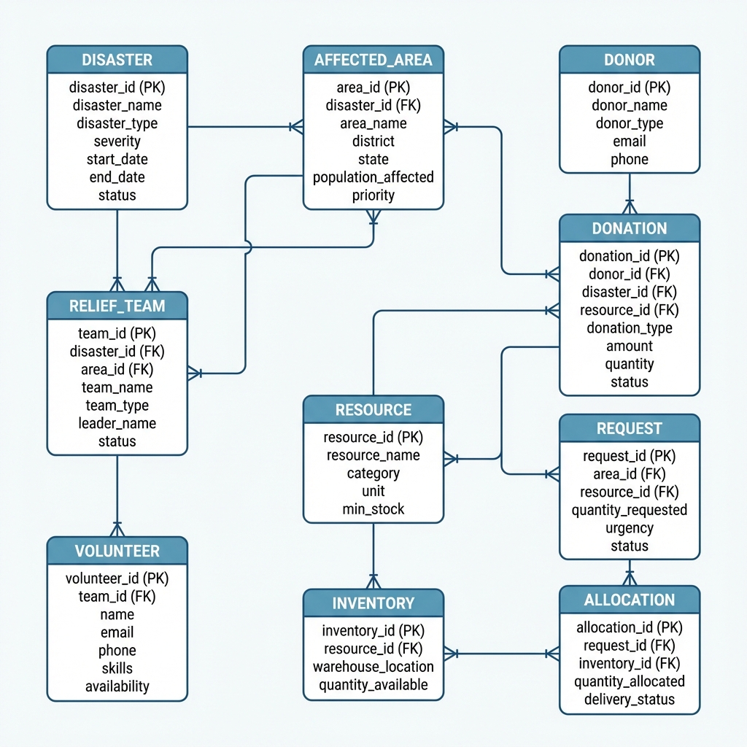
The Entity-Relationship (ER) diagram models the logical structure of the database. It defines the entities, their attributes, and the relationships between them. Please refer to the 'Identification of Entity and Relationships' section for a detailed description of the components shown in the diagram above.

Note:
- Use font family: Times new roman, size 12
- Figure name: Chapter no. Figure no: Figure Name, Place in in bottom center of the figure (eg: Figure 1.1: ER diagram of Student Management System)
- Figures must be clear with all text inside it visible
- Table name: Chapter no. Table no: Table name, Place in in top center of the table
(eg: Table 1.1: Student Schema)
- Table must not be pasted in image format, must be editable
- All text must be properly aligned (justified)
- Set the page margin
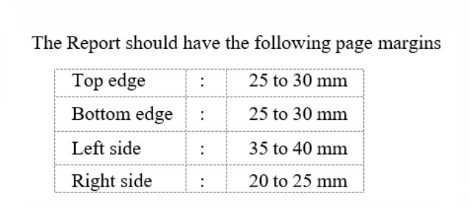
Chapter 2
Design of Relational Schemas, Creation of Database and Tables for <Project Title>

2.1 Relational Schema for <project title>
Sample
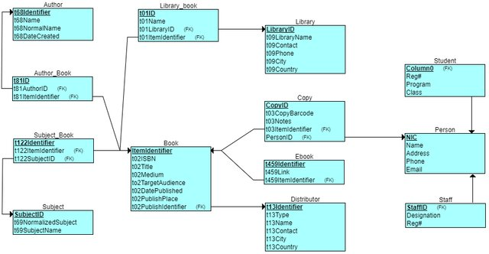
Figure 2.1: Relational Schema for <project title>
The figure 2.1 depicts the relational schema for the <project title> . (give explanation)

2.2 Description of Tables
Sample
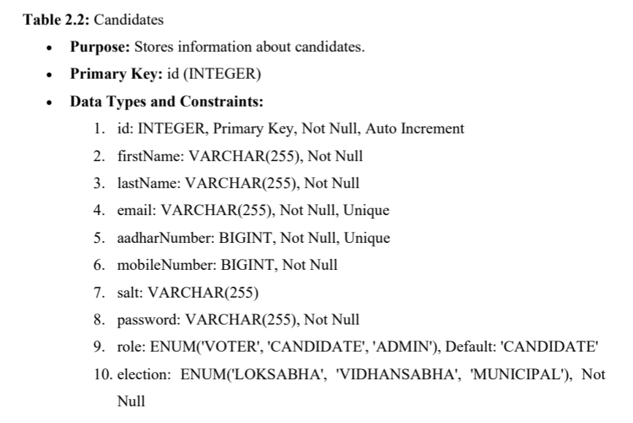

List all the table with the attributes, datatypes, size, constraints
2.3 Creation of Database and Tables - DDL Commands
DDL Commands to create all the tables
2.4 Insertion of tuples into the table – DML commands
Insert SQL (for all tables)
Example:
INSERT INTO Customers (CustomerName, ContactName, Address, City, PostalCode, Country) VALUES ('Cardinal', 'Tom B. Erichsen', 'Skagen 21', 'Stavanger', '4006', 'Norway'),
('Greasy Burger', 'Per Olsen', 'Gateveien 15', 'Sandnes', '4306', 'Norway'),
('Tasty Tee', 'Finn Egan', 'Streetroad 19B', 'Liverpool', 'L1 0AA', 'UK');
Customer table:
CustomerID | CustomerName | ContactName | Address | City | PostalCode | Country
89 | White Clover Markets | Karl Jablonski | 305 - 14th Ave. S. Suite 3B | Seattle | 98128 | USA
90 | Wilman Kala | Matti Karttunen | Keskuskatu 45 | Helsinki | 21240 | Finland

CHAPTER 3
Complex queries based on the concepts of constraints, sets, joins, views, Triggers and Cursors.
(min 3 questions with queries for all topics)
< create complex queries based on the sub-topic with questions and SQL statement with output>

  - Adding Constraints and queries based on constraints
Question:

SQL Statement:

Output:

  - Queries based on Aggregate Functions

Question:

SQL Statement:

Output:

  - Complex queries based on Sets
Question:

SQL Statement:

Output:

  - Complex queries based on Subqueries

Question:

SQL Statement:

Output:

  - Complex queries based on Joins
Question:

SQL Statement:

Output:

  - Complex queries based on views
Question:

SQL Statement:

Output:

  - Complex queries based on Triggers
Question:

SQL Statement:

Output:

  - Complex queries based on Cursors
Question:

SQL Statement:

Output:

CHAPTER 4

ANALYZING THE PITFALLS, IDENTIFYING THE DEPENDENCIES, AND APPLYING NORMALIZATIONS

(show the table before and after respective normalization)

4.1 Analyse the Pitfalls in Relations
4.2 First Normal Form
4.2.1: Identify Dependency
4.2.2: Apply Normalization to 1NF

4.3 Second Normal Form
4.3.1: Identify Dependency
4.3.2: Apply Normalization to 2NF

4.4 Third Normal Form
4.4.1: Identify Dependency
4.4.2: Apply Normalization to 3NF

4.5 BCNF
4.5.1: Identify Dependency
4.5.2: Apply Normalization to BCNF

4.6 Fourth Normal Form
4.6.1: Identify Dependency
4.6.2: Apply Normalization to 4NF

4.7 Fifth Normal Form
4.7.1: Identify Dependency
4.7.2: Apply Normalization to 5NF

CHAPTER 5
IMPLEMENTATION OF CONCURRENCY CONTROL AND RECOVERY MECHANISMS

5.1 Introduction to Transactions
5.1.1 Properties
5.1.2 States
5.2 Transaction Control Language (TCL)
5.2.1 Save point
5.2.2 Commit
5.2.3 Rollback

5.3 create 5 transactions for your project and execute
5.3.1 Transaction1 code with output (min 5 transactions)
Use savepoints, commit, rollback
< Sample:
-- Step 1: Start transaction by updating book availability
UPDATE Books
SET available_copies = available_copies – 1 WHERE book_id = 101;

-- Step 2: Set a savepoint after first change
SAVEPOINT after_first_update;

-- Step 3: Another update
UPDATE Books SET available_copies = available_copies – 1 WHERE book_id = 102;

-- Step 4: Oops! Something's wrong with second update, rollback to savepoint
ROLLBACK TO after_first_update;

-- Step 5: Continue with a safe update
UPDATE Books SET available_copies = available_copies + 1 WHERE book_id = 101;

-- Step 6: Commit all changes since savepoint
COMMIT; >

Sample 2:
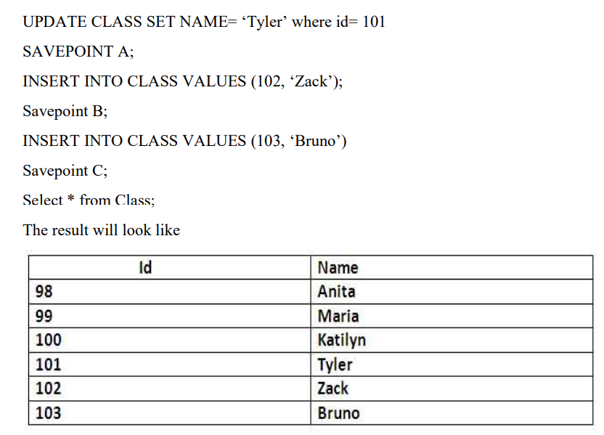
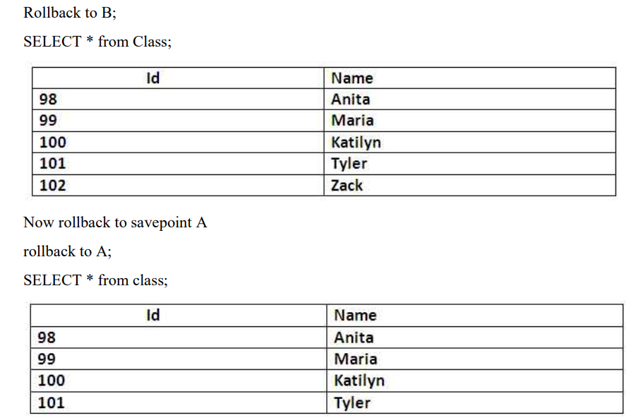

5.3 Concurrency control
5.3.1 Concurrency control Algorithms
5.3.1 Locking commands
a. Row-Level Locking – SELECT ... FOR UPDATE
b. Table-Level Locking – LOCK TABLE
Lock Modes
Lock Mode | Description
ROW SHARE | Allows concurrent access; prevents other sessions from locking the table exclusively.
ROW EXCLUSIVE | Prevents other sessions from locking in share mode. Used by default for DML.
SHARE | Allows queries but not updates or deletes.
SHARE ROW EXCLUSIVE | A mix; more restrictive than SHARE.
EXCLUSIVE | Prevents all other access — full table lock.

c. COMMIT – Release All Locks
d. ROLLBACK – Undo Changes & Release Locks
5.3.2 Example (1 example for your project)

CHAPTER 6
FRONT-END AND BACK-END CODE OF <PROJECT TITLE>

6.1 Front–End Module codes
6.2 Database connectivity

CHAPTER 7
RESULTS AND DISCUSSIONS

7.1 Screenshots of front-end

7.2 Screenshots of Database

References

