Software Design Document
CoCI — Cooking Companion Interface
SDD-CoCI-2026
A Hands-Free, Gesture and Voice Controlled Cooking Assistant
By
- 11214266
- 11214269
- 11214270
- 11214271
- 1121474
- 11214284
- 11314272

Department of Information Management
Chaoyang University of Technology

Advisor: Professor Pan Hsin-hung
Project Group: CoCI Development Team
Version 1.0 — June 2026

Table of Contents
Table of Contents 2
1. Introduction 4
1.1 Specification Objectives 4
1.2 Scope of Specifications 4
1.3 Reference Documents 4
2. System Overview 6
2.1 System Objectives 6
2.2 System Scope 6
2.2.1 System Name 6
2.2.2 System Function Description 6
2.3 Overview of Software Development Requirements 7
2.3.1 Functional Requirements 7
2.3.2 Interface Requirements 7
2.3.3 Operational Requirements 8
2.3.4 Quality Requirements 8
2.3.5 Security Requirements 9
2.3.6 Cost/Production Requirements
2.4 System Environment 9
2.5 Test Plan 9
2.6 System Architecture 10
3. Preliminary Design 11
3.1 Software Architecture 11
3.2 Software Component Design Specifications 11
3.2.1 CV Pipeline 11
3.2.2 Gesture Action Interpreter 12
3.2.3 Realtime Service (WebSocket) 13
3.2.4 Recipe API 14
3.2.5 LLM Client (Voice Query) 15
3.2.6 Frontend HUD 15
4. User Tutorial 17
4.1 System Setup 17
4.2 Starting the System 17
4.3 Waking Up the System (Idle → Menu) 17
4.4 Navigating the Recipe Menu 18
4.5 Ingredient Check Screen 18
4.6 Cooking Mode — Step Navigation 19
4.7 Using Voice Queries (LLM) 19
4.8 Resetting the System 19
4.9 Gesture Quick Reference Card 20
5. System Operation 21
5.1 End-to-End System Overview 21
5.2 Camera Input and CV Pipeline 21
5.3 Gesture Recognition Details 22
5.4 Application State Machine 22
5.5 WebSocket Communication Protocol 23
5.6 Frontend HUD Rendering 23
5.7 LLM Voice Query Pipeline 24
5.8 Recipe Data Management 24
5.9 System Input/Output Summary 25
6. Appendix 26
6.1 GestureAction Enum Reference 26
6.2 Environment Variable Reference 26

1. Introduction
This document describes the software design specifications, objectives, and architecture of the CoCI (Cooking Companion Interface) system. CoCI is a hands-free, real-time cooking assistant that uses computer vision, natural language processing, and projected display technology to guide users through culinary tasks without requiring touch-based interaction with any device.
This Software Design Document (SDD) serves as the authoritative reference for system developers, enabling them to understand the architecture, data flows, and component responsibilities of the CoCI system. It also provides a tutorial section for end users and an operational description of how the system works end-to-end.

1.1 Specification Objectives
The purpose of this document is to describe the full design of the CoCI Cooking Companion Interface. During system development, this document serves as a guide for understanding the overall architecture, operation, and design process, providing a reference for development, integration, testing, and future maintenance, and helping minimize issues during ongoing system evolution.

1.2 Scope of Specifications
This document defines the system objectives, scope, software architecture, component design, data flows, functional design, interface specifications, and operational requirements of the CoCI system. It covers:
- The real-time computer vision pipeline for gesture recognition and object detection
- The gesture-to-action interpretation engine
- The frontend HUD (Heads-Up Display) rendered via Electron and React
- The WebSocket-based real-time communication layer
- The LLM voice query subsystem (Ollama / Llama 3.2)
- Recipe data management and the REST API
- End-to-end user tutorial and system operation documentation

1.3 Reference Documents
ID | Document | Description
[1] | CoCI Proposal Document | System proposal and initial research, HCI rationale, literature review
[2] | MediaPipe Gesture Recognizer Docs | Official documentation for MediaPipe Tasks gesture recognition API
[3] | FastAPI Documentation | Asynchronous web framework reference for Python backend
[4] | Ultralytics YOLOv8/v10 Docs | Object detection framework with ByteTrack integration
[5] | Electron Documentation | Desktop application wrapper for web-based frontend
[6] | React / TypeScript Docs | Frontend UI library and type-safe JavaScript
[7] | Ollama Documentation | Local LLM inference engine for Llama 3.2

2. System Overview
This section describes the objectives, scope, architecture, requirements, and operational environment of the CoCI system.

2.1 System Objectives
CoCI addresses the "Digital Recipe Paradox": home cooks must interrupt their workflow — with dirty or wet hands — to interact with touch-based recipe applications. This forces awkward postures, creates contamination risks, and disrupts cognitive flow.
The system objective is to replace all touch interactions with hands-free controls based on natural hand gestures and spoken voice queries. The system guides users through recipe steps using a projected HUD overlaid on the cooking workspace, allowing cooks to keep both hands active and clean throughout the entire cooking session.

2.2 System Scope

2.2.1 System Name
CoCI — Cooking Companion Interface

2.2.2 System Function Description
CoCI provides the following primary functions:
User Role | Function | Description
Cook | Recipe Menu Navigation | Browse and select from a library of available recipes using hand gestures, no touch required
Cook | Ingredient Check Screen | Review required ingredients for the selected recipe before starting to cook
Cook | Step-by-Step Cooking Guide | Navigate through cooking instructions one step at a time via hand gestures
Cook | Voice Query (LLM) | Ask natural language questions (ingredient substitutions, measurements) and receive spoken/displayed answers
Cook | Gesture Controls | Control all system functions via recognized hand gestures from the webcam
Cook | Object Detection Overlay | See real-time bounding boxes highlighting detected utensils and ingredients in the camera feed
System | CV Pipeline | Continuous camera processing: gesture recognition + YOLO object detection at ~30 fps
System | WebSocket Streaming | Real-time broadcast of CV results, gesture actions, and LLM responses to the frontend
System | Recipe Management API | REST API to load, list, and serve recipe data from local JSON files

2.3 Overview of Software Development Requirements

2.3.1 Functional Requirements
The following table summarizes the functional requirements of the CoCI system:
ID | Requirement | Description
FR-01 | Gesture Recognition | Recognize at least 5 discrete hand gestures: POINTING_UP, CLOSED_FIST, OPEN_PALM, THREE_FINGERS, and dual POINTING_UP, with confidence > 50%
FR-02 | Gesture Action Mapping | Map recognized gestures to application actions based on the current system mode (idle, menu, ingredient_check, cooking)
FR-03 | Recipe Loading | Load recipe data from local JSON files and expose via REST API
FR-04 | Menu Navigation | Allow browsing recipes using POINTING_UP gestures for next/previous selection
FR-05 | Recipe Selection | Confirm recipe selection using CLOSED_FIST gesture
FR-06 | Step Navigation | Navigate cooking steps using right/left POINTING_UP in cooking mode
FR-07 | Voice Query Processing | Accept natural language cooking questions via microphone and return answers via Ollama/Llama 3.2
FR-08 | Object Detection | Detect and track culinary objects (utensils, ingredients) using YOLO with ByteTrack
FR-09 | Real-time HUD | Render a heads-up display in Electron showing current step, progress, and recipe info
FR-10 | WebSocket Streaming | Broadcast CV updates (frame, objects, action) to all connected frontend clients at ~30 fps
FR-11 | Reset Function | Return the system to idle state using dual POINTING_UP gesture

2.3.2 Interface Requirements
The CoCI system interacts with the user and the physical environment through the following interfaces:
Interface Type | Component | Description
Input — Vision | RGB Webcam | Captures continuous 1280 × 720 video stream for gesture and object detection
Input — Audio | Microphone | Captures spoken voice queries for LLM processing
Output — Display | Projector / Monitor | Displays the Electron HUD (recipe steps, ingredient list, menus, overlays)
Output — Audio | Speaker (optional) | Can deliver spoken LLM responses
Software — Backend | FastAPI REST + WebSocket | Serves recipe data and streams CV results to the frontend
Software — Frontend | Electron + React | Renders the HUD, handles WebSocket messages, and displays real-time UI

2.3.3 Operational Requirements
Client Side (Frontend / Electron):
- Launch the Electron desktop application
- The app connects automatically to the local backend WebSocket (ws://localhost:8000/ws/)
- The HUD is displayed in the application window
- Position the webcam so it captures the cooking workspace and the cook's hands
- Use hand gestures to navigate menus and control cooking steps
- Speak queries aloud to trigger voice processing (when LLM integration is active)

Server Side (Python Backend):
- Install dependencies (Python 3.11+, pip install -r requirements.txt)
- Install and start Ollama: ollama pull llama3.2
- Start the backend: uvicorn app.main:app --reload --host 0.0.0.0 --port 8000
- The CV pipeline starts automatically if CV_PIPELINE_ENABLED=true in .env
- The camera is initialized at CAMERA_INDEX=0 (configurable in .env)
- Recipe files are loaded from data/recipes/*.json

2.3.4 Quality Requirements
Quality Attribute | Requirement | Target
Performance | End-to-end gesture latency | < 100 ms (camera to UI action)
Performance | CV pipeline frame rate | ≥ 30 fps
Accuracy | Gesture recognition accuracy | > 85% for core gestures in typical kitchen lighting
Reliability | Backend uptime | Stable during a full cooking session (~60 min)
Usability | Gesture learning time | User can learn all gestures in under 5 minutes
Scalability | Recipe library | Supports any number of JSON recipe files

2.3.5 Security Requirements
- All processing is performed locally on the user's machine. No user data is transmitted to external servers.
- The backend WebSocket and REST API are bound to localhost by default and are not exposed to external networks.
- Recipe data is stored as plain JSON files; no authentication or authorization is required for the local-only deployment.
- Camera and microphone access is governed by the operating system's permission model.

2.4 System Environment
Component | Specification | Notes
OS | Windows 10 / 11 (primary) | Also functional on macOS and Linux with minor path adjustments
Python | 3.11+ | Backend runtime. Required for FastAPI, MediaPipe, and YOLO.
Node.js | 18+ / npm | Required to build and run the Electron/React frontend
Camera | USB Webcam (1280×720) | Index configurable via CAMERA_INDEX environment variable
Ollama | Latest (Llama 3.2 model) | Local LLM inference; must be installed and running on localhost:11434
GPU | Optional (NVIDIA recommended) | YOLO and MediaPipe benefit from GPU acceleration; CPU fallback available

2.5 Test Plan
Test Type | Scope | Method
Unit Tests | Gesture action interpreter, recipe API endpoints | pytest — see backend/tests/
Integration Tests | WebSocket streaming, CV pipeline to frontend | Manual end-to-end session tests
Gesture Accuracy | All gesture commands in varied lighting | Record 100 samples per gesture; measure recognition rate
Latency Benchmark | Camera to UI action delay | Timestamp logging at pipeline entry and frontend action handler
Stress Test | 60-minute continuous operation | Confirm no memory leaks or frame drops

2.6 System Architecture
CoCI follows a three-tier Sensing – Computation – Actuation architecture optimized for local edge processing:

Tier | Layer | Components
Sensing | Input capture | USB Webcam (1280×720 @ 30 fps), Microphone
Computation | CV Engine | MediaPipe Gesture Recognizer (LIVE_STREAM), YOLO object detector + ByteTrack, Gesture Action Interpreter (state machine)
Computation | Communication Hub | FastAPI (uvicorn), WebSocket broadcast, REST recipe API
Computation | LLM Core | Ollama engine running Llama 3.2 for voice query processing
Actuation | Frontend HUD | Electron shell + React 18/TypeScript + Vite + Framer Motion + Tailwind CSS rendering recipe menus, step guides, and CV overlays

Data Flow Summary: The webcam continuously delivers frames to the CV Pipeline. The pipeline runs MediaPipe gesture recognition and YOLO object detection in parallel on each frame. Recognized gestures are fed into the Gesture Action Interpreter state machine, which outputs a GestureAction enum. This action, together with the annotated video frame and detected objects, is broadcast via WebSocket to the Electron frontend. The React HUD receives the WebSocket message and updates the displayed screen (menu, ingredient check, or cooking step) accordingly.

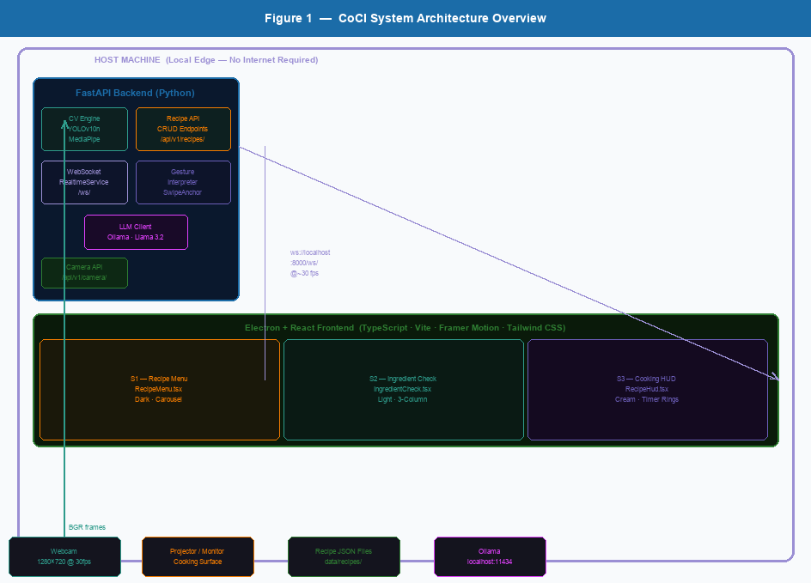
Figure 1: CoCI System Architecture Overview — Host machine layout with Backend, Frontend, and peripheral components.

3. Preliminary Design
This chapter describes the software component architecture, the design specifications of each major software component, data flows, and the database and file system design of the CoCI system.

3.1 Software Architecture
The CoCI software architecture is a client–server application where both client and server run on the same local machine (edge deployment). The backend Python/FastAPI server hosts the CV pipeline, gesture interpreter, LLM client, and recipe API. The frontend Electron/React application connects to the backend via WebSocket and REST HTTP.

Top-level modules:
Module ID | Module Name | Technology | Responsibility
M-01 | CV Pipeline | Python / OpenCV / MediaPipe / YOLO | Capture frames, run gesture recognition and object detection
M-02 | Gesture Action Interpreter | Python | Map raw gestures to semantic GestureAction using state machine
M-03 | Realtime Service | FastAPI / WebSocket | Broadcast CVUpdateMessage to all connected frontend clients
M-04 | Recipe API | FastAPI / REST | Load and serve recipe JSON files
M-05 | LLM Client | Python / Ollama | Process natural language cooking queries via Llama 3.2
M-06 | Frontend HUD | Electron / React / TypeScript | Render menus, steps, overlays; handle WebSocket actions

3.2 Software Component Design Specifications

3.2.1 CV Pipeline
Table M-01: CV Pipeline
Function ID | M-01
Function Name | CV Pipeline
Description | Captures frames from the webcam, runs MediaPipe gesture recognition (async LIVE_STREAM mode) and YOLO object detection, draws annotations on each frame, then broadcasts the result via WebSocket.
Input | Webcam video frames (1280×720), configuration settings (CAMERA_INDEX, CAMERA_WIDTH, CAMERA_HEIGHT)
Output | CVUpdateMessage broadcast via WebSocket: base64-encoded annotated JPEG frame, list of Detection objects (bbox, label, confidence, track_id), resolved GestureAction enum

INPUT | PROCESS | OUTPUT
Camera frame from ThreadedCamera  YOLO: detect and track objects via yolo_model.track()  CVUpdateMessage broadcast over WebSocket to all connected clients | Config: CV_PIPELINE_ENABLED, CAMERA_INDEX  MediaPipe: gesture_recognizer.recognize(frame) in LIVE_STREAM async mode  Annotated video frame (base64 JPEG) displayed in frontend | GestureActionInterpreter.interpret(raw_gestures) → GestureAction  List of Detection objects (bounding boxes, labels)

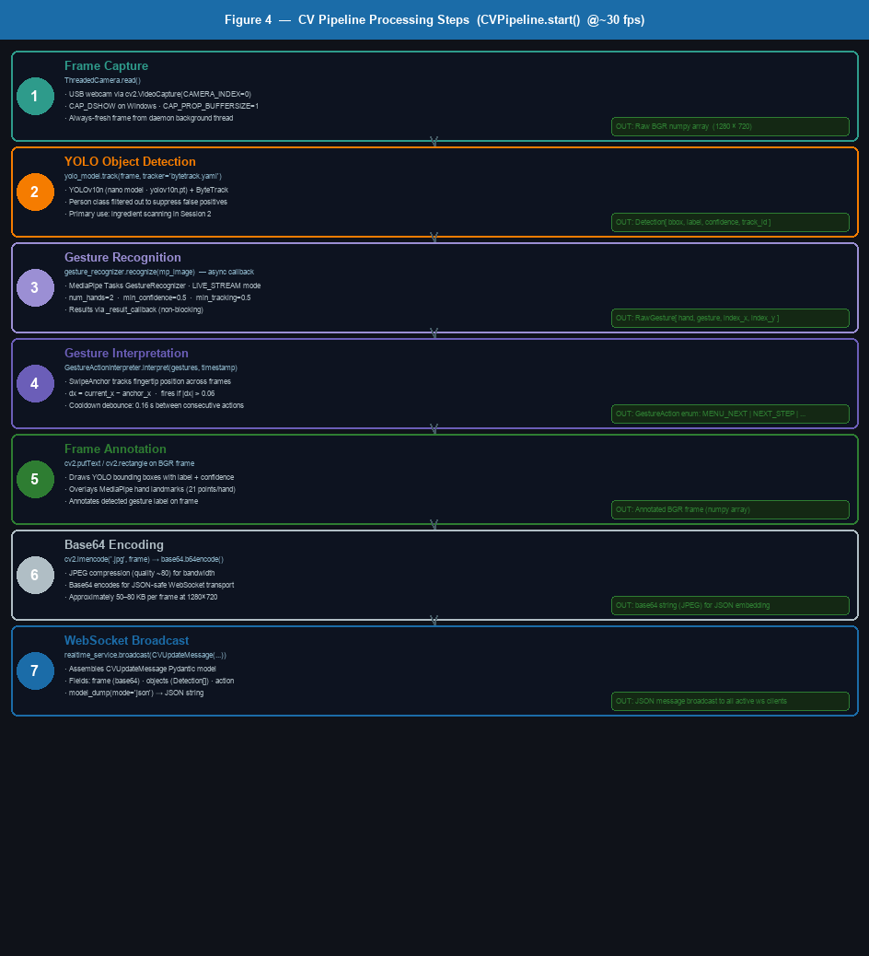
Figure 2: CV Pipeline Processing Steps — Seven-stage pipeline from frame capture to WebSocket broadcast at ~30 fps.

3.2.2 Gesture Action Interpreter
Table M-02: Gesture Action Interpreter
Function ID | M-02
Function Name | Gesture Action Interpreter
Description | A stateful interpreter that converts a list of RawGesture objects (hand, gesture label, index fingertip x/y) into a high-level GestureAction enum. Uses a mode-based state machine with configurable cooldowns, frame counting, and swipe threshold detection.
Input | List of RawGesture objects (hand: Left/Right, gesture: label string, index_x/y: normalized coords), current monotonic timestamp
Output | GestureAction enum value: START_APP | RESET_APP | MENU_NEXT | MENU_PREVIOUS | MENU_CLOSE | BACK_TO_MENU | SELECT_RECIPE | NEXT_STEP | PREVIOUS_STEP | NO_ACTION

INPUT | PROCESS | OUTPUT
List[RawGesture] from CV pipeline  Check for dual POINTING_UP (both hands) → START_APP or RESET_APP  GestureAction.START_APP | Current mode: idle / menu / cooking  Check for single POINTING_UP → MENU_NEXT / NEXT_STEP / PREVIOUS_STEP  GestureAction.RESET_APP | Check for CLOSED_FIST → SELECT_RECIPE or BACK_TO_MENU  GestureAction.MENU_NEXT or MENU_PREVIOUS

Gesture-to-Action Mapping Table:
Gesture | Hand | Mode | GestureAction
Dual POINTING_UP | Both | idle | START_APP (enters menu mode)
Dual POINTING_UP | Both | menu / cooking | RESET_APP (returns to idle)
POINTING_UP | Left only | menu | MENU_NEXT
POINTING_UP | Right only | cooking | NEXT_STEP
POINTING_UP | Left only | cooking | PREVIOUS_STEP
CLOSED_FIST | Any | menu | SELECT_RECIPE (enters ingredient check)
CLOSED_FIST | Any | cooking | BACK_TO_MENU
OPEN_PALM / FIVE_FINGERS | Any | menu | MENU_CLOSE
THREE_FINGERS | Any | any | START_APP (opens menu)

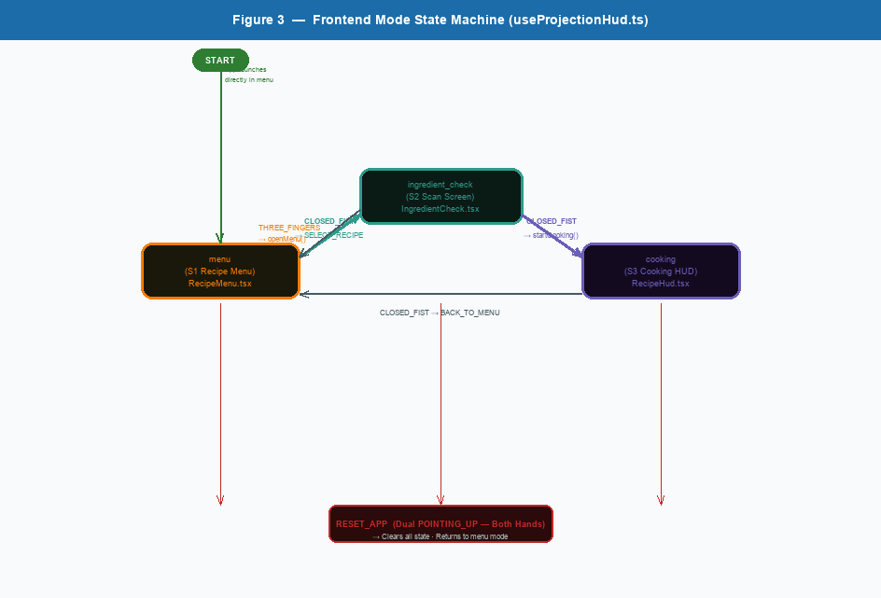
Figure 3: Frontend Mode State Machine — Transitions between menu, ingredient_check, and cooking modes driven by gesture actions.

3.2.3 Realtime Service (WebSocket)
Table M-03: Realtime WebSocket Service
Function ID | M-03
Function Name | Realtime WebSocket Service
Description | Manages active WebSocket connections and broadcasts CVUpdateMessage payloads to all connected clients. Automatically removes stale connections on send failure.
Input | CVUpdateMessage or LLMResponseMessage Pydantic models, WebSocket connection objects
Output | JSON-serialized message broadcast to all active WebSocket clients

INPUT | PROCESS | OUTPUT
WebSocket connect event from client  Accept connection, add to active_connections list  Connection accepted and active | CVUpdateMessage from CV pipeline  Serialize to JSON (model_dump(mode='json'))  Broadcast to all connected clients | Disconnect event or send failure  Remove stale connection from list  Connection list updated

3.2.4 Recipe API
Table M-04: Recipe REST API
Function ID | M-04
Function Name | Recipe REST API
Description | Loads recipe data from JSON files in the data/recipes/ directory and exposes them via HTTP REST endpoints. Supports full CRUD operations: listing all recipes, fetching by ID, fetching a random recipe, creating, updating, and deleting recipes. Also supports keyword-based search via query parameter.
Input | JSON recipe files (data/recipes/*.json), HTTP GET/POST/PUT/DELETE requests from frontend or admin tools
Output | JSON response: list of Recipe objects, single Recipe object, or operation result (create/update/delete). Each Recipe contains title, description, ingredients, and step-by-step instructions.

INPUT | PROCESS | OUTPUT
GET /api/v1/recipes/ [?q=keyword]  GET /api/v1/recipes/random  POST /api/v1/recipes/ | GET /api/v1/recipes/{id}  PUT /api/v1/recipes/{id}  DELETE /api/v1/recipes/{id} | JSON array of all Recipe objects (optional keyword filter)  Single random Recipe object; 404 if none exist  Created Recipe object; recipe saved as new JSON file
INPUT | PROCESS | OUTPUT
RecipeCreate body (JSON) via POST  RecipeUpdate body (JSON) via PUT  recipe_id path parameter via DELETE | Validate with RecipeCreate Pydantic schema; write JSON file  Load existing file; merge fields from RecipeUpdate; save  Remove JSON file from data/recipes/; 404 if not found | New Recipe JSON object  Updated Recipe JSON object  { "message": "Recipe deleted" }

Recipe JSON Schema:
Field | Type | Description
id | string | Unique recipe identifier (derived from filename)
title | string | Display name of the recipe
description | string (optional) | Short description of the dish
prep_time_minutes | int (optional) | Preparation time in minutes
cook_time_minutes | int (optional) | Cooking time in minutes
servings | int (optional) | Number of servings
difficulty | string | Easy / Medium / Hard
cuisine | string | Cuisine type (e.g., Chinese, Italian)
ingredients | list[Ingredient] | Each item: name, amount, unit, notes (optional)
instructions | list[InstructionStep] | Each item: step (number), description, timer_minutes (optional)

3.2.5 Camera API
Table M-04b: Camera REST API
Field | Value / Description
Function ID | M-04b
Function Name | Camera REST API
Description | Provides REST endpoints to enumerate available camera devices and hot-switch the active camera without restarting the backend. GET /devices probes indices 0–4 via cv2.VideoCapture and returns a list of available camera indices. POST /select changes CAMERA_INDEX at runtime, stops the running CV pipeline, and restarts it on the new device.
Input | GET /api/v1/camera/devices — no body; POST /api/v1/camera/select — JSON body: { "index": int }
Output | GET: { "available_cameras": [0, 1, ...], "active_camera": 0 } — POST: { "status": "success", "new_index": int }

3.2.6 LLM Client (Voice Query)
Table M-05: LLM Client
Function ID | M-05
Function Name | LLM Client
Description | Routes natural language cooking queries to the local Ollama server running the Llama 3.2 model. Simple keyword-based routing can direct complex queries (e.g., ingredient substitution) to an extended handler.
Input | LLMQueryMessage via WebSocket (type: llm_query, query: string)
Output | LLMResponseMessage via WebSocket (type: llm_response, data: {query, response})

INPUT | PROCESS | OUTPUT
LLMQueryMessage from frontend (query string)  Keyword routing: if 'substitute' or 'replace' → extended handler; else → local Ollama  LLMResponseMessage broadcast to frontend | Ollama HTTP POST to http://localhost:11434 (llama3.2 model)  Response text displayed on HUD | Return generated response text

3.2.7 Frontend HUD
Table M-06: Frontend HUD (Electron / React)
Function ID | M-06
Function Name | Frontend HUD (Electron / React)
Description | The Electron desktop application renders the cooking HUD. It manages WebSocket connection to the backend, handles incoming GestureAction values, and transitions between three display modes: menu, ingredient_check, and cooking. The UI is built with React 18 + TypeScript, bundled with Vite, and wrapped in an Electron shell for fullscreen projection support. Session 1 (Menu) uses Tailwind CSS with Framer Motion animations for the epic-style recipe carousel. Sessions 2 and 3 use Figma pixel-accurate inline styles for precise HUD layout.
Input | WebSocket messages (CVUpdateMessage, LLMResponseMessage), HTTP GET responses for recipes, user gesture actions resolved by backend
Output | Rendered display: RecipeMenu (menu mode), IngredientCheck (ingredient_check mode), RecipeHud (cooking mode), GestureStatusRail, OverlayCanvas (bounding boxes)

INPUT | PROCESS | OUTPUT
WebSocket cv_update message (action field)  useProjectionHud hook interprets GestureAction and transitions mode  RecipeMenu rendered when mode='menu' | WebSocket cv_update message (frame, objects)  OverlayCanvas draws bounding boxes on annotated camera frame  IngredientCheck rendered when mode='ingredient_check' | HTTP recipe data (on startup)  React state updated (selectedRecipeIndex, currentStepIndex, currentRecipe)  RecipeHud rendered when mode='cooking'

4. User Tutorial
This chapter provides step-by-step instructions for setting up, starting, and using the CoCI system. No touch interaction with any device is required during cooking — all controls are performed through hand gestures recognized by the webcam.

4.1 System Setup
Before using CoCI for the first time, complete the following one-time setup:
- Install Python 3.11 or later from python.org
- Install Node.js 18 or later from nodejs.org
- Install Ollama from ollama.com and run: ollama pull llama3.2
- In the project directory, install backend dependencies: cd backend && pip install -r requirements.txt
- In the project directory, install frontend dependencies: cd frontend && npm install
- Connect your webcam to the computer. The default camera index is 0.
- (Optional) Create a .env file in the backend/ directory to configure camera index or model settings.

4.2 Starting the System
Follow these steps each time you want to use CoCI:
- Open a terminal and start the backend server:
cd backend
uvicorn app.main:app --reload --port 8000
- Open a second terminal and start the Electron frontend:
cd frontend && npm run electron:dev
- The CoCI application window will open on your screen. Position the window so it is visible from your cooking area (or send it to a projector).
- Ensure your webcam is positioned above or facing the cooking workspace so both hands are visible at all times.

4.3 Waking Up the System (Idle → Menu)
When the system first starts, it is in Idle mode and will not respond to single-hand gestures. To wake the system and open the Recipe Menu:
Step | Action | What Happens
1 | Raise BOTH hands with index fingers pointing up (POINTING_UP gesture) | The system detects dual POINTING_UP for 10+ consecutive frames
2 | Hold both hands pointing up for approximately 1 second | GestureAction.START_APP fires; the Recipe Menu appears on the HUD
3 | Lower your hands | The menu remains open; you are now in Menu mode

Tip: Keep your hands clearly in the camera frame. The gesture must be stable for ~10 video frames (~0.33 seconds) to register.

4.4 Navigating the Recipe Menu
In Menu mode, use the following gestures to browse available recipes:
Gesture | Hand | Effect
POINTING_UP (index finger up) | Left hand only | Advance to the next recipe in the list (MENU_NEXT)
POINTING_UP (index finger up) | Right hand only | Go to the previous recipe in the list (MENU_PREVIOUS)
CLOSED_FIST | Either hand | Select the currently highlighted recipe (SELECT_RECIPE) → opens Ingredient Check
OPEN_PALM / five fingers spread | Either hand | Close the menu without selecting (MENU_CLOSE)

The highlighted recipe name and its thumbnail are displayed in the center of the HUD. A gesture status rail at the bottom shows which actions are available in the current mode.

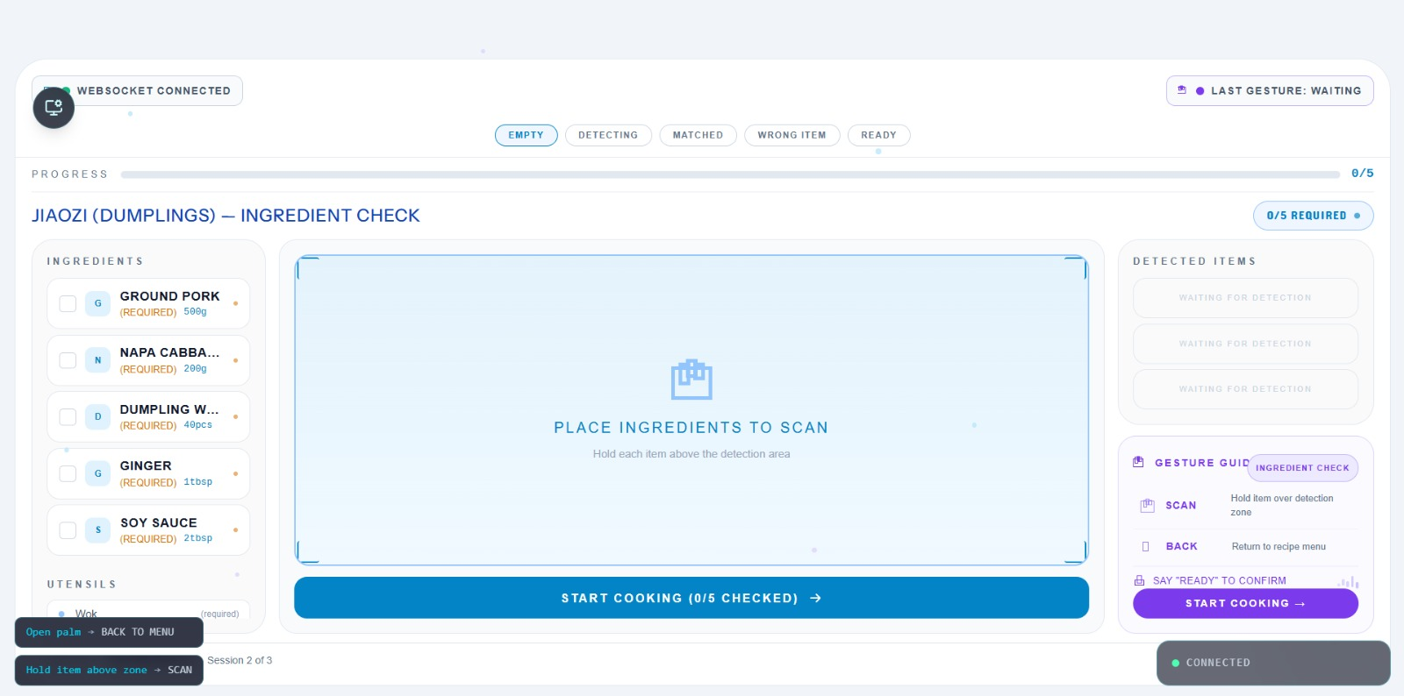
Figure 6 (wa1): Session 1 — Recipe Menu (RecipeMenu.tsx). Epic-style carousel on dark #0C0C0F background. Center card shows selected recipe (Chow Mein) with cuisine/difficulty/time badges, title, description, START COOKING and ingredient count buttons. Side cards fan out with scale and opacity decrease. Bottom-left overlay shows available gesture commands: Right index up / Left index up / Closed fist.

4.5 Ingredient Check Screen
After selecting a recipe with CLOSED_FIST, the Ingredient Check screen appears. This screen lists all required ingredients with their amounts so you can confirm you have everything ready before cooking begins.

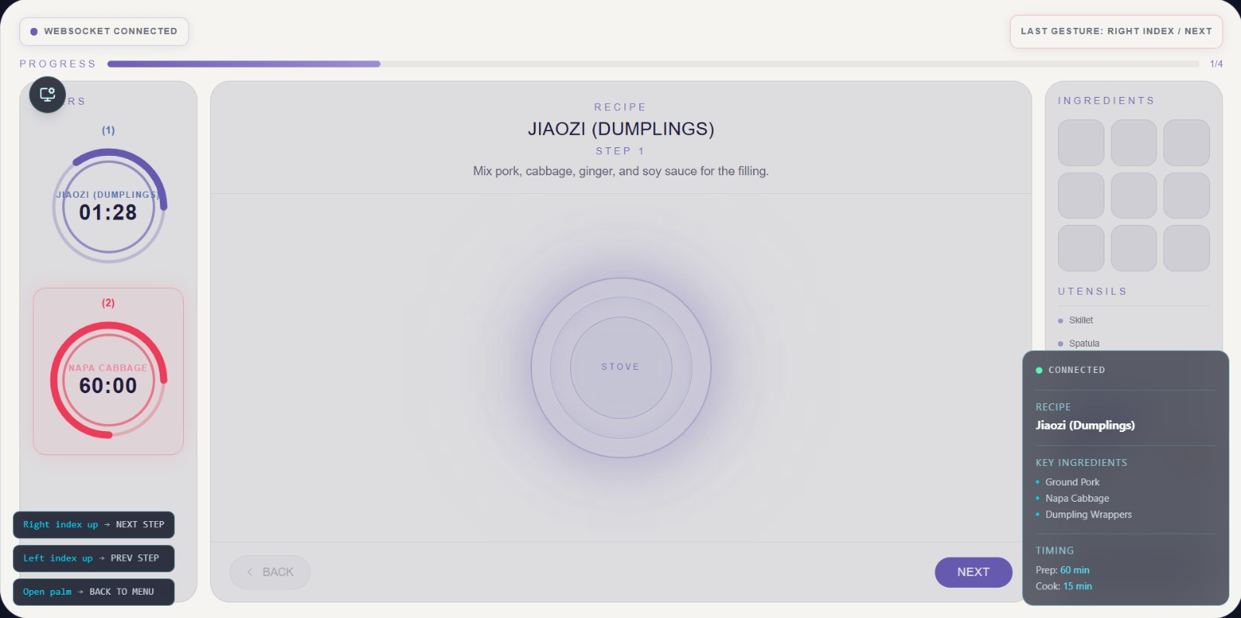
Figure 7 (wa2): Session 2 — Ingredient Check (IngredientCheck.tsx). Light #F1F5F9 background with three-column layout. Left (256px): scrollable ingredient checklist with required amounts and utensils. Center (flex-1): YOLO object detection zone with corner bracket indicators and START COOKING CTA button. Right (280px): detected items panel and gesture guide. Header shows WebSocket status, last gesture, scan-state tabs (EMPTY/DETECTING/MATCHED/WRONG ITEM/READY), and progress bar.
Gesture | Hand | Effect
CLOSED_FIST | Either hand | Confirm ingredients are ready and begin cooking (enters Cooking mode)
THREE_FINGERS | Either hand | Return to the Recipe Menu

4.6 Cooking Mode — Step Navigation
In Cooking mode, the HUD displays the current step number, the instruction text, a progress bar, and the name of the recipe. Navigate between steps using gestures:

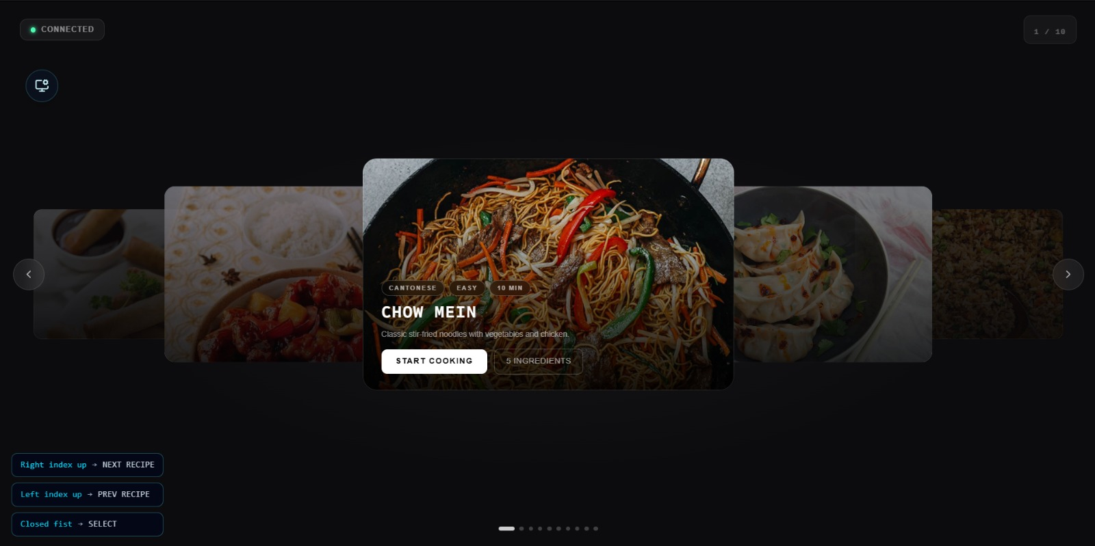
Figure 8 (wa3): Session 3 — Cooking HUD (RecipeHud.tsx). Light cream #F5F4F0 card on dark #0A0F1A background. Left (220px): two SVG circular timer rings — Timer 1 (step timer, purple) and Timer 2 (prep time, red alert). Center (flex-1): recipe name, current step instruction, concentric-circle stove visualization, BACK and NEXT navigation. Right (220px): ingredient thumbnail grid, utensils list, and dark recipe info panel. Purple gradient progress bar at top shows step completion (e.g., 1/4). Bottom-left overlay: Right index up / Left index up / Open palm gesture shortcuts.
Gesture | Hand | Effect
POINTING_UP (index finger up) | Right hand only | Advance to the next cooking step (NEXT_STEP)
POINTING_UP (index finger up) | Left hand only | Return to the previous cooking step (PREVIOUS_STEP)
CLOSED_FIST | Either hand | Return to the Recipe Menu (BACK_TO_MENU)

The progress bar at the top fills as you advance through steps. The current step number and total steps are shown (e.g., Step 3 / 8).

4.7 Using Voice Queries (LLM)
You can ask the CoCI system natural language cooking questions at any time during a session. The LLM subsystem uses a locally running Llama 3.2 model to answer your query without sending any data to external servers.
- To send a voice query, the frontend sends an llm_query WebSocket message with your question text.
- The backend routes the query to Ollama (Llama 3.2) and returns the response as an llm_response WebSocket message.
- The answer is displayed on the HUD.

Example queries you can ask:
- "What can I substitute for oyster sauce?"
- "How many tablespoons are in a quarter cup?"
- "Is the chicken fully cooked when the internal temperature reaches 165°F?"
- "What does it mean to julienne a vegetable?"

4.8 Resetting the System
Action | Gesture | Result
Reset to Idle (from any mode) | Dual POINTING_UP (both hands) held for ~1 second | RESET_APP: system returns to Idle; menu closes; no recipe is selected
Return to Menu (from cooking) | CLOSED_FIST | BACK_TO_MENU: returns to Recipe Menu with last-selected recipe still highlighted

4.9 Gesture Quick Reference Card
Gesture | Icon / Description | Menu Mode | Cooking Mode | Idle Mode
Dual POINTING_UP | Both index fingers up | RESET_APP | RESET_APP | START_APP
Left POINTING_UP | Left index finger up | MENU_NEXT | PREVIOUS_STEP | —
Right POINTING_UP | Right index finger up | — | NEXT_STEP | —
CLOSED_FIST | All fingers curled | SELECT_RECIPE | BACK_TO_MENU | —
OPEN_PALM | All fingers spread | MENU_CLOSE | — | —
THREE_FINGERS | Thumb + index + middle | START_APP | — | START_APP

5. System Operation
This chapter describes how the entire CoCI system works, covering each subsystem from camera input to projected HUD output. It explains all inputs and outputs, the processing that occurs in each component, and how data flows between modules.

5.1 End-to-End System Overview
The CoCI system processes data through three interconnected layers:
Layer | What Happens | Key Input | Key Output
1. Sensing | Webcam captures continuous video frames; microphone awaits voice input | Physical environment (hands, utensils) | JPEG frames (1280×720), audio signal
2. Computation (Backend) | CV pipeline processes frames; gesture interpreter maps to actions; LLM processes voice queries; FastAPI broadcasts results | Video frames, audio text | CVUpdateMessage (frame + objects + action), LLMResponseMessage
3. Actuation (Frontend) | Electron/React HUD receives WebSocket messages, updates the display to show recipe menus, steps, or ingredient lists | WebSocket JSON messages | Rendered HUD on screen/projector

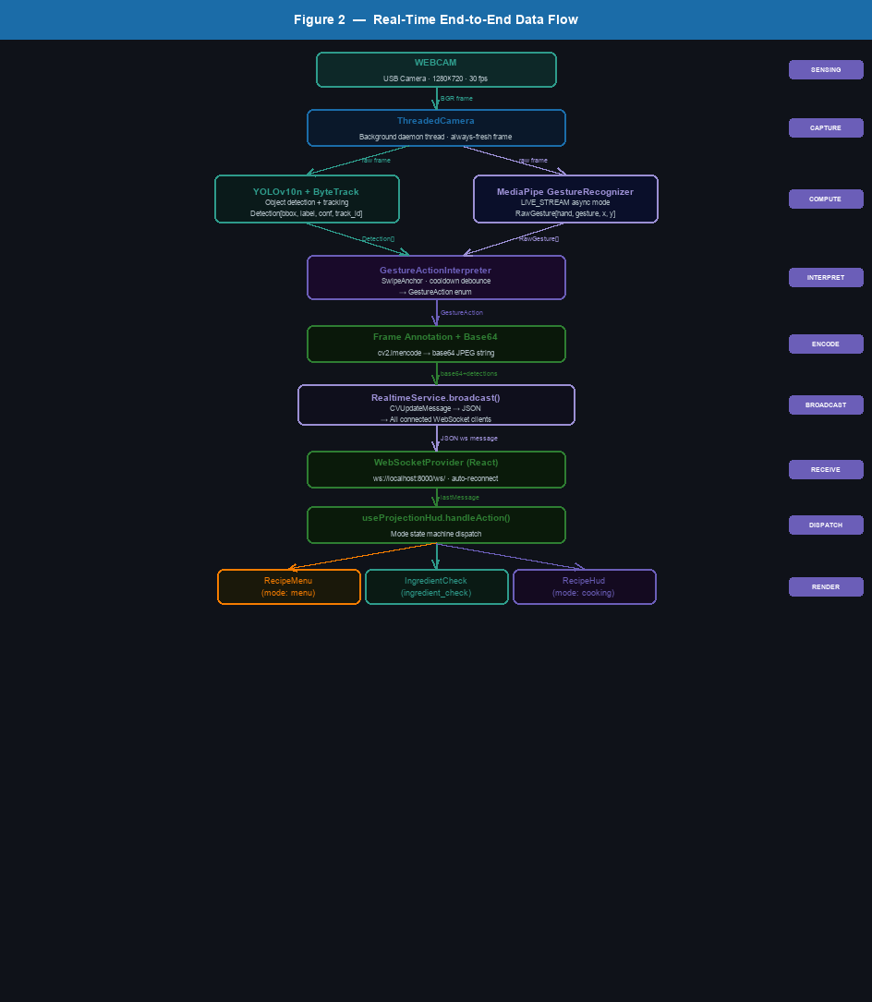
Figure 4: Real-Time End-to-End Data Flow — Camera input through CV processing to frontend HUD rendering.

5.2 Camera Input and CV Pipeline
The CVPipeline class is the backbone of the sensing layer. It operates in a continuous async loop at ~30 fps:
Step | Operation | Input | Output
1 | Frame capture via ThreadedCamera | USB webcam (cv2.VideoCapture) | Raw BGR frame (numpy array)
2 | YOLO object detection | BGR frame | List of Detection(bbox, label, confidence, track_id)
3 | MediaPipe gesture recognition (async) | BGR frame converted to RGB, fed as mp.Image | Latest RawGesture list (hand, gesture, index_x, index_y)
4 | Gesture action interpretation | List[RawGesture], current mode | GestureAction enum value
5 | Frame annotation | Raw frame + landmarks + bounding boxes | Annotated JPEG frame
6 | Base64 encoding | Annotated JPEG frame (cv2.imencode) | base64 string for WebSocket transport
7 | WebSocket broadcast | CVUpdateMessage(frame, objects, action) | JSON message to all connected clients

The ThreadedCamera runs in a background thread to continuously read the freshest available frame, preventing the main async loop from being blocked by camera I/O.

5.3 Gesture Recognition Details
CoCI uses the MediaPipe Gesture Recognizer in LIVE_STREAM mode. This means frames are fed asynchronously to the recognizer and results are returned via a callback function (_result_callback) rather than a blocking call. This design prevents the CV pipeline from stalling while waiting for gesture inference.
For each detected hand, the recognizer outputs:
- Handedness: Left or Right
- Top gesture category (e.g., POINTING_UP, CLOSED_FIST, OPEN_PALM, Thumb_Up, Victory) with confidence score
- 21 hand landmark positions (normalized 0–1.0 x/y coordinates)
The system filters out gestures with confidence < 50% and labels that are 'None'. The index finger tip (landmark 8) x/y position is extracted for swipe detection logic.

5.4 Application State Machine
The GestureActionInterpreter maintains a mode variable that controls how gestures are mapped to actions. The state machine has four modes:
Mode | Trigger to Enter | Active Gesture Mappings | Trigger to Exit
idle | System start, or RESET_APP received | Dual POINTING_UP → START_APP; THREE_FINGERS → START_APP | START_APP fires
menu | START_APP or BACK_TO_MENU fires | Left POINTING_UP → MENU_NEXT; CLOSED_FIST → SELECT_RECIPE; OPEN_PALM → MENU_CLOSE; Dual POINTING_UP → RESET_APP | SELECT_RECIPE or MENU_CLOSE fires, or RESET_APP
ingredient_check | SELECT_RECIPE fires (frontend transition) | Frontend-only: CLOSED_FIST → startCooking; THREE_FINGERS → openMenu | User confirms or returns to menu
cooking | User confirms ingredients (frontend transition) | Right POINTING_UP → NEXT_STEP; Left POINTING_UP → PREVIOUS_STEP; CLOSED_FIST → BACK_TO_MENU; Dual POINTING_UP → RESET_APP | BACK_TO_MENU or RESET_APP fires

Note: The ingredient_check mode transition is handled entirely in the frontend (useProjectionHud hook). The backend state machine transitions between idle → menu → cooking directly.

5.5 WebSocket Communication Protocol
All real-time data between the backend and frontend is exchanged over a single WebSocket connection:
WebSocket endpoint: ws://localhost:8000/ws/
Message types:
Direction | Message Type | Schema | Description
Backend → Frontend | cv_update | { type, data: { frame, objects[], action } } | Sent at ~30 fps; carries annotated camera frame, detected objects, and resolved GestureAction
Backend → Frontend | llm_response | { type, data: { query, response } } | Sent when LLM finishes processing a voice query
Frontend → Backend | llm_query | { type, query } | Sent when user submits a voice or text query
Backend → Frontend | status | { type, data: { message } } | System status messages (connection info, errors)

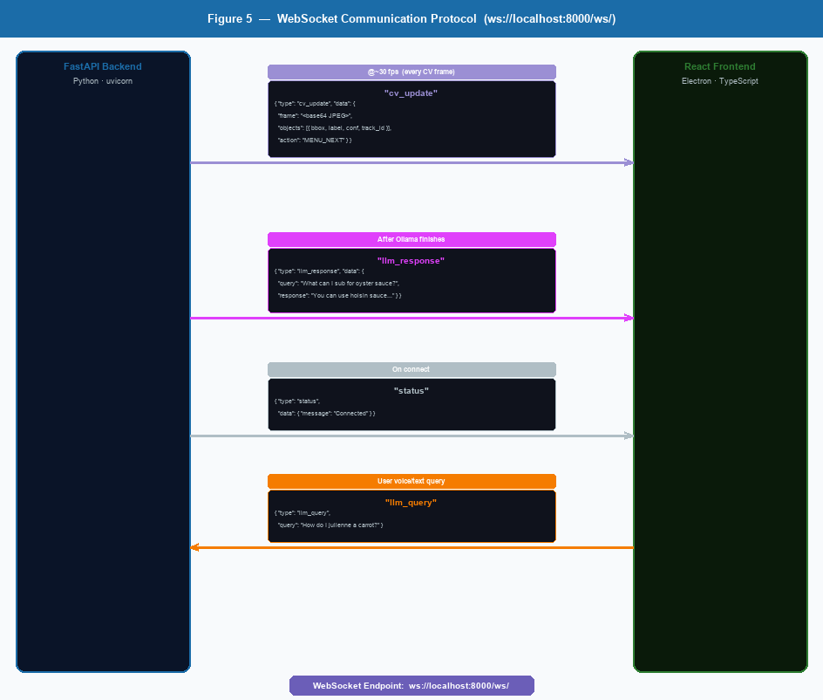
Figure 5: WebSocket Communication Protocol — Message types, JSON schemas, and direction between backend and frontend.

5.6 Frontend HUD Rendering
The React frontend receives WebSocket messages and updates the UI through the useProjectionHud custom hook. The hook maintains the following state:
State Variable | Type | Purpose
mode | menu | ingredient_check | cooking | Controls which screen component is rendered
recipes | Recipe[] | Full list of available recipes (loaded on startup via REST)
selectedRecipeIndex | number | Index of currently highlighted recipe in the menu
currentRecipe | Recipe | null | The recipe chosen for cooking
currentStepIndex | number | Index of the current cooking step (0-based)
lastAction | GestureAction | null | Most recent gesture action received from backend
isConnected | boolean | WebSocket connection status

The component tree is:
- App → WebSocketProvider → ProjectionLayout
- ProjectionHud: conditionally renders RecipeMenu, IngredientCheck, or RecipeHud based on mode
- OverlayCanvas: draws bounding boxes for detected objects on top of the camera feed
- GestureStatusRail: shows available gestures for the current mode
- UtilityStatusPanel: shows connection status and current recipe name

5.7 LLM Voice Query Pipeline
The voice query pipeline allows the cook to ask natural language questions without touching the device. The end-to-end flow is:
- User speaks or types a question
- Frontend sends: { type: 'llm_query', query: '<text>' } via WebSocket
- Backend stream.py endpoint receives the message, calls llm_router.route_query(query)
- The LLM router checks for keywords ('substitute', 'replace') to determine routing
- Keyword matched: calls external placeholder handler; no match: calls llm_client.generate(query)
- llm_client sends POST to http://localhost:11434/api/generate with model: 'llama3.2'
- Ollama returns generated text response
- Backend broadcasts: { type: 'llm_response', data: { query, response } } to all clients
- Frontend displays the response on the HUD

5.8 Recipe Data Management
Recipes are stored as individual JSON files in the data/recipes/ directory. The RecipeLoader service scans this directory on startup and serves recipe data via the REST API at /api/v1/recipes/.
Currently available recipes (10 Chinese dishes):
File | Recipe | Difficulty
chow_mein.json | Chow Mein (Stir-Fried Noodles) | Medium
dumplings_jiaozi.json | Dumplings (Jiaozi) | Hard
fried_rice.json | Fried Rice | Easy
hot_and_sour_soup.json | Hot and Sour Soup | Medium
kung_pao_chicken.json | Kung Pao Chicken | Medium
mapo_tofu.json | Mapo Tofu | Medium
peking_duck.json | Peking Duck | Hard
scallion_pancakes.json | Scallion Pancakes | Medium
spring_rolls.json | Spring Rolls | Medium
sweet_and_sour_pork.json | Sweet and Sour Pork | Medium

To add a new recipe, create a JSON file in data/recipes/ following the RecipeCreate schema. The backend automatically picks up new recipes without requiring a restart.

5.9 System Input/Output Summary
Component | Primary Inputs | Primary Outputs
CV Pipeline | Webcam video frames (1280×720 @ 30 fps) | Annotated frame (base64 JPEG), Detection list, GestureAction
Gesture Interpreter | List[RawGesture], current mode | GestureAction enum (one per CV frame)
WebSocket Service | CVUpdateMessage, LLMResponseMessage (Pydantic models) | JSON-serialized broadcasts to all connected clients
Recipe API | HTTP GET requests, filesystem (data/recipes/*.json) | JSON Recipe objects (list or single)
LLM Client | LLMQueryMessage (query string) | LLMResponseMessage (response text)
Frontend HUD | WebSocket JSON messages, HTTP recipe data | Rendered HUD (menu / ingredient check / cooking step)

6. Appendix

6.1 GestureAction Enum Reference
GestureAction Value | Meaning | Frontend Handler
START_APP | Open the recipe menu | openMenu()
RESET_APP | Reset to idle / close menu | reset()
MENU_NEXT | Advance to next recipe in menu | nextRecipe()
MENU_PREVIOUS | Go to previous recipe in menu | previousRecipe()
MENU_CLOSE | Close menu without selecting | closeMenu()
BACK_TO_MENU | Return to recipe menu from cooking | openMenu()
SELECT_RECIPE | Confirm selection of highlighted recipe | selectRecipe()
NEXT_STEP | Go to next cooking instruction step | nextStep()
PREVIOUS_STEP | Go to previous cooking instruction step | previousStep()
NO_ACTION | No recognized action this frame | (ignored)

6.2 Environment Variable Reference
Variable | Default | Description
CAMERA_INDEX | 0 | Camera device index passed to cv2.VideoCapture()
CAMERA_WIDTH | 1280 | Requested camera capture width in pixels
CAMERA_HEIGHT | 720 | Requested camera capture height in pixels
CV_PIPELINE_ENABLED | true | Enable or disable the CV pipeline on startup
GESTURE_ACTION_COOLDOWN_SECONDS | 0.16 | Minimum time between consecutive gesture action fires
GESTURE_SWIPE_THRESHOLD | 0.06 | Normalized pixel threshold for swipe detection
GESTURE_MONITOR_ENABLED | true | Enable verbose gesture monitoring logs
OLLAMA_BASE_URL | http://localhost:11434 | Base URL for the local Ollama LLM server
OLLAMA_MODEL | llama3.2 | Ollama model name to use for voice queries
RECIPE_DATA_DIR | data/recipes | Directory path for recipe JSON files
CORS_ORIGINS | http://localhost:5173 | Allowed CORS origins for the backend API

