**VEYE Web Application**

**Signup Page**

**SignIn Page**

**About Us Page**

**Dashboard**

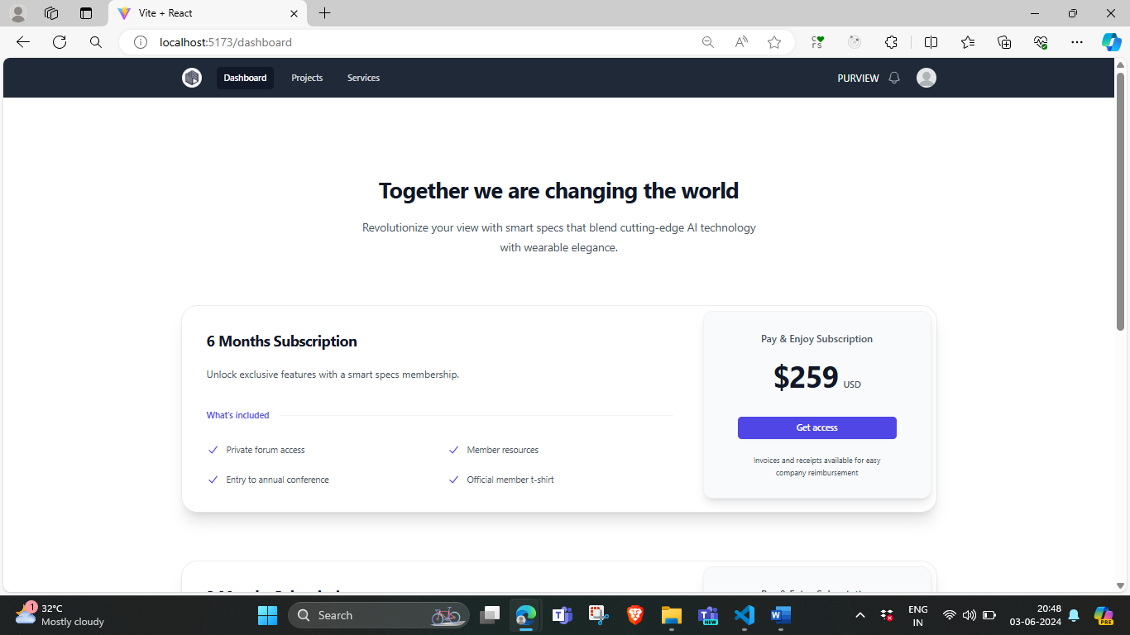

**After Click on Get Access button Confirmation with Details**

**Hitting to Razor pay Payment Gateway**

**During Payment**

**After Payment and Background Verification of Is payment really done.**

**Payment successful**

**Checking in Razor Pay Dashboard**

