**Create the Contact Us, Job agreement plugins and display that data in admin dashboard.**

**The Process Steps:**

**Step-1:** Create the plugins [ contact us and Job agreement ]

In previous document already we discussed the how to create the plugins, again we will recap those steps for better understanding.

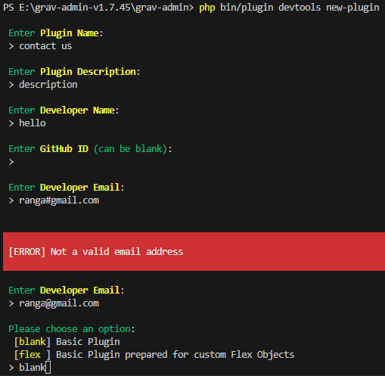

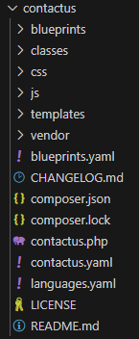**Folder structure of plugin after creation.**

**Working of Plugin :**

**grav-admin\user\plugins\contactus\contactus.php –**  Write the code related to backend functionality and logic.

**grav-admin\user\plugins\contactus\css\contactus.css –** we can write the css style for the twig file and can be access this css styles in that twig file by following code

<link rel="stylesheet" href="{{ url('plugin://contactus/css/contactus.css') }}">

Add this code in head tag or else we can directly include the css code in style tags between to acces those styles.

**grav-admin\user\plugins\contactus\js \contactus.js–** we can write the js code for the twig file and can be access this js code in that twig file by following code

<script src="{{ url('theme://js/chatbot.js') }}"></script>

Or else we can also directly include the js code in between the script tag

**grav-admin\user\plugins\contactus\templates\contactus.html.twig –** write the code related to frontend.

**Note :** Basically grav recognizes the template file either it should be there in main theme/themeName/templates,here[i.e **grav-admin\user\themes\quark\templates**] but we want to access the templates which is present in particular plugin [I.e **grav-admin\user\plugins\contactus\templates\contactus.html.twig**] then include the below code in contactus.php file.

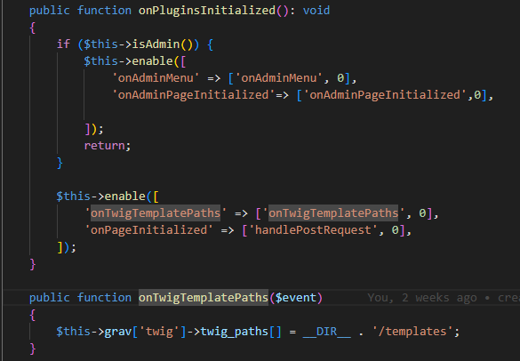

**To view the Template page:**

* First create the folder in pages folder [i.e pages/contactus/default.md]
* Now write the code show below

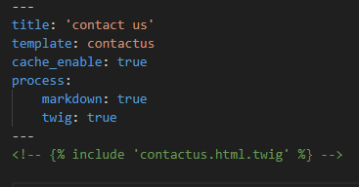

**Note:** In template name should matches with the templateName.html.twig which present in templates /templateName.html.twig

* **Second method** **:** Uncomment that comment code is another method to render the template in pages.

**Whoooohoooo! It looks greate……….!**

**Displaying of Data in Admin Dashboard**

**Step-1:** create the admin pages that you are going to display the data on admin dashboard.

**Note:** Make sure that create the pages in the admin plugin pages location.

Ex: **grav-admin\user\plugins\admin\pages\admin\contact_data.md**

2.Make sure the template file which are created to render the particular data in the admin pages [in contact_data.md] should also present in admin/templates.

Ex: **grav-admin\user\plugins\admin\themes\grav\templates\contact_data.html.twig**

Once the above two are in exact location we are able to access the admin pages.

**Step-2:** Creating the menu item in admin dashboard.

<?php

namespace Grav\Plugin;

use Grav\Common\Plugin;

use RocketTheme\Toolbox\Event\Event;

use Grav\Common\File\CompiledJsonFile;

class JobAgreementPlugin extends Plugin

{

    public static function getSubscribedEvents()

    {

        return [

            'onPluginsInitialized' => ['onPluginsInitialized', 0],

            'onTwigSiteVariables' => ['onTwigSiteVariables', 0]

        ];

    }

    public function onPluginsInitialized(): void

    {

        if ($this->isAdmin()) {

            $this->enable([

                'onAdminMenu' => ['onAdminMenu', 0],

                'onAdminPageInitialized' => ['onAdminPageInitialized', 0],

                'onAdminTwigTemplatePaths' => ['onAdminTwigTemplatePaths', 0]

            ]);

            return;

        }

        $this->enable([

            'onTwigTemplatePaths' => ['onTwigTemplatePaths', 0],

            'onPageInitialized' => ['handlePostRequest', 0],

        ]);

    }

    public function onTwigTemplatePaths()

    {

        $this->grav['twig']->twig_paths[] = __DIR__ . '/templates';

    }

    public function onAdminTwigTemplatePaths()

    {

        $this->grav['twig']->twig_paths[] = __DIR__ . '/templates';

    }

    public function onAdminMenu()

    {

        $this->grav['twig']->plugins_hooked_nav['job_data'] = [

            'route' => 'jobagreement_data',

            'icon' => 'fa-database',

            'authorize' => ['admin.pages', 'admin.super'],

            'priority' => 9

        ];

    }

    public function handlePostRequest()

    {

        if ($this->grav['uri']->post() && $this->grav['uri']->route() === '/jobagreement') {

            $postData = $this->grav['uri']->post();

            $this->storeData($postData);

            echo json_encode(['success' => true, 'response' => $postData]);

            exit();

        }

    }

    public function onAdminPageInitialized()

    {

        if ($this->isAdminPlugin() && $this->grav['uri']->route() === '/jobagreement_data') {

            $this->onTwigSiteVariables();

            $this->grav['twig']->template = 'jobagreement_data.html.twig';

        }

    }

    public function onTwigSiteVariables()

    {

        $file = CompiledJsonFile::instance($this->grav['locator']->findResource('user://data/jobagreement/jobData.json', true, true));

        $data = $file->content();

        $this->grav['twig']->twig_vars['items'] = $data;

    }

    public function storeData($data)

    {

        $existingData = $this->readExistingData();

        $existingData[] = $data;

        $file = $this->grav['locator']->findResource('user://data/jobagreement/jobData.json', true, true);

        $content = json_encode($existingData);

        file_put_contents($file, $content);

    }

    public function readExistingData()

    {

        $file = $this->grav['locator']->findResource('user://data/jobagreement/jobData.json', true, true);

        if (file_exists($file)) {

            $content = file_get_contents($file);

            return json_decode($content, true);

        } else {

            return [];

        }

    }

}

**Above code is about displayin the jobagreement data in admin dashboard,**

**It consist of main functions like :**

**HandlePostRequest –** Which is able to handle the post request for frontend data and send the response.

**StoreData –** which is use to store that post data in the json format at file location of data/jobagreement/jobData.json folder in grav application.

**OnTwigSiteVariables –** which is used to retrieve the data from the **data/jobagreement/jobData.json**  and assign data to **twig variable** [ which can be access that variable in templated or twif files globally].

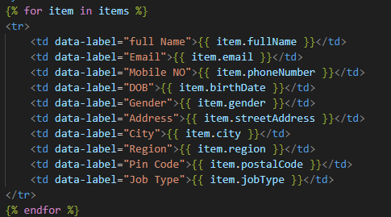

Above template file tells about how to access that twig variable in template files. Here [items – is twig variable which created in php file i.e. contactus.php]

**Results**



