**CTEC 12073 - Structured Programming II**

Assignment II

CT/2020/054

**Snake Game**

The snake game is very simple kid’s game.as well as every people can play this game. It is contain very simple methods. How play this game.

In this article, the task is to snake game**.**Below given some functionalities of this game:

* The snake is represented with a **0**(zero) symbol.
* The fruit is represented with an **\***(asterisk) symbol.
* The snake can move in any direction according to the user with the help of the keyboard (**W**, **A**, **S**, **D** keys).
* When the snake eats a fruit the score will increase by 10 points.
* The fruit will generate automatically within the boundaries.
* Whenever the snake will touch the boundary the game is over.

**Steps to create this game:**

* There will be four user defined function.
* Build a boundary within which the game will be played.
* The fruits are generated randomly.
* Then increase the score whenever the snake eats a fruit

Theuser-definedfunctions created in this program are given below:

* Draw() :This function creates the boundary in which the game will be played.
* Setup()**:**This function will set the position of the fruit within the boundary.
* Input() **:**This function will take the input from the keyboard.
* Logic():This function will set the movement of the snake.

**Built-in functions used:**

* kbhit():

This function in c  is used to determine if a key has been pressed or not. To use this function in a program include the header file conio.h If a key has been pressed, then it returns a non-zero value otherwise it returns zero.

* rand():

 The rand()  function is declared in stdli.b.h It returns a random integer value every time it is called.

**Header files and variables:**

* The header files and variable  used in this program are:

**#include<stdio.h>**

**#include<conio.h>**

**#include<stdlib.h>**

**int i,j;**

**int height=20,width=20;**

**int gameover,score;**

**int x,y,fruitx,fruity,flag;**

* Here include the <unistd.h> header file for the sleep()function.
* Here include the <unistd.h> header file for the sleep()function.

Draw():

This function is responsible to build the boundary within which the game will be played.

**Below is the C program to build the outline boundary using draw ()**

**// C program to build the outline**

**// boundary using draw ()**

**#include <stdio.h>**

**#include <stdlib.h>**

**int i, j, height = 30;**

**int width = 30, gameover, score;**

**// Function to draw a boundary**

**void draw()**

**{**

**// system("cls");**

**for (i = 0; i < height; i++) {**

**for (j = 0; j < width; j++) {**

**if (i == 0 || i == width - 1 || j == 0**

**|| j == height - 1) {**

**printf("#");**

**}**

**else {**

**printf(" ");**

**}**

**}**

**printf("\n");**

**}**

**}**

**// Driver Code**

**int main()**

**{**

**// Function Call**

**draw();**

**return 0;**

**}**

**Output:**

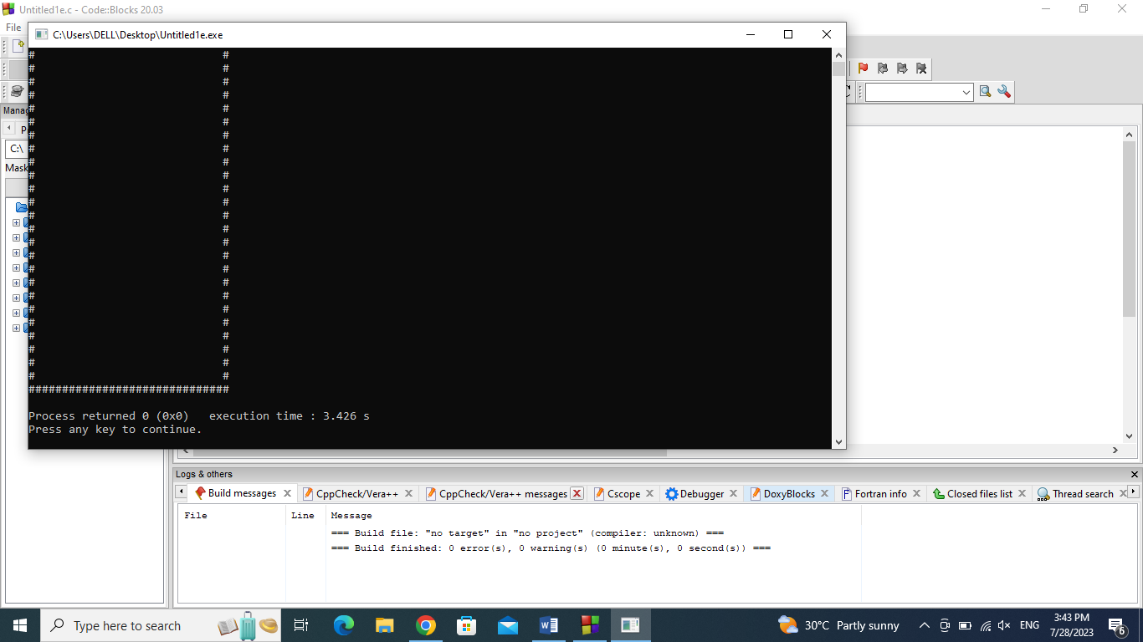

setup():

NThisbfunction is used to write the code to generate the fruit within the boundary using rand() function.

* Using rand()%20 because the size of the boundary is length = 20andwidth= 20so the fruit will generate within the boundary.

**Void setup ()**

**{**

**gameover=0;**

**x=height/2;**

**y=width/2;**

**label1:**

**fruitx=rand()%20;**

**if(fruitx==0)**

**goto label1;**

**label2:**

**fruity=rand()%20;**

**if(fruity==0)**

**goto label2;**

**score=0;**

**}**

**Input():**

In this function, the programmer writes the code to take the input from the keyboard (W, A, S, D, X keys).

**void input()**

**{**

**if (kbhit())**

**{**

**switch(getch())**

**{**

**case 'a':**

**flag=1;**

**break;**

**case 's':**

**flag=2;**

**break;**

**case 'd':**

**flag=3;**

**break;**

**case 'w':**

**flag=4;**

**break;**

**case 'x':**

**gameover=1;**

**break;**

**}**

**}**

**}**

**logic():**

 Here, write all the logic for this program like for the movement of the snake, for increasing the score, when the snake will touch the boundary the game will be over, to exit the game and the random generation of the fruit once the snake will eat the fruit.

**void logic()**

**{**

**sleep(0.01);**

**switch(flag)**

**{**

**case 1:**

**y--;**

**break;**

**case 2:**

**x++;**

**break;**

**case 3:**

**y++;**

**break;**

**case 4:**

**x--;**

**break;**

**default:**

**break;**

**}**

**if(x<0) ||x>height ||y<0|| y>width)**

**gameover=1;**

**if(x==furuitx && y==fruity)**

**{**

**label3:**

**fruitx=rand()%20;**

**if(fruitx==0)**

**goto label3;**

**label4:**

**fruity=rand()%20;**

**if(fruity==0)**

**goto label4;**

**score=10;**

**}**

**}**

sleep():

This function in C is a function that delays the program execution for the given number of seconds. In this code sleep() is used to slow down the movement of the snake so it will be easy for the user to play.

main():

 From the main() function the execution of the program starts. It calls all the functions.

**void main()**

**{**

**int m,n;**

**setup;**

**while(!gameover)**

**{**

**draw();**

**input();**

**logic();**

**}**

**}**

Below is the C program to build the complete snake game:

// C program to build the complete

// snake game

#include <conio.h>

#include <stdio.h>

#include <stdlib.h>

#include <unistd.h>

int i, j, height = 20, width = 20;

int gameover, score;

int x, y, fruitx, fruity, flag;

// Function to generate the fruit

// within the boundary

void setup()

{

gameover = 0;

// Stores height and width

x = height / 2;

y = width / 2;

label1:

fruitx = rand() % 20;

if (fruitx == 0)

goto label1;

label2:

fruity = rand() % 20;

if (fruity == 0)

goto label2;

score = 0;

}

// Function to draw the boundaries

void draw()

{

system("cls");

for (i = 0; i < height; i++) {

for (j = 0; j < width; j++) {

if (i == 0 || i == width - 1

|| j == 0

|| j == height - 1) {

printf("#");

}

else {

if (i == x && j == y)

printf("0");

else if (i == fruitx

&& j == fruity)

printf("*");

else

printf(" ");

}

}

printf("\n");

}

// Print the score after the

// game ends

printf("score = %d", score);

printf("\n");

printf("press X to quit the game");

}

// Function to take the input

void input()

{

if (kbhit()) {

switch (getch()) {

case 'a':

flag = 1;

break;

case 's':

flag = 2;

break;

case 'd':

flag = 3;

break;

case 'w':

flag = 4;

break;

case 'x':

gameover = 1;

break;

}

}

}

// Function for the logic behind

// each movement

void logic()

{

sleep(0.01);

switch (flag) {

case 1:

y--;

break;

case 2:

x++;

break;

case 3:

y++;

break;

case 4:

x--;

break;

default:

break;

}

// If the game is over

if (x < 0 || x > height

|| y < 0 || y > width)

gameover = 1;

// If snake reaches the fruit

// then update the score

if (x == fruitx && y == fruity) {

label3:

fruitx = rand() % 20;

if (fruitx == 0)

goto label3;

// After eating the above fruit

// generate new fruit

label4:

fruity = rand() % 20;

if (fruity == 0)

goto label4;

score += 10;

}

}

// Driver Code

void main()

{

int m, n;

// Generate boundary

setup();

// Until the game is over

while (!gameover) {

// Function Call

draw();

input();

logic();

}

}

**Output:**

