FDF_SURVEY_IVR_DeploymenT Document

0.03

December 10, 2019

**Contents**

1.1 Upload the configurations in Document Management 2

1.1.1 Upload the fdf_ivrConfig.xml in Document Management 2

1.1.1.1 fdf_ivrconfig.xml 2

1.1.1.2Configuration details 4

1.1.2 Upload the log4j.properties in Document Management 4

1.2 Upload the required prompts in the prompt management 7

1.2.1 Steps to upload the English phrases 7

1.2.2 PhrasesList 8

1.2.2 Steps to upload the Arabic phrases 8

1.3 Upload the UCCX Scripts(.aef) files under the script management 9

1.4 Create an application and associate the script and Trigger 9

1.5 Verify call is landing to IVR through Reactive Debugging 9

2.1 To Stop Running Apache Server 10

2.2 To deploy the UI Build Files 10

2.3 To deploy war files 10

3.1 To run db script 11

1. Steps involved in UCCX Survey IVR Deployment

# Upload the configurations in Document Management

Following are the 2 configuration files used by the Survey IVR.

1. fdf_ivrconfig.xml
2. log4j.properties

## 1.1.1 Upload the fdf_ivrConfig.xml in Document Management

Load the ivr level configuration file fdf_ivrconfig.xml file under Document management **/ en_US/ FDF_SURVEY**

**File Name :** fdf_ivrconfig.xml

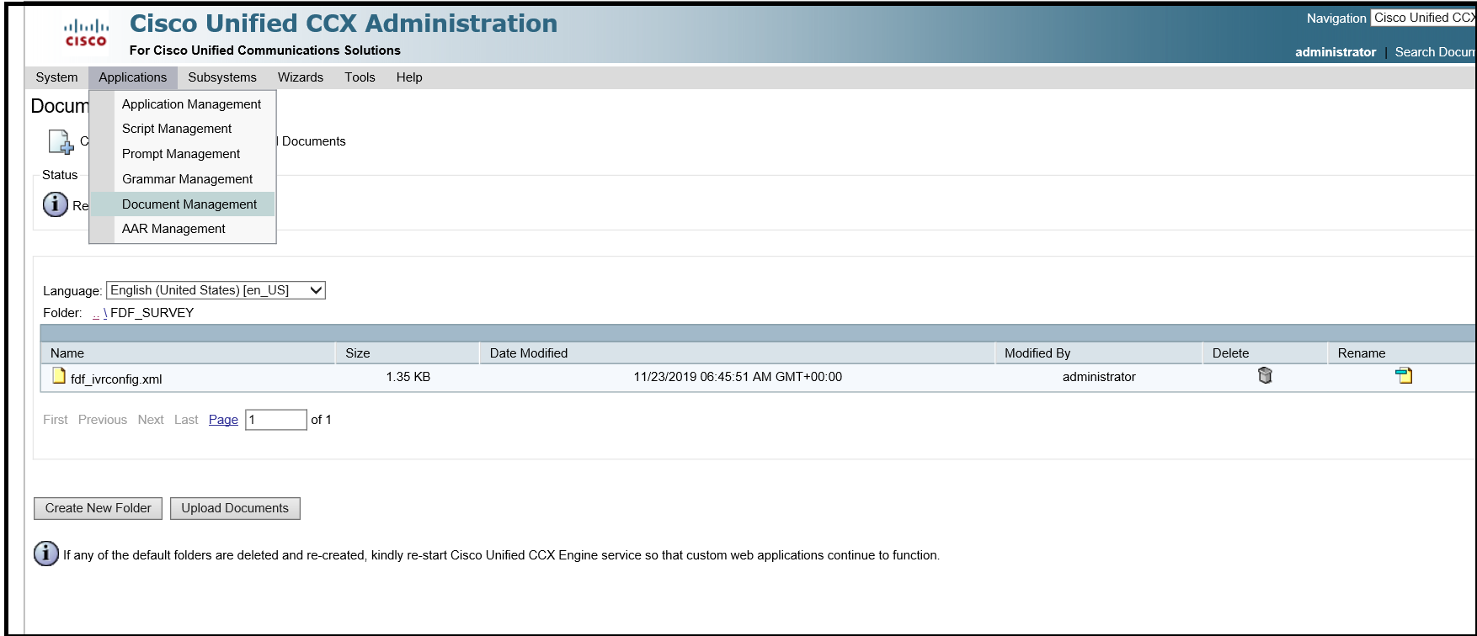

## fdf_ivrconfig.xml

Following are the configurations set in fdf_ivrconfig.xml

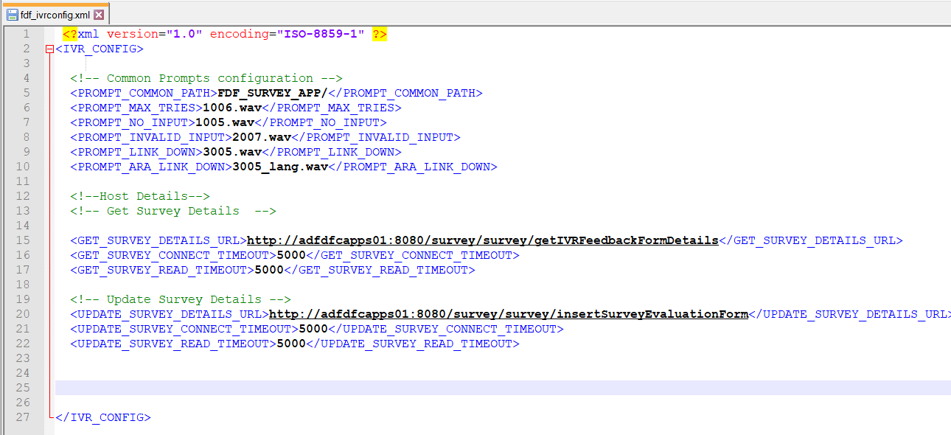

## 1.1.1.2 Configuration details

|  |  |  |  |
| --- | --- | --- | --- |
| S.No | Field Name | Field Description | Sample value |
| 1 | PROMPT_COMMON_PATH | Prompt path where common prompts like no input prompts, invalid prompts, maximum tries prompts are loaded for each language.  Note: This folder should be created in prompt management under each language and the respective prompts should be loaded. Steps for uploading the prompts are available here | FDF_SURVEY_APP/ |
| 2 | PROMPT_MAX_TRIES | The file name of maximum tries exceeded prompt | 1006.wav |
| 3 | PROMPT_NO_INPUT | The name of the prompt file to be played when caller does not give any input | 1005.wav |
| 4 | PROMPT_INVALID_INPUT | The name of the prompt file to be played when caller gives invalid input to the menu | 2007.wav |
| 5 | PROMPT_LINK_DOWN | The name of the prompt to be played when host interaction fails or link down | 3005.wav |
| 6 | PROMPT_ARA_LINK_DOWN | The name of the Arabic prompt to be played when host interaction fails or link down | 3005_lang.wav |
| 7 | GET_SURVEY_DETAILS_URL | The URL to access to get the welcome message, survey Questions, minimum score, maximum score and Thank you message from the application server | http:/hostip:port  /survey/survey/  getIVRFeedbackFormDetails |
| 8 | GET_SURVEY_CONNECT_TIMEOUT | Timeout in seconds for connecting the get Survey URL | 5000 |
| 9 | GET_SURVEY_READ_TIMEOUT | Time out in seconds for reading the get survey detail | 5000 |
| 10 | UPDATE_SURVEY_DETAILS_URL | Host URL to update the survey results | http:/hostip:port  /survey/survey/  insertSurveyEvaluationForm |
| 11 | UPDATE_SURVEY_CONNECT_TIMEOUT | Timeout in seconds for connecting the update survey details | 5000 |
| 12 | UPDATE_SURVEY_READ_TIMEOUT | Timeout in seconds for reading the response from update survey details | 5000 |

# 

## 1.1.2 Upload the log4j.properties in Document Management

1. Upload the log4j.properties under the folder **default** in document management

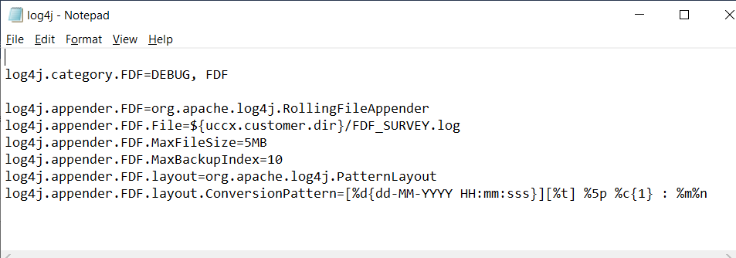

1. upload “log4j-1.2.17.jar” in system “Custom File Configuration”

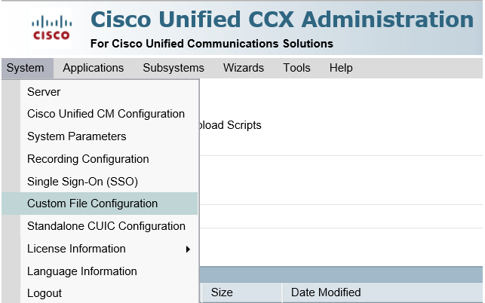

1. Choose upload custom jar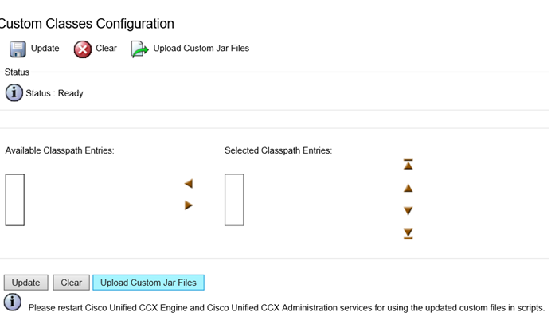
2. Upload the jar file on the next screen

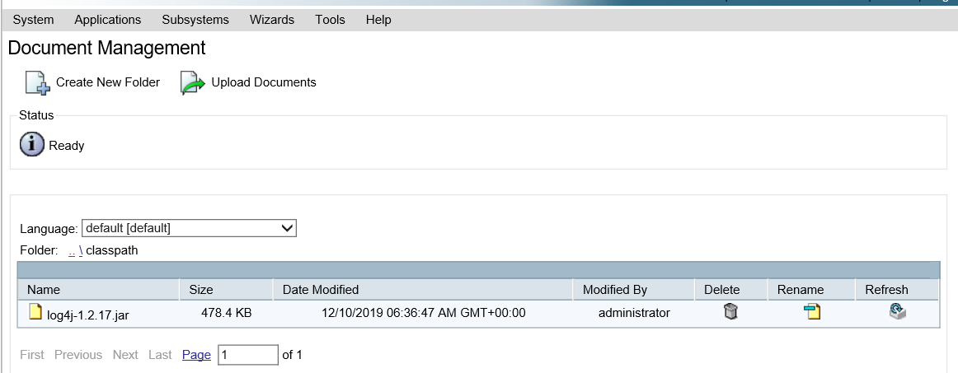

1. And move the jar file to the selected classpath entry

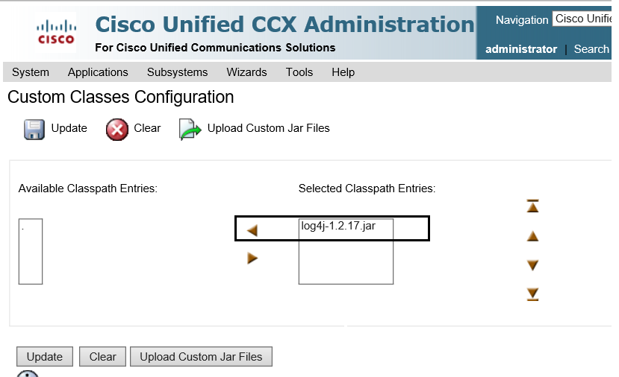

1. Restart the UCCX Engine service and UCCX Appadmin service to get the log4j work

# 1.2 Upload the required prompts in the prompt management

**Open the prompt management page in UCCX appadmin**

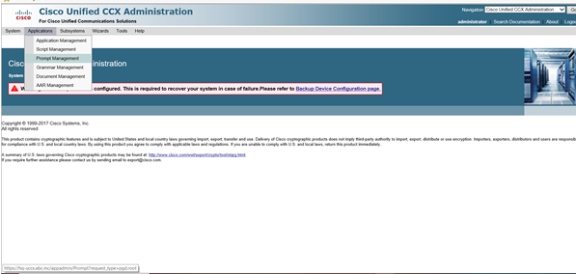

## 1.2.1 Steps to upload the English phrases

1. Under prompt Management spot en_US folder

2. Create the folder FDF_SURVEY_APP

3. Create folders WelcomeMessage, SurveyQuestions and ThankYou folders under FDF_APP

4.Upload the prompts as per following list in specified folders

## 1.2.2 PhrasesList

|  |  |  |
| --- | --- | --- |
| **Phrases for Family Call Center Survey call flow** | | |
| **Folder name** | **Phrase Name** | **Phrase content** |
| FDF_SURVEY_APP/ | 1005 | Sorry we have not received any input from you. Kindly key in the number. |
| 1006 | Sorry you have exceeded the maximum number of tries. |
| 2007 | You entered an invalid value |
| 3005 | Sorry, the system is currently unavailable. Please try again later. |
| FDF_SURVEY_APP/WelcomeMessage | 3001 | Welcome to conducted survey for Family Development Foundation’s call center . Dear customer we would like to know your opinion to improve quality of our services. |
| FDF_SURVEY_APP/SurveyQuestions | 3002 | How satisfied are you with the service provided in Family Call Center? |
| 3003 | Please selecta rating from 0 to 5 .. which is 0 means not satisfied and 5 means completely satisfied |
| FDF_SURVEY_APP/ThankYou | 3004 | Thank you |

## 1.2.2 Steps to upload the Arabic phrases

1.Under prompt Management create the folder ar_SA folder

2.Create the folder FDF_SURVEY_APP

3. Create folders WelcomeMessage, SurveyQuestions and ThankYou folders under FDF_APP

4.Upload the prompts as per the list in specified folders\

# 1.3 Upload the UCCX Scripts(.aef) files under the script management

1. Go to script management

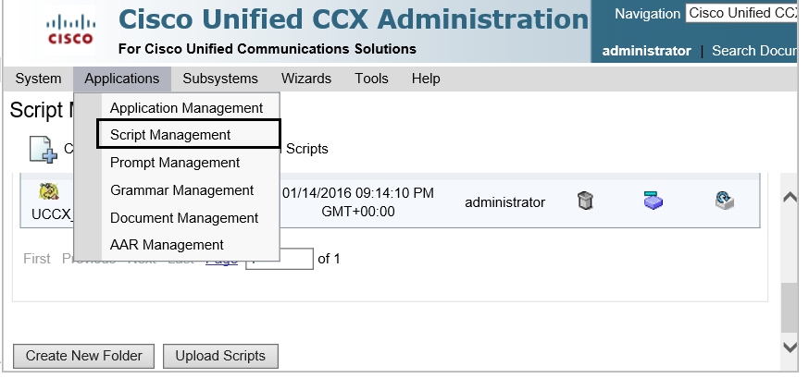

1. Create folder FDF_SURVEY
2. Upload the following uccx aef scripts.

1. FDF_Survey_IVR.aef (Master Script)

2. subflowCallHost.aef

3. subflowParseResponse.aef

4. subflowUpdateResponse.aef

# 1.4 Create an application and associate the script and Trigger

1. Go to application management
2. Create an application named FDF_Survey and associate the master script “FDF_Survey_IVR.aef”
3. Associate a trigger the application to get invoked.

# 1.5 Verify call is landing to IVR through Reactive Debugging

Steps involved

1. Open the UCCX Script editor with UCCX appadmin login credentials
2. From Toolbar choose “Debug” and “Choose Reactive Script”
3. Choose the IVR name to debug . Example “FDF_Survey_IVR.aef”
4. Specify wait time in seconds. Example 30s
5. Invoke the appropriate Trigger and verify call is landing in to IVR.

2. Steps involved to deploy UI build files and backend war in Admin Application

# 2.1 To Stop Running Apache Server

- Click win+R type services.msc

- In the Services list Search Apache Tomcat , right Click and Press Stop /Start respectively.

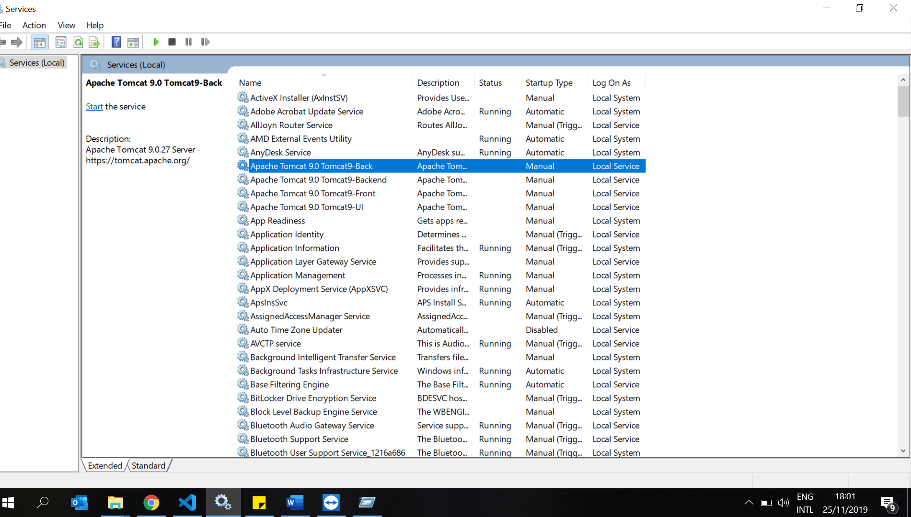

# 2.2 To deploy the UI Build Files

- Go to the location in the server :\Program Files\Apache Software Foundation\Tomcat 9.0_Tomcat9\webapps/apps

- Delete all the existing files inside the folder and place newly provided build Files.

# 2.3 To deploy war files

- Go to the location in the server :\Program Files\Apache Software Foundation\Tomcat 9.0_Tomcat9\webapps

- Delete 4 files (ie survey.war, survey folder, user.war, user folder)

-Copy 2 war files given to the location.

- Start the Apache (steps given in first Point)

1. To Run the DB script

# 3.1 To run db script

1. Open My SQL Workbench 8.0, local instance

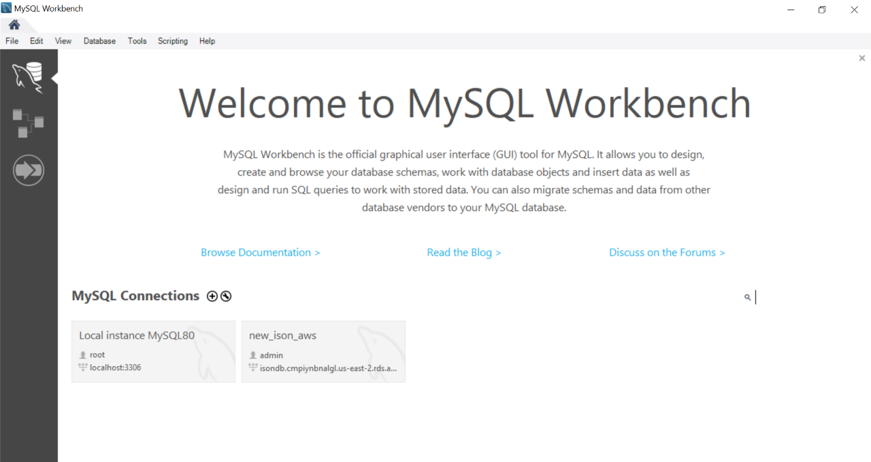

2. Select Server, Data Import , choose db script Provided .

3. Select Start Import

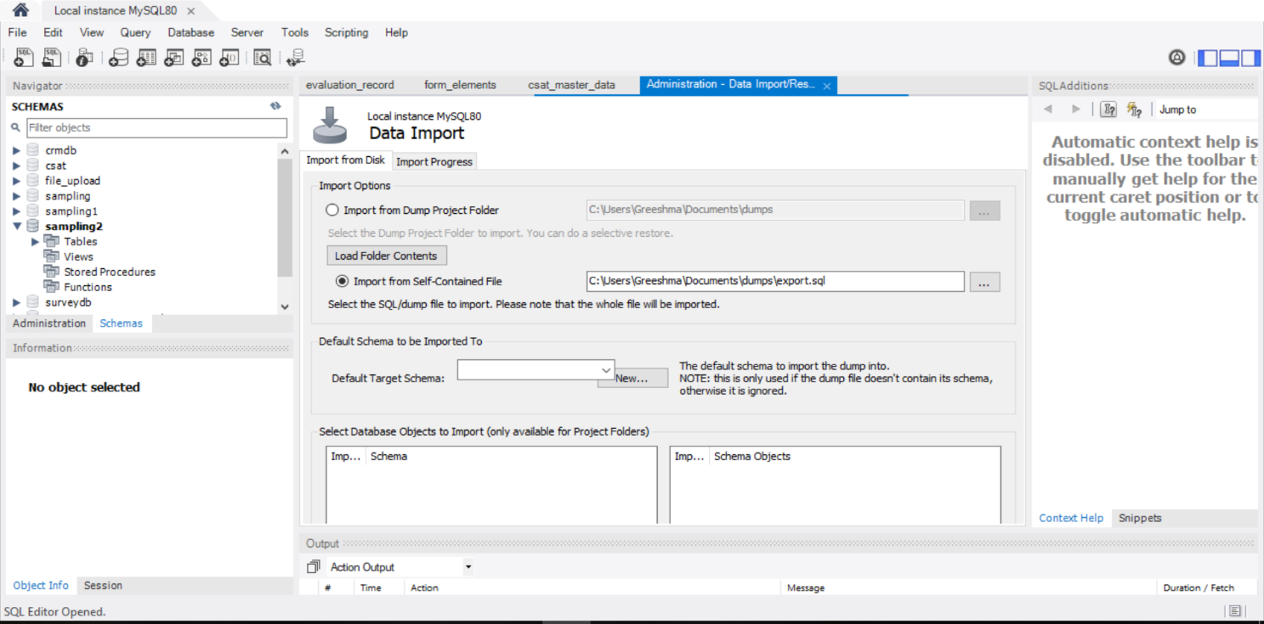

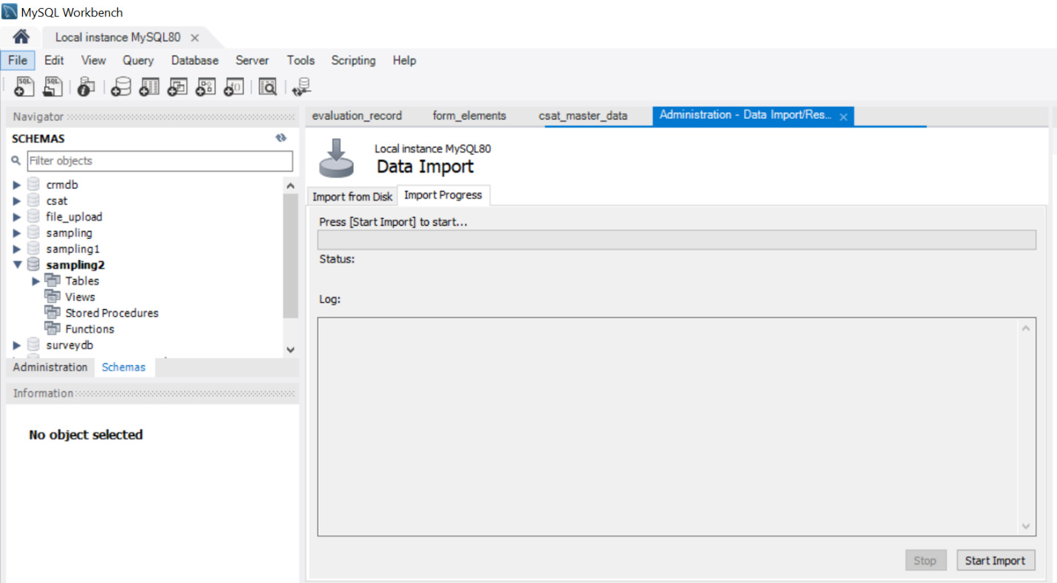

1. Once Import Completed, database also imported
2. Deployment Finished

.