Steps involved in UCCX Survey IVR Troubleshooting

# Verify the IVR level configurations

The survey related configurations are set in the fdf_ivrconfig.xml file under Document management **/ en_US/ FDF_SURVEY**

**File Name :** fdf_ivrconfig.xml

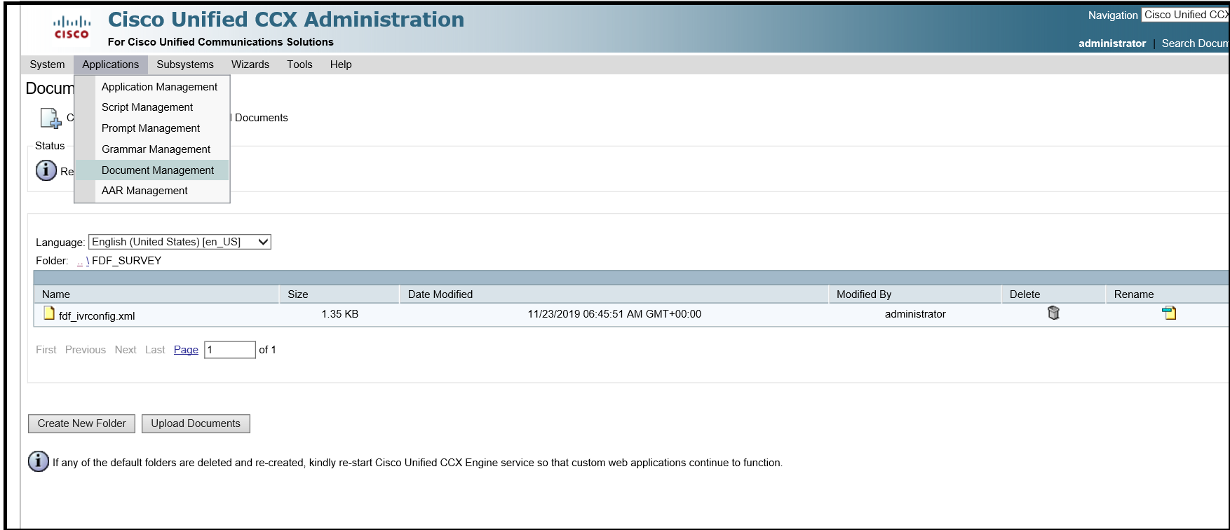

## Configuration details

Ensure following configurations are set properly

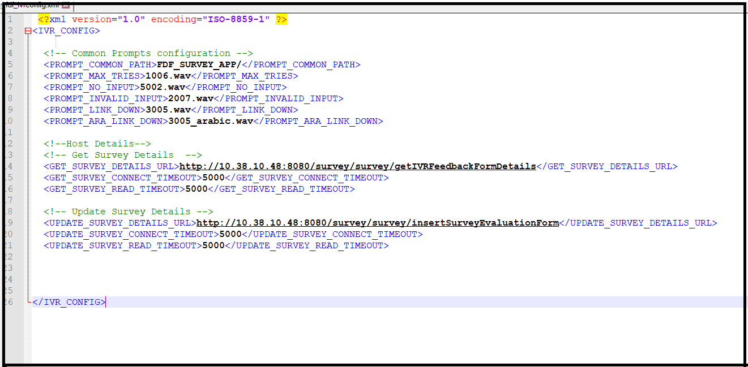

|  |  |  |  |
| --- | --- | --- | --- |
| S.No | Field Name | Field Description | Sample value |
| 1 | PROMPT_COMMON_PATH | Prompt path where common prompts like no input prompts, invalid prompts, maximum tries prompts are loaded for each language.  Note: This folder should be created in prompt management under each language and the respective prompts should be loaded. Steps for uploading the prompts are available here | FDF_SURVEY_APP/ |
| 2 | PROMPT_MAX_TRIES | The file name of maximum tries exceeded prompt | 1006.wav |
| 3 | PROMPT_NO_INPUT | The name of the prompt file to be played when caller does not give any input | 5002.wav |
| 4 | PROMPT_INVALID_INPUT | The name of the prompt file to be played when caller gives invalid input to the menu | 2007.wav |
| 5 | PROMPT_LINK_DOWN | The name of the prompt to be played when host interaction fails or link down | 3005.wav |
| 6 | PROMPT_ARA_LINK_DOWN | The name of the Arabic prompt to be played when host interaction fails or link down | 3005_arabic.wav |
| 7 | GET_SURVEY_DETAILS_URL | The URL to access to get the welcome message, survey Questions, minimum score, maximum score and Thank you message from the application server | http:/hostip:port  /survey/survey/  getIVRFeedbackFormDetails |
| 8 | GET_SURVEY_CONNECT_TIMEOUT | Timeout in seconds for connecting the get Survey URL | 5000 |
| 9 | GET_SURVEY_READ_TIMEOUT | Time out in seconds for reading the get survey detail | 5000 |
| 10 | UPDATE_SURVEY_DETAILS_URL | Host URL to update the survey results | http:/hostip:port  /survey/survey/  insertSurveyEvaluationForm |
| 11 | UPDATE_SURVEY_CONNECT_TIMEOUT | Timeout in seconds for connecting the update survey details | 5000 |
| 12 | UPDATE_SURVEY_READ_TIMEOUT | Timeout in seconds for reading the response from update survey details | 5000 |

## FDF_ivrconfig.xml configuration details and sample values

# Verification of Prompts and its contents

**Ensure prompts are uploaded in the en_US and ar_SA folders as follows in Prompt management**

|  |  |  |
| --- | --- | --- |
| **Phrases for Family Call Center Survey call flow** | | |
| **Folder name** | **Phrase Name** | **Phrase content** |
| FDF_SURVEY_APP/ | 1005 | Sorry we have not received any input from you. Kindly key in the number. |
| 1006 | Sorry you have exceeded the maximum number of tries. |
| 2007 | You entered an invalid value |
| 3005 | Sorry, the system is currently unavailable. Please try again later. |
| FDF_SURVEY_APP/WelcomeMessage | 3001 | Welcome to conducted survey for Family Development Foundation’s call center . Dear customer we would like to know your opinion to improve quality of our services. |
| FDF_SURVEY_APP/SurveyQuestions | 3002 | How satisfied are you with the service provided in Family Call Center? |
| 3003 | Please selecta rating from 0 to 5 .. which is 0 means not satisfied and 5 means completely satisfied |
| FDF_SURVEY_APP/ThankYou | 3004 | Thank you |

# Verify the aef scripts are uploaded in script management

Ensure following aef scripts are uploaded in Script management under FDF_SURVEY folder

1. FDF_Survey_app.aef

2. subflowCallHost.aef

3. subflowParseResponse.aef

4. subflowUpdateResponse.aef

# Verify application status

1.Verify application FDF_Survey is created and the master script “FDF_Survey_app.aef” is associated with it

2. The call trigger is associated with the application