Postman sample for checking the upload contacts through json

Create a campaign through cisco UCCX server

To List the details of campaign and to findout the campaign ID use the following URL

Request Type: Get

<https://hq-uccx.abc.inc/adminapi/campaign>

output :

{

    "@type": "campaignXMLList",

    "campaign": [

        {

            "self": "https://hq-uccx.abc.inc/adminapi/campaign/2",

            "campaignId": 2,

            "campaignName": "Test",

            "enabled": false,

            "description": "",

            "startTime": "08:00",

            "endTime": "21:00",

            "timeZone": "GMT+00:00",

            "campaignType": "AGENT",

            "dialerType": "DIRECT_PREVIEW",

            "pendingContacts": 0

        }

    ]

}

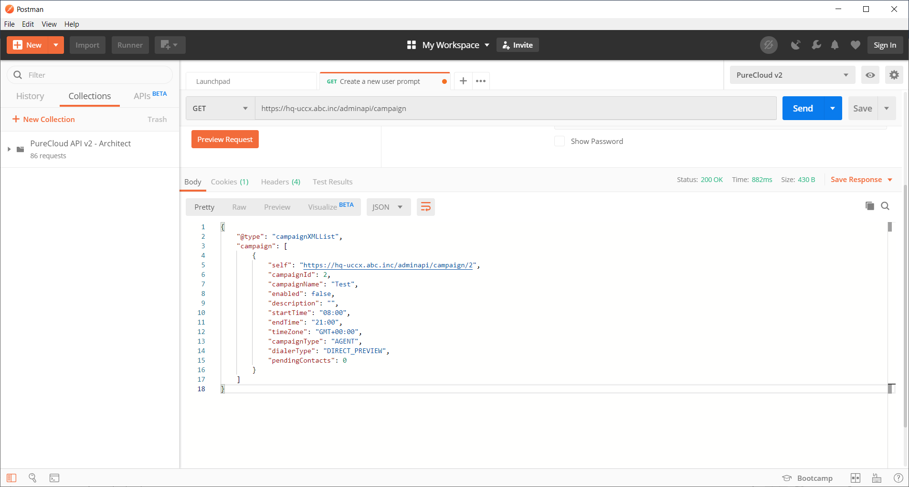

URL:

<https://hq-uccx.abc.inc/adminapi/campaign/2/contacts>

Request:

{

"campaign": {

"@name": "Test",

"refURL": "https://hq-uccx.abc.inc/adminapi/campaign/2"

},

"allowDuplicateContacts": "true",

"csvdata": "Account Number, First Name, Last Name ,Phone1, Phone2, Phone3, Dial Time\nABCD1234, John , Doe, 1401111, 1402232, 1403333, 12:35\nABCD1235, Jane , Smith, 1504444, 1505545, 1506666, 12:35\nABCD1236, Jane , Smith, 1504444, 1505545, 1506666, 12:38"

}

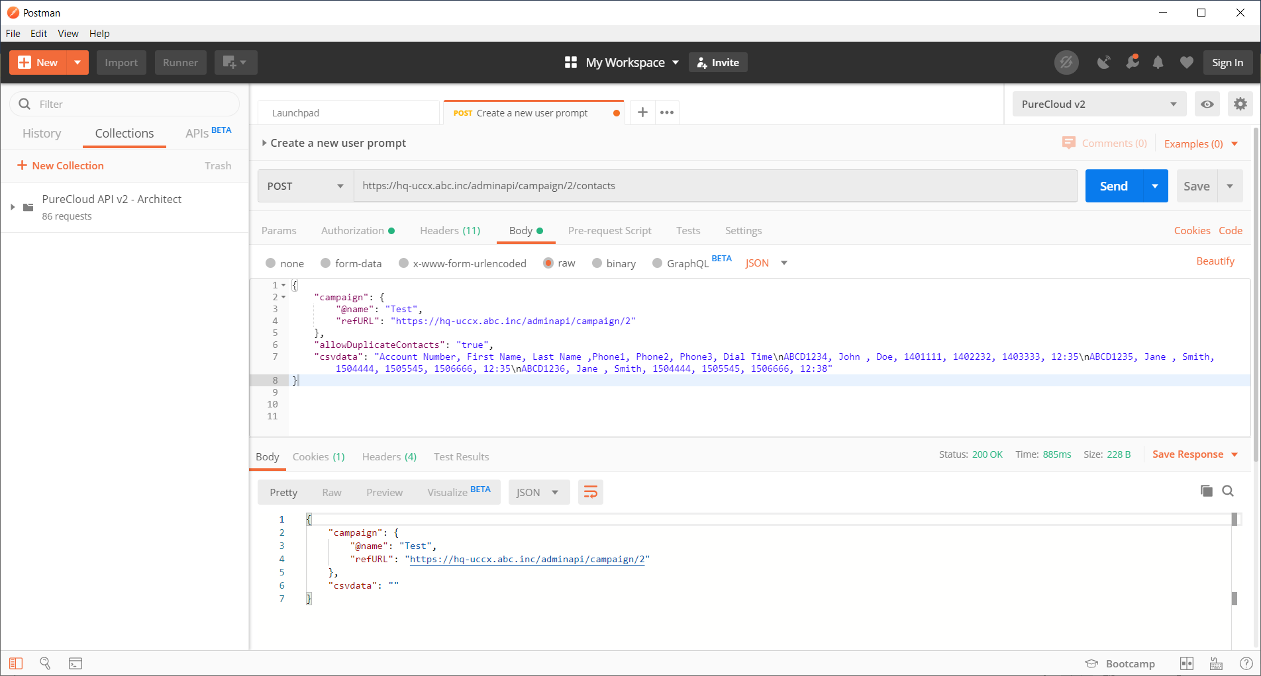

Received 200 ok

Response received

Status : 200 ok

{

    "campaign": {

        "@name": "Test",

        "refURL": "https://hq-uccx.abc.inc/adminapi/campaign/2"

    },

    "csvdata": ""

}

https://ccxcgnx1.corp.cognicx.com/adminapi/campaign/2

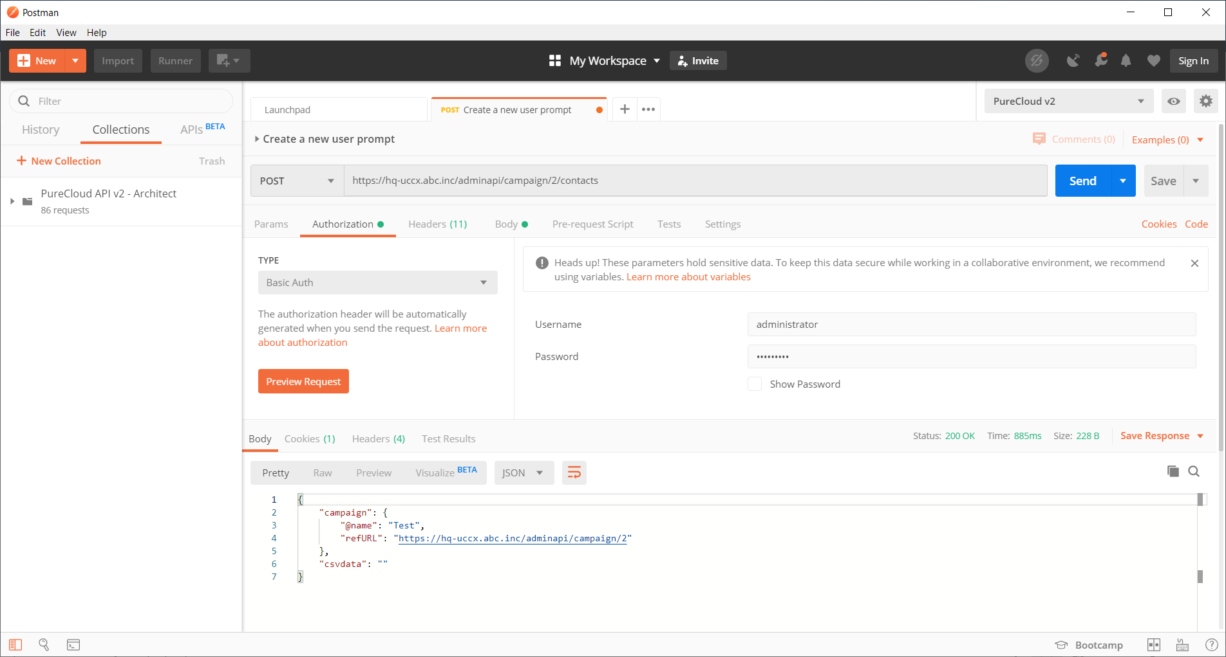

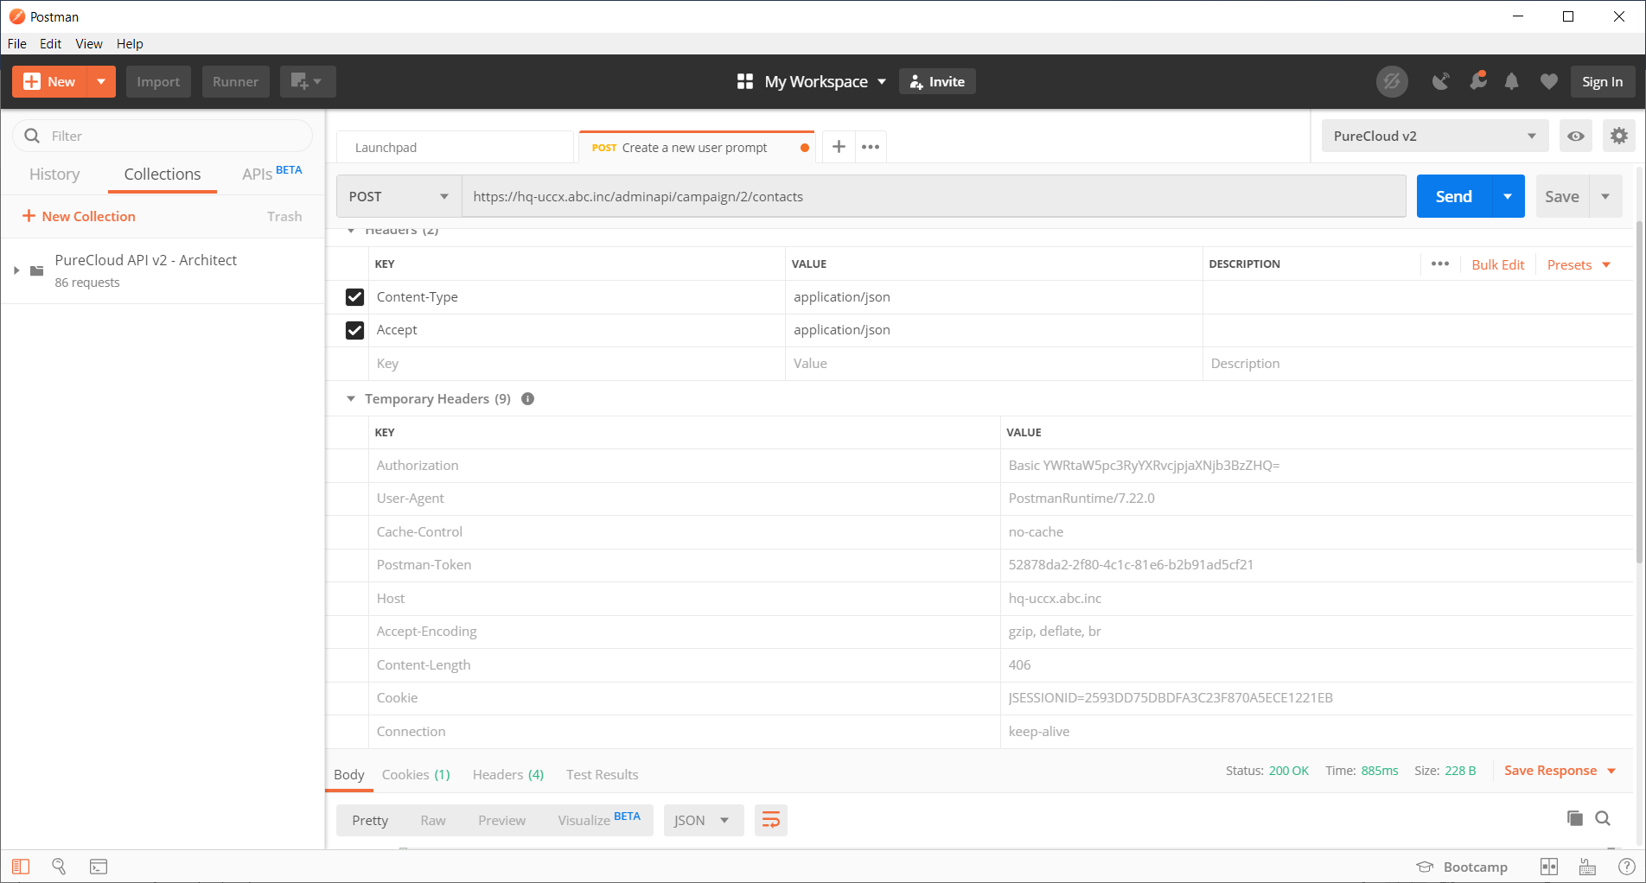

Alternatively, the xml input format is as below

<?xml version="1.0" encoding="UTF-8"?>

<campaignContacts xmlns:xsi="https://www.w3.org/2001/XMLSchema-instance" xsi:noNamespaceSchemaLocation="campaignContacts.xsd">

<campaign name="Test">

<refURL>https://hq-uccx.abc.inc/adminapi/campaign/2</refURL>

</campaign>

<allowDuplicateContacts>true</allowDuplicateContacts>

<csvdata>

Account Number, First Name, Last Name ,Phone1, Phone2, Phone3, Dial Time

ABCD1234, John , Doe, 1401111, 1402222, 1403333, 12:35

ABCD1235, Jane , Smith, 1504444, 1505555, 1506666, 12:35

</csvdata>

</campaignContacts>

Java is working with json content only not with XMLs

Application.properties

UploadContactURL=https://hq-uccx.abc.inc/adminapi/campaign/2/contacts

ReferenceURL=https://hq-uccx.abc.inc/adminapi/campaign/2

contactHeading=Phone1, First Name, Last Name ,Account Number, Phone2, Phone3, Dial Time\n

contactSuffix=,,,,,,\n

authString=administrator:ciscopsdt

From script response

U"{\"campaign\":{\"@name\":\"Test\",\"refURL\":\"https://hq-uccx.abc.inc/adminapi/campaign/2\"},\"csvdata\":\"\"}"