SURVEY_IVR_DeploymenT Document

0.04

February 25, 2020

Contents

1.1 Upload the configurations in Document Management 2

1.1.1 Upload the ivrConfig.xml in Document Management 2

1.1.1.1 ivrconfig.xml 2

1.1.1.2Configuration details 4

1.1.2 Upload the log4j.properties in Document Management 4

1.2 Upload the required prompts in the prompt management 5

1.2.1 Steps to upload the English phrases 5

1.2.2 PhrasesList 5

1.2.2 Steps to upload the Arabic phrases 6

1.3 Upload the UCCX Scripts(.aef) files under the script management 6

1.4 Create an application and associate the script and Trigger 7

1.5 Verify call is landing to IVR through Reactive Debugging 7

2.1 Pre-requisites 8

2.2 To Stop Running Apache Server 8

2.2 To deploy the UI Build Files 8

2.3 To deploy war files 9

2.4 Steps to verify the successful installation of UI files 9

2.5 Steps to configure the DNIS 9

3.1 Pre-requisites 10

3.2 To run db script 10

3.1 Steps to deploy the contacts.war 12

3.2 Configurations related to Outbound campaign 12

1. Steps involved in UCCX Survey IVR Deployment

# Upload the configurations in Document Management

Following are the 2 configuration files used by the Survey IVR.

1. ivrconfig.xml
2. log4j.properties

## 1.1.1 Upload the ivrConfig.xml in Document Management

Load the ivr level configuration file ivrconfig.xml file under Document management **/ en_US/ SURVEY**

**File Name :** ivrconfig.xml

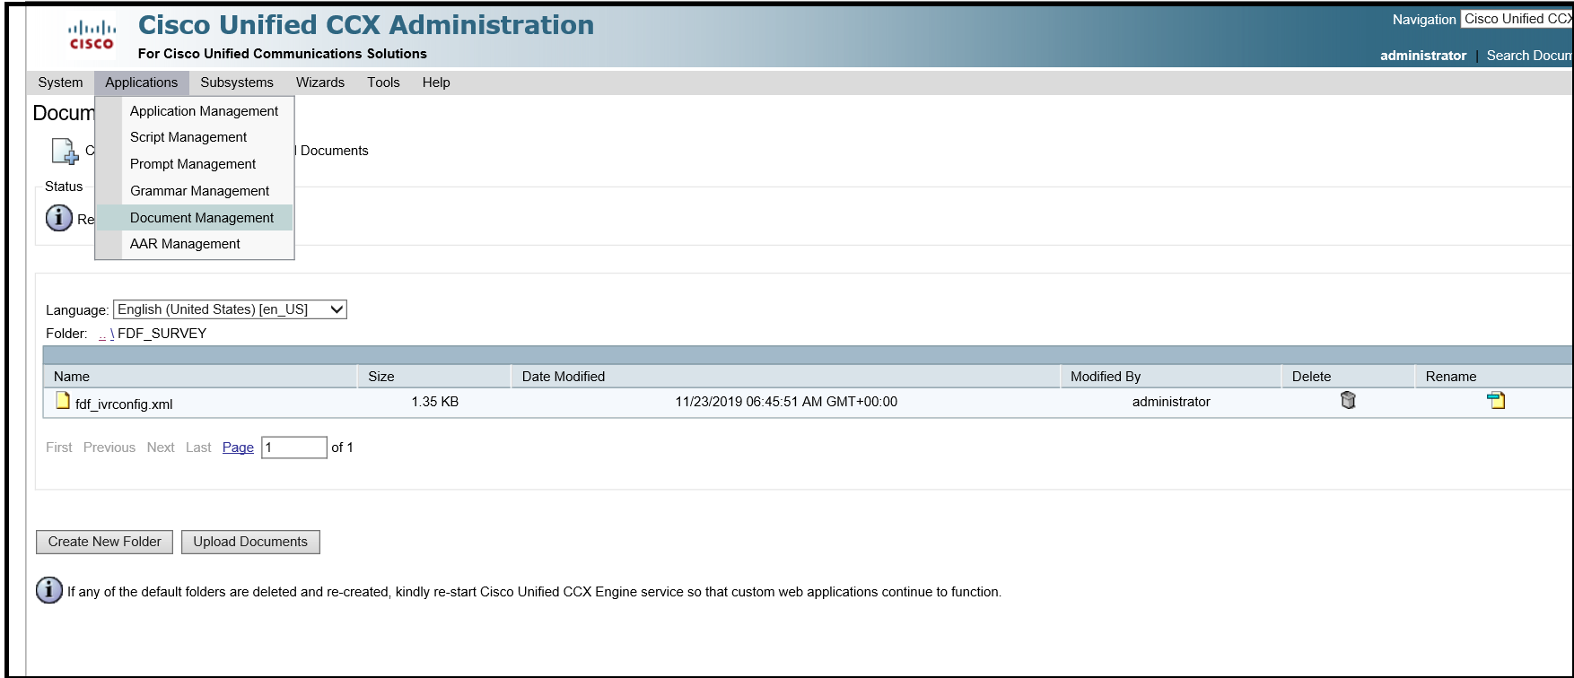

## ivrconfig.xml

Following are the configurations set in ivrconfig.xml

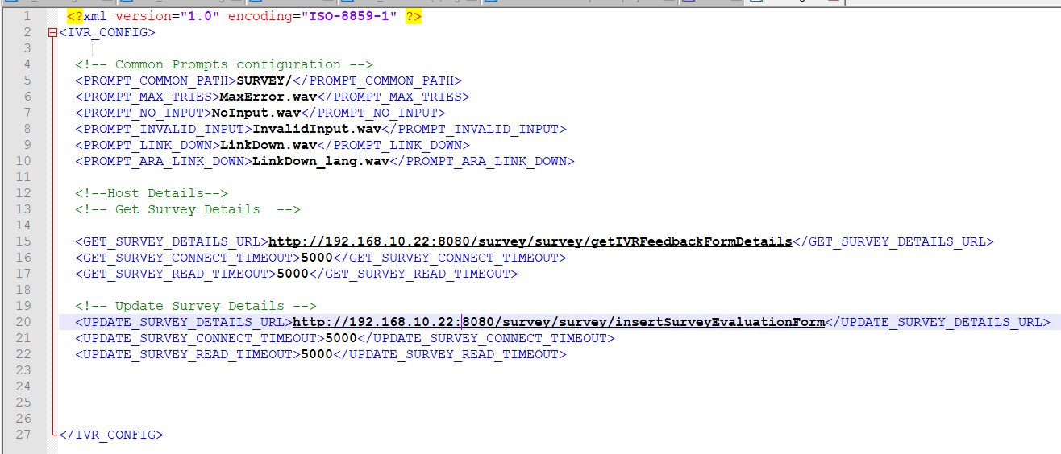

## 1.1.1.2 Configuration details

|  |  |  |  |
| --- | --- | --- | --- |
| S.No | Field Name | Field Description | Sample value |
| 1 | PROMPT_COMMON_PATH | Prompt path where common prompts like no input prompts, invalid prompts, maximum tries prompts are loaded for each language.  Note: This folder should be created in prompt management under each language and the respective prompts should be loaded. Steps for uploading the prompts are available here | SURVEY/ |
| 2 | PROMPT_MAX_TRIES | The file name of maximum tries exceeded prompt | MaxError.wav |
| 3 | PROMPT_NO_INPUT | The name of the prompt file to be played when caller does not give any input | NoInput.wav |
| 4 | PROMPT_INVALID_INPUT | The name of the prompt file to be played when caller gives invalid input to the menu | InvalidInput.wav |
| 5 | PROMPT_LINK_DOWN | The name of the prompt to be played when host interaction fails or link down | LinkDown.wav |
| 6 | PROMPT_ARA_LINK_DOWN | The name of the Arabic prompt to be played when host interaction fails or link down | LinkDown_lang.wav |
| 7 | GET_SURVEY_DETAILS_URL | The URL to access to get the welcome message, survey Questions, minimum score, maximum score and Thank you message from the application server | http:/hostip:port  /survey/survey/  getIVRFeedbackFormDetails |
| 8 | GET_SURVEY_CONNECT_TIMEOUT | Timeout in seconds for connecting the get Survey URL | 5000 |
| 9 | GET_SURVEY_READ_TIMEOUT | Time out in seconds for reading the get survey detail | 5000 |
| 10 | UPDATE_SURVEY_DETAILS_URL | Host URL to update the survey results | http:/hostip:port  /survey/survey/  insertSurveyEvaluationForm |
| 11 | UPDATE_SURVEY_CONNECT_TIMEOUT | Timeout in seconds for connecting the update survey details | 5000 |
| 12 | UPDATE_SURVEY_READ_TIMEOUT | Timeout in seconds for reading the response from update survey details | 5000 |

# 

## 1.1.2 Upload the log4j.properties in Document Management

1. Upload the log4j.properties under the folder **default** in document management

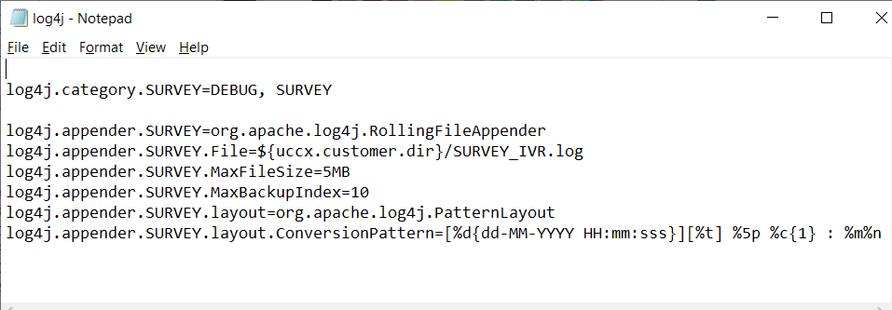

# 1.2 Upload the required prompts in the prompt management

**Open the prompt management page in UCCX appadmin**

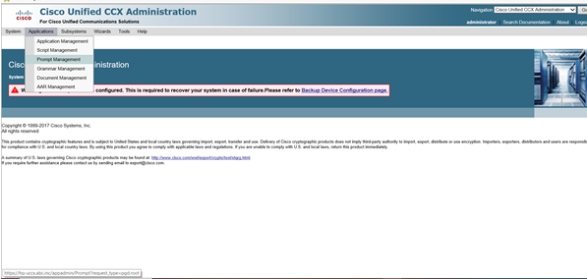

## 1.2.1 Steps to upload the English phrases

1. Under prompt Management spot en_US folder

2. Create the folder SURVEY

3. load the prompts as per following list in specified folders

## 1.2.2 PhrasesList

|  |  |  |
| --- | --- | --- |
| **Phrases for Family Call Center Survey call flow** | | |
| **Folder name** | **Phrase Name** | **Phrase content** |
| SURVEY/ | NoInput | Sorry we have not received any input from you. Kindly key in the number. |
| MaxError | Sorry you have exceeded the maximum number of tries. |
| Invalid | You entered an invalid value |
| Linkdown | Sorry, the system is currently unavailable. Please try again later. |
| SURVEY/ | Welcome | Welcome to conducted survey for Sharjah Municipality Corporation. Dear customer we would like to know your opinion to improve quality of our services. |
| SURVEY/ | Question1 | How would you like to rate the customer service Experience in the scale of 1 to 5, where 5 represents excellent , 1 represents poor |
|  |  |
| SURVEY/ | Thankyou | Thank you |

## 1.2.2 Steps to upload the Arabic phrases

1.Under prompt Management create the folder ar_SA folder

2.Create the folder SURVEY

3.Upload the prompts as per the list in specified folders\

# 1.3 Upload the UCCX Scripts(.aef) files under the script management

1. Go to script management

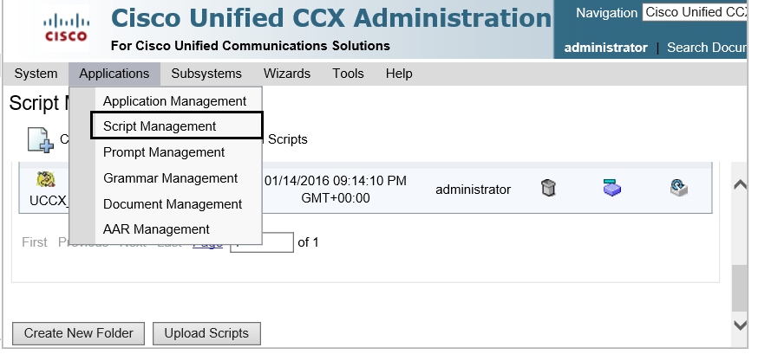

1. Create folder SURVEY
2. Upload the following uccx aef scripts.

1. Survey_IVR.aef (Master Script)

2. subflowParseResponse.aef

3. subflowUpdateResponse.aef

# 1.4 Create an application and associate the script and Trigger

1. Go to application management
2. Create an application named Survey and associate the master script “Survey_IVR.aef”
3. Associate a trigger the application to get invoked.

# 1.5 Verify call is landing to IVR through Reactive Debugging

Steps involved

1. Open the UCCX Script editor with UCCX appadmin login credentials
2. From Toolbar choose “Debug” and “Choose Reactive Script”
3. Choose the IVR name to debug . Example “Survey_IVR.aef”
4. Specify wait time in seconds. Example 30s
5. Invoke the appropriate Trigger and verify call is landing in to IVR.

2. Steps involved to deploy UI build files and backend war in Admin Application

# 2.1 Pre-requisites

1. Install Java jdk or later [use the exe jdk-8u231-windows-x64]

2. Install Apache Tomcat Server 9.0.30 [apache-tomcat-9.0.30]

# 2.2 To Stop Running Apache Server

- Click win+R or type services.msc

- In the Services list Search Apache Tomcat , right Click and Press Stop /Start respectively.

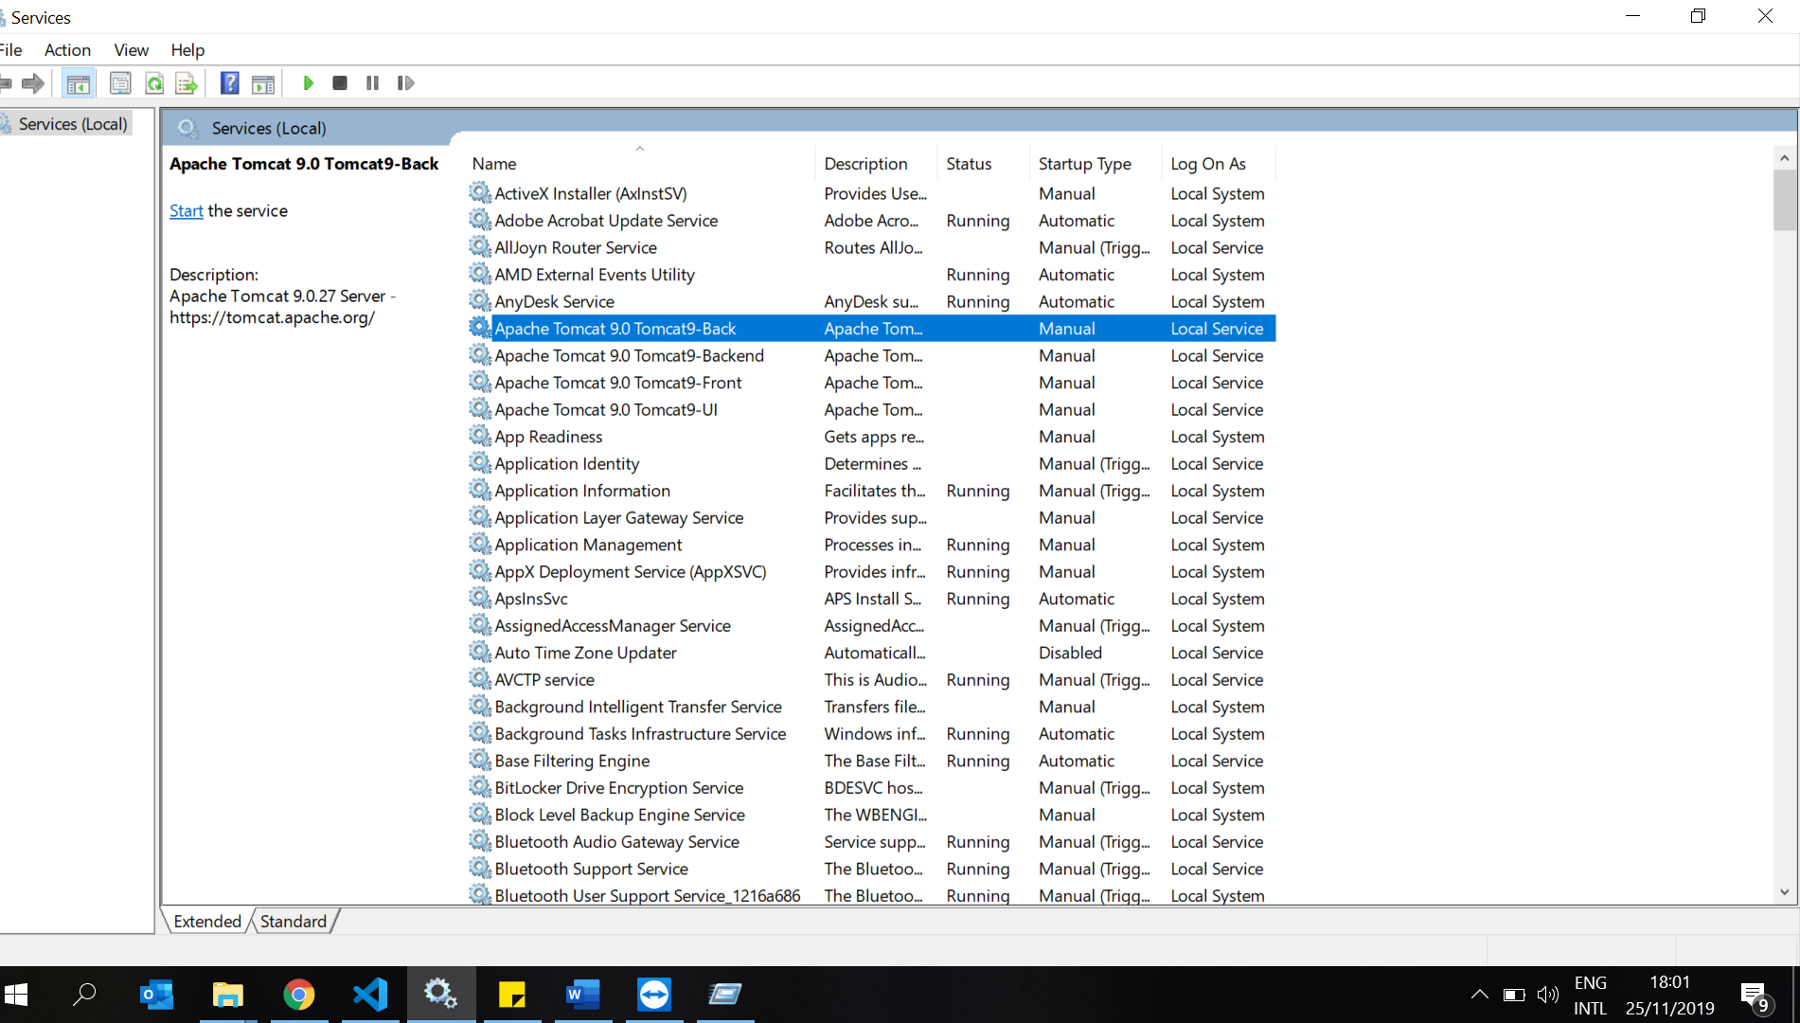

# 2.2 To deploy the UI Build Files

- Go to the location in the server :\Program Files\Apache Software Foundation\Tomcat 9.0_Tomcat9\webapps/apps

- Delete all the existing files inside the folder and place newly provided build Files

- To generate build files go to UI code location and put command ‘npm run build’.

# 2.3 To deploy war files

- Go to the location in the server :\Program Files\Apache Software Foundation\Tomcat 9.0_Tomcat9\webapps

- Delete 4 files (ie survey.war, survey folder, user.war, user folder)

-Copy 2 war files given to the location.

- Start the Apache (steps given in first Point)

# 2.4 Steps to verify the successful installation of UI files

- Go to the location in the server :\Program Files\Apache Software Foundation\Tomcat 9.0_Tomcat9\webapps/apps

Verify files are present. And start the Apacahe Server

-Go to browser localhost:[port no apache deployed] by default <http://localhost:8080/apps/>

You should see login Screen.

# 2.5 Steps to configure the DNIS

- Login to the application

- Go to IVR Configurations, Click Edit Icon, and edit IVR Extension values.

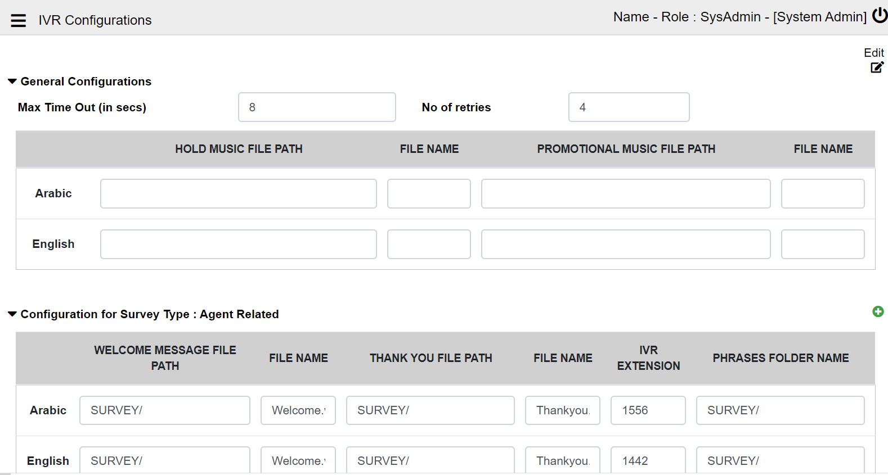

1. To Run the DB script

# 3.1 Pre-requisites

Install the MySQL workbench using the exe [mysql-installer-community-8.0.18.0 ]

# 3.2 To run db script

1. Open My SQL Workbench 8.0, local instance

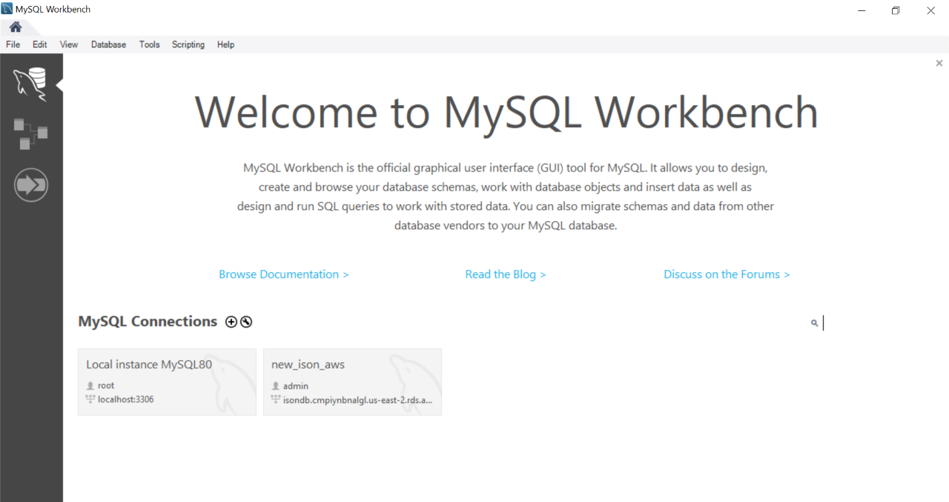

2. Select Server, Data Import , choose db script Provided .

3. Select Start Import

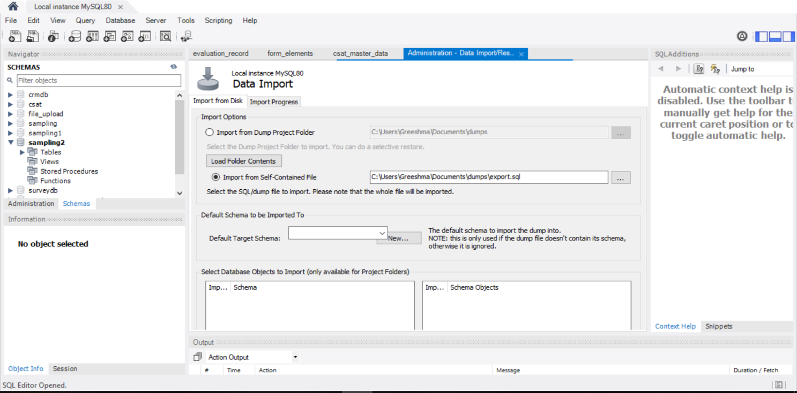

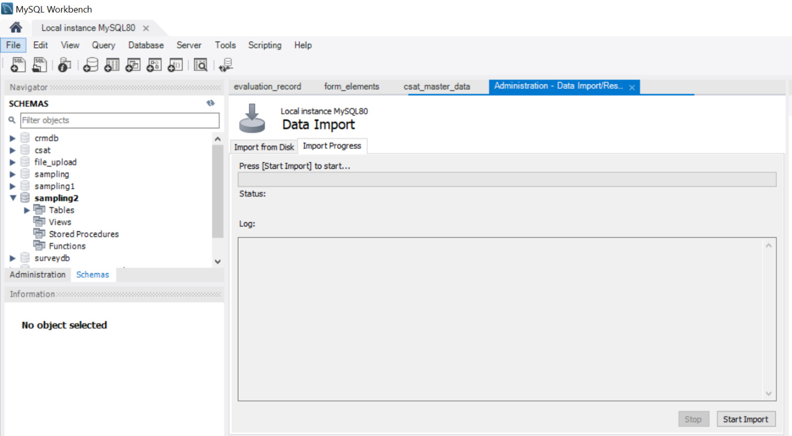

1. Once Import Completed, database also imported
2. Deployment Finished

.

3.Steps involved to deploy abandoned calles Outbound campaign

# 3.1 Steps to deploy the contacts.war

1. Go to the location in the server :\Program Files\Apache Software Foundation\Tomcat 9.0_Tomcat9\webapps
2. For first time deployment
   1. Place the Contacts.war and restart the tomcat service
3. For consequent deployments
   1. Delete Contacts.war and its corresponding folder
   2. Place the new “Contacts.war” restart the tomcat service

# Configurations related to Outbound campaign

The configurations for outbound campaign name, URL , authentication, source file for CSV files are configured in application.properties of Contacts application.

