**DAILY ONLINE ACTIVITIES SUMMARY**

|  |  |  |  |  |  |  |  |  |
| --- | --- | --- | --- | --- | --- | --- | --- | --- |
| **Date:** | **26MAY2020** | | | | | **Name:** | **Rani M.D** | |
| **Sem & Sec** | **VI & B** | | | | | **USN:** | **4AL17CS075** | |
| **Online Test Summary** | | | | | | | | |
| **Subject** | | **Computer graphics and Visualization** | | | | | | |
| **Max. Marks** | |  | | **Score** | | |  | |
| **Certification Course Summary** | | | | | | | | |
| **Course** | **Machine Learning with Python** | | | | | | | |
| **Certificate Provider** | | | **Cognitive class** | | **Duration** | | | **10 hours** |
| **Coding Challenges** | | | | | | | | |
| **Problem Statement:**  1.**Write a c program to print all permutation of given string. 2.Write a c++ program for given array A of size N where the array elements contain values from 1 to N with duplicates, the task is to find total number of subarrays which start and end with the same element. 3.Write a python program to print all integers range from 0 to 50 excluded the integer shouldn't divisible by 2 and 3. 4.Write a python program to print that given number is a palindrome or not.** | | | | | | | | |
| **Status: Done** | | | | | | | | |
| **Uploaded the report in Github** | | | | | **Yes** | | | |
| **If yes Repository name** | | | | | **Daily Status** | | | |
| **Uploaded the report in slack** | | | | | **yes** | | | |

Online Test Details: (Attach the snapshot and briefly write the report for the same)

Certification Course Details: (Attach the snapshot and briefly write the report for the same)

1.

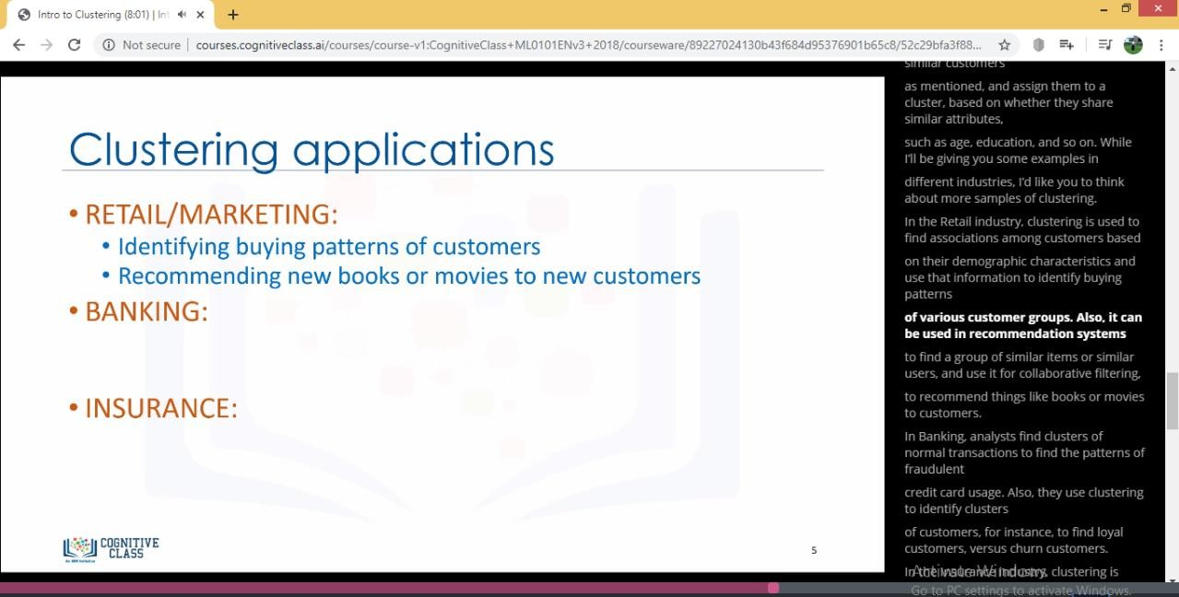

2. 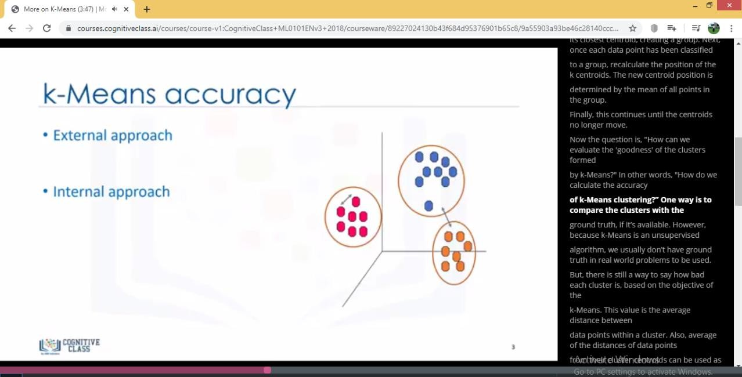

3.

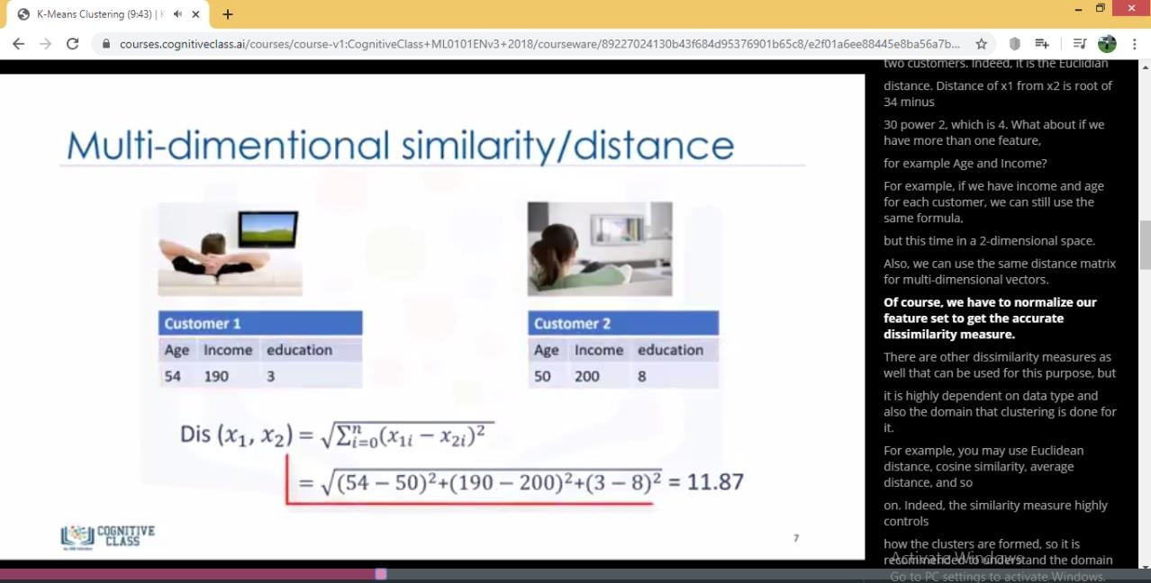

1. Classification algorithms predict categorical

class labels. This means, assigning instances to pre-defined classes such as “Defaulted” or “Non-Defaulted.”

For example, if an analyst wants to analyse

customer data in order to know which customers might default on their payments, she uses a labeled dataset as training data, and uses classification approaches such as a decision tree, Support Vector Machines (or SVM), or, logistic regression to predict the default value for a new, or unknown customer. Generally speaking, classification is a supervised learning where each training data instance belongs to a particular class.

In clustering, however, the data is unlabelled and the process is unsupervised.

1. There are various types of clustering algorithms, such as partitioning, hierarchical, or density-based

clustering. k-Means is a type of partitioning clustering,

that is, it divides the data into k non-overlapping subsets (or clusters) without any cluster-internal structure, or labels. This means, it’s an unsupervised algorithm.

Objects within a cluster are very similar and objects across different clusters are very different or dissimilar. As you can see, for using k-Means, we have

to find similar samples

# A k-Means algorithm works by randomly placing k centroids, one for each cluster.

The farther apart the clusters are placed, the better.The next step is to calculate the distance of each data point (or object) from the centroids. Euclidean distance is used to measure the distance from the object to the centroid

Coding Challenges Details: (Attach the snapshot and briefly write the report for the same)

1.

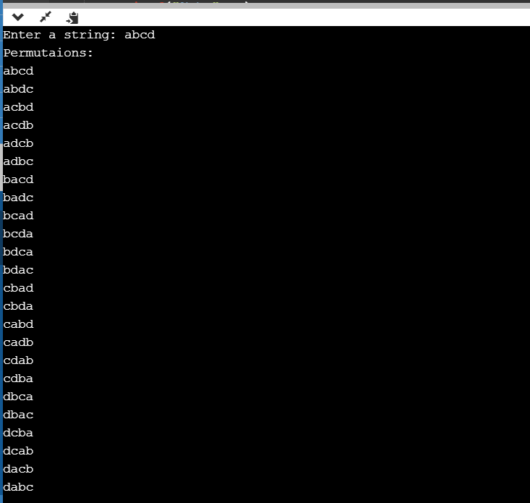

2.

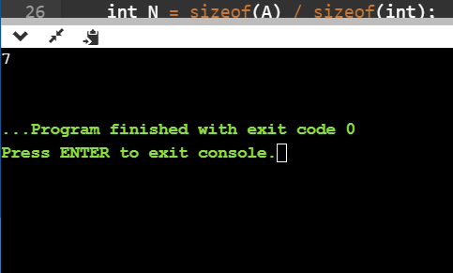

3.

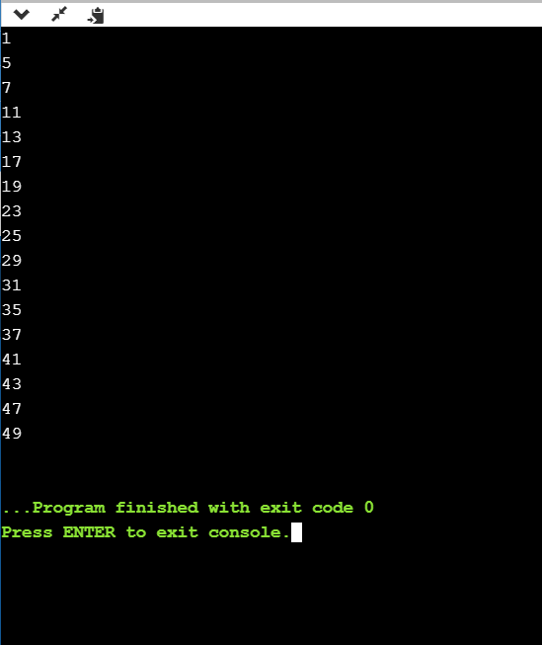

4.

