**DAILY ONLINE ACTIVITIES SUMMARY**

|  |  |  |  |  |  |  |  |  |
| --- | --- | --- | --- | --- | --- | --- | --- | --- |
| **Date:** | **29MAY2020** | | | | | **Name:** | **Rani M.D** | |
| **Sem & Sec** | **VI & B** | | | | | **USN:** | **4AL17CS075** | |
| **Online Test Summary** | | | | | | | | |
| **Subject** | | **Operation Reserach** | | | | | | |
| **Max. Marks** | | **30** | | **Score** | | | **30** | |
| **Certification Course Summary** | | | | | | | | |
| **Course** | **Machine Learning with Python** | | | | | | | |
| **Certificate Provider** | | | **CognitiveClass** | | **Duration** | | | **15 hours** |
| **Coding Challenges** | | | | | | | | |
| **Problem Statement:** **1)Write a Java program to get to know the balanced bracket if its balanced it will print true or else print false.**  **2)Write a Python program to get the digit root of a given number until it becomes single digit.** | | | | | | | | |
| **Status:Done** | | | | | | | | |
| **Uploaded the report in Github** | | | | | **YES** | | | |
| **If yes Repository name** | | | | | **Daily Status** | | | |
| **Uploaded the report in slack** | | | | | **Yes** | | | |

Online Test Details: (Attach the snapshot and briefly write the report for the same)

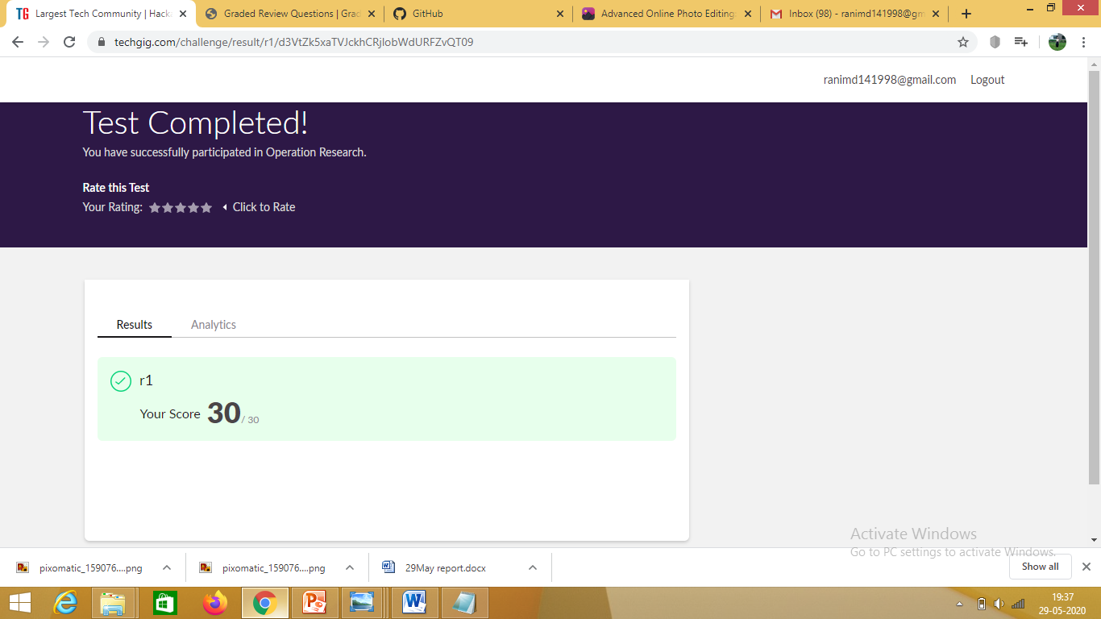

Certification Course Details: (Attach the snapshot and briefly write the report for the same)

1. 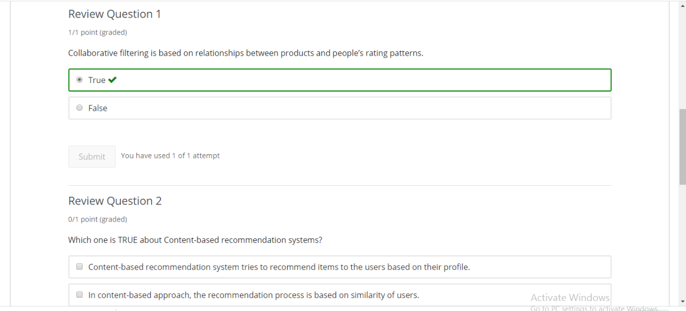

2.

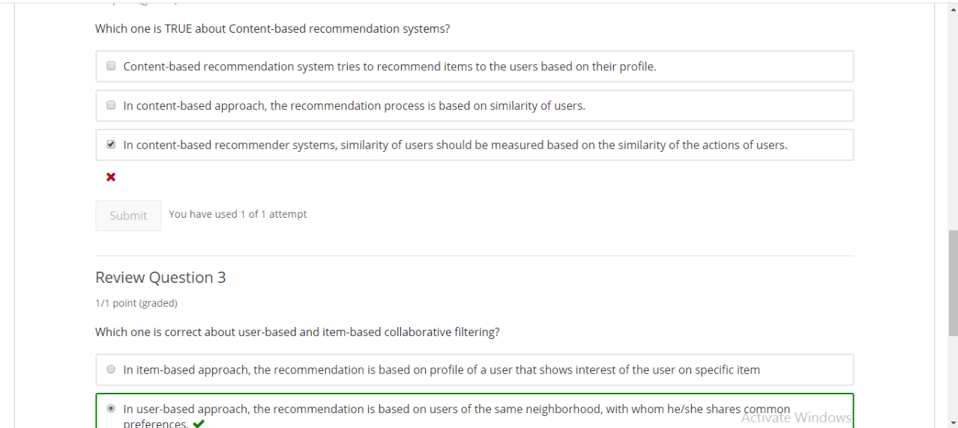

Today attended the test on python

Coding Challenges Details: (Attach the snapshot and briefly write the report for the same)

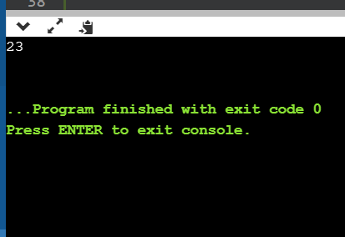

This program implemented in order to get the direct values using Chinese remainder theorem in C.

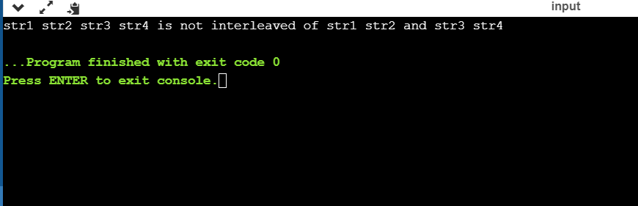

**This java program shows the string interleaved or not.**

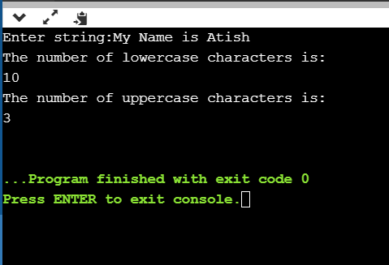

**This python program takes the input from user and calculate total number of lowercases and uppercases in the string.**