**DAILY ONLINE ACTIVITIES SUMMARY**

|  |  |  |  |  |  |  |  |  |
| --- | --- | --- | --- | --- | --- | --- | --- | --- |
| **Date:** | **30MAY2020** | | | | | **Name:** | **Rani M.D** | |
| **Sem & Sec** | **VI&B** | | | | | **USN:** | **4AL17CS075** | |
| **Online Test Summary** | | | | | | | | |
| **Subject** | | **Python** | | | | | | |
| **Max. Marks** | | **30** | | **Score** | | | **12** | |
| **Certification Course Summary** | | | | | | | | |
| **Course** | **Machine Learning with Python** | | | | | | | |
| **Certificate Provider** | | | **CognitiveClass** | | **Duration** | | | **15 hours** |
| **Coding Challenges** | | | | | | | | |
| **Problem Statement:** 1.**Python program to read a number and print the pattern**  **2.Java program to Count number of trailing zeros in product of array** | | | | | | | | |
| **Status:Done** | | | | | | | | |
| **Uploaded the report in Github** | | | | | **YES** | | | |
| **If yes Repository name** | | | | | **Daily status** | | | |
| **Uploaded the report in slack** | | | | | **YES** | | | |

Online Test Details: (Attach the snapshot and briefly write the report for the same)

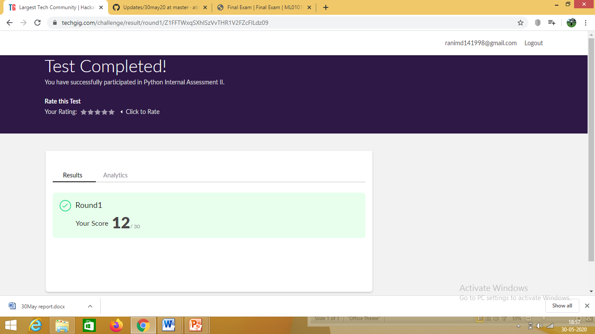

Certification Course Details: (Attach the snapshot and briefly write the report for the same)

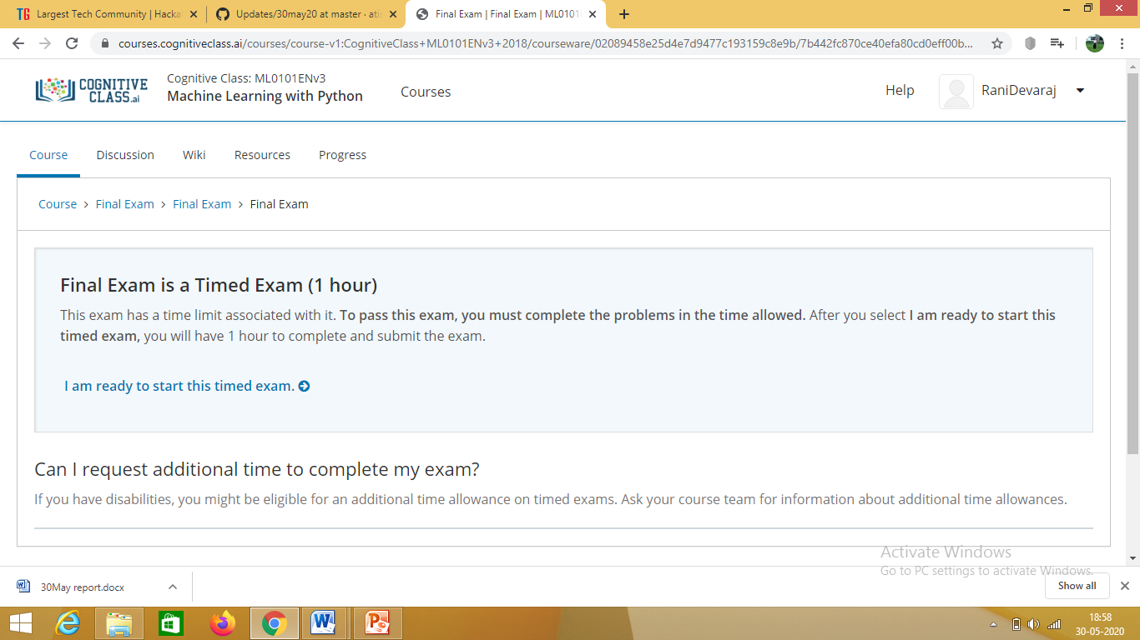

**Attended final exam of Python**

Coding Challenges Details: (Attach the snapshot and briefly write the report for the same)

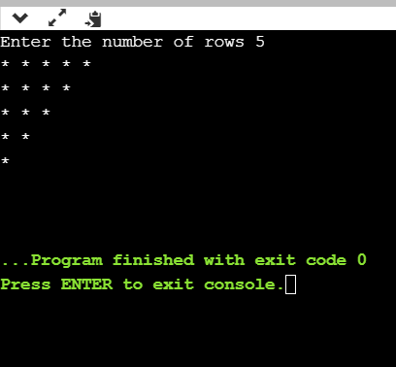

Python program to read a number and print the pattern

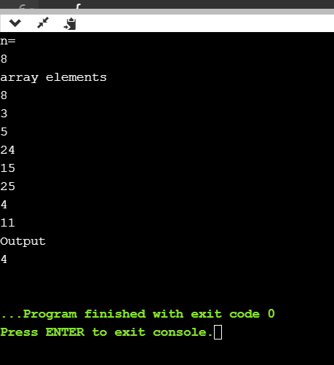

Java program to Count number of trailing zeros in product of array