**DAILY ONLINE ACTIVITIES SUMMARY**

|  |  |  |  |  |  |  |  |  |
| --- | --- | --- | --- | --- | --- | --- | --- | --- |
| **Date:** | **09-06-2020** | | | | | **Name:** | **Rani M.D** | |
| **Sem & Sec** | **6th B** | | | | | **USN:** | **4AL17CS075** | |
| **Online Test Summary** | | | | | | | | |
| **Subject** | | **CNSC and CGV** | | | | | | |
| **Max. Marks** | | **60 and 30** | | **Score** | | | **32 and 27** | |
| **Certification Course Summary** | | | | | | | | |
| **Course** | **TCS edge Carrier** | | | | | | | |
| **Certificate Provider** | | | **TCS** | | **Duration** | | | **15 days** |
| **Coding Challenges** | | | | | | | | |
| **Problem Statement: Programs given** | | | | | | | | |
| **Status: Completed** | | | | | | | | |
| **Uploaded the report in Github** | | | | | **Yes** | | | |
| **If yes Repository name** | | | | | **Daily Status** | | | |
| **Uploaded the report in slack** | | | | | **Yes** | | | |

Online Test Details: (Attach the snapshot and briefly write the report for the same)

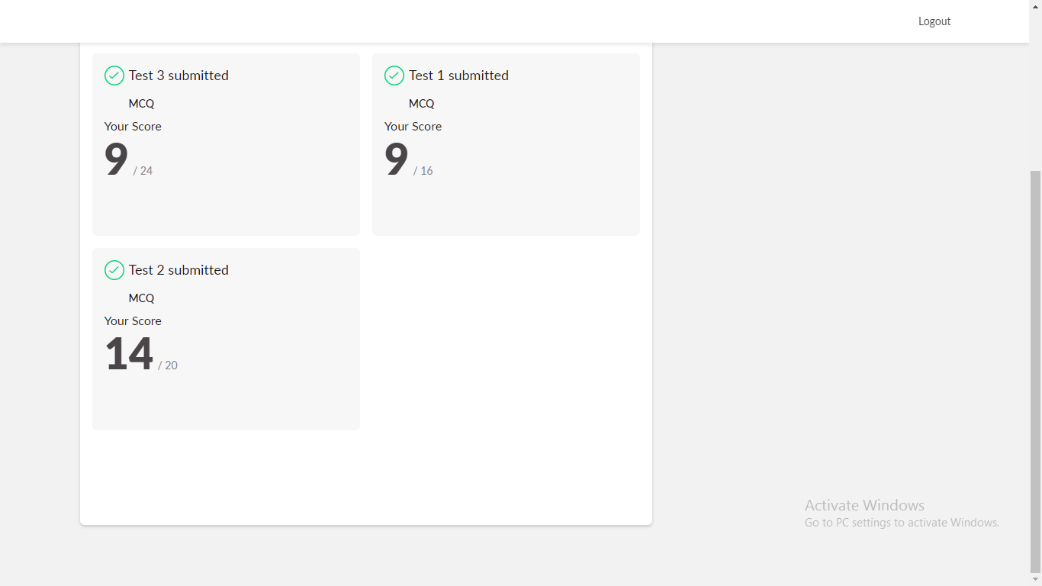

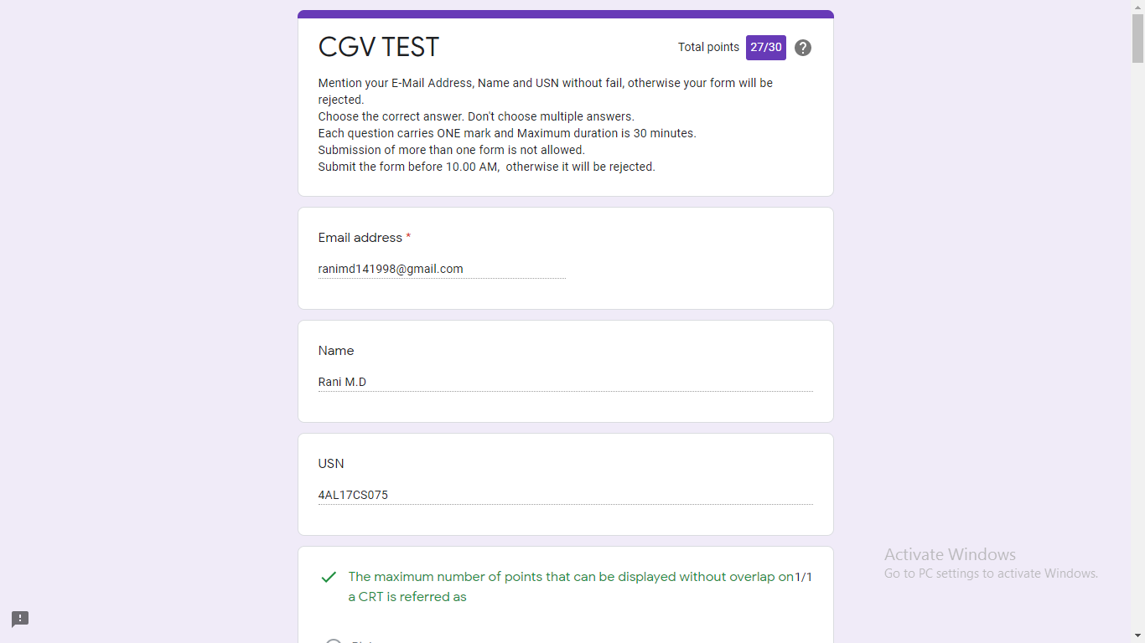

Certification Course Details: (Attach the snapshot and briefly write the report for the same)

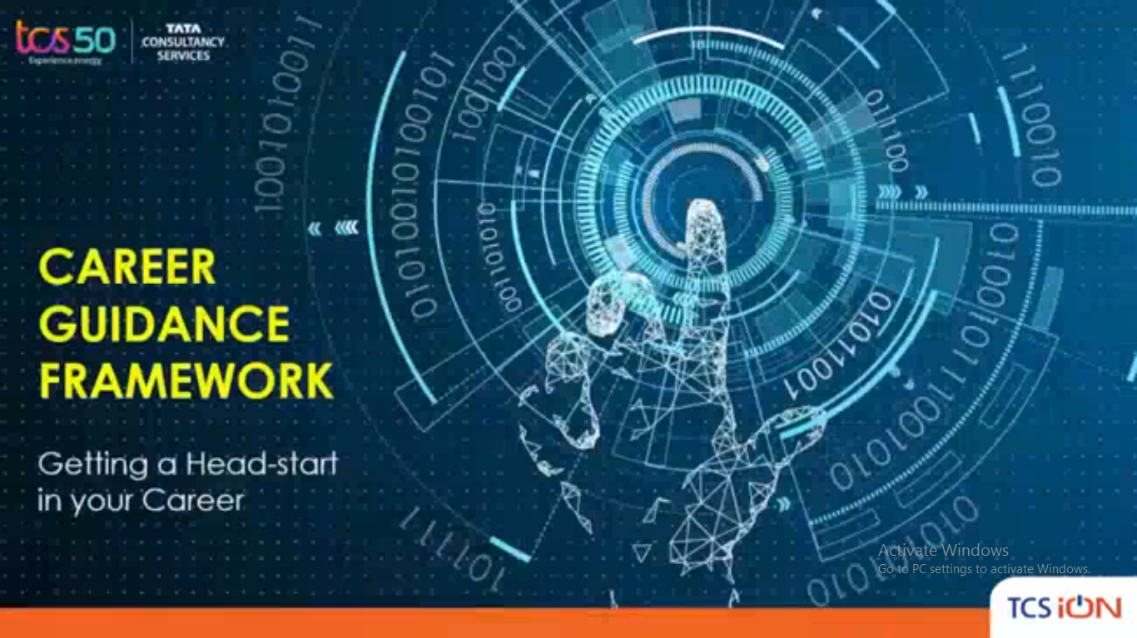

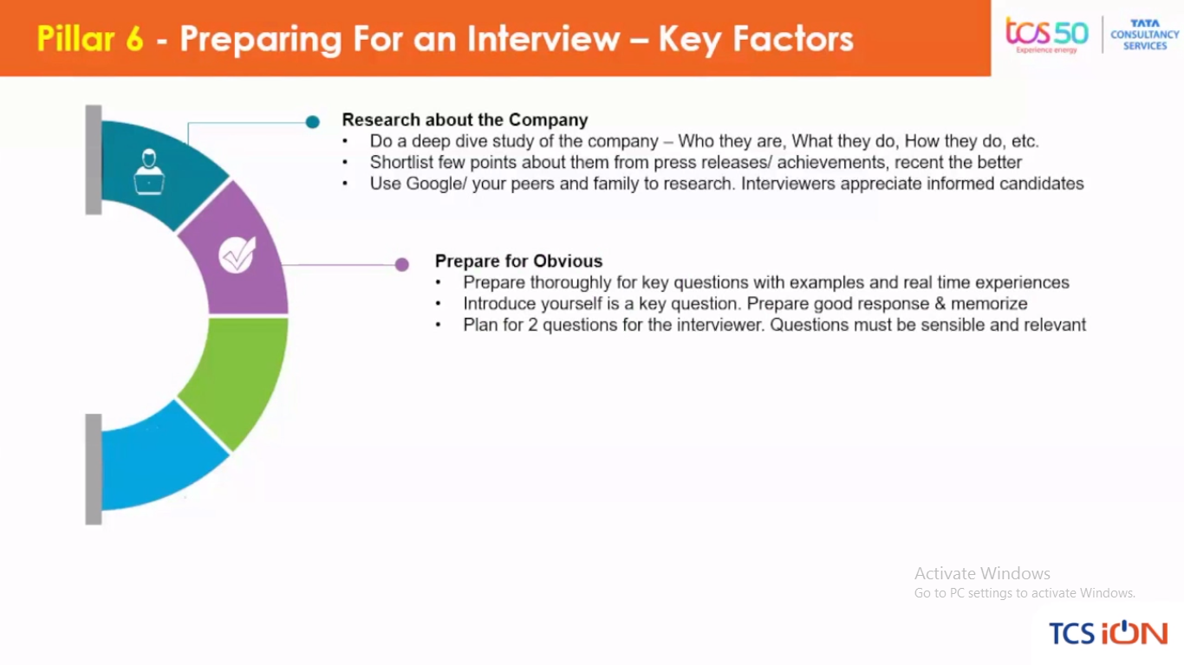

Coding Challenges Details: (Attach the snapshot and briefly write the report for the same)

**Output:**

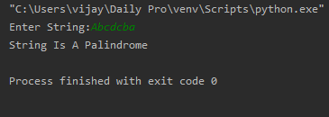

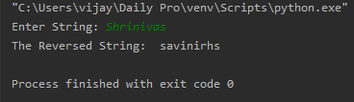

**Output:**

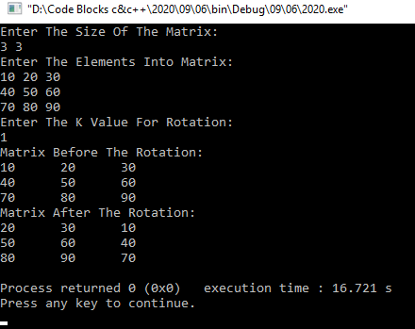

**Output:**

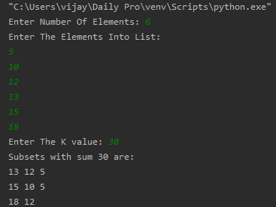

**Output:**

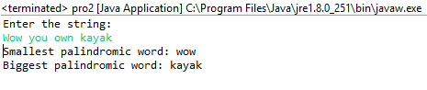

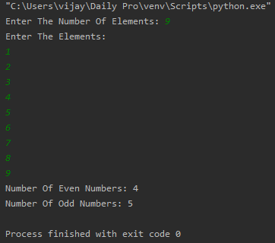

**Output:**

