**Project Name: University Educational Website**

**OVERVIEW:**

International University website is all about the educational details and information about the facilities availalbe by the University. It gives the detailed information about the educational, cultural, hospatality services being provided to students. It also shows the educational, cultural side of the university and encourage students to join the university.

**Home page structure:**

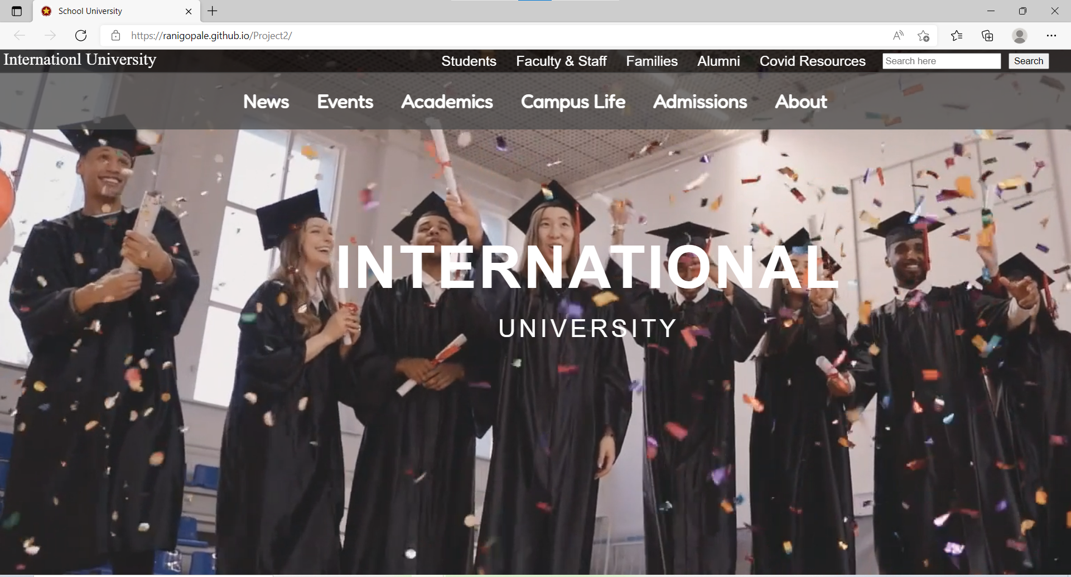

**Website Details and it’s structure:**

**Home Page:**

Menu Bar

Navigation Bar

Search Options for details

University campus video in the background

Footer: details to contact University

**Academics:**

Online/Offline educational programmes

Undergraduate Studies

Graduate Studies

Departments and Programs

Academic Calender and Courses

**Login Page for students:**

fees/food payment- Payment Gateway

**Campus Details:**

Lecture classrooms

Libraries

Sports ground

Events Auditorium

Dormitory Facility

**Events:**

Event Calender

Exhibition

Lecture/Presentations

Arts and Culture

Sports

**Technology Used:**

**Front End:**

**HTML5**

**CSS3**

**Bootstrap5**

**Javascript ES6**

**Back End:**