Test Cases for Swag Labs
FOR the first 13 Test Cases, the usernames are: standard_user, Password: secret_sauce
Test Number | Description | Steps | Expected Results | Actual Results | Pass/failed | Evidence
TC001 | Verify that the system displays an appropriate error message when a valid username is entered with an incorrect password. | 1. Navigate to the Swag Labs login page.  2. Enter standard_user in the Username field.  3. Enter: Secret_sauce in the Password field.  4. Click the Login button. | The login attempt should fail, and the system should display the error message  : Username and password do not match any user in this service, and the user should remain on the login page. | Login failed as expected, Error message displayed | Pass | https://drive.google.com/file/d/1kchJXo6dJTBxqRESyJtobWQnt6VxivEv/view?usp=sharing
TC002 | Verify that the Login button is functional and triggers the login process when clicked. | 1. Enter a valid username& password in the username field.  2.Click the Login button. | The Login button should respond to the click and successfully redirect the user to the home page. | Login button responded to the click. | Pass | https://drive.google.com/file/d/1WYxAl3RHOUF4k2FXvqXU6rBEjLUVHJBR/view?usp=drive_link
TC003 | Verify that clicking the “Add to Cart” button adds the product to the shopping cart and changes the button to “Remove”. | 1. Navigate to the product listing page.  2. Locate the product titled Sauce Labs Bike Light.  3. Click the Add to Cart button. | 1.The product should be added to the cart.  2. The button label should change from Add to Cart to Remove.  3. Cart icon or item count should update accordingly. | 1. Product was added to the cart successfully.  2.Button label changed to Remove.  3.Cart item count updated. | Pass | https://drive.google.com/file/d/1Bvk1iloi73JfYKMKUFxy5yXVEc7HlNcs/view?usp=drive_link
TC004 | Verify that clicking the “Remove” button removes the product from the shopping cart and changes the button back to “Add to Cart”. | 1. Navigate to the product listing page.  2. Locate the product titled Sauce Labs Bike Light.  3. Confirm that the button label is Remove.  4. Click the Remove button. | 1. The product should be removed from the cart.  2. The button label should change back to Add to Cart.  3. Cart icon or item count should update accordingly. | 1.Product was removed from the cart successfully.  2. Button label changed to Add to Cart.  3. Cart item count updated. | Pass | https://drive.google.com/file/d/1zGpew7wgv_nl4qL783dJO_99BjcfGtIW/view?usp=drive_link
TC005 | Verify that selecting the “Name (A to Z)” option from the sort dropdown arranges the product list in ascending alphabetical order. | 1. Navigate to the product listing page.  2. Locate the sort dropdown menu.  3. Select the option “Name (A to Z)”.  4. Observe the order of displayed products. | Products should be sorted alphabetically from A to Z by their names. | Products were sorted correctly in ascending alphabetical order. | Pass | https://drive.google.com/file/d/1F9KZonjQvoYSUAapng1pNNsWeKH2ZGhb/view?usp=drive_link
TC006 | Verify that the system rejects whitespace-only input in required fields on the checkout form. | 1. Navigate to the Checkout page.  2. Enter only whitespace (e.g., " ") in all three fields.  3. Click the “Continue” button. | 1.System should detect invalid input and display error messages for each field.  2.Form submission should be blocked until valid data is entered. | System accepts whitespace-only input and proceeds to the next step without validation. | Failed | https://drive.google.com/file/d/1t11x27HjlhVpLfM9h48x8PXRx2tWvMlw/view?usp=sharing
TC007 | Verify that selecting the “Price (low to high)” option from the sort dropdown arranges the product list in ascending order of price. | 1. Navigate to the product listing page.  2. Locate the sort dropdown menu.  3. Select the option “Price (low to high)”.  4. Observe the order of displayed products. | Products should be sorted by price in ascending order (lowest price first). | Products were sorted correctly from lowest to highest price. | Pass | https://drive.google.com/file/d/1j6hizZTfLH5jZOIelITR3GhwNDzN36H0/view?usp=drive_link
TC008 | Verify that the system prevents checkout progression when required fields are left empty. | 1. Navigate to the Checkout page.  2. Leave all fields empty.  3. Click the “Continue” button. | 1.A red error message appears: Enter First Name is required.  2. Red error icons are displayed next to each empty field.  3.The user remains on the same page.  4. The form cannot be submitted until all three fields are filled. | As Expected | Pass | https://drive.google.com/file/d/1oSU_RxbW8XPx_fkprlvY8epVi72gr0aU/view?usp=sharing
TC009 | Verify that all footer links (social media and legal) are functional and redirect to their respective pages when clicked. | 1. Scroll to the bottom of the page to view the footer.  2. Click each of the following links one by one: Twitter icon, Facebook icon  And LinkedIn icon  3. Observe the behaviour after each click. | 1. Each link should open in a new tab or window.  2. The user should be redirected to the correct external page. | 1.All links opened successfully in new tabs.  2. Each redirected to the correct destination. | Pass | https://drive.google.com/file/d/1bvn-sHfEEJW7akGLHXXTgtvR0CgOk_Uq/view?usp=drive_link
TC010 | Verify that clicking the “Checkout” button redirects the user to the checkout process page. | 1. Navigate to the cart page.  2. Confirm that the cart contains at least one item.  3. Locate and click the Checkout button. | 1. User should be redirected to the checkout page.  2. Checkout page should display cart summary. | User was redirected to the checkout page and shows cart summary successfully. | Pass | https://drive.google.com/file/d/1gEjYOomOr8Fjtfq5vvDSpfP9p1JCpN-G/view?usp=drive_link
TC011 | Verify that clicking the “Continue” button after entering valid user information redirects the user to the checkout overview page. | 1. Navigate to the “Your Information” page.  2. Fill in all required fields with valid data.  3. Click the Continue button. | 1. User should be redirected to the checkout overview page.  2. The page should display cart summary, payment details, and shipping information/price total.  3. Buttons like Finish and Cancel should be visible. | 1. User was redirected successfully to the checkout overview page.  2. Cart summary and payment/shipping/piece total details were displayed. | Pass | https://drive.google.com/file/d/1CcohV_DVr_D8dY7WGUZEvv3qWntDigKv/view?usp=drive_link
TC012 | Verify that clicking the “Finish” button on the checkout overview page completes the order and displays the confirmation message. | 1. Navigate to the checkout overview page.  2. Review the cart summary, payment, and shipping details.  3. Click the Finish button. | 1.Order should be completed successfully.  2.User should be redirected to the confirmation page.  3.Confirmation message should be displayed:  "Thank you for your order! Your order has been dispatched, and will arrive just as fast as the pony can get there!"  4.A Back Home button should be visible. | As expected. | Pass | https://drive.google.com/file/d/1XYjclnh5prp5PRHyOjeZhIsaw5s5Zd_E/view?usp=drive_link
For the rest of the test cases, the username is: problem_user/ Password: secret_sauce
TC013 | Validate that the “Remove” button correctly removes a product from the shopping cart or product list. | 1. Navigate to the product listing page.  2. Ensure that a product (e.g.,  Sauce Labs Bike Light  ) is present in the cart or list.  3. Click the “Remove” button associated with the product.  4. Observe the system’s response and UI behaviour. | The selected product should be removed from the list/cart immediately. The UI should update to reflect the removal without errors, and the product should no longer be visible. | Clicking the “Remove” button does not trigger any action. The product remains visible in the list, with no confirmation message or error displayed, and no network activity is observed. | Failed | https://drive.google.com/file/d/1ikEPGeiToEPyg5njvlVIHmUtKVVA5PQi/view?usp=sharing
TC014 | Ensure that clicking the “Go to Cart” icon successfully navigates to the cart page without freezing or displaying a blank screen. | 1. Open the product listing page.  2. Add any product to the cart (e.g.,  Sauce Labs Bike Light  ).  3. Click the “Cart” icon.  4. Observe the system behaviour and page rendering. | User is redirected to the cart page, which loads correctly and displays the added products. No freezing or blank screen should occur. | Clicking the “Go to Cart” icon causes the system to freeze and display a blank white screen. No content is rendered, and the user cannot proceed. | Failed | https://drive.google.com/file/d/19O8usXxac5UBPmBd4ggaz1VBLphcFK8A/view?usp=sharing
TC015 | Ensure that the “Add to Cart” button successfully adds the selected product to the shopping cart. | 1. Navigate to the product listing page.  2. Locate a product with an “Add to Cart” button (e.g.,  Sauce Labs Bolt T-Shirt  ).  3. Click the “Add to Cart” button.  4. Observe the system’s response and check if the product is added to the cart. | The selected product should be added to the cart immediately. The cart icon or cart page should reflect the updated item count, and the UI should confirm the addition. | Clicking the “Add to Cart” button does not trigger any action. The product is not added to the cart, and no feedback or confirmation is displayed. | Failed | https://drive.google.com/file/d/14qQNS1kKb_JTUEX6pJXvJZsjtH-gcZRw/view?usp=sharing
TC016 | Ensure that clicking on a product from the listing page navigates to its detail page and displays valid product information. | 1. Navigate to the product listing page.  2. Click on a product (e.g.,  Sauce Labs Fleece Jacket  ).  3. Observe the content of the product detail page. | The product detail page should load successfully, showing the correct product name, description, price, image, and functional buttons (e.g., Remove). | The page displays an error message: “ITEM NOT FOUND” with a mock telephone recording. The price is shown as “$-1”, and no valid product data is rendered. | Failed | https://drive.google.com/file/d/1a8mGIHsQ23Klk2Pb-5m6Jf-WBtgLX1cg/view?usp=sharing
TC017 | Ensure that clicking on a product label or title does not falsely reflect that the product is already added to the cart when it’s not. | 1. Navigate to the product listing page.  2. Locate a product that shows “Add to Cart” button (e.g.,  Sauce Labs Fleece Jacket  ).  3. Click on the product label or title (not the “Add to Cart” button).  4. Observe the product detail or redirected view. | The product detail view should reflect the correct cart state. If the product was not added to the cart, the button should still show “Add to Cart”. | Clicking the product label redirects to a view where the button incorrectly shows “Remove”, implying the product is already in the cart — even though the user never clicked “Add to Cart”. | Failed | https://drive.google.com/file/d/1SPfvheksd6BSwyI_LjjOqBnENbV5Au7Q/view?usp=sharing
TC018 | Ensure that the product detail page displays consistent and accurate information that matches the product shown in the listing view. | 1. Navigate to the product listing page.  2. Locate a product (e.g.,  Test.allTheThings() T-Shirt (Red)  ).  3. Click on the product name to open its detail page.  4. Compare the product name, description, and price between the listing and the detail page. | The product detail page should display the same name, description, and price as shown in the listing. No mismatch should occur. | Clicking the product opens a detail page with incorrect information — the product name and price differ from what was shown in the listing. | Failed | https://drive.google.com/file/d/1mi_5HurhLum4KuzvcWwvce40E5tk3hwa/view?usp=sharing
TC019 | Ensure that selecting “Name (A to Z)” sorts products alphabetically in ascending order. | 1. Navigate to the product listing page.  2. Open the sorting dropdown menu.  3. Select “Name (A to Z)”.  4. Observe the product order. | Products should be displayed alphabetically from A to Z. | No change occurs in product order. Products remain in the same sequence. | Failed | https://drive.google.com/file/d/1nV81w1LkPbsK2X58oyeVyMn6BXHGHLqI/view?usp=drive_link
TC020 | Ensure that selecting “Name (Z to A)” sorts products alphabetically in descending order. | 1. Navigate to the product listing page.  2. Open the sorting dropdown menu.  3. Select “Name (Z to A)”.  4. Observe the product order. | Products should be displayed alphabetically from Z to A. | No change occurs in product order. Products remain in the same sequence. | Failed
TC021 | Ensure that selecting “Price (high to low)” sorts products by descending price. | 1. Navigate to the product listing page.  2. Open the sorting dropdown menu.  3. Select “Price (high to low)”.  4. Observe the product order. | Products should be displayed from the most expensive to the cheapest. | No change occurs in product order. Products remain in the same sequence. | Failed
TC022 | Ensure that selecting “Price (low to high)” sorts products by ascending price. | 1. Navigate to the product listing page.  2. Open the sorting dropdown menu.  3. Select “Price (low to high)”.  4. Observe the product order. | Products should be displayed from the cheapest to the most expensive. | No change occurs in product order. Products remain in the same sequence. | Failed
TC023 | Ensure that typing into the “Last Name” field correctly stores input in the “Last Name” field, without affecting the “First Name” field. | 1. Navigate to the checkout form page.  2. Enter a value into the “First Name” field (e.g., RANA).  3. Attempt to type into the “Last Name” field.  4. Observe where the typed characters appear. | 1.Text entered in “Last Name” should remain in the “Last Name” field.  2.“First Name” should retain its original value without changes. | 1. The “Last Name” field does not accept input.  2. Characters typed are redirected and appear in the “First Name” field, overwriting its value | Failed | https://drive.google.com/file/d/1bSnlBfLtjAJ3Z_dnxKdw0LGuJw_tjRF-/view?usp=sharing
TC024 | Ensure that clicking the “About” link in the sidebar correctly navigates to the intended informational page without errors. | 1. Navigate to the main inventory or product listing page.  2. Locate the sidebar menu.  3. Click on the “About” link.  4. Observe the page that loads. | User should be redirected to a valid “About” page containing company or site information. No error message should appear. | Clicking the “About” link leads to a “404 Not Found” error page. The message indicates the page may have been removed, renamed, or deleted. | Failed | https://drive.google.com/file/d/11rqv8SuFyInFv7k11RdhbDQzTNUV69Xb/view?usp=sharing

Swag Labs-Functional Bug Report
For Bug, the username is: problem_user/ Password: secret_sauce

Field | Details
ID | Bug-001
Title | Add to Cart Button Not Working
Severity | Critical
Priority | Immediate
Steps | 1. Navigate to the product listing page.  2. Locate a product with an “Add to Cart” button (e.g.,  Sauce Labs Bolt T-Shirt  ).  3. Click the “Add to Cart” button.  4. Observe the system’s response.
Expected | Product added to cart, cart count updated.
Actual | No action triggered, product not added.
Evidence | https://drive.google.com/file/d/14qQNS1kKb_JTUEX6pJXvJZsjtH-gcZRw/view?usp=sharing

Field | Details
ID | Bug-002
Title | Product Detail Data Mismatch.
Severity | High
Priority | High
Steps | 1. Navigate to the product listing page.  2. Click on a product (e.g.,  Sauce Labs Fleece Jacket  ).  3. Observe the content of the product detail page.
Expected | Same product name, description, price.
Actual | The detail page shows different product info.
Evidence | https://drive.google.com/file/d/1mi_5HurhLum4KuzvcWwvce40E5tk3hwa/view?usp=sharing

Field | Details
ID | Bug-003
Title | Product Detail Page Shows “ITEM NOT FOUND TITLE”
Severity | Critical
Priority | High
Steps | 1. Navigate to the product listing page.  2. Click on a product (e.g.,  Sauce Labs Fleece Jacket  ).  3. Observe the content of the product detail page.
Expected | Product detail loads with correct info.
Actual | Error message “ITEM NOT FOUND”, price -$1.
Evidence | 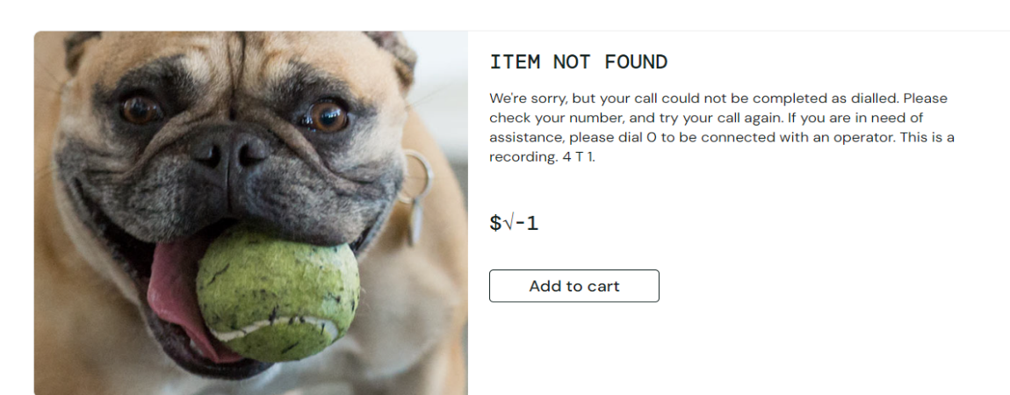

Field | Details
ID | Bug-004
Title | Checkout Form – Last Name Field Bug.
Severity | Critical
Priority | Immediate
Steps | 1. Navigate to the checkout form page.  2. Enter a value into the “First Name” field (e.g., RANA).  3. Attempt to type into the “Last Name” field.  4. Observe where the typed characters appear.
Expected | Text appears in the Last Name field independently.
Actual | Last Name field blocked; input overwrites First Name.
Evidence | https://drive.google.com/file/d/1bSnlBfLtjAJ3Z_dnxKdw0LGuJw_tjRF-/view?usp=sharing

Field | Details
ID | Bug-005
Title | “About” Link Leads to 404 Page.
Severity | Medium
Priority | Medium
Steps | 1. Navigate to the main inventory or product listing page.  2. Locate the sidebar menu.  3. Click on the “About” link.  4. Observe the page that loads.
Expected | Valid About page loads
Actual | 404 Not Found error page.
Evidence | 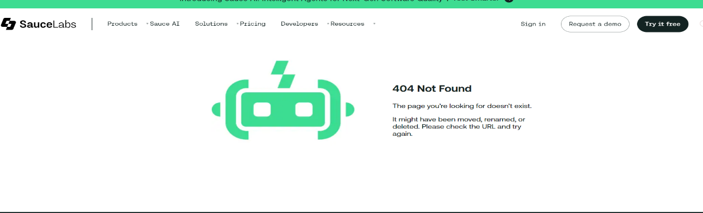

Field | Details
ID | Bug-006
Title | Product Label Navigation Reflects Incorrect Cart State
Severity | High
Priority | High
Steps | 1. Navigate to the product listing page.  2. Locate a product that shows “Add to Cart” button (e.g.,  Sauce Labs Fleece Jacket  ).  3. Click on the product label or title (not the “Add to Cart” button).  4. Observe the product detail or redirected view.
Expected | Product detail view should show the correct cart state. If not added, the button remains “Add to Cart.”
Actual | Product detail view incorrectly shows “Remove”, implying the product is in the cart without user action.
Evidence | https://drive.google.com/file/d/1SPfvheksd6BSwyI_LjjOqBnENbV5Au7Q/view?usp=sharing

Field | Details
ID | Bug-007
Title | Sorting by Name (A to Z) Not Functional.
Severity | Medium
Priority | Medium
Steps | 1.product listing page.  2. Open the sorting dropdown menu.  3. Select “Name (A to Z)”.  4. Observe the product order.
Expected | Products should reorder alphabetically from A to Z
Actual | No change occurs; products remain in the same sequence
Evidence | https://drive.google.com/file/d/1nV81w1LkPbsK2X58oyeVyMn6BXHGHLqI/view?usp=drive_link

Field | Details
ID | Bug-008
Title | Navigation to Cart Page Freezes
Severity | Critical
Priority | Immediate
Steps | 1. Open the product listing page.  2. Add any product to the cart (e.g.,  Sauce Labs Bike Light  ).  3. Click the “Cart” icon.  4. Observe the system behaviour and page rendering.
Expected | User redirected to cart page, products displayed, no freeze or blank screen
Actual | System freezes, blank white screen shown, no content rendered
Evidence | https://drive.google.com/file/d/19O8usXxac5UBPmBd4ggaz1VBLphcFK8A/view?usp=sharing

Field | Details
ID | Bug-009
Title | Checkout form accepts whitespace-only input in required fields
Severity | Critical
Priority | Immediate
Steps | 1. Navigate to the Checkout page.  2. Enter only whitespace (e.g., " ") in First Name, Last Name, and Zip/Postal Code fields.  3. Click the Continue button.
Expected | 1. System should reject whitespace-only input.  2. Error messages should be displayed for each required field.  3. Form submission should be blocked until valid data is entered.
Actual | 1. System accepts whitespace-only input.  2. Checkout continues without validation
Evidence | https://drive.google.com/file/d/1t11x27HjlhVpLfM9h48x8PXRx2tWvMlw/view?usp=sharing

