# Standard design page

## Backend Stories:

**As a BE Content Manager**, I can create new standard design page and fill the AR, EN names, Page order on the menu and select the menu item which the page will appear at its menu.

Also I can activate/ Deactivate the page.

<https://apps.orchtech.com/mpmar-admin-qc/DynamicPageRoute>

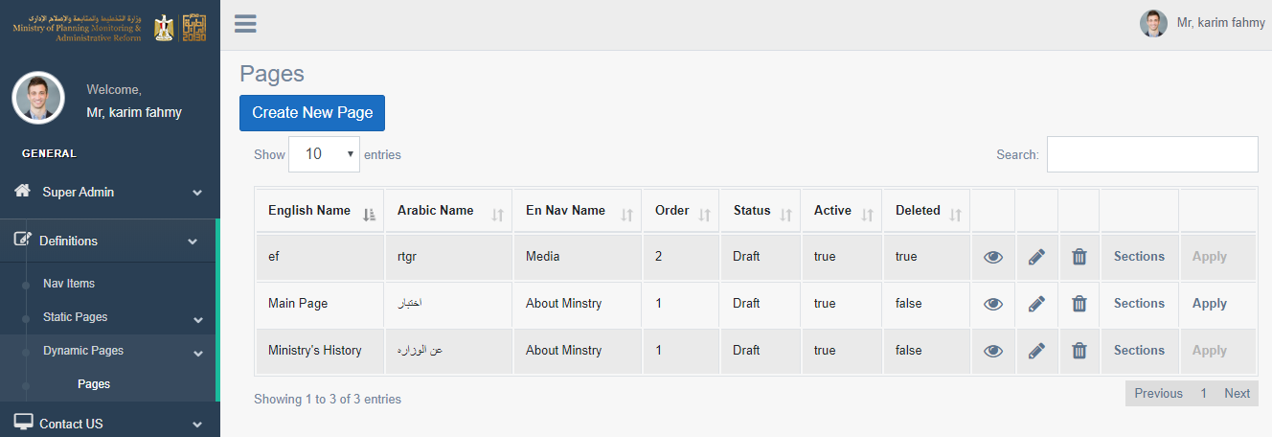

Figure . List of standard pages.

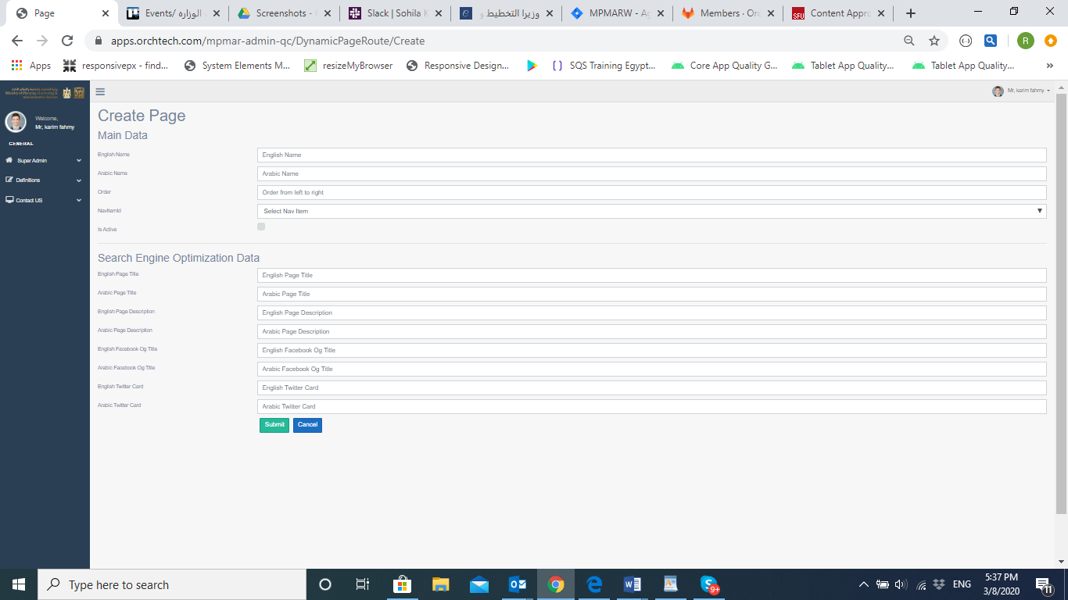

Figure . Create new page (Page Details)

### Page Fields

1. Main data
2. Page name (AR/EN).
3. Activate/ deactivate the page. (checkbox)
4. Change the page order in the website menu.
5. link the page to another menu item.

B. Page SEO data:

1. English page title
2. Arabic page title
3. English page description
4. Arabic page description
5. English Facebook og title
6. Arabic Facebook og title
7. English twitter card
8. Arabic Twitter card

**As a BE** **Content Manager,** I can add, Edit, Activate, Deactivate or delete any of the 8 sections to the page and the added sections will appear at the related page as content with the correct order. Already exists.

<https://apps.orchtech.com/mpmar-admin-qc/DynamicPageSection/Create?pageRouteVersionId=24>

**As a BE** **Content Manager,** I can add, Edit, Activate, Deactivate or delete cards to section (Section 8

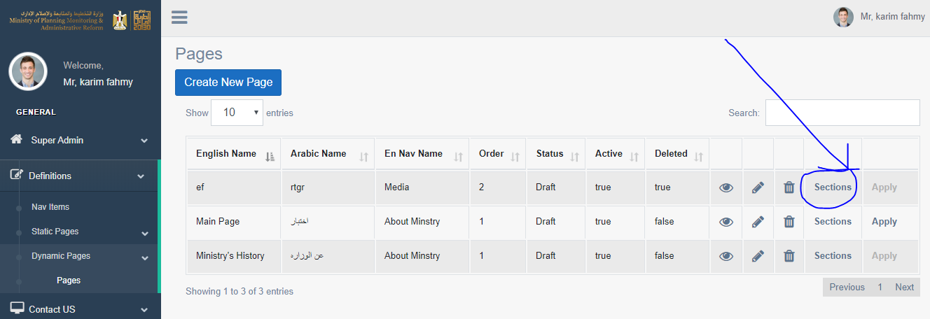

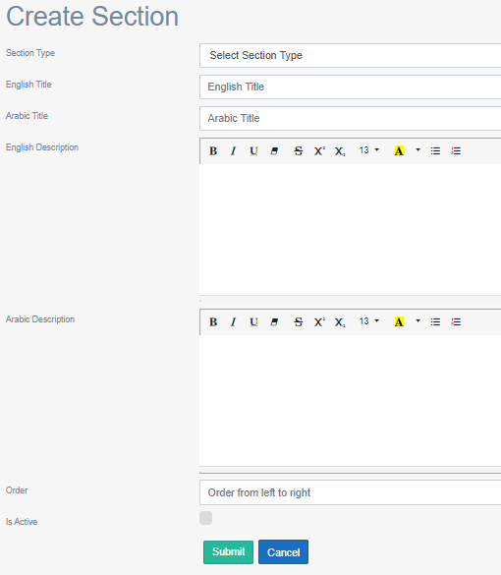

Figure . Add section to page.

### Fields:

1. Sections main data:

Section Type: drop menu contain 8 sections.

Section AR title: text

Section EN title: text

AR Description: text

EN Description: text

1. Section 1, 3, 4, 6 fields:

When sections from 1 to 6 has been selected, the following fields should be fields:

1. Title: text
2. Description: text
3. Image: image should be uploaded.
4. Section 2, 5 fields:

When sections from 1 to 6 has been selected, the following fields should be fields:

1. Title: text
2. Description: text
3. Video: video should be YouTube link
4. Section 7 fields

When section 7 has been selected, the following fields should be fields:

1. Title: text
2. Description: text
3. Section 8 fields

When section 8 has been selected, the following fields should be fields:

1. Title: text
2. Description: text
3. List of cards fields:

<https://apps.orchtech.com/mpmar-admin-qc/DynamicSectionCard?id=9>

* + 1. Card AR title: text, maximum no of characters (with spaces): 69
    2. Card EN title: text, maximum no of characters (with spaces): 69
    3. Card AR description: text, Body text maximum number of characters (with spaces): 192
    4. Card EN description: Body text maximum number of characters (with spaces): 192
    5. Card image: image should be uploaded.
    6. Upload file: Should scan for security.

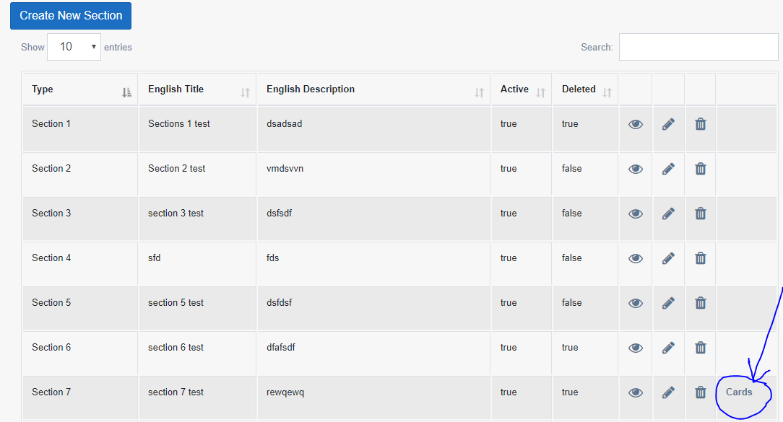

Figure . Click to open cards list from sections page (section 7)

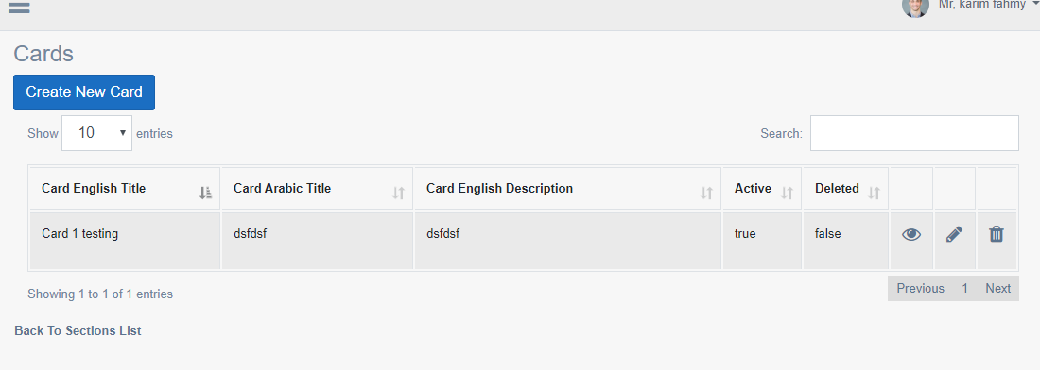

Figure . Cards list

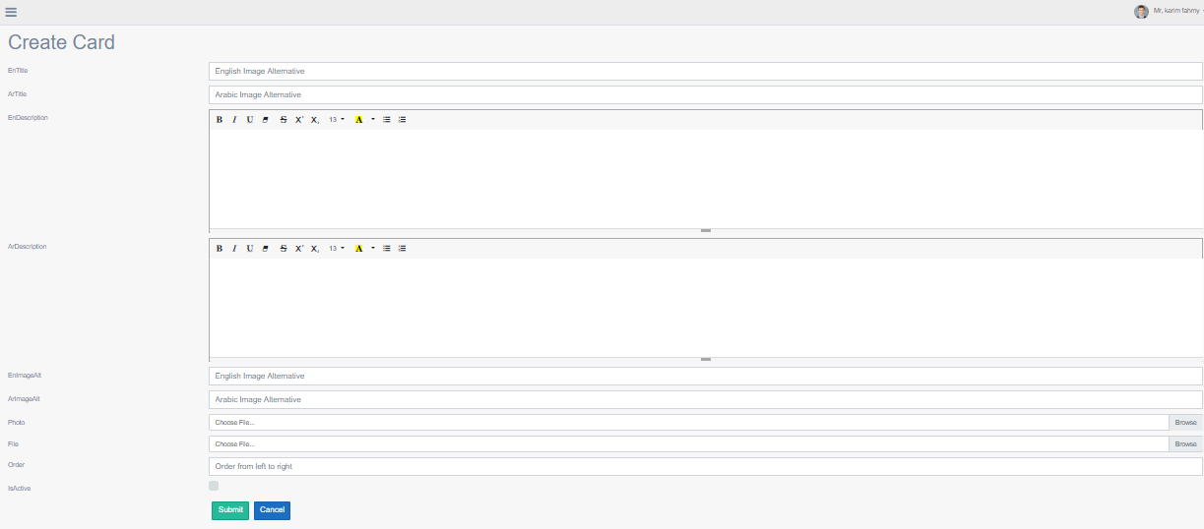

Figure . Card Details

### Sections view at the website:

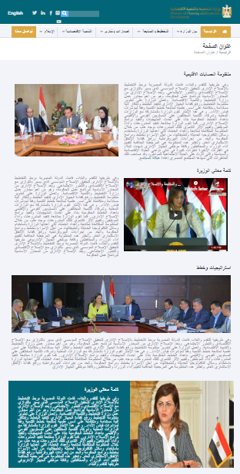

Page title

**Section 1**

Title: 63 characters

Description: 717 char.

Image: 379 x 263 px

**Section 2**

Title: 63 char

Description: 717 char

Video: YouTube link, 379 x 263 px

**Section 3**

Title: 63 char

Description: 20000 char

Image: 818 x 215 px

**Section 4**

Title: 32 char

Description: 865 char

Image: 379 x 450 px

Figure . Standard page sections part1.

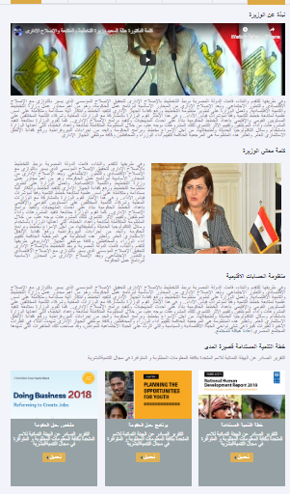

**Section 5**

Title: 63 char

Description: 20000 char

Video: YouTube link, 818 x 300 px

**Section 6**

Title: 63 char

Description: 717 char.

Image: 379 x 263 px

**Section 7**

Title: 63 char

Description: 20000 char

**Section 8**

Title: 63 char

Description: 20000

List of cards:

1. Card title: 69 char
2. Card: description char: 192
3. Card image
4. Uploaded file

Figure . Standard page sections part 2.

### Validations:

* I can add every section any number of times.
* I can all 8 sections at the same time to one page without any conflict or validations.
* When BE content manager selects certain section, it will display the related fields to be filled, every section should have its fields depends on the content which it will show.
* When sections are more than 3, cards will go to the next line, every line will have 3 cards.
* Backend content manager can add video Youtube URL.
* Website user should be able to watch the Video at same website page in a small frame without redirecting to YouTube page.

## Website visitor stories

**As a website visitor,** I can open standard page by clicking on the menu item and click page name so that i can see the page content with all sections added and approved.

**As a website Visitor,** I can view section 8, I can see list of cards, I can read the card title and description in Arabic and English, I can see the image of each card, also I can open the file attached to the card, it will open in another tab, check[*Figure 9.* *Standard page section part 2.**]*

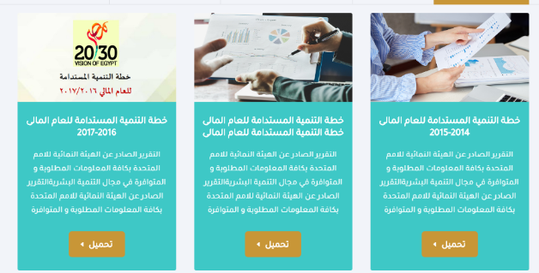

**As a website Visitor,** I can clickto watch the Video at same website page in a small frame without redirecting to YouTube page.