1- Write a PHP program to count the words in the string and the length of this string

2- Write a PHP program to reverse the string

3- draw this table

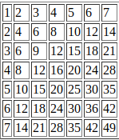

4- read and write from file

5- create a layout of page by using php   
 **Rules & Hint :- ( use require or include function)**