Software Development -2020

sheet 3

1. Write a Python function that checks whether a passed string is palindrome or not.
2. Write a Python programto print Palindrome numbers from the given list.
3. Write a Python program to access a function inside a function.
4. Write a Python program to execute a string containing Python code.
5. Write a Python function to create and print a list where the values are square of numbers between 1 and 30 (both included).
6. Write a Python program that accepts a hyphen-separated sequence of words as input and prints the words in a hyphen-separated sequence after sorting them alphabetically.
7. Write a Python function to check whether a string is a pangram or not.

Note : Pangrams are words or sentences containing every letter of the alphabet at least once.For example : "The quick brown fox jumps over the lazy dog"

1. Write a Python function that prints out the first n rows of Pascal's triangle.  
   Note : Pascal's triangle is an arithmetic and geometric figure first imagined by Blaise Pascal.Sample Pascal's triangle :

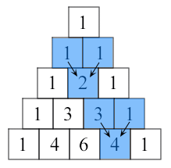

Each number is the two numbers above it added together.

1. Write a Python function that prints out lower triangle pattern ?

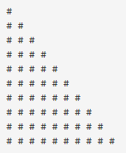

1. Write a Python function to check whether a number is perfect or not.

Note:

In number theory, a perfect number is a positive integer that is equal to the sum of its proper positive divisors, that is, the sum of its positive divisors excluding the number itself (also known as its aliquot sum). Equivalently, a perfect number is a number that is half the sum of all of its positive divisors (including itself).

*Example* : The first perfect number is 6, because 1, 2, and 3 are its proper positive divisors, and 1 + 2 + 3 = 6. Equivalently, the number 6 is equal to half the sum of all its positive divisors: ( 1 + 2 + 3 + 6 ) / 2 = 6. The next perfect number is 28 = 1 + 2 + 4 + 7 + 14. This is followed by the perfect numbers 496 and 8128.

1. Write a Python program to print the even numbers from a given list.
2. Write a Python program to print the even numbers from a given list using list comprehension:
3. Write a Python program to print the even numbers from a given list using lambda and map: