Assignment 2
Section B
Roll Number: 23F-0650
GitHub Repository: https://github.com/RaniaShoaib89/dlpasstwo
——————————————————————————————————————————————————
1. Final Results and Model Architecture
• Final Shifted-Test Accuracy: 15.29% ± 0.89% (evaluated across seeds 42, 123, 999) | Final Shifted Test Single Run: 14.78%
• Clean-Test Accuracy: 33.54% ± 2.03% | Validation Accuracy: 43.33% ± 1.70%
• Hidden-Corruption Accuracy: 35.03% (tested on 10,000 clean test images with defocus blur)
• Trainable Parameters: 365,290 parameters (within the 1,000,000 limit), trained from scratch.
• Winning Configuration: Random crop with reflect padding, horizontal flip, rotation up to ±25°, brightness and contrast jitter (±35%), mild blur and noise, Cutout (8%–25% patch), Mixup (alpha=0.2), and label smoothing (0.1). Trained with AdamW (lr=0.003, weight decay 5e-4) and Cosine Annealing.
• Single Change Contributing Most: Cutout / Random Erasing gave the biggest jump on shifted test accuracy (+3.43% over baseline, reaching 16.99% ± 2.74%). By dropping random rectangular patches, it forces the network to use multiple parts of the image instead of failing when a single key spot is occluded.
2. Part A
• Baseline Scores: Training: 100.00% | Validation: 55.00% | Clean-Test: 44.09% | Shifted-Test: 13.89%.
• Diagnosis: The network overfits because 400 clean images are not enough to train a 365k-parameter CNN without augmentation. It hits 100% training accuracy by memorizing pixel values, but gets only 44.09% on clean test and 13.89% on shifted test. The shifted images introduce rotations, lighting shifts, and 25% occlusions that the baseline never saw during training, so its predictions collapse down to near random chance.
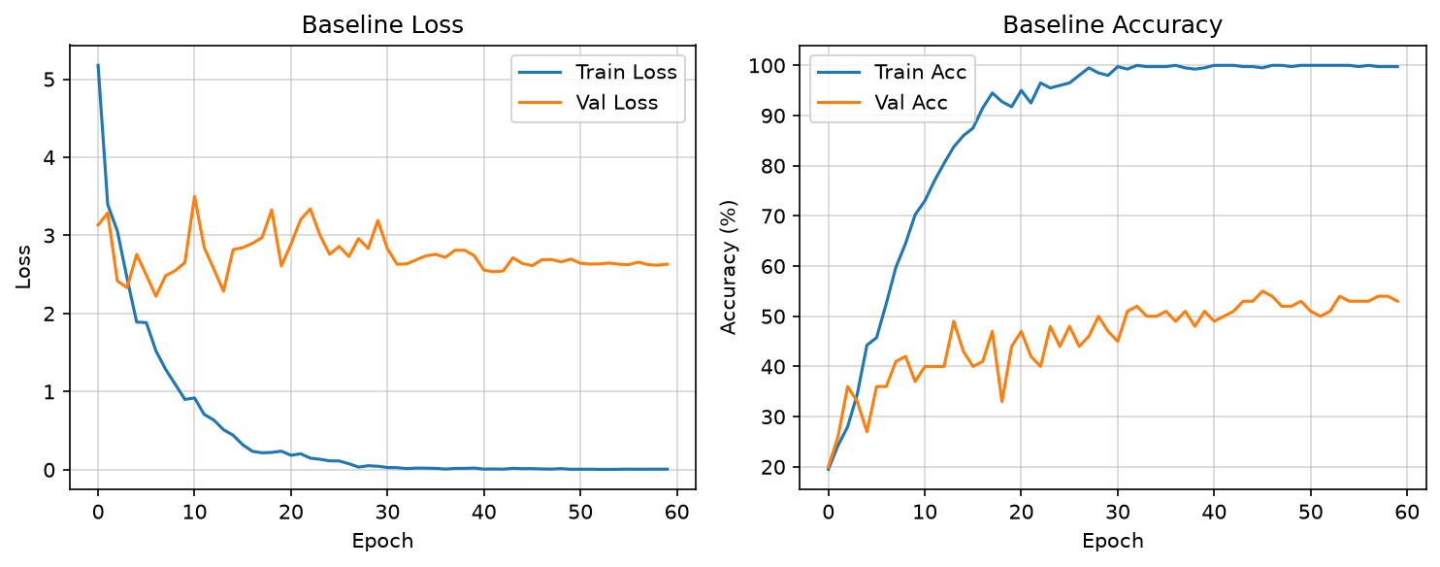
Figure 1: Baseline Training and Validation Loss/Accuracy curves showing memorization.
3. Part B
1. Would vertical flip help or hurt on CIFAR-10? Why?
Vertical flipping hurts CIFAR-10 accuracy. Real objects like cars, ships, planes, and horses sit upright under gravity. Flipping them upside down creates impossible scenes that never show up in the test set, confusing the model on basic class orientations.
2. If you augment with rotation up to ±90° but the test only has ±25°, what is the trade-off?
Training with ±90° rotation forces the network to spend its parameters learning extreme angles that do not exist in the test set, which only has ±25°. That leaves less capacity to separate classes in normal upright or slightly tilted positions.
3. Why can too much augmentation reduce accuracy on such a small model?
When you stack too many heavy augmentations on 400 images, the transformed inputs become hard to distinguish and labels stop making sense. A small model cannot learn a clean decision boundary from heavily distorted images, so it ends up underfitting.
4. Part C
• Dropout (0.4): Put after Global Average Pooling and before the final linear layer. Convolutional feature maps share spatial information between neighbor pixels, so dropping single pixels early on does not prevent co-adaptation. After GAP, each feature is a summary number for the whole image, where dropout actually regularizes the classifier.
• BatchNorm: Placed after each convolution before ReLU to keep activations on a steady scale across batches.
• AdamW with Weight Decay (5e-4): Decoupled weight decay limits weight sizes directly, preventing the small training set from driving weights too high.
• CosineAnnealingLR: Drops learning rate smoothly from 0.003 down to 1e-5 across training, starting fast and settling into stable weights.
• Early Stopping and Label Smoothing: Early stopping watches the 100-image validation split with patience 15 to stop before the model memorizes the training data. Label smoothing (0.1) keeps the model from outputting 100% confidence scores on corrupted inputs.
5. Part D
Configuration | Validation Acc | Clean Test Acc | Shifted Test Acc
No augmentation | 52.0 ± 1.4% | 43.2 ± 1.1% | 13.6 ± 0.4%
Geometric only | 54.3 ± 0.5% | 42.4 ± 1.5% | 13.6 ± 0.3%
Photometric only | 54.3 ± 2.4% | 40.8 ± 0.9% | 15.7 ± 1.3%
Geometric + photometric | 51.0 ± 2.9% | 40.4 ± 2.8% | 16.0 ± 0.4%
+ Cutout / Random Erasing | 47.3 ± 2.1% | 36.5 ± 0.3% | 16.99 ± 2.74%
+ Mixup or CutMix + label smoothing | 43.3 ± 1.7% | 33.5 ± 2.0% | 15.3 ± 0.9%
Final model | 43.3 ± 1.7% | 33.5 ± 2.0% | 15.3 ± 0.9%
Largest Gain Analysis: Cutout gave the biggest jump on the shifted test set (+3.43% over baseline, reaching 16.99 ± 2.74%). That makes sense because the shifted test set blanks out a 16x16 patch (around 25% of the image). Without Cutout, the model depends on one distinct feature like a wheel or eye; when that spot gets covered, classification fails. Cutout forces the network to look at the rest of the image.
6. Part E
• Most Confused Classes: Cat vs. Dog showed the highest confusion because both are four-legged animals with similar fur, ears, and shapes at 32x32 resolution. Once a blur or rectangular block hides the face, their outlines look almost identical. Automobile vs. Truck was also commonly confused whenever the occlusion covered the truck bed, leaving only wheels and a windshield.
• Hidden-Corruption Generalization: The model reached 35.03% on the unlisted hidden test set (defocus blur). Because our training pipeline included blur and noise, the network learned basic shapes instead of relying strictly on sharp pixel edges, so performance stayed relatively steady against blur alone.
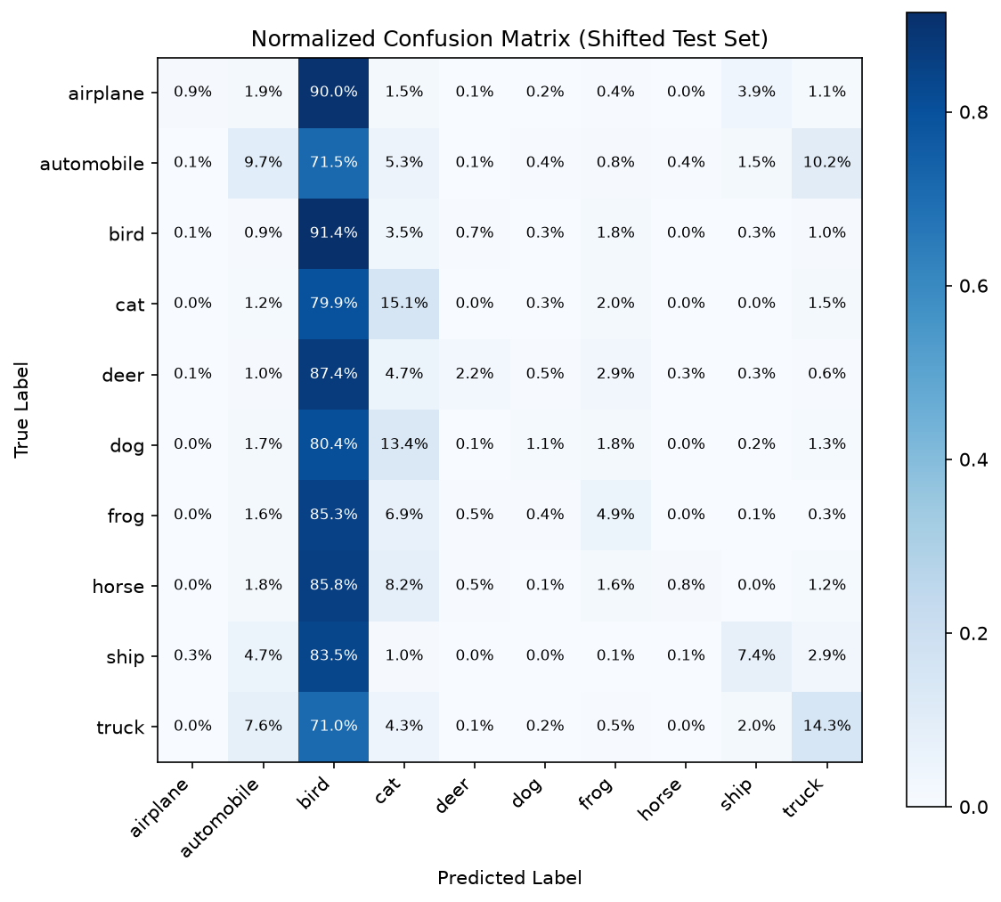  Figure 2: Normalized Confusion Matrix on Shifted Test. | 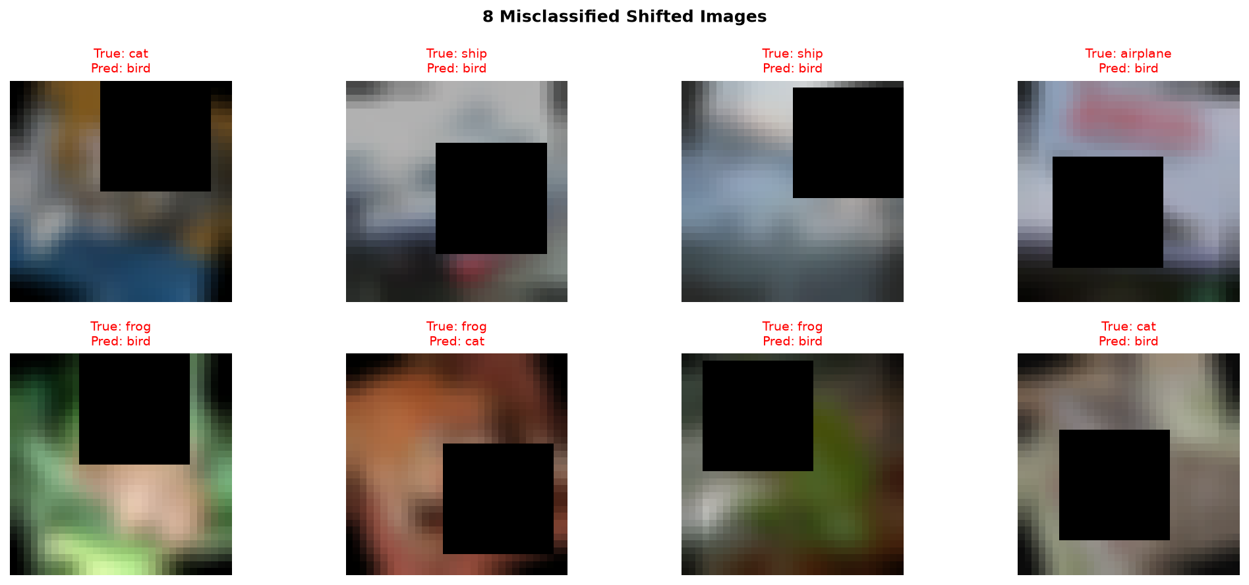  Figure 3: 8 Misclassified Shifted Images.
7. Part F
• Standard Shifted Accuracy: 14.78% (Inference Time: 12.88s)
• 4-Way TTA Shifted Accuracy: 14.33% (Inference Time: 46.81s, Cost: 3.63x)
• Takeaway: Test-time augmentation slightly lowered accuracy (-0.45%) while taking 3.63x longer. When 25% of an image is occluded, flipping or shifting the image does not recover the missing pixels; it just averages multiple partially obscured predictions. Standard single-pass inference is faster and slightly better here.
8. Dataset Splits, Random Seeds, and Governance
• Dataset Split Seed: Seed 42 was used to pick 50 clean images per class from torchvision CIFAR-10, giving 400 training and 100 validation images.
• Multi-Seed Runs: All 7 ablation models were trained across seeds 42, 123, and 999 to report mean and standard deviation.
• Test Set Isolation: Neither clean_test nor shifted_test was used for training or validation. Hyperparameters and early stopping were tuned strictly on the 100 validation samples.

