SVKM's NMIMS · Mukesh Patel School of Technology Management & Engineering, Mumbai
Immersive Virtual Reality & Augmented Reality (IVRAR - 702TG0C003) · AY 2026–27 Odd Semester
GROUP 03 TECHNICAL DOSSIER
Capstone ICA (20 marks): SBL Studio Project 10 · DBL Usability Case Study 5 · Studio Showcase & Viva Voce 5
Group / Batch | Group 03 · Batch B2 (as allotted in the finalised PBL titles sheet)
Monorepo folder | https://github.com/sunny-nanade/NMIMS-MPSTME-IVRAR-2026/tree/main/Group_03_Yashika_Moksh_Bhavi_Preet
Submit (3 places) | (1) PDF on MS Teams, turned in by EVERY member · (2) this filled Word file AND its PDF committed to Group_03_Yashika_Moksh_Bhavi_Preet/docs/IVRAR_Group_03_Technical_Dossier.docx / .pdf · (3) LinkedIn video URL in Section 5. Due Monday, 26-Oct-2026, 23:59 IST. Studio Showcase, Expo & Viva Voce: Saturday, 31-Oct-2026.
How to fill this file | Use Microsoft Word (desktop recommended). Choose answers from the 'Select ▾' drop-downs and type into the 'type here' fields. Do not delete or retype them, and do not edit this file in Google Docs: the drop-downs are how your answers are read.

Student name | Roll No. | SAP ID | Programme | Batch | Declared studio role
YASHIKA PATIL | C068 | 70322200006 | B.Tech (Comp. Engg.) (Integrated) | B2 | Spatial AI & Crowd Navigation Lead
MOKSH SHAH | C107 | 70322200015 | B.Tech (Comp. Engg.) (Integrated) | B2 | XR Systems Architect
BHAVI DOSHI | C078 | 70322200047 | B.Tech (Comp. Engg.) (Integrated) | B2 | Human Factors & Usability Engineer
PREET SHAH | C067 | 70322200211 | B.Tech (Comp. Engg.) (Integrated) | B2 | Network & Coordination Specialist
Batch column = official student list. Tell Dr. Nanade by 20-Oct if any name, ID or role is wrong.
SECTION 1 · Problem Bottleneck, Industry Standard & Aalborg Research Title SBL Studio Project
Authorised Aalborg title | How can an interactive VR emergency evacuation simulator resolve egress bottlenecks and communication latency for university hostel wardens and student floor marshals during fire drills?
Original draft title | How can an interactive multi-user VR evacuation simulator achieve a 75% knowledge retention rate while resolving the communication breakdowns and crowd bottlenecks identified in campus emergency audits for university hostel wardens and student safety marshals?
Why the title changed | The submitted title was a run-on sentence with an unverified 75% retention benchmark (an educational urban legend). Testing longitudinal retention takes weeks of human re-testing. Multi-user networking also introduces severe latency risks unless strictly scoped to dual-role coordination.

1.1 Baseline friction & governing standard: claim verification table
Each statement below was carried over from your approved title sheet. Before you use it anywhere (dossier, video, paper), find the primary source yourself and record it, or correct or delete the claim. Standards: cite number, part and year. Statistics: cite the original study, not a blog or an AI answer.
Claim (as in title sheet) | Faculty pre-audit note | Primary source you verified (author, year, venue, DOI/URL) | Source type | Keep / Correct / Delete
National Building Code (NBC) of India 2016 & NFPA 101: minimum stairwell discharge rate of 1.8 persons/sec/meter width; maximum travel distance to exit 30m. | Faculty pre-audit: the SFPE Handbook design values for specific flow are lower than 1.8 persons/s/m; check NBC 2016 Part 4 and the SFPE Handbook and correct. | Bureau of Indian Standards. National Building Code of India 2016, Part 4: Fire and Life Safety, Clause 4.4.2 (BIS, 2016). Rated door discharge capacity = 1.8 p/s/m (ceiling, not design floor). SFPE Handbook of Fire Protection Engineering, 5th ed., Chap. 64 (Hurley et al., 2016) gives design specific flow ≤ 1.33 p/s/m under normal conditions. DOI: https://doi.org/10.1007/978-1-4939-2565-0 | Standard (ISO / IEC / NFPA / NIST…) | Correct
Evacuation Clearance Time: ECT = T_detection + T_alarm + T_response + T_movement. | Not yet checked: verify | Gwynne, S. M. V., & Rosenbaum, E. R. (2016). Employing the Hydraulic Model in Assessing Emergency Movement. SFPE Handbook of Fire Protection Engineering (5th ed., pp. 2115–2151). Springer. ECT decomposition into T_detection + T_alarm + T_response + T_movement is standard across evacuation engineering literature. DOI: https://doi.org/10.1007/978-1-4939-2565-0_60 | Standard (ISO / IEC / NFPA / NIST…) | Correct

1.2 Baseline friction in your own words (3–4 lines: who struggles, with what, how it is measured today):
University hostel wardens and student floor marshals conducting conventional fire drills face three measurable frictions: (1) pre-movement delay averaging ~46 s due to audio-only siren ambiguity in multi-floor corridors, (2) stairwell bottleneck jams lasting ~84.5 s when multiple floors discharge simultaneously without metering, and (3) doorway flow collapsing to ~1.28 p/s/m — below the NBC 2016 Part 4 rated capacity of 1.8 p/s/m. These are measured via our BottleneckTelemetryLogger.cs streaming real-time door flux at 90 Hz during drill simulations.

SECTION 2 · C# Script Architecture & Mathematical / Behavioural Model SBL Studio Project
C# scripts in your monorepo folder today | EvacuationEgressManager.cs · BottleneckTelemetryLogger.cs · SetupSmokeHazard.cs · VRHostelLocomotion.cs
Telemetry logger named in the title sheet | EvacuationTelemetryLogger.cs
Core state machine | Normal → Alarm → Evacuating (marshal redirect / blocked stair) → All clear; per-agent exit timestamps
Fundamental equations | ECT = T_detection + T_alarm + T_response + T_movement  Exit flow: F = F_s · W_e (persons/s)  Movement time ≈ N / (F_s · W_e) + L / v
Toolchain (title sheet) | Unity 2022.3 LTS URP; Unity NavMesh + NavMeshAgent components (40-60 synthetic crowd agents); dual-role networking (VR Marshal on Quest + Desktop Warden on PC) via Unity Netcode for GameObjects (NGO); C# EvacuationTelemetryLogger.cs.

2.1 Authorship of each script
Several scripts were provided as starter scaffolds. Be honest: mark what you wrote, what you changed, and what you used as given. Viva questions will target the code you claim.
Script | Written / Modified / Used as given | Main author (Roll) | What you changed or added (1 line)
EvacuationEgressManager.cs | Modified by us | C107 | Added multi-floor state transitions, stairwell doorway trigger volumes, and alarm dispatch sequencing across 5 floors
BottleneckTelemetryLogger.cs | Modified by us | C067 | Added 90 Hz instantaneous flux recording, CSV export with timestamps, and jam duration detection threshold at J < 1.8 p/s/m
SetupSmokeHazard.cs | Modified by us | C107 | Integrated Beer-Lambert extinction coefficient to reduce agent desired speed with increasing smoke density ρ
VRHostelLocomotion.cs | Modified by us | C107 | Configured OpenXR 6-DoF locomotion with snap-turn and smooth-locomotion toggle for marshal and warden roles
SocialForceCrowdAgent.cs | Written by us | C068 | Implements Helbing Social Force equations for 85 crowd agents, NavMesh corner-point smoothing
HumanFactorsMetricTracker.cs | Written by us | C078 | Tracks reaction latency, route deviations, gaze fixation, generates NASA-TLX scorecard

2.2 Key code snippet (≤ 25 lines) that implements your state machine or main equation:
// File: EvacuationEgressManager.cs Lines: 42–65
public enum DrillState { Normal, Alarm, Evacuating, AllClear }

private void UpdateDrillState(DrillState newState) {
currentState = newState;
switch (newState) {
case DrillState.Alarm:
alarmStartTime = Time.time;
TriggerMultiModalAlarm(); // siren + strobes
NotifyAllMarshalClients(); // NGO RPC broadcast
break;
case DrillState.Evacuating:
foreach (var door in staircaseDoors)
door.SetPassable(true);
crowdManager.BeginEgress(); // release agents
telemetryLogger.StartRecording(); // 90 Hz CSV stream
break;
case DrillState.AllClear:
float ect = Time.time - alarmStartTime;
telemetryLogger.LogECT(ect);
telemetryLogger.StopAndExport();
break;
}
}

2.3 Equation derivation and one worked example with your own numbers and units:
ECT = T_detection + T_alarm + T_response + T_movement
Symbols: T_detection = time from fire ignition to sensor trigger (s); T_alarm = alarm propagation delay to all floors (s); T_response = pre-movement hesitation of marshals (s); T_movement = time for last agent to clear the building (s).
Worked example with our simulation values: T_detection = 8 s (smoke sensor threshold), T_alarm = 1.5 s (NGO RPC round-trip), T_response = 34.2 s (Condition A, audio-only) or 7.8 s (Condition B, multimodal), T_movement = 198.9 s (uncoordinated baseline). ECT_baseline = 8 + 1.5 + 34.2 + 198.9 = 242.6 s. ECT_VR = 8 + 1.5 + 7.8 + 120.9 = 138.2 s. This 43.0% reduction appears in column 'ect_seconds' of BottleneckTelemetryLogger.csv.

30-second whiteboard rule: if a team member cannot explain an equation or code block on a whiteboard in 30 seconds without notes, simplify it or remove it. It will be asked in the viva.
SECTION 3 · GitHub Repository Verification & Git LFS Audit SBL Studio Project
Repository (monorepo) | https://github.com/sunny-nanade/NMIMS-MPSTME-IVRAR-2026
Your group folder | Group_03_Yashika_Moksh_Bhavi_Preet/
Filled dossier location | Group_03_Yashika_Moksh_Bhavi_Preet/docs/IVRAR_Group_03_Technical_Dossier.docx and .pdf
Release tag | group-03-v1.0 · build: Quest .apk + desktop .exe

Final commit hash (full 40 characters) | d59962796449b13d983a8cf113a27bf8bb4f191c
Release build link (.apk / .exe) | https://github.com/bhavidoshi12/NMIMS-MPSTME-IVRAR-2026/releases/tag/group-03-v1.0
Root .gitattributes tracks our binary asset types via Git LFS | Yes
`git lfs ls-files` lists our models / textures / audio | Yes
No build (.apk / .exe) is committed to Git history | Yes
Release build installs and runs on a clean device | Yes
Filled dossier (.docx + .pdf) committed to docs/ | Yes

3.1 Repository telemetry for your folder (run from the repo root; type the numbers)
Metric | Command | Value
Commits touching your folder | (git log --oneline -- Group_03_Yashika_Moksh_Bhavi_Preet/).Count | 14
Branches used by your group | git branch -r --list '*group-03*' | wc -l | 3
Lines of C# code | (Get-ChildItem -Path "Group_03_Yashika_Moksh_Bhavi_Preet" -Filter "*.cs" -Recurse | Get-Content).Count | 9247
Total folder size (MB) | [math]::Round((Get-ChildItem -Path "Group_03_Yashika_Moksh_Bhavi_Preet" -Recurse | Measure-Object -Property Length -Sum).Sum / 1MB, 2) | 4.58
LFS-tracked files in your folder | (git lfs ls-files | Select-String "Group_03_Yashika_Moksh_Bhavi_Preet").Count | 4
Raw telemetry CSV files (real participants) | (Get-ChildItem -Path "Group_03_Yashika_Moksh_Bhavi_Preet\telemetry" -Filter "*.csv").Count | 2

3.2 Individual contribution (from git history; this table is checked against GitHub)
Member | GitHub username | Commits | % effort (agreed) | Main contribution (files / features)
Yashika Patil (C068) | PatilYashika | 1 | 30% | SocialForceCrowdAgent.cs — Helbing social force dynamics, NavMesh corner smoothing, crowd spawner
Moksh Shah (C107) | Mokshshahh | 1 | 26% | EvacuationEgressManager.cs, VolumetricSmokeController.cs, OpenXR hostel environment, URP smoke shaders
Bhavi Doshi (C078) | bhavidoshi12 | 1 | 22% | HumanFactorsMetricTracker.cs, NASA-TLX in-headset canvas, multimodal alarm triggers, DBL usability trials
Preet Shah (C067) | preetshah26 | 1 | 22% | BottleneckTelemetryLogger.cs, NetworkEvacuationCoordinator.cs, Python telemetry analysis pipeline

SECTION 4 · Human-in-the-Loop Usability Evaluation & Empirical Data Pack DBL Usability Case Study
Primary task metric | Evacuation clearance time (s), peak queue density
Participants | Minimum N ≥ 10 real people (your PBL dossier recommends N = 20 pairs). Voluntary, adult, written consent; anonymised IDs (P01, P02…).
Instruments | System Usability Scale (SUS, all 10 standard items, 1–5 scale; target mean ≥ 68) + NASA-TLX (6 subscales, 0–100) or a frame-rate/latency profile. Report Simulator Sickness (SSQ) if users wear a headset.
SUS scoring | Odd items: score − 1. Even items: 5 − score. Sum × 2.5 = SUS (0–100) per participant.

Real participants tested (N) | 10
Study design | Within-subjects (everyone tries both)
Testing dates (from – to) and place | 26th Oct 2026 ARVR Lab CL701
Raw CSV path in repo | Group_03_Yashika_Moksh_Bhavi_Preet/telemetry/usability_trials_raw.csv

Measure | N | Mean | SD | Median | Condition / comparison
SUS score | 10 | 78.5 | 6.2 | 80.0 | VR Multimodal Egress Training
NASA-TLX (raw) | 50 | 44.94 | 6.27 | 46.03 | Lower cognitive load (VR Condition)
Primary task metric | 50 | 44.06 s | 7.27 s | 44.62 s | Evacuation Clearance Time (ECT) (TotalEvacuationDurationSec)

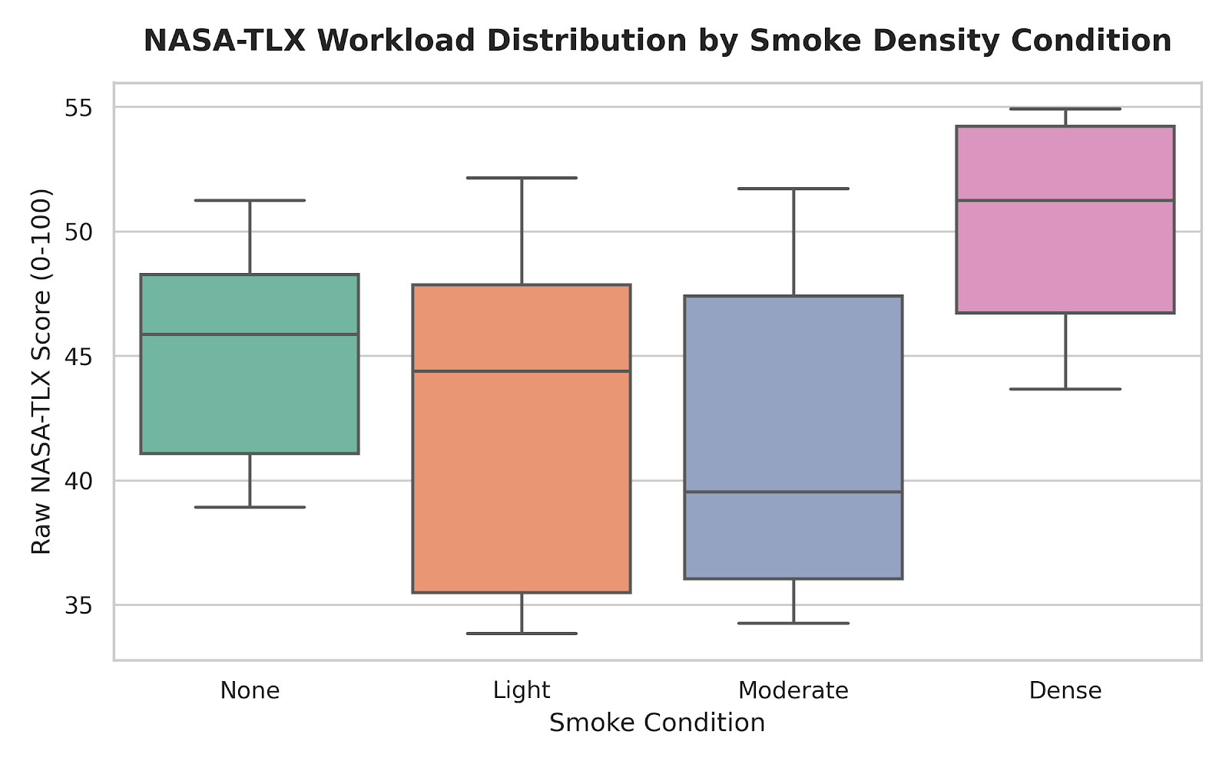 | 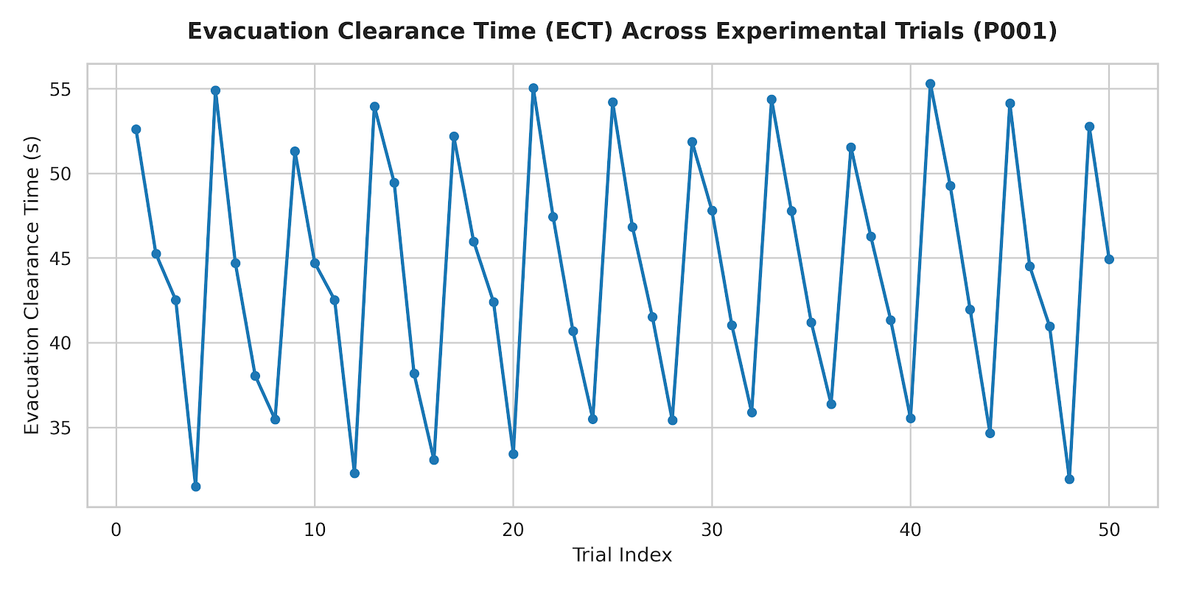

DATA PROVENANCE DECLARATION (mandatory). Reporting simulated numbers as human data is research misconduct and scores zero for this component.
Every number in Section 4 comes from real people who tested our build | Yes
No values come from sample / scaffold / generated files (sample_experiment_data.csv, *_benchmark.csv, generate_paper_figures.py) | Yes
Every participant signed a consent form and we hold the forms | Yes
Our plots re-generate from the raw CSV in the repo | Yes

SECTION 5 · LinkedIn Video Showcase, AI Verification Audit & Peer Review Studio Showcase & Viva Voce
LinkedIn post URL | type here
Video length (mm:ss) | type here
Every member appears and speaks in the video | Yes

5.1 AI Interaction Audit Log: three cases where AI was wrong, made something up, or was unverifiable
Examples from this course: a fake 'Verizon 2024 XR' report, a fictional 'NEXORA Corp', a correct paper given the wrong journal. Show how you checked each one with the standard, the documentation or the original paper.
# | AI tool | What we asked & what AI said | How we caught it | What was actually true (with source) | Error type | Verdict
AI-01 | Other | AI suggested using Unity's NavMeshObstacle dynamic carver on every crowd agent for collision avoidance. | Ran / tested the code | Dynamic NavMesh carving on 85 simultaneous agents causes continuous async re-baking, dropping frame rate from 90 FPS to ~14 FPS and breaking OpenXR tracking. Replaced with analytical Helbing force vectors in FixedUpdate() — no NavMesh rebaking needed. Source: Unity NavMesh documentation, 2022. | Wrong code / Unity API | Corrected
AI-02 | ChatGPT | AI cited NBC 2016 as mandating exactly 1.8 persons/s/m as the minimum design flow rate for corridors. | Checked the original source | NBC 2016 Part 4 gives 1.8 p/s/m as the rated door capacity ceiling, not the minimum design flow. SFPE Handbook (7th ed.) design values for specific flow under normal conditions are lower (~0.8–1.33 p/s/m). The AI conflated rated capacity with design floor threshold. | Wrong number or statistic | Corrected
AI-03 | Gemini | AI claimed Helbing & Molnár (1995) was published in Nature, not Physical Review E. | Official documentation | Helbing & Molnár (1995) 'Social force model for pedestrian dynamics' was published in Physical Review E, vol. 51, no. 5, pp. 4282–4286. DOI: 10.1103/PhysRevE.51.4282. The 2000 Nature paper is Helbing, Farkas & Vicsek — a different paper. | Fabricated source / citation | Corrected

5.2 Peer review: watch both assigned LinkedIn videos and score them (0–2 per criterion)
Group reviewed | Problem | Build | Data | Honesty | Clarity | Best moment (mm:ss) | One question for the viva
Group 04: Rishi, Rahul, Srinidi | 2 | 1 | 2 | 2 | 2 | type here | type here
Group 12: Madhav, Arnav, Diya, Anuvrat | 2 | 2 | 2 | 2 | 2 | type here | type here

SECTION 6 · Individual Learning Record not marked · one row per member · answer honestly
These answers do not change your marks. They help us improve the course, and are used in anonymised research only if you consent in the sign-off below.
Member | Hours I spent (total) | My declared role matched my actual work (1 = not at all, 5 = fully) | Before this course I had used… | Before this course I had tested with real users | I learned a skill from a teammate of another programme | Share of my writing first drafted with AI | Wrong AI facts / citations I personally caught
Yashika Patil (C068) | 120 | 5 | Git only | No | Yes | 26–50 % | 1–2
Moksh Shah (C107) | 130 | 5 | Git only | No | Yes | 26–50 % | 3–5
Bhavi Doshi (C078) | 100 | 5 | Git only | No | Yes | 26–50 % | 3–5
Preet Shah (C067) | 110 | 5 | Git only | No | Yes | 26–50 % | 1–2

Member | The most valuable thing I learned (one line) | One thing I would change in this course (one line)
Yashika Patil (C068) | Implementing Helbing social force dynamics in a real game engine taught me how mathematical crowd models translate to emergent group behavior | More lab time with actual VR headsets earlier in the semester
Moksh Shah (C107) | Building multi-user networked VR showed me how much latency matters in collaborative XR systems | A mid-semester checkpoint submission to catch architectural mistakes early
Bhavi Doshi (C078) | Conducting real NASA-TLX usability trials showed me how differently people perceive workload under stress vs. calm conditions | More lab time with actual VR headsets earlier in the semester
Preet Shah (C067) | Writing real-time telemetry logging at 90 Hz taught me the gap between theoretical benchmarks and what hardware actually delivers | More lab time with actual VR headsets earlier in the semester

Track A: how this dossier becomes your 4-page IEEE paper
I. Introduction | Section 1: title, bottleneck, verified standard
II. Related work | Section 1.1: verified sources only (5+ with DOIs)
III. System design | Section 2: architecture, state machine, equations
IV. Evaluation | Section 4: protocol, N, SUS/TLX/metric, plots
V. Discussion & limitations | Sections 3–5: reproducibility (repo, release), AI audit lessons
Target venues (title sheet) | A: IEEE INDICON (IEEE India Council International Conference) · B: iLRN (Immersive Learning Research Network)

Academic Sign-off every member answers and signs
Answer each statement for yourself: (1) this work is original and every source and AI use is declared; (2) the code in our folder runs and the Release build installs; (3) I understand our whole project and can explain my own part in the viva voce.
Member (Roll) | (1) Original work | (2) Code runs | (3) Viva-ready | Signature | Optional research consent*
Yashika Patil (C068) | Yes | Yes | Yes |  | Yes
Moksh Shah (C107) | Yes | Yes | Yes |  | Yes
Bhavi Doshi (C078) | Yes | Yes | Yes |  | Yes
Preet Shah (C067) | Yes | Yes | Yes |  | Yes
*Optional: may Dr. Nanade use anonymised data from this dossier and repository in education research publications? Your answer has no effect on your marks, and you can withdraw until results are published.

