Canonical Issue on Website

Note: - Website page should be opened with only one version of URL. Here same pages are open with different versions of URLs.
Home Page
Status code of below pages should be 301 permanent redirected
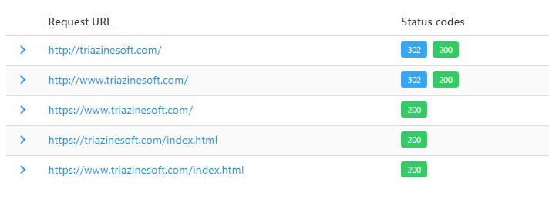
Action Required
Apply 301 Redirect from below URLs to https://triazinesoft.com/
http://triazinesoft.com/
http://www.triazinesoft.com/
https://www.triazinesoft.com/
https://triazinesoft.com/index.html
https://www.triazinesoft.com/index.html

Inner Pages
Status code of below pages should be 301 permanent redirected

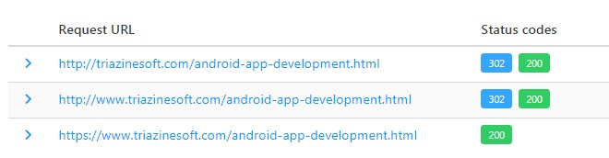

Action Required

Apply 301 Redirect from below URLs to https://triazinesoft.com/android-app-development.html

http://triazinesoft.com/android-app-development.html
http://www.triazinesoft.com/android-app-development.html
https://www.triazinesoft.com/android-app-development.html

Note: - Similarly apply 301 redirect on all pages of website.

