KR24_SDC-II_III-I_2026 Project Review-I
PERSONALIZED TECHNICAL INTERVIEW PREPARATION IN HIGHER EDUCATION
(SmartInterview - G-1392) | Date: 24-09-2026
Project Team ID: Team G-1392
# | Name | Roll Number
1 | SHAMAKURA SAITEJA GOUD | 24BD1A665K
2 | THODSAM SRUJAN | 24BD1A665R
3 | VASIREDDY VIGNESH REDDY | 24BD1A665X
4 | AELUGU RANITH KUMAR | 25BD5A6615
5 | KONDURI ABHIRAM | 25BD5A6620

Problem Statement
In modern technical recruitment, graduating engineering students face severe preparation barriers: static question banks, anxiety during live technical interviews, lack of personalized feedback, and a disconnect between university curricula, candidate resumes, and dynamic industry job descriptions. Existing mock interview platforms rely on rigid question sets or ungrounded generative AI bots that hallucinate questions, exhibit significant conversational latency, and lack systematic evaluation methodologies.
When candidates prepare for specific software engineering roles, the target job descriptions require skills spanning Data Structures, System Design, Operating Systems, Database Management Systems, Computer Networks, and Machine Learning. Static platforms fail to compare a candidate resume against a target job description to identify the exact role overlap and critical skill deficiencies.
Traditional evaluation also fails to measure cognitive depth. Candidate responses must be evaluated across multiple technical dimensions - technical correctness, completeness, conceptual coverage, semantic relevance, and communication clarity - and difficulty must scale using a validated educational framework so that candidates receive actionable remediation paths.
SmartInterview addresses these limitations with an AI-powered, RAG-grounded adaptive technical mock interview platform. It integrates dense vector retrieval with Bloom's Taxonomy cognitive progression, multi-signal response evaluation, in-memory neural text-to-speech, and automatic speech recognition to deliver an authentic, personalized, low-latency interview preparation experience.

Software Requirement Specification
for
Personalized Technical Interview Preparation in Higher Education
(SmartInterview - G-1392)
Version 1.0 approved
Prepared by:
# | Name | Roll Number
1 | SHAMAKURA SAITEJA GOUD | 24BD1A665K
2 | THODSAM SRUJAN | 24BD1A665R
3 | VASIREDDY VIGNESH REDDY | 24BD1A665X
4 | AELUGU RANITH KUMAR | 25BD5A6615
5 | KONDURI ABHIRAM | 25BD5A6620

Under the Guidance of:
Dr. TVG Sridevi (Faculty Mentor)
Department of Computer Science and Engineering (AI&ML)
KESHAV MEMORIAL INSTITUTE OF TECHNOLOGY (KMIT)
(An Autonomous Institution, Approved by AICTE, Affiliated to JNTUH, Accredited by NBA & NAAC)
Narayanaguda, Hyderabad, Telangana - 500029
Date: 24-09-2026 | KR24_SDC-II_III-I_2026 Project Review-I

Table of Contents
Revision History 4
1. Introduction 5
1.1 Purpose 5
1.2 Document Conventions 5
1.3 Intended Audience and Reading Suggestions 5
1.4 Product Scope 5
1.5 References 6
2. Overall Description 7
2.1 Product Perspective 7
2.2 Product Functions 7
2.3 Operating Environment 8
2.4 User Characteristics 8
2.5 Design and Implementation Constraints 8
2.6 Assumptions and Dependencies 8
3. Specific Requirements 10
3.1 Functional Requirements 10
3.2 Non-Functional Requirements 12
3.3 External Interface Requirements 13
3.4 Requirements Traceability Matrix 13
Software Development Life Cycle (SDLC) 14
Stages of SDLC 14
SDLC Models & Methodology Selection 15
Literature Survey 16
4. System Designing & UML Diagrams 18
Overview of UML & Conceptual Model 18
Structural vs. Behavioral Diagrams 18
4.1 Use Case Diagram & Template 19
4.2 Sequence Diagrams 22
4.3 Collaboration Diagram 25
4.4 Class Diagram 26
4.5 Statechart Diagram 27
4.6 Activity Diagram 28
4.7 Package Diagram 30
4.8 Component Diagram 31
4.9 Deployment Diagram 32
4.10 Entity Relationship Diagram (ERD) 33
4.11 Data Flow Diagrams (Level 0 and Level 1) 34
5. Implementation 36
6. Testing (Validation, Verification & Test Cases) 37
7. Conclusion 38

Revision History
Name | Date | Reason for changes | Version
Week-1 | 12-07-2026 | Problem Statement, Team Constitution & Feasibility | 0.1
Week-2 | 19-07-2026 | Literature Review & Research Gap Analysis | 0.2
Week-3 | 26-07-2026 | Functional & Non-Functional Requirements (SRS Drafting) | 0.3
Week-4 | 02-08-2026 | SDLC Methodology Selection & Academic Template Alignment | 0.4
Week-5 | 09-08-2026 | Use Case Modeling & Use Case Template Specification | 0.5
Week-6 | 16-08-2026 | Sequence and Collaboration Diagrams Specification | 0.6
Week-7 | 23-08-2026 | Class Diagram & Relational Entity-Relationship Design | 0.7
Week-8 | 30-08-2026 | Statechart and Activity Diagrams Modeling | 0.8
Week-9 | 06-09-2026 | Package, Component, and Deployment Architecture | 0.9
Week-10 | 13-09-2026 | Data Flow Modeling, Testing Cases, Interface Requirements, Traceability Matrix & Final SRS Approval | 1.0 (Final)

1. Introduction
The Software Requirement Specification (SRS) documents the technical agreement between the candidate, project stakeholders, academic evaluators, and system developers regarding the SmartInterview software platform. It provides a complete specification of system functional behavior, performance parameters, and architectural constraints, and serves as the authoritative baseline for implementation, system testing, architectural review, and deployment verification.

1.1 Purpose
This document specifies the software requirements for SmartInterview: an AI-powered technical mock interview platform. The system automates the technical interview preparation lifecycle for engineering candidates. It provides personalized interview sessions grounded in domain-specific computer science knowledge, adjusts question difficulty dynamically based on candidate performance, delivers spoken question output, transcribes verbal answers, and produces a comprehensive analytical evaluation report.

1.2 Document Conventions
The document conforms to academic software engineering documentation standards (IEEE Std 830-1998) and institutional guidelines:
- Section Headings (H1): 16 pt, Bold, Times New Roman.
- Subheadings (H2): 14 pt, Bold, Times New Roman.
- Sub-subheadings (H3): 12.5 pt, Bold, Times New Roman.
- Body Content: 12 pt, line spacing 1.15, Times New Roman.
- Requirement Identifiers: each functional requirement is uniquely designated RI.01.XX. Priority levels range from 1 (Critical) to 4 (Informational).
- Figures are numbered by section (e.g., Figure 4.2a) and every UML figure is followed by a short explanatory note.

1.3 Intended Audience and Reading Suggestions
This document is intended for project mentors, faculty evaluators, system developers, QA engineers, and engineering candidates. Developers should focus on Sections 2, 3, and 4 for system architecture, interface specifications, and UML models. Academic evaluators and mentors should review the Problem Statement, SDLC methodology, Literature Survey, and Requirements Specification to assess project rigor and architectural soundness.

1.4 Product Scope
SmartInterview is an intelligent web-based application that bridges the preparation gap between university education and software industry hiring expectations. The platform provides continuous 24x7 self-directed interview practice. Unlike generic chat interfaces, SmartInterview grounds interview content in an authoritative local vector store of 402 curated computer science topics across 8 technical domains (DSA, DBMS, OS, CN, System Design, OOP, Design Patterns, and ML/DL).
The system analyzes candidate resumes and target job descriptions to compute skill overlap and role deficiencies, conducts dynamic multi-turn technical interviews across Bloom's Taxonomy cognitive tiers, evaluates answers across 5 technical and semantic criteria, adjusts subsequent question difficulty, and provides spoken voice delivery alongside a downloadable performance evaluation report.

1.5 References
[1] A. Wahid, A. Jha, M. Munshi, S. Sonwane, and A. Chakrawarti, "AI Mock Interview: An Intelligent Voice-Driven Interview Simulation System using Gemini AI and Whisper," IJERT, vol. 15, no. 03, pp. 1-4, Mar. 2026. (Base Paper 1)
[2] M. K. Nagarajan, A. Kumar, I. V. S. Vignesh, A. Nehal, and M. Musthafa, "Development of an Autonomous AI Interview Engine Using Sentence-BERT and Large Language Models for End-to-End Candidate Evaluation," IJMRR, vol. 4, no. 2, pp. 33-40, Feb. 2026. (Base Paper 2)
[3] IEEE Std 830-1998, IEEE Recommended Practice for Software Requirements Specifications.
[4] N. Reimers and I. Gurevych, "Sentence-BERT: Sentence Embeddings using Siamese BERT-Networks," EMNLP, 2019.
[5] P. Lewis et al., "Retrieval-Augmented Generation for Knowledge-Intensive NLP Tasks," NeurIPS, 2020.
[6] L. W. Anderson and D. R. Krathwohl, A Taxonomy for Learning, Teaching, and Assessing: A Revision of Bloom's Taxonomy of Educational Objectives. Longman, 2001.
[7] A. Radford et al., "Robust Speech Recognition via Large-Scale Weak Supervision," ICML, 2023.
[8] Groq Inc., "Language Processing Unit (LPU) Hardware Architecture Overview," Whitepaper, 2024.
[9] FastAPI Framework Documentation, Version 0.115.0, https://fastapi.tiangolo.com
[10] ChromaDB Vector Database Technical Reference, Version 0.6.3, https://docs.trychroma.com
[11] SmartInterview Project Repository (KMIT CSE). Available: https://github.com/konduriabhiram29-ai/SmartInterview-main

2. Overall Description

2.1 Product Perspective
SmartInterview is an independent, self-contained three-tier web application integrated with local vector retrieval and high-speed cloud inference. The presentation tier is a responsive React single-page application; the application tier is a FastAPI backend running under the Uvicorn ASGI server; the persistence tier uses a relational MySQL 8.0 database for user accounts and session records and an embedded ChromaDB 0.6.3 instance for vector embeddings. External AI services (Groq LLM, Groq Whisper, Microsoft edge-tts) are consumed over HTTPS.
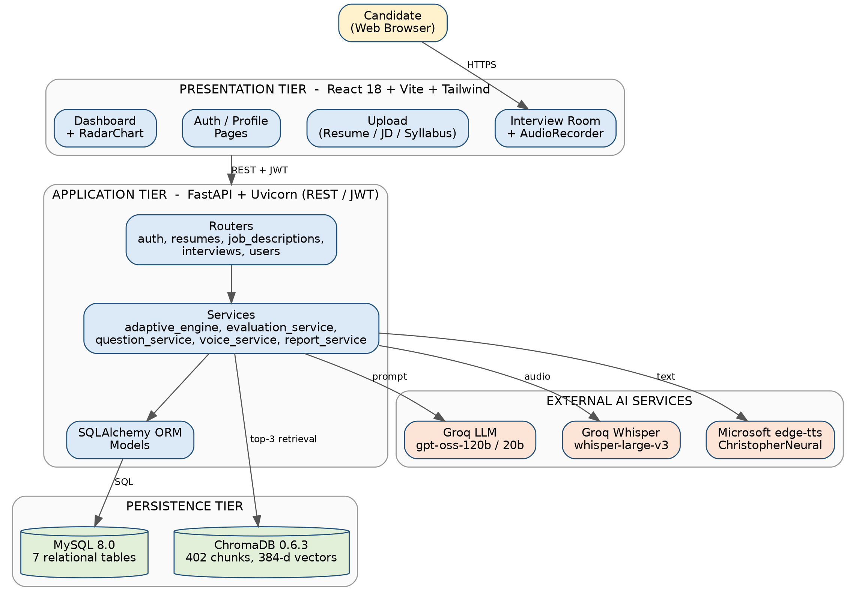
Figure 2.1 - Layered System Architecture and Context of SmartInterview

2.2 Product Functions

2.2.1 Candidates / Users
- User registration, authentication with JWT, and profile management.
- Resume upload (PDF) with automated section parsing and skill extraction.
- Job description upload (PDF) with Group A (Role Overlap) and Group B (Role Gap) mapping.
- Syllabus mode upload (PDF/DOCX/TXT) creating isolated temporary vector collections.
- Interactive technical mock interviews with real-time text and speech input options.
- Instant multi-signal performance scoring and cognitive depth progression.
- Performance dashboard, session history, and downloadable PDF report.

2.2.2 System / Adaptive RAG Engine
- Deterministic skill-gap calculation between candidate resumes and job descriptions.
- Domain-filtered semantic retrieval of the top-3 context chunks from 402 curated computer science topics.
- Bloom-levelled single-question generation powered by the Groq LLM (openai/gpt-oss-120b).
- Deterministic adaptive progression adjusting difficulty and cognitive depth after each response.
- In-memory neural text-to-speech question synthesis via Microsoft edge-tts.
- Speech-to-text audio transcription via the Groq Whisper API (whisper-large-v3).

2.3 Operating Environment
- Client Operating System: Windows 10/11, macOS, or a modern Linux distribution.
- Client Hardware: commodity desktop or laptop with at least 4 GB RAM and a working microphone.
- Client Web Browser: Google Chrome 90+, Microsoft Edge 90+, Mozilla Firefox 88+, or Safari 14+ with JavaScript enabled.
- Server Runtime: Python 3.10+ (FastAPI 0.115.0, Uvicorn 0.30.0, SQLAlchemy 2.0.35).
- Frontend Runtime: Node.js 18+ (React 18/19, Vite build tool, Tailwind CSS).
- Database Engines: MySQL Server 8.0+ (port 3306) and ChromaDB 0.6.3 (local embedded SQLite/HNSW store).
- External AI Cloud: Groq Cloud API (valid GROQ_API_KEY) and Microsoft edge-tts.

2.4 User Characteristics
The primary users are undergraduate engineering students, job seekers, and software engineering candidates preparing for campus placements and industry interviews. Users are assumed to be familiar with web browsers and file-upload workflows; no programming knowledge is required to operate the interview interface.

2.5 Design and Implementation Constraints
- An active internet connection is mandatory for cloud LLM generation (Groq API), speech transcription, and edge-tts synthesis.
- A valid GROQ_API_KEY must be configured in the project .env file.
- Document uploads (Resume, Job Description, Syllabus) are restricted to 5.0 MB per document.
- Stateful candidate sessions rely on signed JWT Bearer tokens in the HTTP Authorization header.
- The permanent RAG knowledge base is constrained to eight core domains (cn, dbms, design-patterns, dsa, ml-dl, oop, os, system-design).

2.6 Assumptions and Dependencies
- Candidate resumes, job descriptions, and syllabi are provided in English in supported formats (PDF, DOCX, TXT).
- The client browser grants microphone permission when voice answering mode is selected.
- The MySQL schema in backend/setup_database.sql has been initialized before the application starts.
- Third-party libraries: FastAPI, PyMuPDF, SentenceTransformers, ChromaDB, edge-tts, ReportLab, and the Groq SDK.

3. Specific Requirements

3.1 Functional Requirements
The functional requirements specify the behavioral responses and operations of SmartInterview across all candidate modules. Each requirement follows the template fields Requirement ID, Title, Description, and Priority (1 = Critical ... 4 = Informational).

3.1.1 Candidate Requirements (RI.01.01 - RI.01.06)
Requirement ID : RI.01.01
Title : Candidate Account Registration
Description : The system shall allow new candidates to register using email, full name, and password. The password shall be hashed using bcrypt (12 rounds) with 72-byte truncation protection before storage in the MySQL users table.
Priority : 1
Requirement ID : RI.01.02
Title : Authentication & JWT Issuance
Description : The system shall authenticate existing candidates against stored bcrypt hashes and issue an HS256-signed JSON Web Token (JWT) valid for 24 hours (1440 minutes) on successful credential verification.
Priority : 1
Requirement ID : RI.01.03
Title : Resume Ingestion & PDF Parsing
Description : The system shall accept resume uploads (PDF, <= 5 MB), validate file headers, parse text using PyMuPDF (fitz), and extract technical skills, projects, and education history.
Priority : 1
Requirement ID : RI.01.04
Title : Job Description Upload & Role Extraction
Description : The system shall parse target job descriptions (PDF <= 5 MB), extracting required qualifications, mandatory skills, and technical responsibilities to guide personalized interview staging.
Priority : 2
Requirement ID : RI.01.05
Title : Skill Overlap and Gap Mapping
Description : The system shall compute the set intersection and set difference between resume skills and job description skills, partitioning them into Group A (Role Overlap) and Group B (Role Gaps).
Priority : 2
Requirement ID : RI.01.06
Title : Syllabus Mode Ingestion & Vector Staging
Description : The system shall accept course syllabi (PDF, DOCX, TXT <= 5 MB), generate 384-dimensional embeddings with SentenceTransformers all-MiniLM-L6-v2, and stage an isolated temporary ChromaDB collection temp_syllabus_<id>.
Priority : 3

3.1.2 System / Adaptive RAG Engine Requirements (RI.01.07 - RI.01.13)
Requirement ID : RI.01.07
Title : RAG-Grounded Bloom-Adaptive Question Generation
Description : The system shall retrieve the top-3 relevant context chunks from ChromaDB for the target skill, assemble a prompt incorporating Bloom's Taxonomy cognitive verbs, and invoke the Groq LLM (openai/gpt-oss-120b) to generate exactly one contextual technical question.
Priority : 1
Requirement ID : RI.01.08
Title : Multi-Signal 5-Factor Answer Evaluation
Description : The system shall evaluate answers on five dimensions: Technical Correctness (30%), Completeness (20%), Relevance (20%), Semantic Similarity via SentenceTransformers (15%), and Concept Coverage (15%), producing an overall score on a 0-100 scale.
Priority : 1
Requirement ID : RI.01.09
Title : Deterministic Adaptive State Progression
Description : The system shall deterministically adjust Bloom level and difficulty: score >= 80% advances the Bloom level (+1) and scales difficulty; 50% <= score < 80% maintains the level; score < 50% regresses the level (-1).
Priority : 1
Requirement ID : RI.01.10
Title : Neural Text-to-Speech Question Streaming
Description : The system shall synthesize the question with Microsoft edge-tts (en-US-ChristopherNeural) and stream audio/mpeg in-memory to the client without creating temporary disk files.
Priority : 3
Requirement ID : RI.01.11
Title : Whisper Speech-to-Text Transcription
Description : The system shall accept recorded microphone audio (WebM or WAV), dispatch it to Groq Whisper (whisper-large-v3), and return verbatim transcribed text for automated evaluation.
Priority : 3
Requirement ID : RI.01.12
Title : Downloadable PDF Interview Report
Description : The system shall generate a server-side PDF report with ReportLab on session completion, containing candidate details, score breakdown, a radar chart of Bloom levels, and question-by-question analysis.
Priority : 2
Requirement ID : RI.01.13
Title : Performance Analytics Dashboard
Description : The system shall aggregate historical session data across all completed interviews, visualizing skill proficiency across computer science domains and cognitive depth distributions.
Priority : 2

3.2 Non-Functional Requirements

3.2.1 Performance Requirements
- Semantic Search Latency: local ChromaDB top-3 context retrieval shall complete in <= 100 ms on CPU.
- Generation Latency: Groq Cloud LLM question formulation and critique generation shall complete in <= 2.5 seconds.
- TTS Streaming Latency: neural voice streaming via edge-tts shall commence playback in <= 1.2 seconds.
- Database Operations: relational session commits and state persistence in MySQL shall execute in <= 50 ms.

3.2.2 Safety Requirements
The software is an instructional web application and shall not cause physical harm or hardware damage. In-memory temporary audio buffers are discarded immediately after transcription so that no audio is written to disk.

3.2.3 Security Requirements
- Authentication: access is guarded by HS256-signed JWTs with a 24-hour expiry.
- Password Storage: passwords are hashed with bcrypt using a work factor of 12 rounds.
- File Upload Sanitization: uploaded resumes and job descriptions undergo MIME/header validation and size verification (<= 5 MB).
- Environment Secrets: third-party API keys (GROQ_API_KEY, SECRET_KEY) are kept out of the codebase in .env configuration.

3.2.4 Error Handling
- Network Disruption: if the Groq Cloud LLM is unreachable, the system retries automatically and falls back to openai/gpt-oss-20b before returning a structured error to the client.
- Microphone Faults: if microphone permission is denied or capture fails, the UI falls back to text input without invalidating the session.
- Invalid Uploads: unsupported file types or files above 5 MB are rejected with an HTTP 400 response and a clear message.

3.3 External Interface Requirements
Interface | Specification
User Interface | Responsive React single-page application with Login/Register, Upload (Resume, JD, Syllabus), Interview Room (question text, audio playback, microphone and text answer controls), Results/Feedback, and Dashboard (radar chart, history, PDF download) screens.
Hardware Interface | Client microphone for voice answers and speakers/headphones for spoken questions. No special server hardware is needed; the embedding model runs on CPU.
Software Interface | MySQL 8.0 (SQLAlchemy ORM), ChromaDB 0.6.3 (vector store), SentenceTransformers all-MiniLM-L6-v2, PyMuPDF (PDF parsing), ReportLab (report generation).
Communication Interface | HTTPS REST with JSON payloads; JWT Bearer token in the Authorization header; multipart/form-data for uploads; audio/mpeg streaming for TTS; WebM/WAV audio upload for STT; outbound HTTPS to the Groq Cloud API and the edge-tts service.

3.4 Requirements Traceability Matrix
The matrix links each functional requirement to the use case that realizes it, the main software component, and the verifying test case (see Section 6).
Req. ID | Use Case | Primary Component | Test Case | Status
RI.01.01 | UC-01 | Auth Router, Security (bcrypt) | TC-01 | Passed
RI.01.02 | UC-01 | Auth Router, JWT middleware | TC-07 | Planned
RI.01.03 | UC-02 | Resume Router, PyMuPDF | TC-02 | Passed
RI.01.04 | UC-03 | Job Description Router | TC-08 | Planned
RI.01.05 | UC-04 | Skill gap computation | TC-09 | Planned
RI.01.06 | UC-05 | Syllabus ingestion, ChromaDB | TC-10 | Planned
RI.01.07 | UC-07 | Question Service, ChromaDB, Groq | TC-03 | Passed
RI.01.08 | UC-07, UC-10 | Evaluation Service, SBERT | TC-11 | Planned
RI.01.09 | UC-07 | Adaptive Engine | TC-04, TC-05 | Passed
RI.01.10 | UC-09 | Voice Service (edge-tts) | TC-06 | Passed
RI.01.11 | UC-08 | Voice Service (Whisper) | TC-12 | Planned
RI.01.12 | UC-12 | Report Service (ReportLab) | TC-13 | Planned
RI.01.13 | UC-11 | Dashboard, Analytics | TC-14 | Planned

Software Development Life Cycle (SDLC)
The Software Development Life Cycle (SDLC) is a structured process used by engineering teams to design, develop, test, and maintain high-quality software. It aims to produce software that meets customer expectations, satisfies formal requirements, and is completed within time and resource constraints. ISO/IEC 12207 is the international standard governing software life-cycle processes.
The following figure is a graphical representation of the various stages of a typical SDLC.
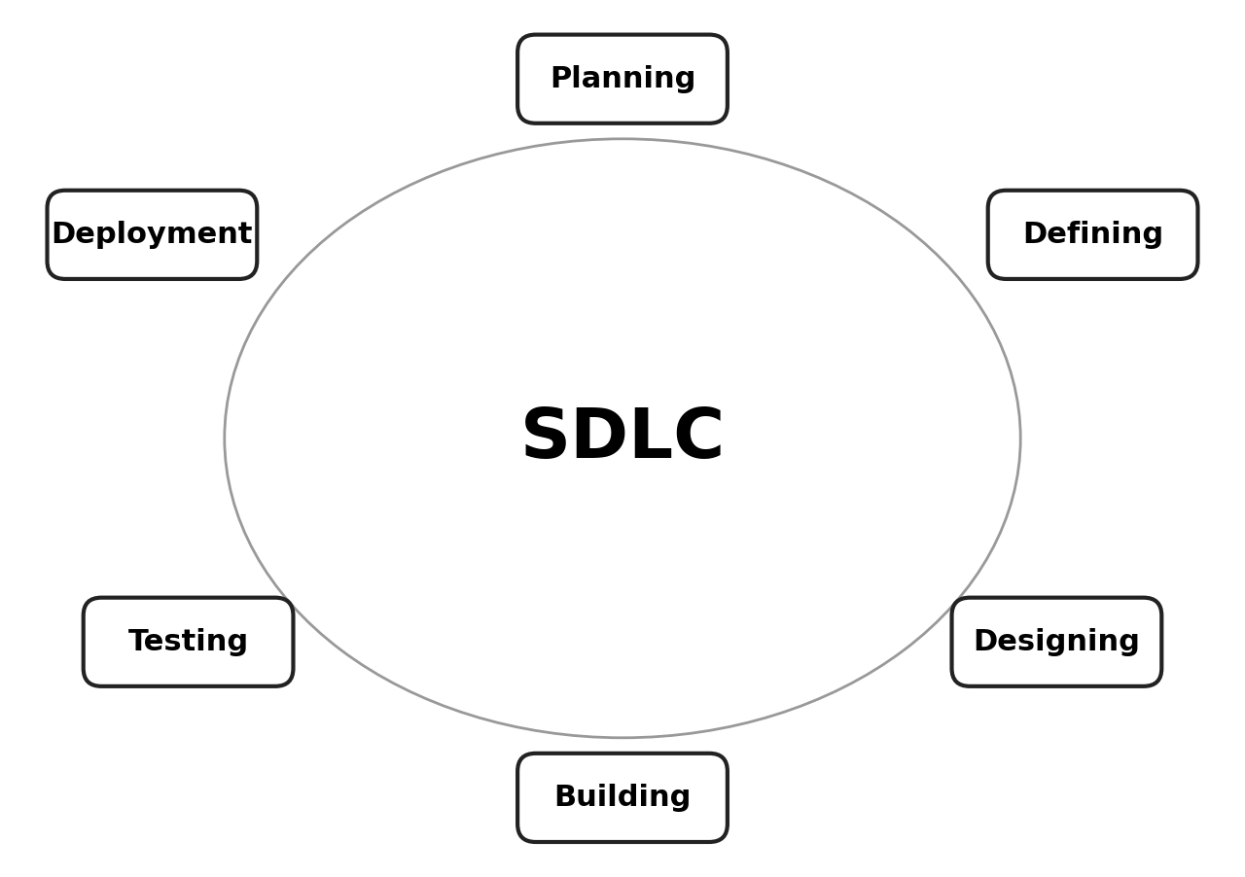
Figure - Stages of the Software Development Life Cycle

Stages of SDLC

Stage 1: Planning and Requirement Analysis
Requirements were gathered by analyzing candidate interview bottlenecks, academic syllabus standards, and technical job descriptions. Feasibility studies confirmed that open-weight embeddings (SentenceTransformers) combined with Groq cloud inference satisfy low-latency and zero-cost local retrieval constraints.

Stage 2: Defining Requirements
Requirements are documented in this SRS. All functional capabilities (RI.01.01 through RI.01.13), non-functional constraints, and performance benchmarks are reviewed by faculty mentors and academic evaluators.

Stage 3: Designing the Product Architecture
Several architectural approaches were evaluated. A three-tier decoupled client-server architecture was selected, using FastAPI for asynchronous services, ChromaDB for local vector embeddings, MySQL for ACID persistence, and React for the single-page application (Section 4).

Stage 4: Building the Product
The backend was developed in Python 3.10+ with FastAPI and SQLAlchemy; the frontend in React 18 with Vite. Modular services manage authentication, RAG retrieval, LLM prompt formatting, adaptive Bloom progression, and TTS/STT processing.

Stage 5: Testing the Product
Defects are tracked, fixed, and retested against SRS specifications. Unit tests cover JWT authorization, integration tests cover ChromaDB retrieval and Groq LLM pipelines, and end-to-end acceptance tests cover the mock interview workflow (Section 6).

Stage 6: Deployment and Maintenance
The application is served by Uvicorn ASGI behind an Nginx reverse proxy with MySQL schema scripts, and monitored through logs for API latency and token consumption.

SDLC Models & Methodology Selection
- Waterfall: linear-sequential phases with rigid sign-offs.
- Iterative: incremental development through repeated cycles of small feature sets.
- Spiral: risk-driven model combining iteration with systematic risk assessment.
- V-Model: parallel development and corresponding testing phases.
- Big Bang: minimal planning; suitable only for very small exercises.
- Agile: sprint-based framework emphasizing continuous integration, modular delivery, and adaptability.
Selected methodology: SmartInterview followed the Agile / Iterative methodology over a 14-week incremental plan (Week 1 Problem Statement through Week 14 Final Deployment). The SRS was baselined in Week 10 (see Revision History). Weekly sprint deliverables enabled rapid mentor feedback, modular integration of the RAG pipeline, and continuous validation of the adaptive learning rules.

Literature Survey
The literature survey examines published research and benchmarks relevant to the project and establishes the research gap that SmartInterview addresses.
1. AI Mock Interview: An Intelligent Voice-Driven Interview Simulation System using Gemini AI and Whisper (Wahid et al., IJERT 2026 - Base Paper 1)
Wahid et al. built a voice-driven interview simulator with Google Gemini and Whisper in Streamlit, showing that speech-to-text and automated feedback can reduce student interview anxiety. SmartInterview takes this voice-interactive paradigm as its baseline and extends it with curricular RAG grounding in ChromaDB, Bloom's cognitive escalation, and a dual-model fallback to limit hallucination.
2. Development of an Autonomous AI Interview Engine Using Sentence-BERT and LLMs (Nagarajan et al., IJMRR 2026 - Base Paper 2)
Nagarajan et al. showed that Sentence-BERT embeddings match resumes and job descriptions better than keyword-based ATS filters and paired this with an LLM conversational pipeline. SmartInterview adopts S-BERT (all-MiniLM-L6-v2) for resume-JD alignment and extends it to RAG chunk retrieval and semantic answer-similarity scoring.
3. Sentence-BERT: Sentence Embeddings using Siamese BERT-Networks (Reimers & Gurevych, 2019)
SBERT modifies pre-trained BERT with siamese and triplet structures to produce sentence embeddings comparable by cosine similarity. SmartInterview uses the 384-dimensional all-MiniLM-L6-v2 model locally for fast semantic similarity between candidate answers and retrieved knowledge chunks.
4. Retrieval-Augmented Generation for Knowledge-Intensive NLP Tasks (Lewis et al., 2020)
Lewis et al. combined parametric memory (pre-trained language models) with non-parametric memory (dense vector retrieval), reducing factual hallucination. SmartInterview grounds Groq LLM question generation in a ChromaDB store of 402 computer science topics across 8 domains.
5. A Taxonomy for Learning, Teaching, and Assessing: A Revision of Bloom's Taxonomy (Anderson & Krathwohl, 2001)
The revised taxonomy defines six cognitive tiers: Remember, Understand, Apply, Analyze, Evaluate, Create. SmartInterview encodes these tiers as a deterministic state machine so that questions assess cognitive depth rather than syntax recall.
6. Robust Speech Recognition via Large-Scale Weak Supervision (Radford et al., 2023 - Whisper)
Whisper delivers strong zero-shot transcription across accents, noise, and technical jargon. SmartInterview uses Groq-hosted whisper-large-v3 for real-time answer transcription without local GPU requirements.
7. Language Processing Unit (LPU) Architecture (Groq Inc., 2024)
Groq's deterministic LPU architecture provides fast, predictable-latency token generation. SmartInterview uses Groq inference to keep question generation and answer critique within the interactive latency budget.
8. Attention Is All You Need (Vaswani et al., 2017)
Introduced the transformer architecture built on self-attention, the foundation of modern LLMs. SmartInterview uses instruction-tuned transformers for structured evaluation scoring and personalized feedback.
9. IEEE Std 830-1998: Recommended Practice for Software Requirements Specifications
Defines the structure and quality attributes of a good SRS (correct, unambiguous, complete, consistent, verifiable, traceable). This document follows that guidance, including the traceability matrix in Section 3.4.

Research Gap
Existing systems provide either voice simulation without curricular grounding, or semantic resume matching without adaptive interviewing. None combines (i) RAG-grounded questions from a curated knowledge base, (ii) Bloom-based deterministic difficulty adaptation, (iii) a transparent five-signal scoring rubric, and (iv) in-memory neural voice interaction. SmartInterview integrates all four.

4. System Designing & UML Diagrams
System design defines the architecture, modules, components, interfaces, and data schemas needed to satisfy the specified requirements. It provides the detail required to implement the system consistently with the architectural models.

Overview of UML & Conceptual Model
The Unified Modeling Language (UML) is an industry-standard visual language used to visualize, specify, construct, and document software systems. It is a graphical notation, not a programming language, and portrays both structural and behavioral aspects of complex systems. UML was adopted by the Object Management Group (OMG) in 1997 and published as ISO/IEC 19501.
- Class: blueprint defining attributes and operations of an entity.
- Object: concrete runtime instance of a class.
- Inheritance: child classes derive properties and methods from parent classes.
- Abstraction: hiding implementation detail behind clean interfaces.
- Encapsulation: binding data and operations together and protecting internal state.
- Polymorphism: different behaviors presented through a common interface.

Structural vs. Behavioral Diagrams
Category | Diagrams in this SRS | Purpose
Structural | Class (4.4), Package (4.7), Component (4.8), Deployment (4.9), ERD (4.10) | Static architecture, data schema, and physical layout
Behavioral | Use Case (4.1), Sequence (4.2), Collaboration (4.3), Statechart (4.5), Activity (4.6), DFD (4.11) | Runtime interactions, state changes, control and data flow

4.1 Use Case Diagram & Template
The Use Case Diagram depicts the interactions between the system actors - the Candidate (primary actor) and the external AI services, Groq Cloud API (LLM and Whisper) and Microsoft edge-tts (secondary actors) - and the core functional use cases.
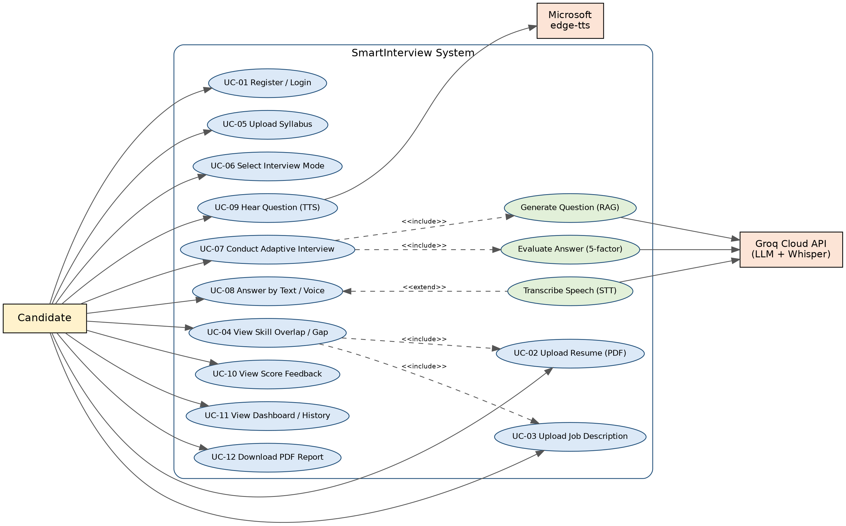
Figure 4.1 - Use Case Diagram for the SmartInterview Platform
Diagram notes:
- UC-07 includes question generation (RAG) and answer evaluation; UC-08 is extended by speech transcription when the candidate chooses voice input; UC-04 includes the resume and job description uploads (UC-02, UC-03).

Use Case Template
Field | Description
Use Case ID: | UC-07
Use Case Name: | Conduct Adaptive Technical Mock Interview
End Objective: | Conduct a personalized, RAG-grounded technical interview that dynamically scales question difficulty based on Bloom's Taxonomy.
Created by: | Team G-1392 (24BD1A665K, 24BD1A665R, 24BD1A665X, 25BD5A6615, 25BD5A6620)
On (date): | September 2026
User / Actor: | Candidate (primary); Groq Cloud API (LLM, Whisper) and edge-tts (external)
Precondition: | Candidate is logged in (valid JWT); for Job-Specific mode a resume and job description are uploaded.
Trigger: | Candidate selects interview configuration and clicks "Start Interview".
Postcondition: | Session status is completed; answers, evaluations, and recommendations are stored; report is available.

Basic / Normal Flow
User Actions | System Actions
1. Candidate selects mode and question count and clicks "Start Interview". | 1. System verifies prerequisites, creates an InterviewSession in MySQL, and initializes AdaptiveState.
2. Candidate receives the question on screen (and optionally as audio). | 2. System embeds the target skill, retrieves the top-3 chunks from ChromaDB, calls the Groq LLM, and streams the question.
3. Candidate records a spoken answer or types a response. | 3. System captures audio or text and invokes Whisper STT when voice is used.
4. Candidate reviews the answer and clicks "Submit Answer". | 4. System computes the 5-factor score (SBERT similarity, concept coverage, LLM critique) and stores it in MySQL.
5. Candidate views feedback and receives the next question at the adapted level. | 5. Adaptive engine updates the Bloom level (+1 if >= 80%, -1 if < 50%) and generates the next question.
6. Candidate completes all questions and views the summary. | 6. System computes the final weighted score, generates AI recommendations, and renders the dashboard.

Exception Flows
Exception Flow | System Response
Candidate starts a Job-Specific interview without a resume or job description. | System blocks the launch and shows a validation error prompting the upload.
Groq LLM is unreachable. | System retries and falls back to openai/gpt-oss-20b; if still failing, returns a structured error.
Microphone permission denied. | UI falls back to text input; the session continues.

Use Case Template - UC-04
Field | Description
Use Case ID / Name: | UC-04 View Skill Overlap and Gap
End Objective: | Show the candidate which resume skills match the target role (Group A) and which required skills are missing (Group B).
Actor / Trigger: | Candidate; clicks "Analyze" after uploading a resume (UC-02) and a job description (UC-03).
Normal Flow: | 1. System parses both PDFs with PyMuPDF. 2. Extracts skill sets. 3. Computes intersection (Group A) and difference (Group B). 4. Displays both groups and uses Group B to prioritize interview skills.
Exception Flow: | Non-PDF or oversized file (> 5 MB): upload rejected with HTTP 400 and message.

4.2 Sequence Diagrams
Sequence diagrams show object interactions arranged in time order. Three key scenarios are modelled: authentication, session staging with RAG question retrieval, and answer submission with scoring and adaptation.

4.2a Candidate Authentication and Token Issuance
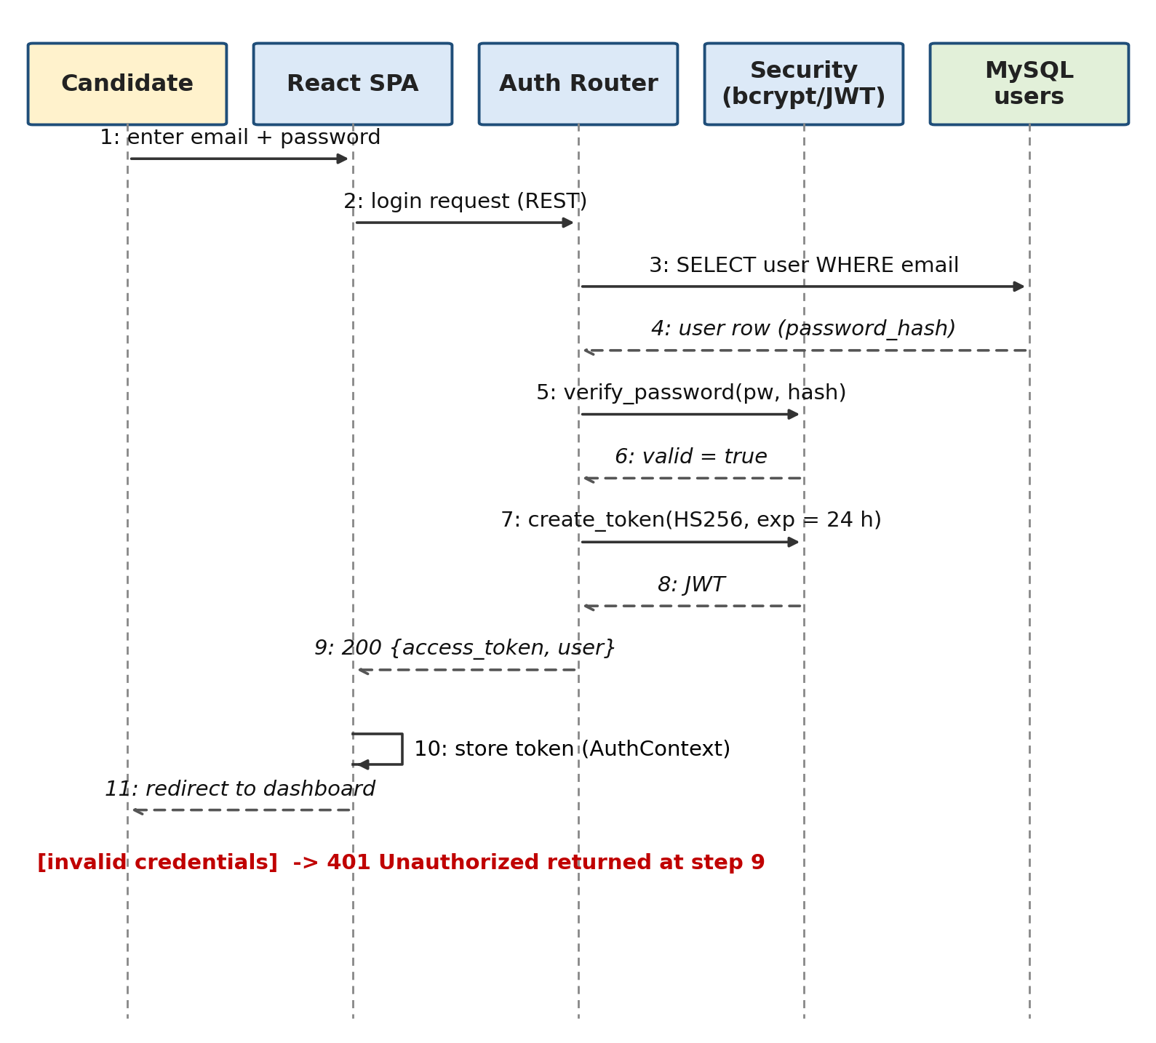
Figure 4.2a - Sequence Diagram: Candidate Authentication and Token Issuance
Diagram notes:
- Password is verified against the stored bcrypt hash; on success an HS256 JWT valid for 24 hours is returned and kept in AuthContext.

4.2b Interview Session Staging and RAG Question Retrieval
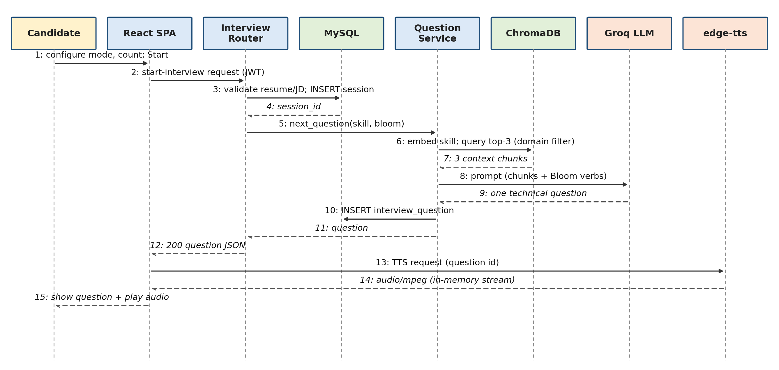
Figure 4.2b - Sequence Diagram: Interview Session Staging and RAG Question Retrieval
Diagram notes:
- The Question Service embeds the target skill, filters by domain in ChromaDB, and passes the top-3 chunks plus Bloom verbs to the LLM; the TTS stream is requested separately and kept in memory.

4.2c Answer Submission, Multi-Factor Scoring, and Bloom Adaptation
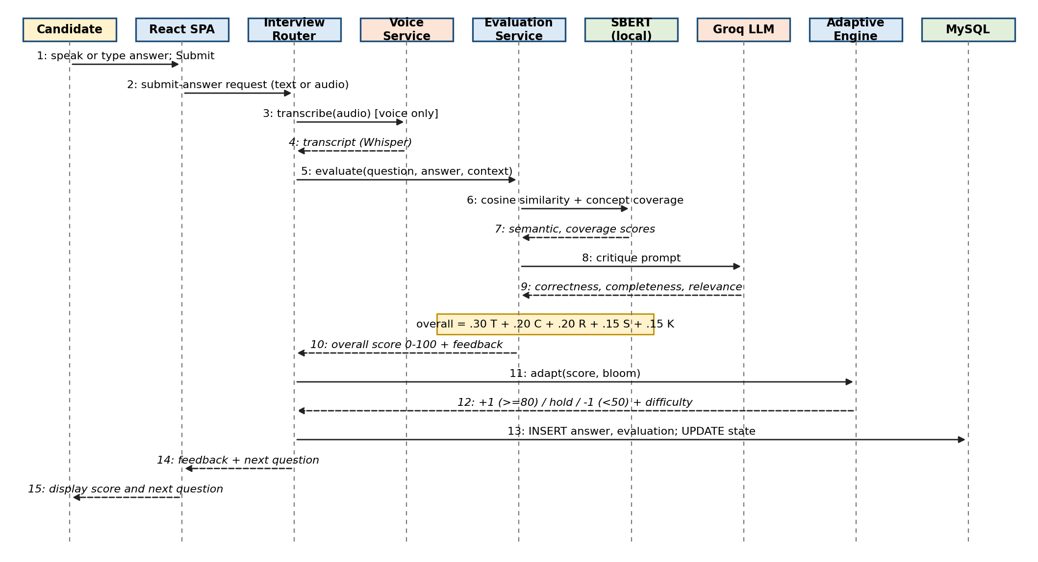
Figure 4.2c - Sequence Diagram: Answer Submission, Multi-Factor Scoring, and Bloom Adaptation
Diagram notes:
- Overall score = 0.30 Technical + 0.20 Completeness + 0.20 Relevance + 0.15 Semantic similarity + 0.15 Concept coverage. The Adaptive Engine maps the score to +1 / hold / -1.

4.3 Collaboration Diagram
The Collaboration (Communication) Diagram emphasizes the structural organization of objects and the numbered messages they exchange during one interview turn.
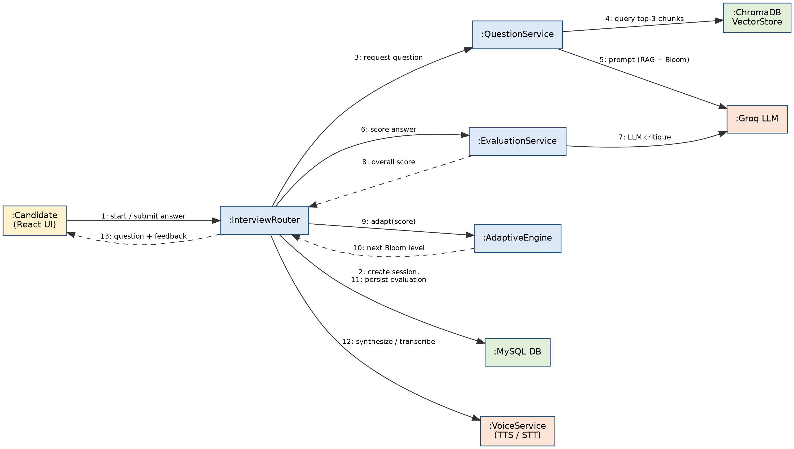
Figure 4.3 - Collaboration Diagram: Object-to-Object Message Flow in SmartInterview
Diagram notes:
- Numbers 1-13 give the message order. The Interview Router is the only coordinator: Question, Evaluation, Adaptive, and Voice services are invoked by the router and do not call one another directly.

4.4 Class Diagram
The Class Diagram shows the static structure: persistent SQLAlchemy entities, their key attributes and operations, and the relationships among them.
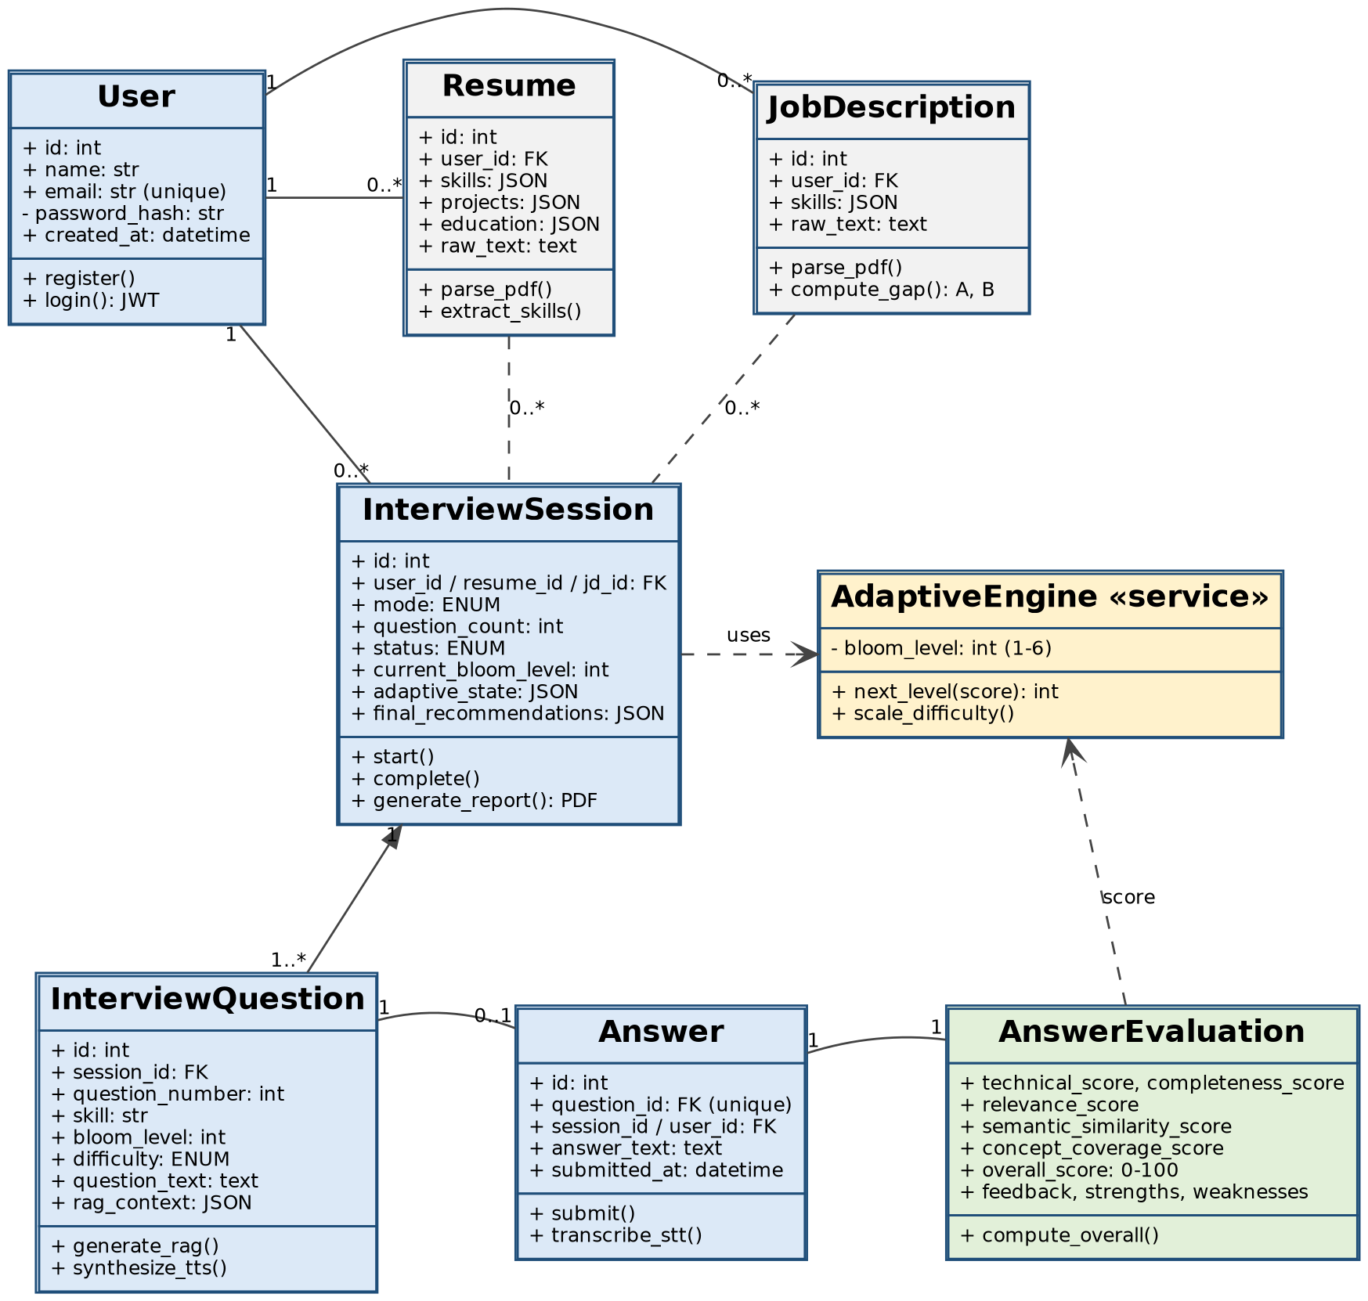
Figure 4.4 - Class Diagram: Relational Model Entities and Service Interfaces
Diagram notes:
- A User owns many Resumes, JobDescriptions, and InterviewSessions; a Session is composed of 1..* InterviewQuestions; each Question has at most one Answer, which has exactly one AnswerEvaluation. AdaptiveEngine is a stateless service used by the Session.

4.5 Statechart Diagram
The Statechart models the event-driven lifecycle of the Adaptive Learning Engine across Bloom's six cognitive tiers.
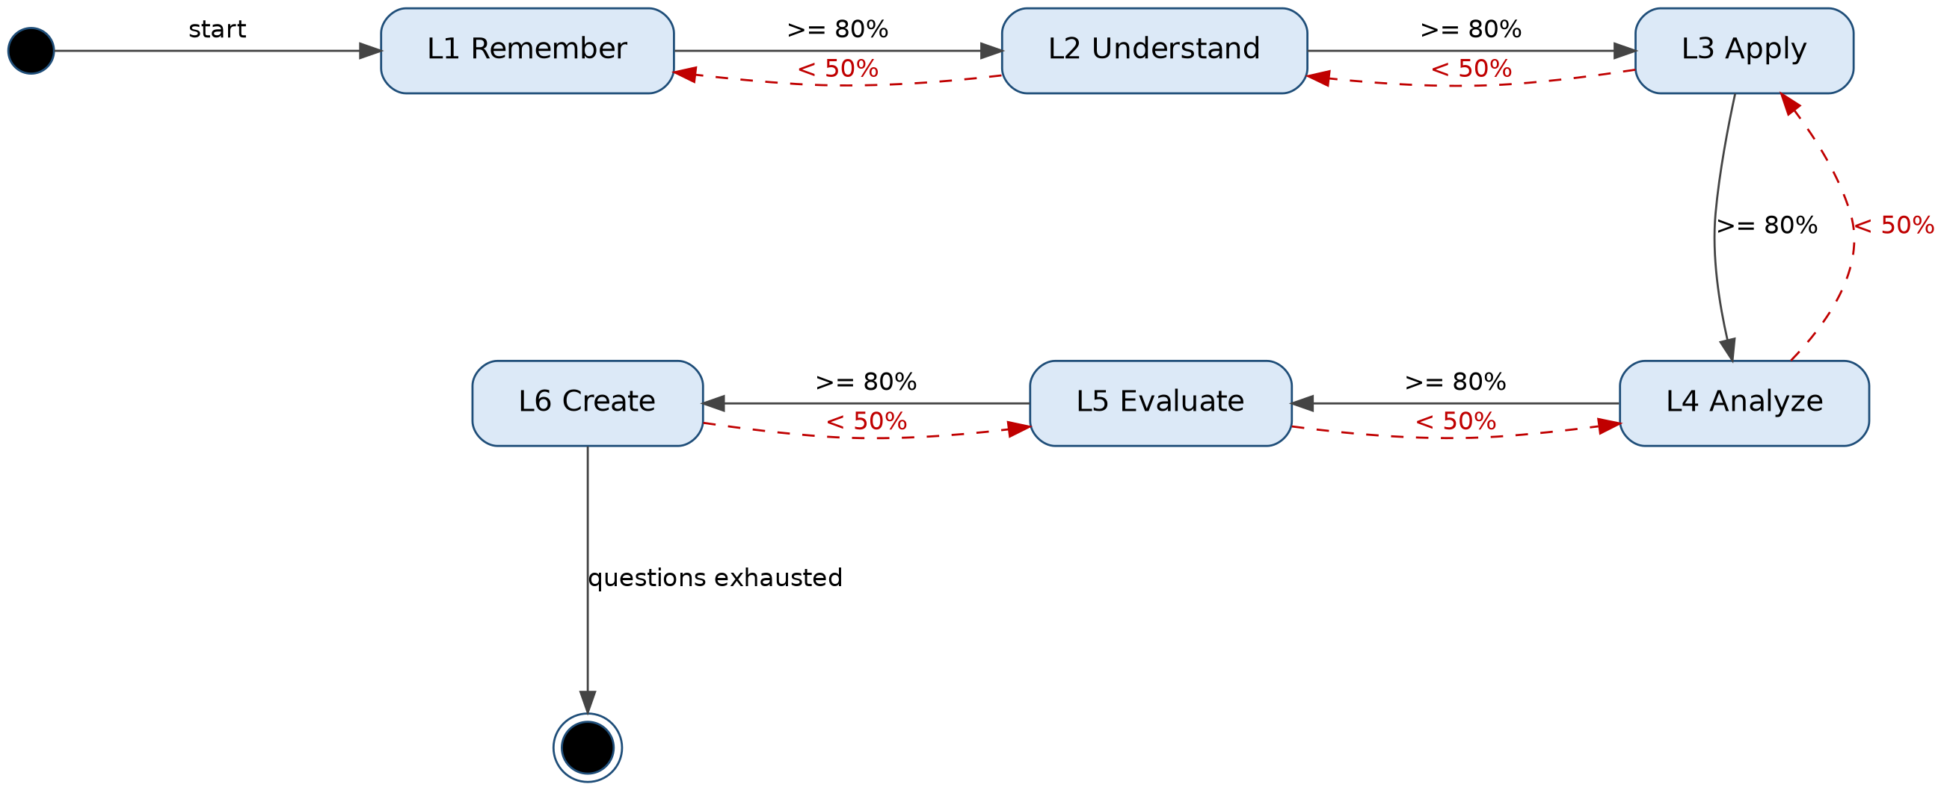
Figure 4.5 - Statechart Diagram: Bloom's Taxonomy Cognitive State Transitions
Diagram notes:
- Score >= 80% moves one tier up; score < 50% moves one tier down (dashed red); 50-79% keeps the current tier (self-transition, omitted for clarity). Level 1 cannot regress and Level 6 cannot advance.

4.6 Activity Diagram
The Activity Diagram shows the control flow of the complete candidate journey. Part A covers login, mode selection, document ingestion, and session creation; Part B covers the question-answer-adapt loop and report generation.
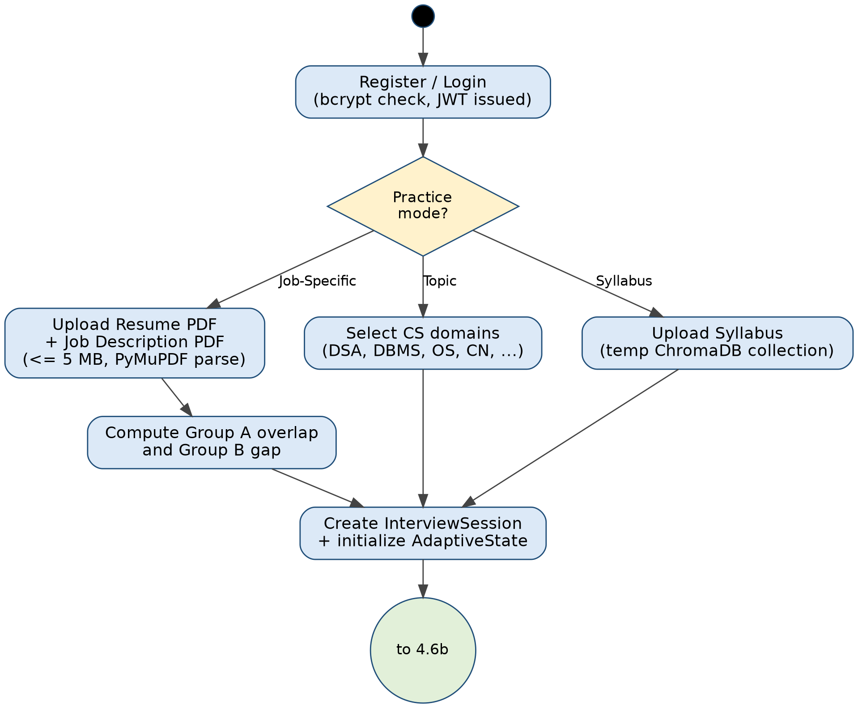
Figure 4.6a - Activity Diagram (Part A): Login, Mode Selection, and Session Setup
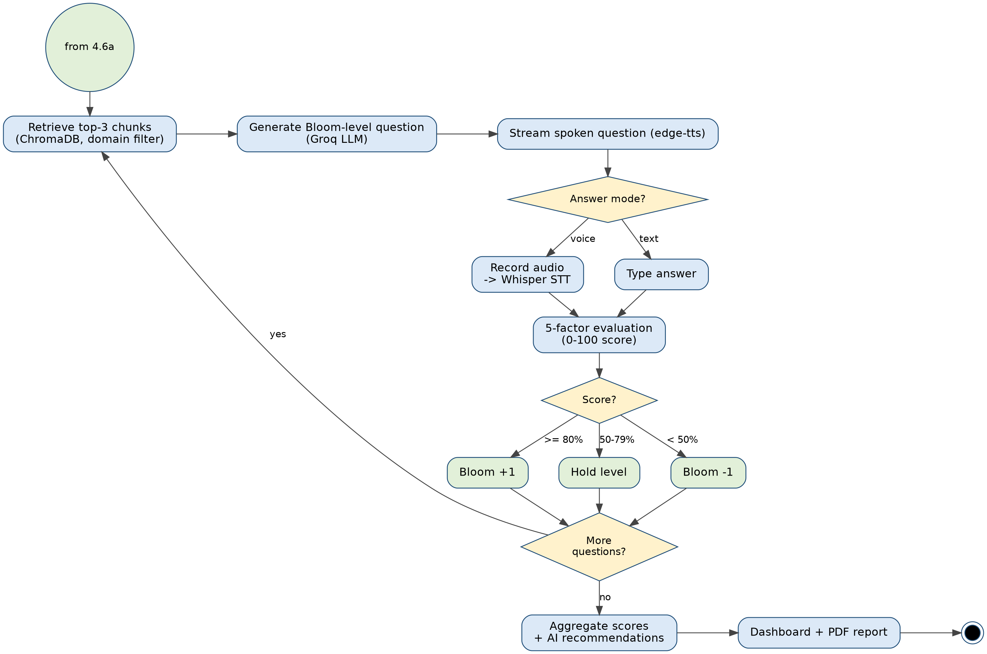
Figure 4.6b - Activity Diagram (Part B): Interview Loop, Adaptation, and Report Generation

4.7 Package Diagram
The Package Diagram organizes the modular subsystems into Presentation, Application, Data, and External Service packages.
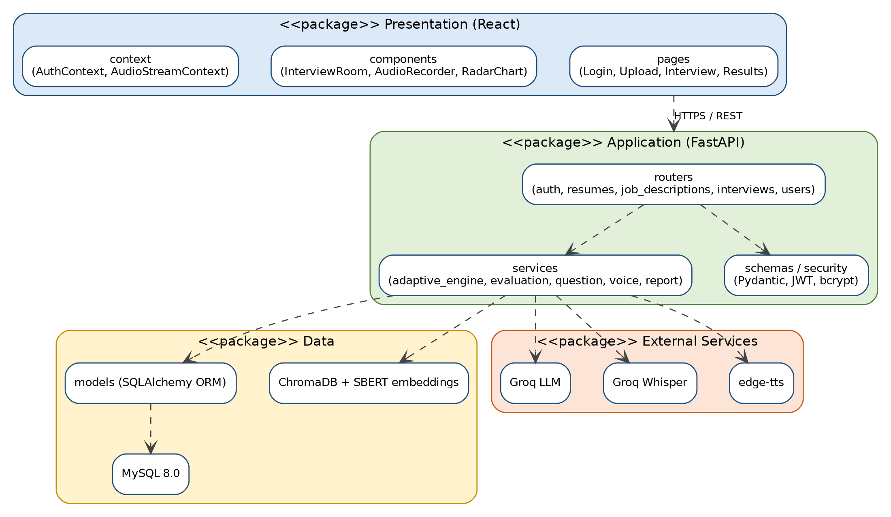
Figure 4.7 - Package Diagram: Layered Subsystem Architecture
Diagram notes:
- Dependencies point downward: the presentation package depends only on the REST API of the application package; only the application package accesses data and external services.

4.8 Component Diagram
The Component Diagram illustrates the software components that make up the FastAPI application and their provided and required interfaces.
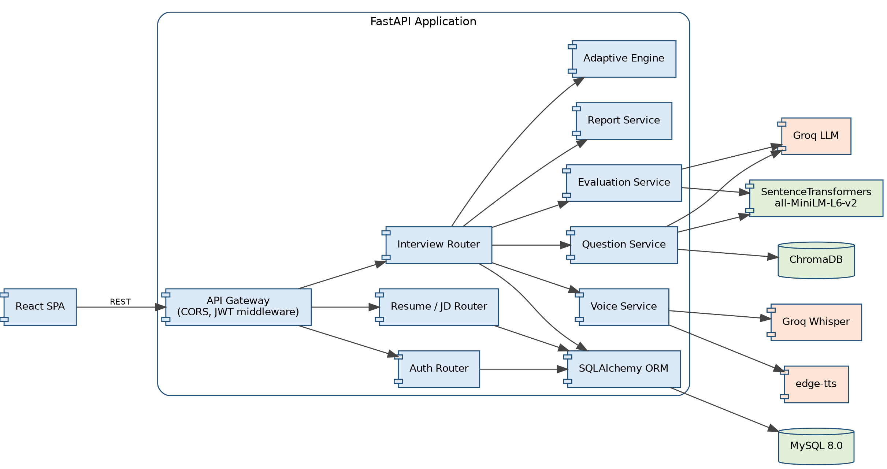
Figure 4.8 - Component Diagram: Internal Service Wiring and External Interfaces
Diagram notes:
- The Interview Router is the only component that coordinates Adaptive, Evaluation, Question, Voice, and Report services; all persistence goes through the SQLAlchemy ORM.

4.9 Deployment Diagram
The Deployment Diagram depicts the physical execution architecture: the client device, the application host, and the external cloud services.
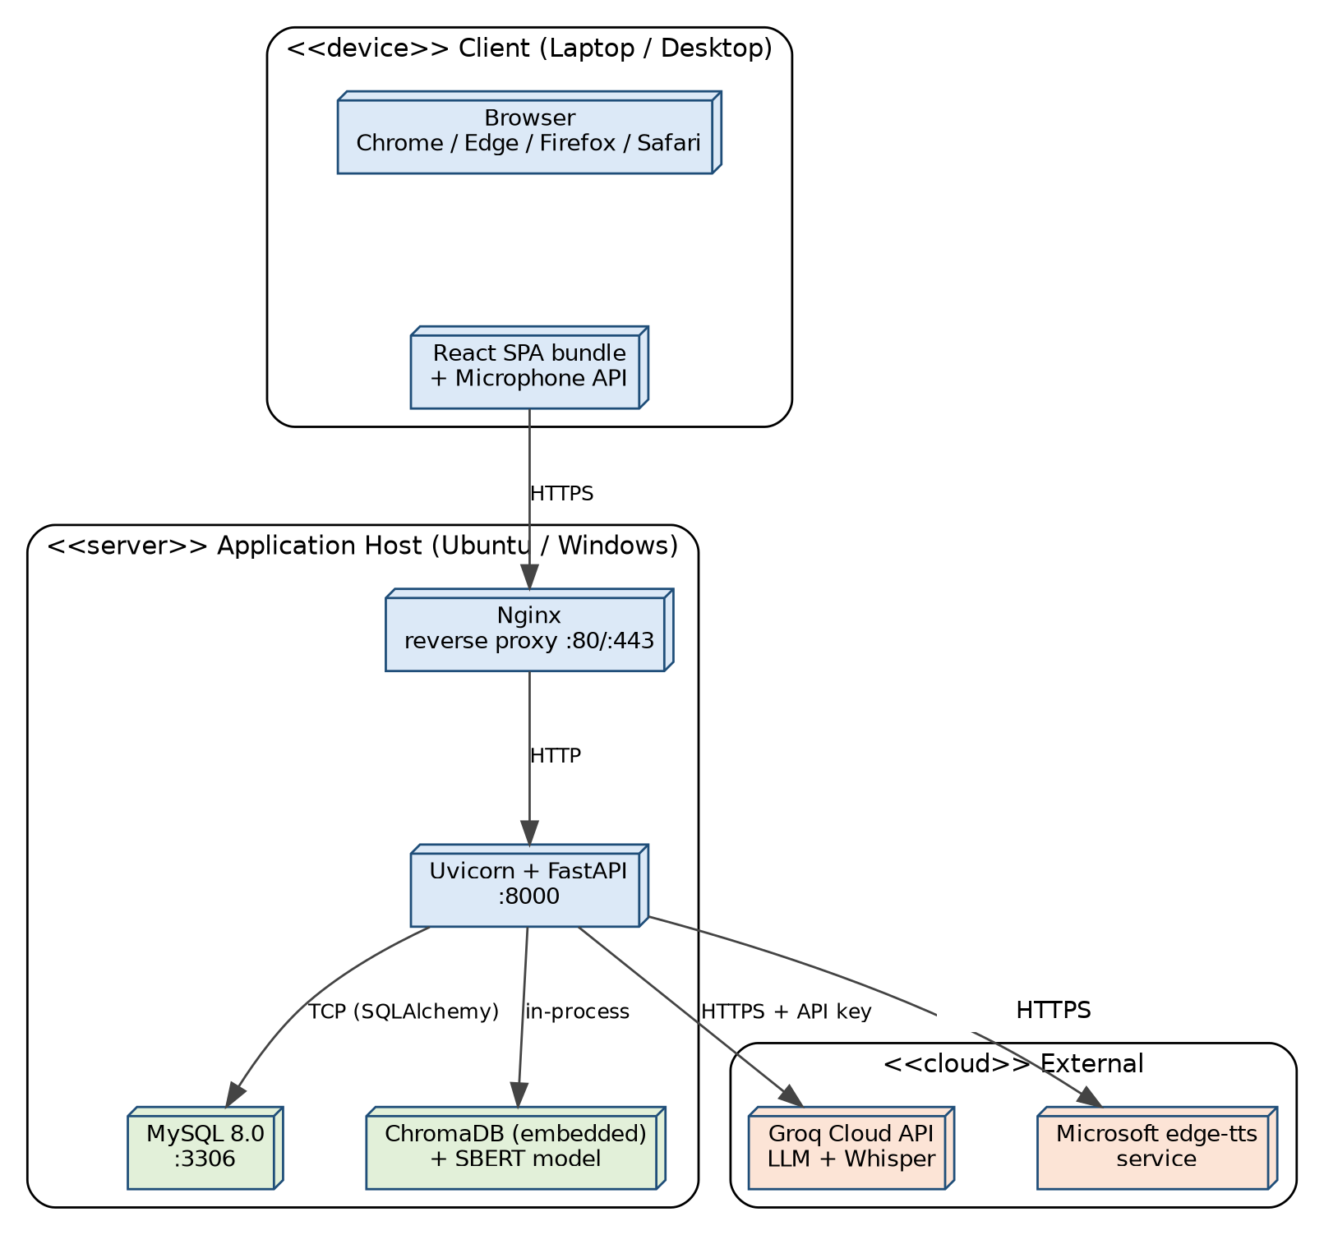
Figure 4.9 - Deployment Diagram: Physical Hardware Nodes and Network Topology
Diagram notes:
- Nginx terminates HTTPS and proxies to Uvicorn on port 8000; MySQL listens on 3306; ChromaDB and the SBERT model run in-process with the API server.

4.10 Entity Relationship Diagram (ERD)
The ERD defines the relational schema implemented in MySQL 8.0, comprising 7 interconnected tables. Deleting a user cascades to all owned records.
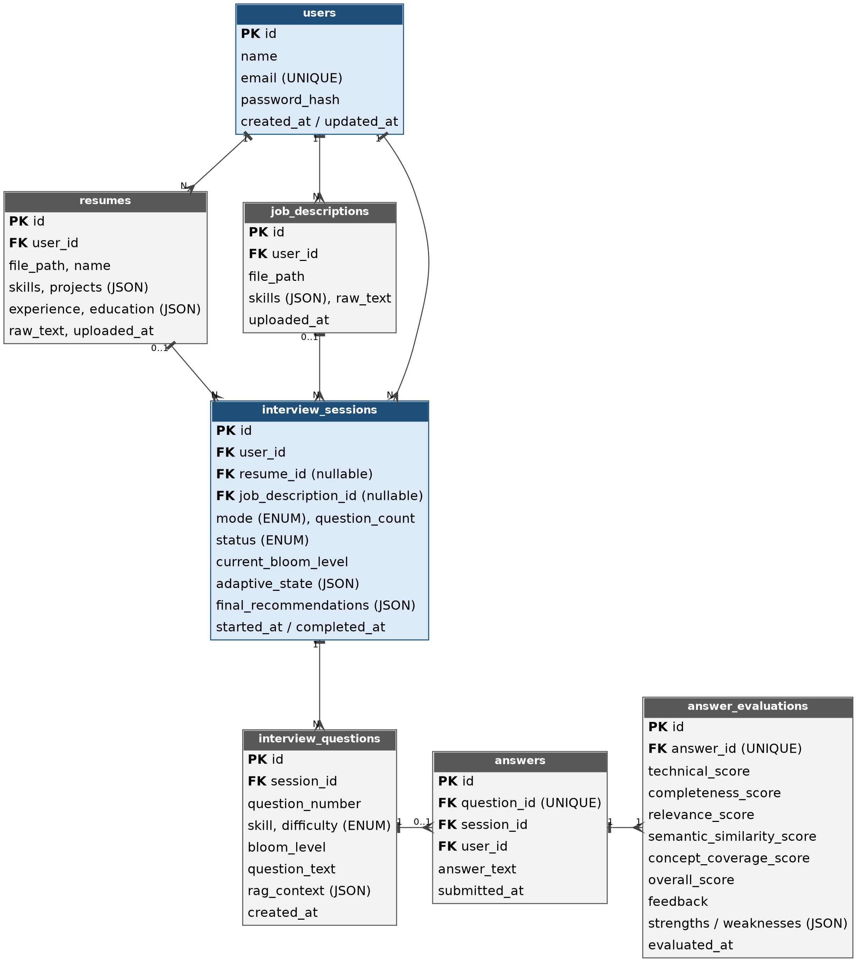
Figure 4.10 - Entity-Relationship Diagram (MySQL 8.0, 7 Relational Tables)

4.11 Data Flow Diagrams (Level 0 and Level 1)
Data Flow Diagrams model the movement, transformation, and storage of data across process boundaries.

Level 0 - Context Diagram
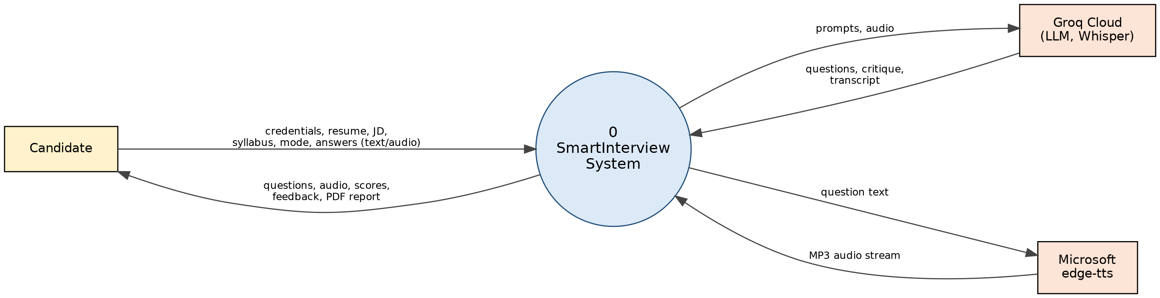
Figure 4.11a - Context-Level Data Flow Diagram (Level 0)

Level 1 - Decomposed Diagram
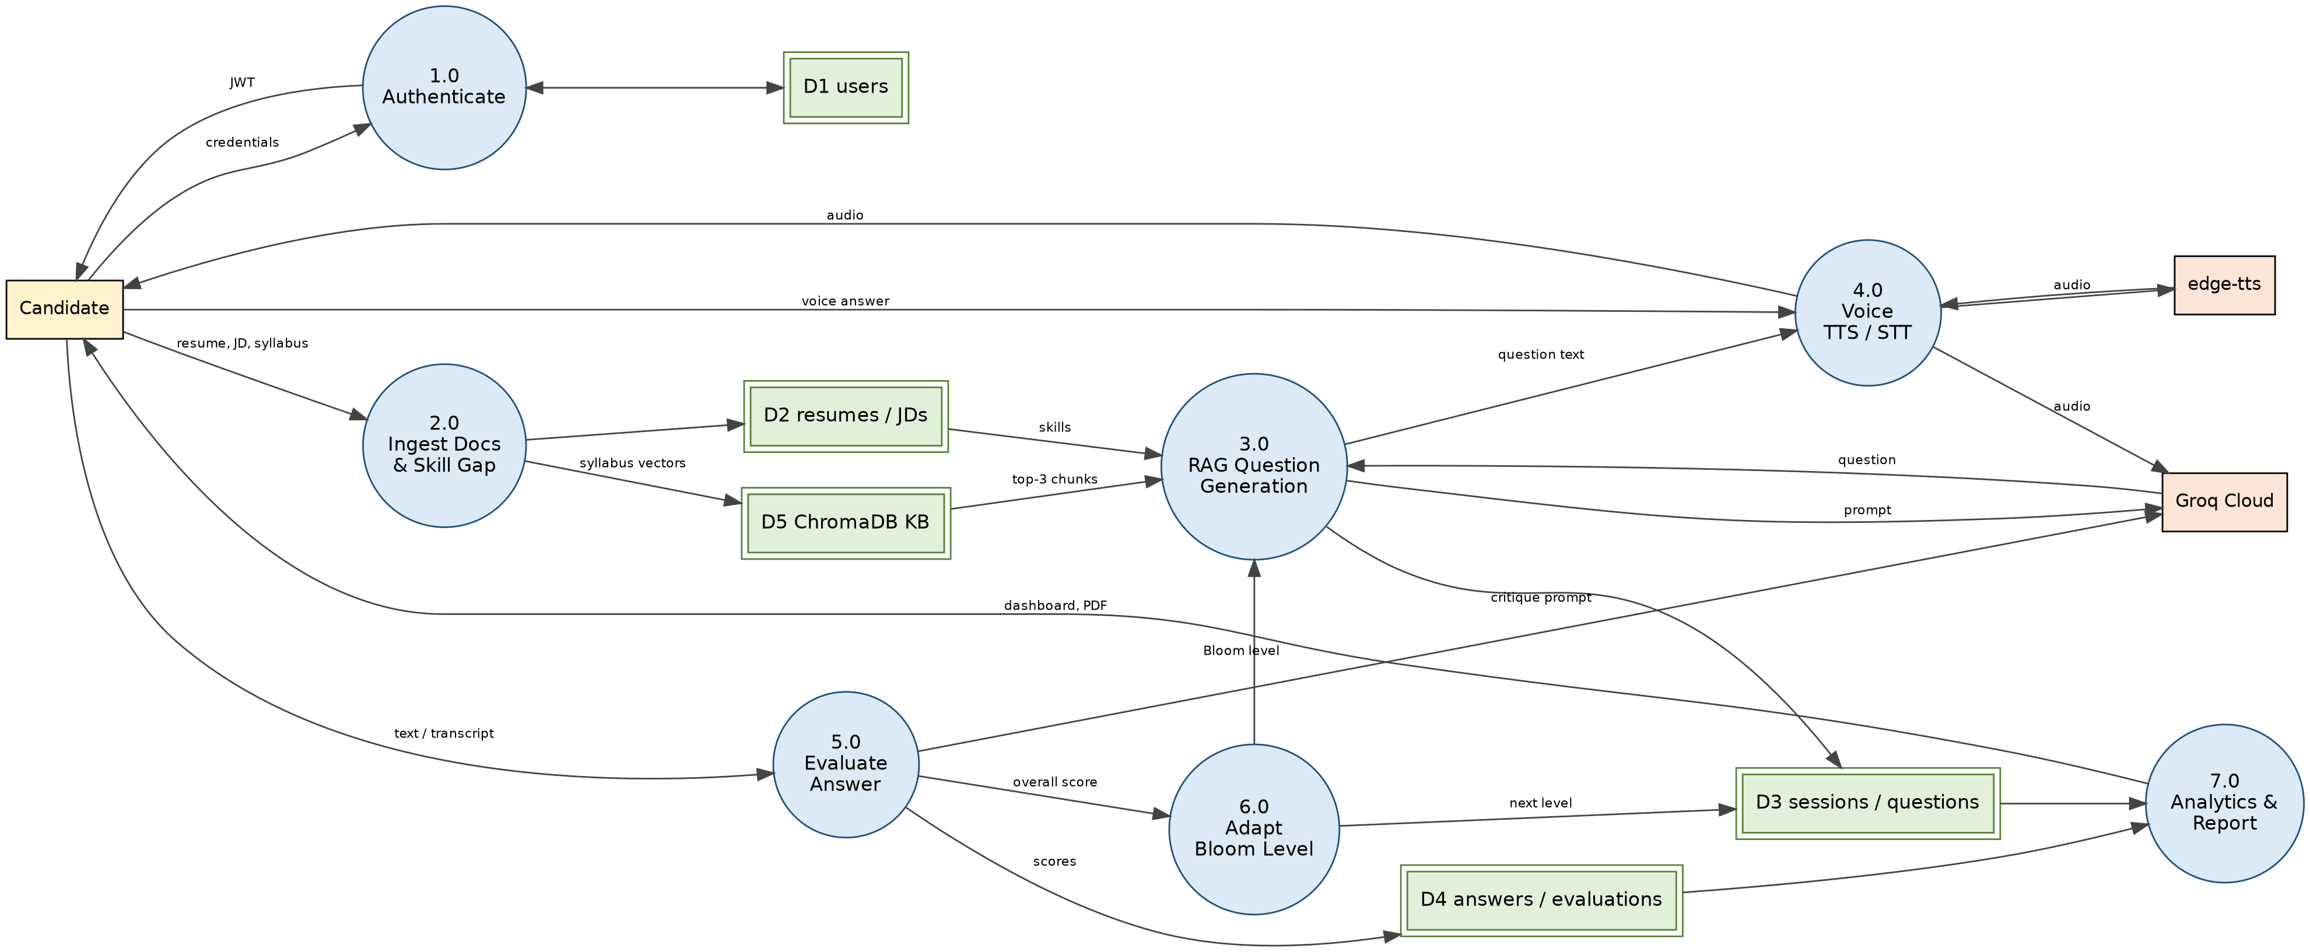
Figure 4.11b - Decomposed Data Flow Diagram (Level 1)
Diagram notes:
- Seven processes (1.0-7.0) exchange data with five data stores (D1-D5); the Bloom level produced by process 6.0 feeds back into question generation (3.0).

5. Implementation
Implementation transforms the architecture, data schemas, and algorithm specifications into functional, integrated software units ready for acceptance verification.
- Frontend Architecture: React 18/19 with Vite 6 and Tailwind CSS v4. State is managed with React Context (AuthContext for JWT, AudioStreamContext for microphone streams); routing uses React Router v7.
- Backend Services: FastAPI 0.115 on Python 3.10+, served by Uvicorn. Routers: auth, resumes, job_descriptions, interviews, users. Services: adaptive_engine, evaluation_service, question_service, voice_service, report_service. Persistence via SQLAlchemy ORM models.
- Vector Grounding (RAG): ChromaDB 0.6.3 stores 402 pre-indexed chunks across 8 domains. Embeddings are generated on CPU with SentenceTransformers all-MiniLM-L6-v2 (384 dimensions), avoiding API cost for dense retrieval.
- Generative AI & Inference: Groq Cloud with openai/gpt-oss-120b for question formulation and evaluation reasoning; openai/gpt-oss-20b is the automatic failover.
- Voice Subsystem: Microsoft edge-tts (en-US-ChristopherNeural) for in-memory neural speech and Groq Whisper (whisper-large-v3) for transcription.

Scoring and Adaptation Rules
Rule | Definition
Overall score | 0.30 x Technical + 0.20 x Completeness + 0.20 x Relevance + 0.15 x Semantic similarity + 0.15 x Concept coverage
Bloom advance | Score >= 80%: level + 1 (maximum L6) and difficulty scaled up
Bloom hold | 50% <= score < 80%: level unchanged
Bloom regress | Score < 50%: level - 1 (minimum L1)

6. Testing (Validation, Verification & Test Cases)
Software testing is the systematic evaluation of the software against requirements and technical specifications. It comprises validation and verification.

Software Validation
Validation ensures the software satisfies user needs at the end of the SDLC ("Are we building the right product?"). For SmartInterview, validation confirms that candidates can complete end-to-end mock interviews with appropriate adaptive progression.

Software Verification
Verification confirms the software adheres to the specified design ("Are we building the product right?"). For SmartInterview it covers API response schemas, database foreign-key constraints, and the correctness of the 5-factor scoring formula.

Test Cases
TC-01 to TC-06 have been executed and passed. TC-07 to TC-14 are designed to cover the remaining requirements (see the traceability matrix in Section 3.4) and are planned for execution before final submission.
Test ID | Module | Test Scenario | Input Data | Expected Result | Status
TC-01 | Auth | Register with duplicate email | Existing user email | HTTP 400 Bad Request | PASSED
TC-02 | Resume | Upload non-PDF file | sample.txt to resume endpoint | HTTP 400, file type rejected | PASSED
TC-03 | RAG | Retrieve top-3 chunks for 'DBMS' | Skill: 'sql', Domain: 'dbms' | 3 valid ChromaDB chunks in <= 100 ms | PASSED
TC-04 | Adaptive | Score >= 80% Bloom advancement | Evaluation score = 88% | Bloom level +1 | PASSED
TC-05 | Adaptive | Score < 50% Bloom regression | Evaluation score = 38% | Bloom level -1 | PASSED
TC-06 | Voice | Synthesize TTS stream | Valid question ID | HTTP 200, audio/mpeg | PASSED
TC-07 | Auth | Login and token expiry | Valid credentials | JWT returned, exp = 24 h | Planned
TC-08 | JD | Upload job description PDF | Valid JD PDF <= 5 MB | Skills and role text extracted | Planned
TC-09 | Gap | Overlap / gap mapping | Resume {python, sql, react}; JD {python, sql, docker} | A = {python, sql}; B = {docker} | Planned
TC-10 | Syllabus | Syllabus staging | Syllabus TXT <= 5 MB | temp_syllabus_<id> collection, 384-d vectors | Planned
TC-11 | Evaluation | Weighted 5-factor score | T=80, C=70, R=90, S=60, K=50 | Overall = 72.5 | Planned
TC-12 | Voice | Whisper transcription | WebM audio answer | Verbatim transcript returned | Planned
TC-13 | Report | PDF report download | Completed session | PDF with scores and radar chart | Planned
TC-14 | Dashboard | Aggregate analytics | >= 2 completed sessions | Domain proficiency and Bloom distribution shown | Planned

7. Conclusion
SmartInterview demonstrates the integration of Retrieval-Augmented Generation (RAG) with a deterministic adaptive learning engine based on Bloom's Revised Taxonomy, addressing the flaws of static question banks and hallucinating AI interview bots.
By enforcing domain-filtered retrieval across 402 curated computer science topics in ChromaDB, the system keeps technical questions grounded in authoritative material. The hybrid 5-signal evaluation provides transparent scoring that balances semantic understanding with LLM technical reasoning.
This specification documents the requirements, traceability, and UML models of the implemented architecture. The executed test cases passed, and the remaining planned cases will be run before final submission. Future work includes spaced-revision reminders and a conference paper on RAG-based Bloom-adaptive mock interviews.

