**Case Study: Instagram - Big Data Analysis**

**Abstract**

This case study is aimed at exploring how Instagram, which is one of the most favorite social media platforms all over the world, applies big data analytics to optimize its business operations and user experience with respect to its users. On a daily basis, as a matter of fact, Instagram generates very large amounts of data from its over one billion active accounts such information as: user interactions; posts, both video clips or texts; story related data and also metrics related to user engagement. In this paper, we investigate the architecture and technology used in managing a large amount of data in Instagram, which includes systems for storing data across multiple computers, frameworks that can process information as it comes in, and methods for teaching computers how to learn from examples. “The case” is about some specific purposes like checking trends or distinguishing advertising messages from spam where “Big Data” tips from analytics strongly affect process of making decisions.

**Introduction**

Instagram, a Meta (previously Facebook) owned social network platform, ranks as one of the largest photo and video sharing application worldwide. It has more than 2 billion active users each month till 2023. Each of these posts attracts caring comments, hashtags and expressions about how people love them from everywhere in the world. The uploaded media files can be managed using filters as well as geotagging upon uploading them into the app. With access to popular content like photos, keeping tracks of others with their personal feeds, followers can also locate user’s photos though tagging them to the map.

"The platform exemplifies an app that employs massive data analysis by creating and managing vast amounts of data. Instagram is not really a photo company or a communications company in the words of Kevin Systrom, the CEO of Instagram, we will also be a big data company."

**Technologies Used**

**1. Data Management and Storage:** Instagram employs Cassandra, an distributed NoSQL database designed to handle vast quantities of data across multiple machines. The high-availability feature by not compromising speed makes Instagram host real-time information on Cassandra.

• Amazon S3: Is a facility for saving vast quantities of media documents like movies as well as pictures. It’s scalable storage infrastructure assists unstructured data from Instagram fans stored on Amazon S3.

**2.Data Processing and Analysis:** Apahce Hadoop processes large files at the same time. Its MapReduce and HDFS make up the Hadoop ecosystem, enabling Instagram to handle and analyze historical data very well.

• Apache Spark: This can be used for real-time data processing. Furthermore, Instagram is able to deal with data faster by utilizing Spark; it employs in-memory computing which in turn supports real-time analytics and streaming.

**3. AI and Machine Learning:** Instagram uses PyTorch and TensorFlow for various machine learning models. Instagram employs these technologies to offer AI-based solutions such as image recognition, spam detection, and content suggestion advice.

**4.Data Visualization and Monitoring:**

• Tableau and Kibana: These are data visualization tools that Instagram data analysts and engineers employ to observe trends, track system performance and make decisions backed by data.

• GraphQL: This is a more powerful and efficient alternative to REST APIs for data manipulation and querying in the backend.

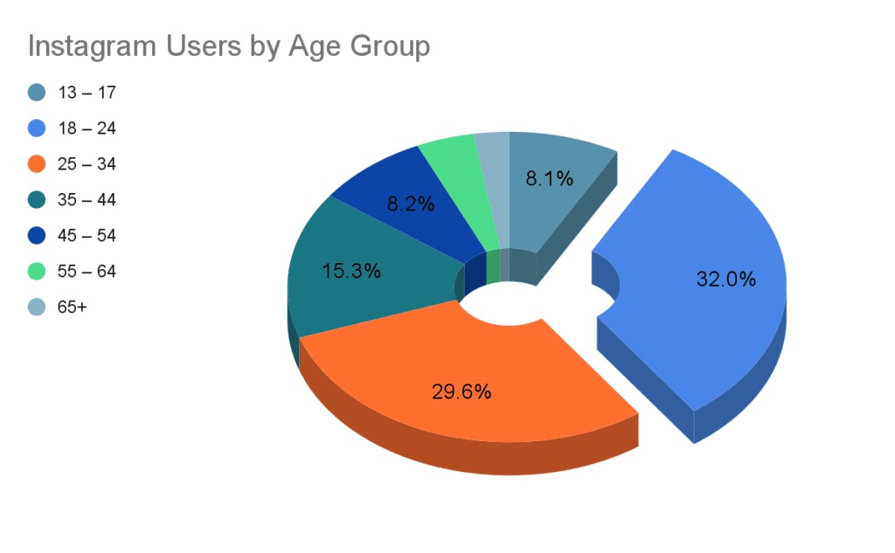

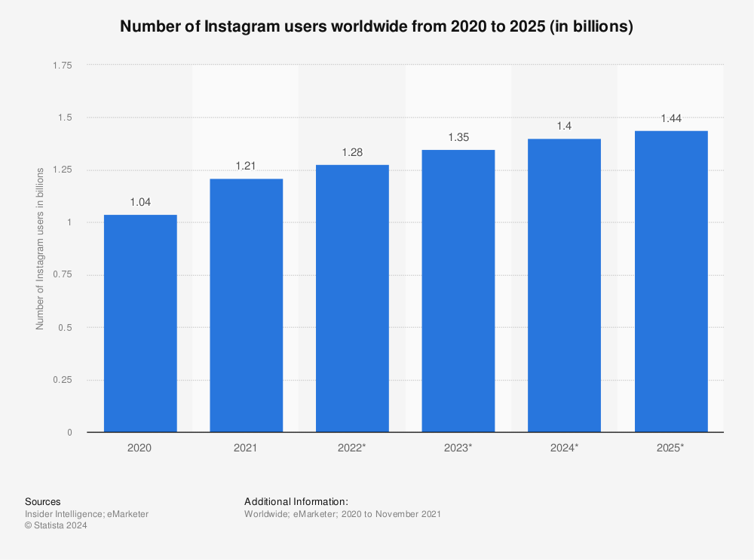

### Operational Workflow of Instagram

**1.Information Gathering :**  
The following pieces of information can be collected during; Through followers, shares, comments, likes and other engagements is how you end up obtaining user activity information. Articles, Narratives, Videos, Live Broadcasts or IGTV Content He amount of time spent on it, how frequent one uses it or even any other app-interaction patterns is what is referred as user engagement.

**2. Data Ingestion and Storage:**

• To ingest data in real-time, we use programs like Apache Kafka for user interactions data and content creation data.

• Regular basis data loads involving user metadata and past interaction records are ingested as batches.

• For the purpose of managing huge data sets which are in both structured format and also unstructured format one can rely on distributed storage solutions like cloud storage services and Hadoop system.

**3. Transformation and Processing of Data**

• ETL stands for Extract, Transform and Load which involves getting data out of different sources, converting it into a format that can be used and storing it into data warehouses after which it can be analyzed.  
• The stream processing is embraced in many engagements including updating engagement metrics which will assist in identifying trends quickly. Apache Flink and Apache Storm are some programs that aid in real-time data streams processing. • For insights and reports production, Apache Spark and Hadoop are deemed useful when dealing with voluminous batches of historical data.

**4. Machine Learning and Data Analysis –**

• Descriptive analytics refers to visualizing current data and identifying trends in user behavior with program like Tableau and Power BI Predictive analytics, on the other hand, involve using machine learning models for forecasting user engagement, content virality and future growth areas.

•Recommendation systems: These are algorithms used by companies to recommend users products that they might like, based on what the users have shown interest in so far.

•Natural Language Processing (NLP): It is possible to analyze feelings and track a particular event using different sets of text data such as messages, captions and comments.

**5. Data Security and Privacy:**

•Ways of preventing valuable data from becoming anonymous, thus making it difficult for people who need to analyze it to understand it while ensuring that none other than the owner can access it

•Compliance: Demonstrating that collecting and managing data is compatible with provisions of CCPA or GD

•Access Control: There must be stringent access rules to ensure that only authorized persons reach highly confidential information.

**6. The Feedback Loop and Ongoing Enhancement**The process of continually improving the user experience, models, and algorithms entails iterative development"

• User Feedback: This is when you look at comments left by users through surveys, reviews of one’s app and communication with customer care.

• A/B testing: This is the time when one makes trials with a few users before finally releasing new features and upgrades to the whole system. In this text, we discusses the concept of iterative design which means that improving the user experience, models and algorithms is done continuously by debugging and modifying statistical models based on constant analysis and feedback captured for software platforms meant for AI.

**7. Decision Making and user engagement** are some of the most important things that every startup needs to do. Below, there are three ways how to handle them: •Personalized content delivery - this involves generation of feeds and story recommendations based on data analysis insights.

•Targeted advertising - through serving consumers tailor-made adverts depending on their interests and browsing behavior, this enhances ad click-through rates as well as revenue generation by reducing irrelevant clicks that will cost more than necessary for both parties involved in the transaction;

•Trend identification - involves selection top of the charts materials as well emerging fads in websites’ explore page and trending categories.

##### **How Instagram Uses Big Data and Artificial Intelligence**

**1. Producing Individual Content Utilization** of big data and artificial intelligence by Instagram has greatly facilitated the creation of personalized feed for all persons who use it. Thus the Instagram algorithm has been designed in a way that enables it enable all users to found interesting materials from their feeds. Instagram utilize AI in organizing the feed and showing materials that users are more likely to enjoy, or share with others. The reason behind this idea is; the technology endeavors to know worthwhile information progressively.

##### **Getting rid of offensive content** unauthorizedcontent sharing and cyberbullying continue to increase on platforms for socialization. For example, 42% of young people say they have faced cyberbullying while using Instagram. The fact cannot be denied that most of the social media sites have more offensive content than ever. Because of this, Instagram has concluded that in order to reduce the spread of unwanted behavior on their platform they should employ AI as well as other forms of technology including Artificial Intelligence (“AI”), Machine Learning (ML), etcetera. In actual fact It is possible within few minutes after being posted before it is taken down by the algorithms integrated into the app Would soon be notified about such posts which can be deleted by them or blocked if they do not want them being archived.

##### **3. Browsing the Explore Page** The Explore Page on Instagram is considered to be holly grail. This search tool is imbibed with artificial intelligence. In particular, it helps them to keep abreast of trending topics through monitoring of tags. By this search feature, users can find new accounts, articles and information. This is the reason why businesses struggle to appear on the explore section, therefore, the content featured on here may have the ability to attract more people to come see an Instagram page hence increasing its followers.

**4. Human behavior research** The big data system enables applications like Instagram to observe the ways that users conduct themselves through the content they upload. This flows into the necessity for algorithms that can examine many items every single day because there are always a lot of contents being shared across various networks everyday; consequently there is need for daily analyses by an algorithm developed accordingly. This becomes even more pronounced when we consider that it will enable the technology to collect valuable information.A common application of machine learning is the examination of vast amounts of data collected by the app. And in doing so, the AI analyzes the information and learns about the social, cultural, and economic aspects of human life all throughout the world. AI is also useful in recognizing and comprehending consumer behavior. This guarantees that content about products is suited to those who are interested in them. This is a very useful feature for marketers.   
Additionally, Instagram can improve its platform to support ethnic diversity by knowing human behavior.

**5.Identifying & Halt Spam** There will always be spam in the app because every day, so much content is published too much there. How does Instagram choose which messages are spam and which ones are not? To send spam messages; Instagram uses artifical intelligence algorithm referred to as DeepText.More than nine languages have been identified by its spam filter, including English, Arabic and Chinese. To further strengthen cybersecurity, it promptly eliminates the spam messages. This is not all; the same tech can also be used to prevent fake profiles and data.

**Conclusion**   
In fact, one of the well-known businesses which use big data and artificial intelligence effectively is Instagram and the results show the position of these advanced technologies. Our detailed analysis of Instagram indicates that much of its success is because of its ability to appropriately exploit big data. Instagram because of its sophisticated technological operation process can improve on its features continuously, tailor user interaction to individual specific users and adapt to changes in trends and behavior by users.

The public can now check the volume of diesel fuel emitted by different models of cars into the atmosphere at Low Emission Zone (LEZ) in Germany and on the Internet. Among those who are likely to gain or lose are affected companies, environmental groups and concerned consumers.

To sum up, Instagram uses big data effectively to get feedback from its users hence giving it an upper hand in the ever-changing landscape of social networking. The outcome of the case study can be a reference point for other platforms aspiring to exploit big data for purposes of enhancing practice and innovating.

**Reference**

<https://www.analyticsinsight.net/artificial-intelligence/how-instagram-uses-big-data-and-artificial-intelligence>

<https://www.statista.com/statistics/183585/instagram-number-of-global-users/>

<https://supplygem.com/publications/instagram-statistics/>