Part-1

Query-1

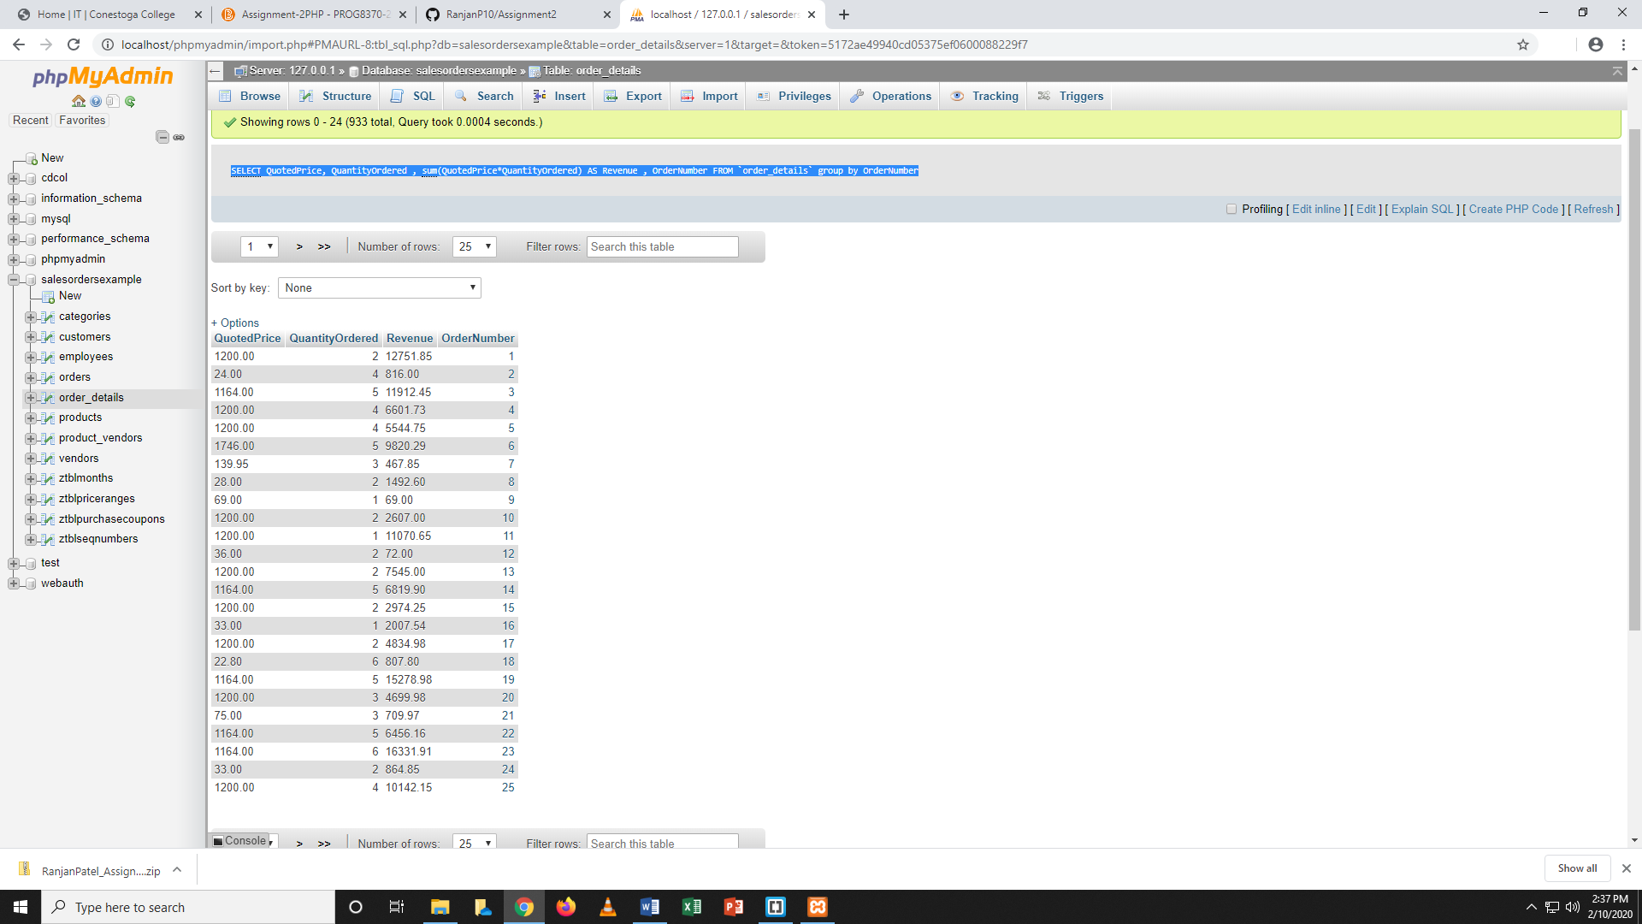

Query-2

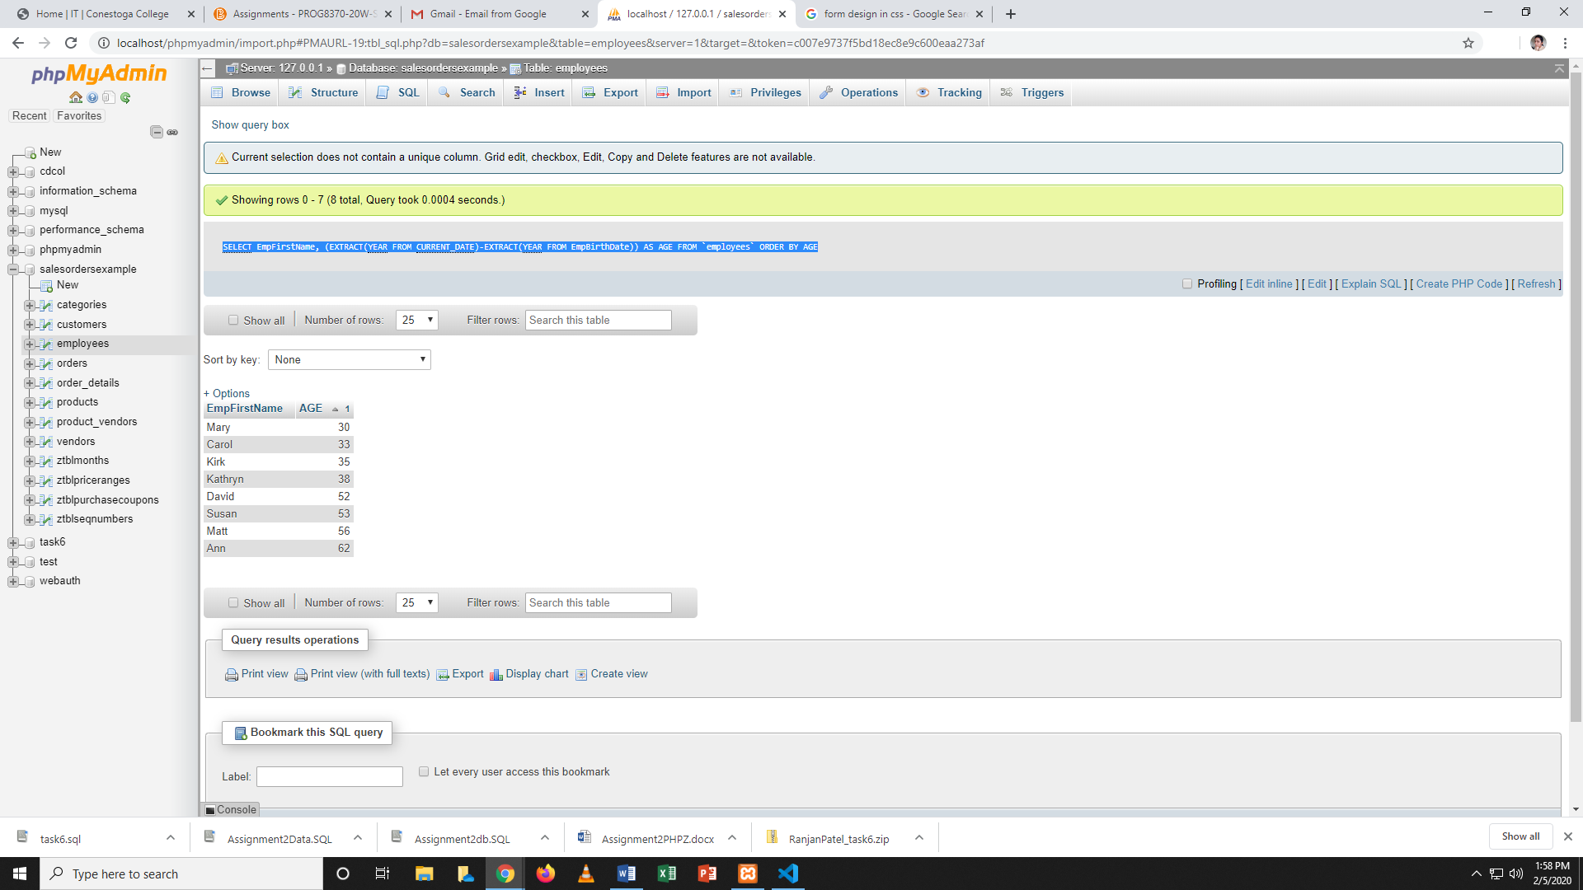

PART-2

Query-1

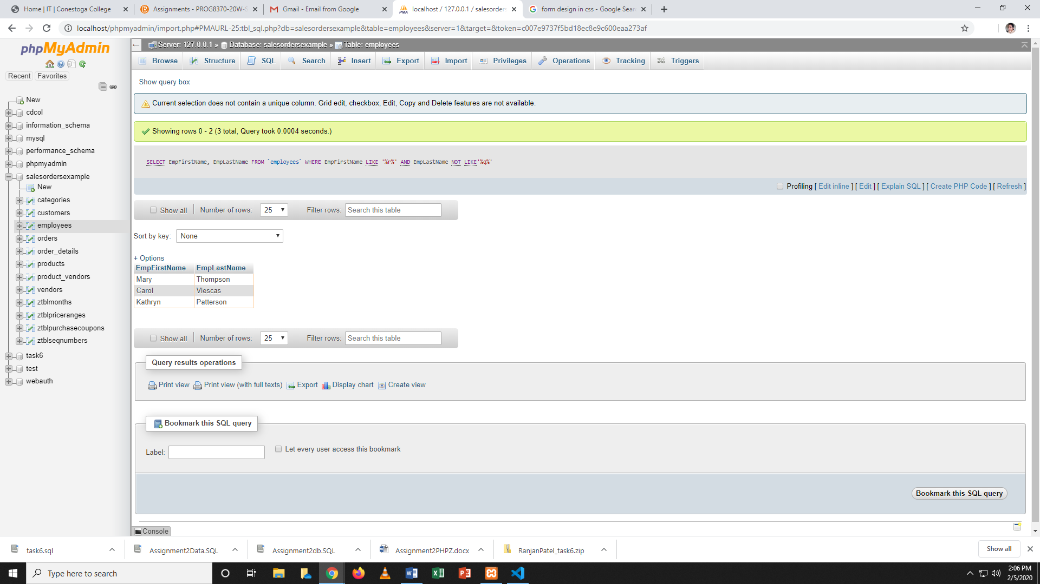

Part-3

In my understanding products should not be in one column otherwise later you cannot able to find product details any way like total sale of particular product stock of particular

product so all product name in single column is wrong here.

we have use normalization here by creating one product table which have productid and its name so, further we can use product id with all table.

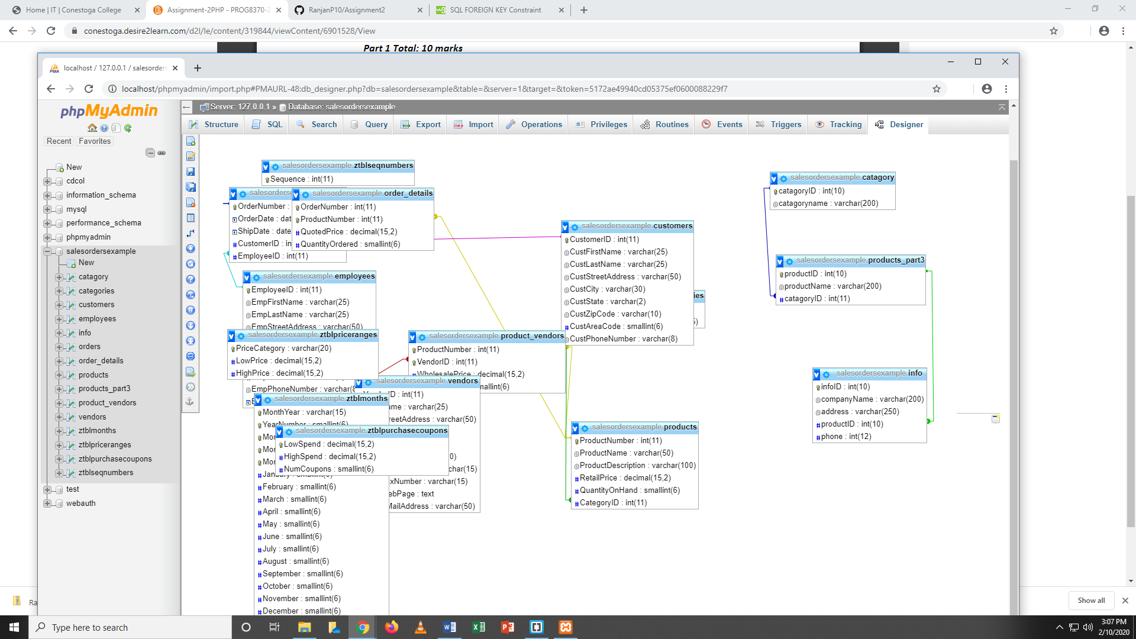

Part-4

Query-1

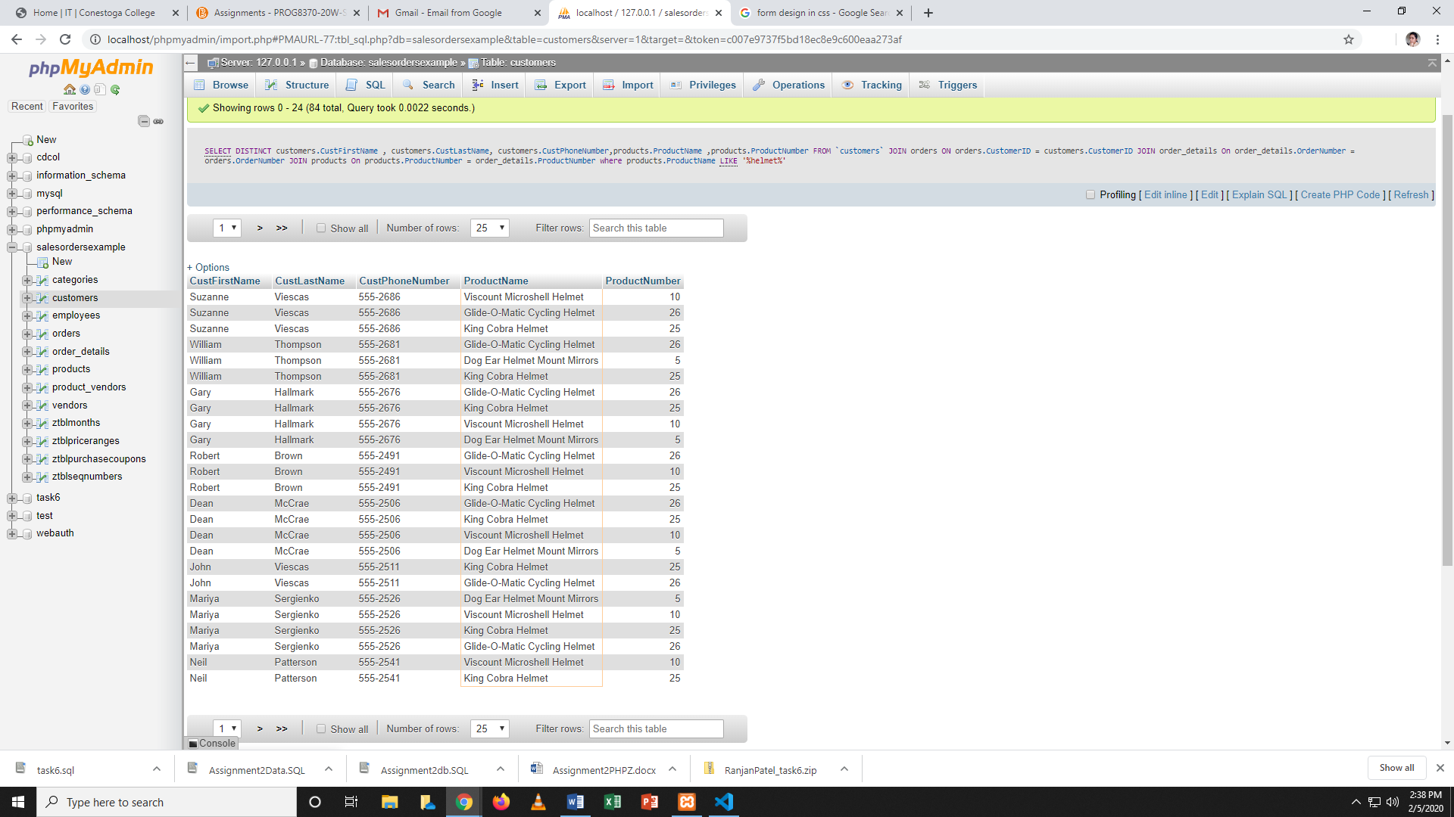

Query-2

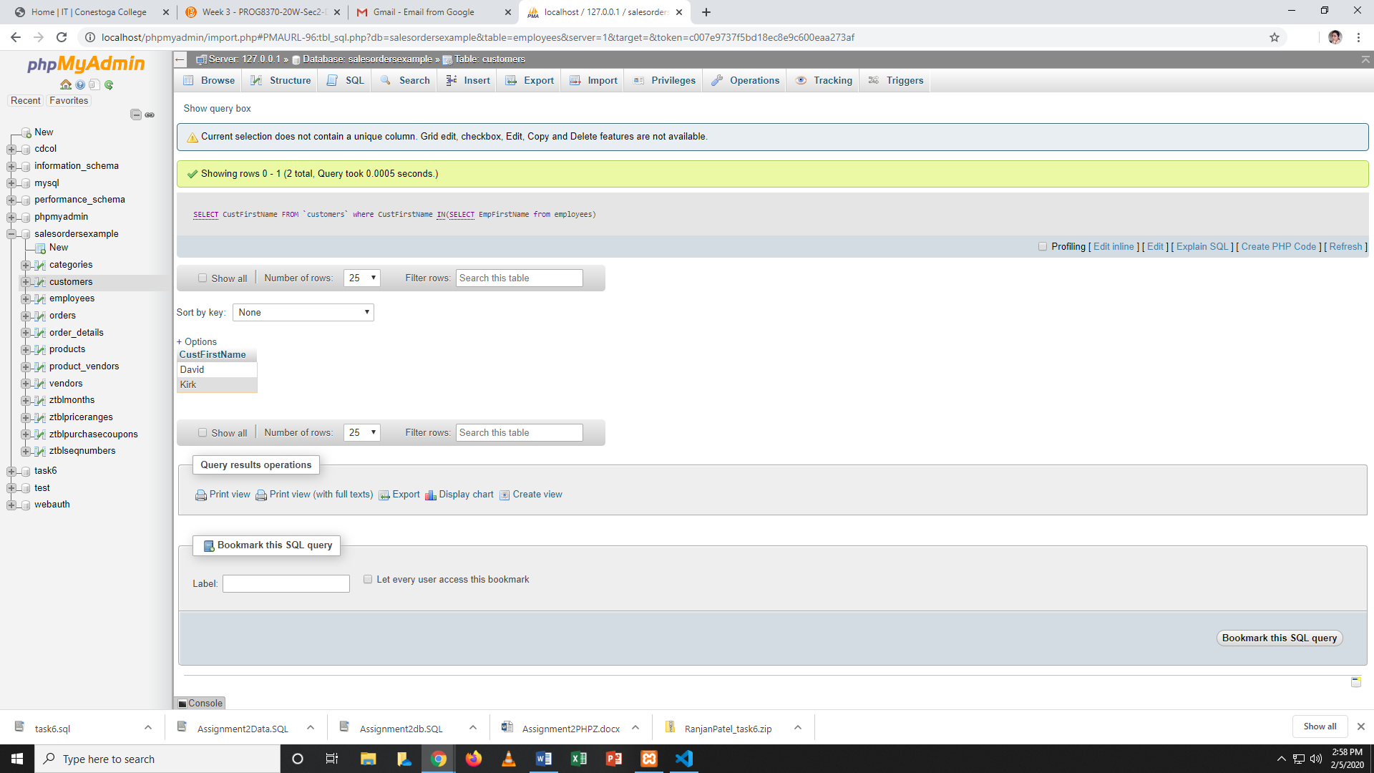

Part-5

Query-1

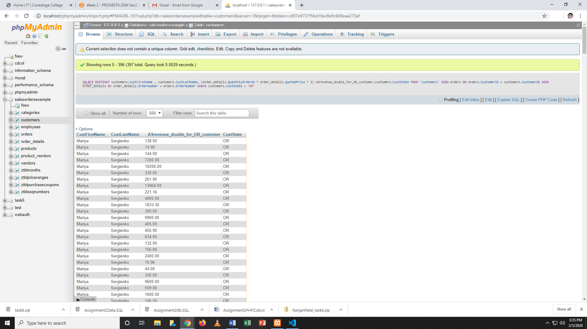

Sum of all transaction

