
Department of Computer Science & Engineering
INDIAN INSTITUTE OF INFORMATION TECHNOLOGY TIRUCHIRAPPALLI
(An Institute of National Importance under MHRD, Govt. of India)
NIT CAMPUS, TIRUCHIRAPPALLI - 620015

Roll No: CSE17U017
Name: Ravi Ranjan Kumar
Date of submission: Mar23(1:00 AM)

Title: Andriod program to read a data from calender
Code:
MainActivity.java
package com.example.calendarex;
import android.content.Context;
import android.os.Build;
import android.os.VibrationEffect;
import android.os.Vibrator;
import android.support.annotation.NonNull;
import android.support.annotation.RequiresApi;
import android.support.v7.app.AppCompatActivity;
import android.os.Bundle;
import android.widget.CalendarView;
import android.widget.TextView;
public class MainActivity extends AppCompatActivity {
@Override
protected void onCreate(Bundle savedInstanceState) {
super.onCreate(savedInstanceState);
setContentView(R.layout.activity_main);
CalendarView calendarView = (CalendarView)findViewById(R.id.calendarView);
calendarView.setOnDateChangeListener(new CalendarView.OnDateChangeListener() {
@RequiresApi(api = Build.VERSION_CODES.O)
@Override
public void onSelectedDayChange(@NonNull CalendarView calendarView, int i, int i1, int i2) {
TextView textView = (TextView)findViewById(R.id.textView);
textView.setText(Integer.toString(i2) + "/" + Integer.toString(i1) + "/" + Integer.toString(i));
}
});
}
}

Activity_main.xml
<?xml version="1.0" encoding="utf-8"?>
<android.support.constraint.ConstraintLayout xmlns:android="http://schemas.android.com/apk/res/android"
xmlns:app="http://schemas.android.com/apk/res-auto"
xmlns:tools="http://schemas.android.com/tools"
android:layout_width="match_parent"
android:layout_height="match_parent"
tools:context=".MainActivity">
<CalendarView
android:id="@+id/calendarView"
android:layout_width="wrap_content"
android:layout_height="wrap_content"
app:layout_constraintBottom_toTopOf="@+id/textView"
app:layout_constraintEnd_toEndOf="parent"
app:layout_constraintStart_toStartOf="parent"
app:layout_constraintTop_toTopOf="parent" />
<TextView
android:id="@+id/textView"
android:layout_width="wrap_content"
android:layout_height="wrap_content"
android:layout_marginBottom="20dp"
android:hint="Date"
android:textSize="36sp"
app:layout_constraintBottom_toBottomOf="parent"
app:layout_constraintEnd_toEndOf="parent"
app:layout_constraintStart_toStartOf="parent" />
</android.support.constraint.ConstraintLayout>

Screenshots:
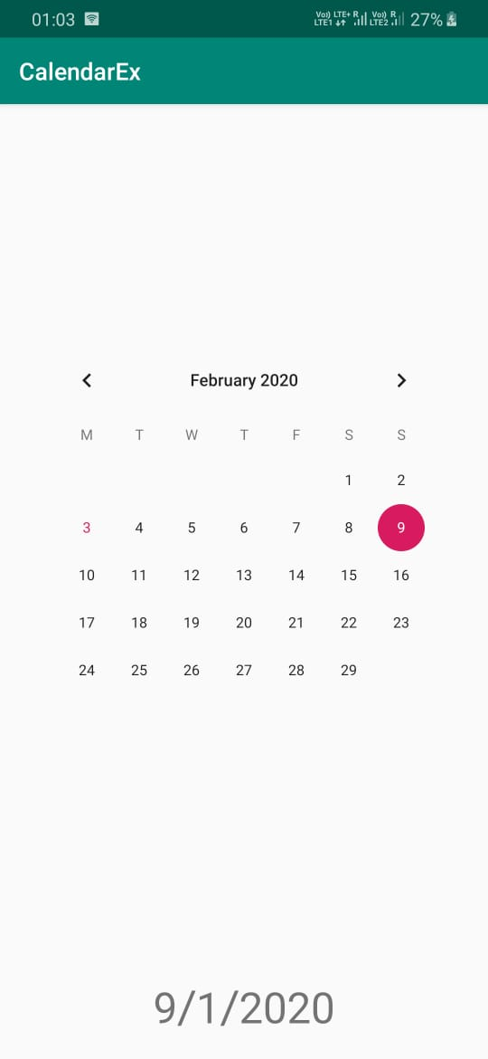

Title:Start a Service to Vibrate Phone.
Code:
MainActivity.java
package com.example.calendarex;
import android.content.Context;
import android.content.DialogInterface;
import android.os.Build;
import android.os.VibrationEffect;
import android.os.Vibrator;
import android.support.annotation.NonNull;
import android.support.annotation.RequiresApi;
import android.support.v7.app.AppCompatActivity;
import android.os.Bundle;
import android.view.View;
import android.widget.Button;
import android.widget.CalendarView;
import android.widget.TextView;
public class MainActivity extends AppCompatActivity {
@Override
protected void onCreate(Bundle savedInstanceState) {
super.onCreate(savedInstanceState);
setContentView(R.layout.activity_main);
Button btn = (Button) findViewById(R.id.vibrate);
btn.setOnClickListener(new View.OnClickListener() {
@RequiresApi(api = Build.VERSION_CODES.O)
@Override
public void onClick(View view) {
Vibrator vib = (Vibrator) getSystemService(Context.VIBRATOR_SERVICE);
vib.vibrate(VibrationEffect.createOneShot(100, VibrationEffect.DEFAULT_AMPLITUDE));
}

});
}
}
activity_main.xml
<?xml version="1.0" encoding="utf-8"?>
<android.support.constraint.ConstraintLayout xmlns:android="http://schemas.android.com/apk/res/android"
xmlns:app="http://schemas.android.com/apk/res-auto"
xmlns:tools="http://schemas.android.com/tools"
android:layout_width="match_parent"
android:layout_height="match_parent"
tools:context=".MainActivity">
<Button
android:id="@+id/vibrate"
android:layout_width="wrap_content"
android:layout_height="wrap_content"
android:text="Button"
app:layout_constraintEnd_toEndOf="parent"
app:layout_constraintStart_toStartOf="parent"
tools:layout_editor_absoluteY="315dp" />
</android.support.constraint.ConstraintLayout>
Screenshots:
