**Python Decorator**

**409. Function Aliasing and Nested Functions**

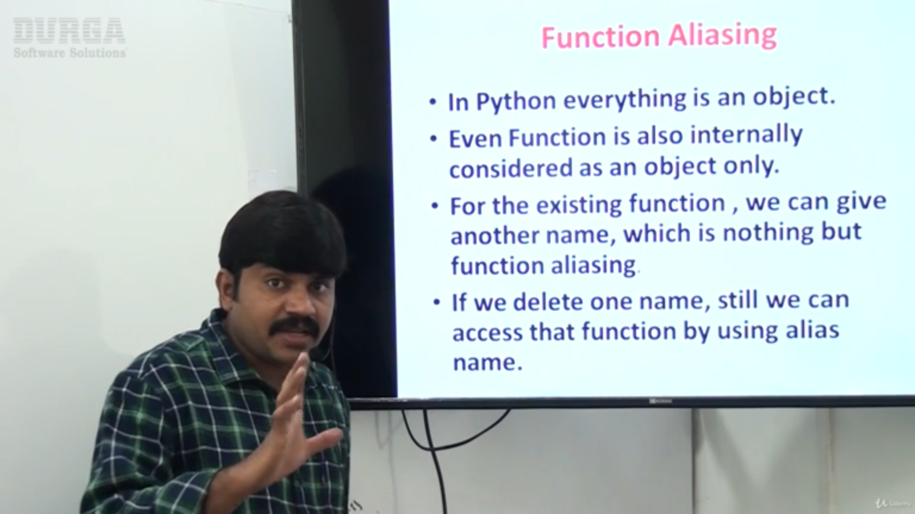

Inner function we can not call from outside function, If we do we will get error as “Name Error”

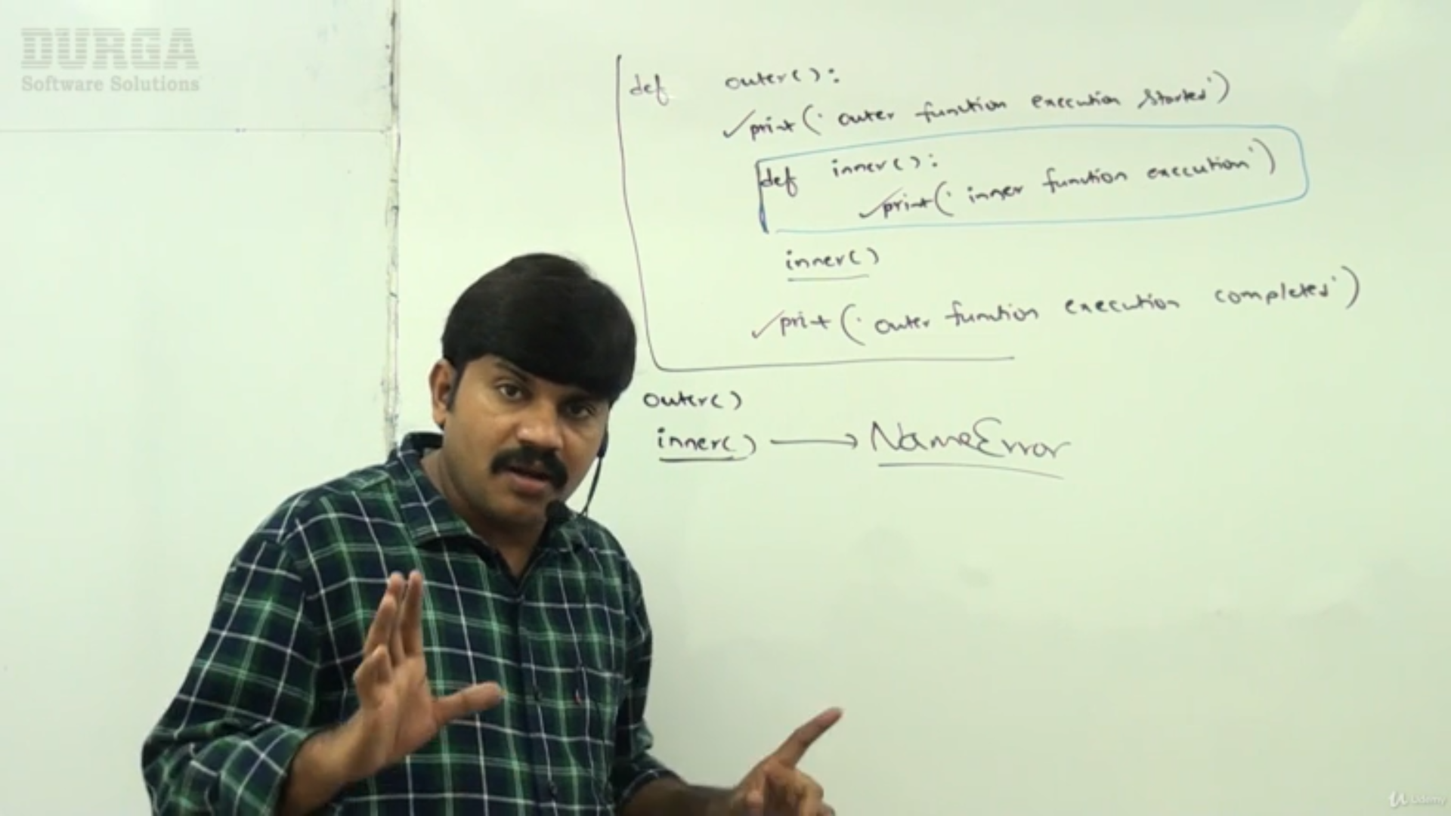

**410. Function as Return Value and Function as Argument**