**Data Mining in Cloud Computing**

**G Sasikala**

Assit Professor, School of Computer Science and Applications, REVA University, Bengaluru, Karnataka, India.

sasikalag@reva.edu.in

**Ranjan Suresh**

Masters in Computer science at School of Computer Science and Applications, REVA University, Bengaluru, Karnataka, India.

Ranjan.suresh18@gmail.com

**ABSTRACT**

Data Mining could be a method of extracting doubtless helpful info from data. This paper deals with the study of however data processing is employed in cloud computing. However SaaS is incredibly helpful in cloud computing. Data processing applications will derive abundant demographic info regarding customers that was antecedently not well-known or hidden within the knowledge. When processors become out there, the information is stirred to the processors, the mixing of information mining techniques into traditional day-after-day activities has become common place. we tend to square measure confronted daily with targeted advertising, and businesses became additional economical through the utilization of information mining activities to cut back prices we've got recently seen a rise in data processing techniques targeted to such applications as fraud detection, distinguishing criminal suspects, and prediction of potential terrorists.

By and huge, data processing systems that are developed to knowledge for clusters, distributed clusters and grids have assumed that the processors square measure the scarce resource, and thus shared.

Keywords: DataMining, computing, antecedently, potential terrorists.

**I. INTRODUCTION**

Data processing, the extraction of hidden predictive information from large databases, may well be a strong new technology with nice potential to help firms target the foremost vital data in their information warehouses. Data processing tools predict future trends and behaviors, allowing businesses to make proactive, knowledge-driven decisions. The automated, prospective analyses offered by processing advance the far facet the analyses of past events provided by retrospective tools typical of decision call support systems. As information sets have fully grown in size and complexness, direct active information analysis has progressively been increased with indirect, automatic processing. This has been aided by completely different discoveries in engineering, like neural networks, cluster analysis, genetic algorithms (1950s), decision trees (1960s) and support vector machines (1990s). information is that the method of applying these methods to data with the intention of uncovering hidden patterns in large data sets. data processing is sorting through data to identify patterns and establish relationships.

**STATEMENT** - Discovering patterns in information that may cause cheap predictions regarding the long run This space of information mining is understood as prognosticative analytics.

So there square measure several application within which the information mining term is incredibly helpful. therefore from several application we are going to be discussing on cloud computing, however data processing is employed in cloud computing.

**II.DATA PROCESSIN PARAMETERS INCLUDE:**

1)Association - probing for patterns wherever one event is connected to a different event.

2)Sequence or path analysis - probing for patterns wherever one event results in another later event

3)Classification - probing for new patterns

4)Clump - Finding and visually documenting teams of facts not antecedently familiar

**III. WHAT’S CLOUD COMPUTING**

The term "cloud" is employed as a figure for the net, supported the cloud drawing employed in the past to represent the phone network, the particular term "cloud" borrows from telecommunication therein telecommunications corporations, WHO till the Nineties offered primarily dedicated point-to-point knowledge circuits, began providing Virtual non-public Network(VPN) services with comparable quality of service however at a way lower value. In early 2008,OpenNebula, enhanced at intervals the RESERVOIR European Commission-funded project, became the first computer code computer file computer code package for deploying private and hybrid clouds, and for the federation of clouds. Cloud computing may well be a general term for love or cash that involves delivering hosted services over information superhighway. These services unit of measurement typically divided into three categories: Infrastructure-as-a-Service (IaaS), Platform-as-a-Service (PaaS) and Software-as-a-Service (SaaS).

The name cloud computing was galvanized by the cloud image that's generally accustomed represent information superhighway in flowcharts and diagrams. June 2, 2008 - Cloud computing is turning into one among consecutive trade.

Buzz words. It joins the ranks of terms including: grid computing, utility computing, virtualization, clustering, etc. The abstract overlap is partially attributable to technology changes, usages and implementations over the years.

Cloud computing overlaps a number of the ideas of distributed, grid and utility computing, but it will have its own which means if contextually used properly There square measure in fact folks resources to stay hardware, operation systems and networking in correct order. however from the angle of a user or application developer solely the cloud is documented. The cloud could be a virtualization of resources that maintains and manages itself. associate degree application or service developer requests access from the cloud instead of a selected termination or named resource.

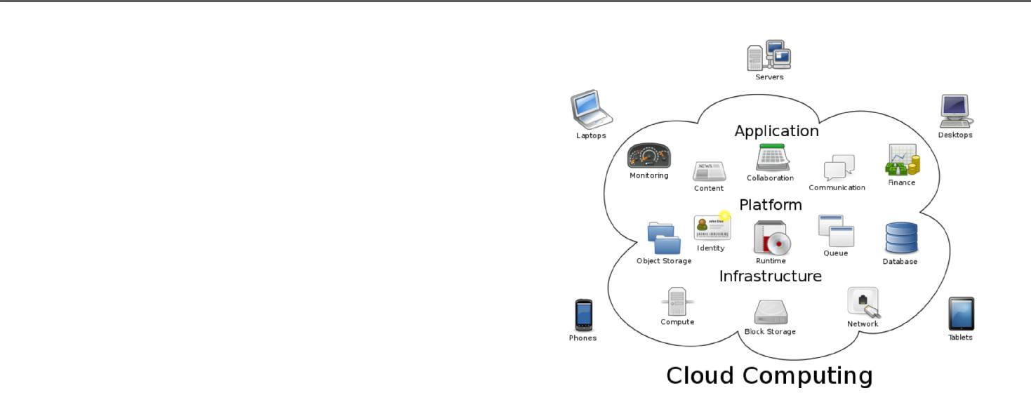

**IV. Frameworks provide mechanisms are:**

* Self-healing
* Self monitoring
* Resource registration and discovery
* Service level agreement definitions
* Automatic reconfiguration

**V. SPOTLIGHT ON CLOUD SERVICE**

There are 3 sorts of cloud services infrastructure as a Service, platform as a Service, computer code as a Service. within which SaaS is king of all the services. SaaS : engineered on underlying IaaS and PaaS Layer. Delivers the appliance over the net or computer network via a cloud Infrastructure.

1)IaaS : Provides monumental potential for extensibility and scale. Delivers laptop infrastructure as a utility service, generally in a very virtualized atmosphere.

2) PaaS : Delivers a platform or answer stack on a cloud infrastructure. Sits on a high of the IaaS design and integrates with development and middleware capabilities additionally as information, messaging.

3) SaaS :CLOUD MINING IS BORN The SaaS Distribution model (Software-as-a-Service) outsourcing the hardware effort.

At SaaS, the code is not applied at intervals the corporate, it lies at a code service suppliers server. which suggests the provider deals with the hardware, takes care of code updates and maintains technically everything.

**VI. SCALE BACK DATA PROCESSING PRICES BY**

**SaaS – CLOUD MINING IS BORN**

**The SaaS Distribution model (Software-as-a-Service)**

Outsourcing the hardware effort. At SaaS, the code isn't applied within the company, it lies at a code service suppliers server. which means the supplier deals with the hardware, takes care of code updates and maintains technically everything. In Cloud Mining, the servers that give the code square measure the Cloud.

That makes him save plenty compared to advanced data processing suites that he's not victimization complete. And on the opposite hand he simply pays for the prices that square measure generated by victimization the Cloud. He doesn't need to maintain a hardware infrastructure, he will apply data processing simply via his browser. This reduces the barriers that keep little firms from benefiting of knowledge Mining. this may be the general public cloud from Google, Amazon.com etc, or a non-public cloud on the servers of one supplier. That has 2 main effects; on one hand the client solely pays for the tools of knowledge Mining he wants.

**VII. KEY CHARACTERISTICS OF SaaS**

• Single-instance, multi-tenant architecture: There may be multiple variations of however one instance extremely gets enforced and the way multi-tenancy extremely gets achieved.

A one-to-many model implies one physical instance with customers hosted in separate logical areas.

• Centralized feature updates : This obviates the necessity for downloadable patches associate degreed upgrades typical of an on-premise code installation.

• Managed centrally and accessed over the Internet: there's no code element put in at the client website. All applications may be accessed remotely over the net.

• Mostly subscription-based, no direct license.

**VIII CLOUD MININGBYBEDDED**

**TECHNOLOGIES**

* By providing high-quality technology, infrastructure and support, bedded school permits customers to eliminate capital expenses and save on in operation prices whereas that specialize in core business problems.
* Layered Technologies may be a leading world supplier of managed dedicated hosting, on-demand virtualization/cloud computing and net services bedded Tech's ascendible infrastructure powers countless sites and Internet-enabled applications together with e-commerce, code as a service (SaaS), content distribution and additional. Our purchasers vary from The new platform may be a hybrid cloud computing infrastructure that offers customers a virtualized surroundings on dedicated servers inside bedded school knowledge centers, similarly as levels of flexibility on the way to firmly access their VPDC, whether or not by dedicated lines, VPN or net. Jan.
* 11, 2010 - bedded Technologies, Inc. (Layered Tech), a number one worldwide supplier of on-demand IT infrastructure, has developed a brand new virtual non-public knowledge center (VPDC) platform with levels of managed services, security and suppleness via a proprietary API that were antecedently out of stock in associate integrated giving. new Virtual non-public knowledge Center (VPDC) platform from bedded Technologies.
* The supplier of on-demand IT infrastructure tries to beat users issues if their knowledge is safe by having a enterprise level security standard . it'll be doable to design, order associated deploy a secure virtualized surroundings inside an hour. Customers will select no matter plattform they have, together with 3Teras AppLogic, VMware and Microsoft Hyper-V. . The client API, created by bedded school and supported trade normal protocols (SOAP and XML-RPC), provides simple property and permits customers to perform activities like customizing proprietary applications, observance and managing resources, reviewing analytics, and additional via pc or mobile device.
* Layered Tech's new integrated virtualized platform provides customers the responsibility of dedicated servers with the high availableness, process power and quantifiability of virtual machines to satisfy perpetually dynamic business desires {the knowledge| the info| the information} mining in Cloud Computing permits organizations to centralize the management of code and data storage, with assurance of economical, reliable and secure services for his or her users. Here we have a tendency to explore the however the information mining tools like SAS, PAS and IaaS area unit employed in cloud computing to extract the data.
* Cloud Computing denotes the new trend in net services that trust clouds of servers to handle tasks. data {processing} in cloud computing is that the process of extracting structured data from unstructured or semi-structured net knowledge sources. A cloud supplier for an information mining and tongue process system. Leading cloud computing suppliers Amazon net Services, Windows Azure, OpenStack. firms use this service to envision what reasonably data is floating within the world wide net for his or her merchandise or services and take actions supported {the data| the info |the data} conferred individuals use this feature to create information listing, get data regarding totally different topics by looking in forums etc.
* It is but, counseled that users ought to make sure that the request created to the IaaS is inside the scope of integrated knowledge warehouse and is evident and straightforward. Thus, creating the work for the multi-agent system easier through application of {the data| the info |the data} mining algorithms to retrieve important information from the information warehouse. the data retrieval sensible model DMCloud is efficacious capability for IWs that may wish to begin considering SQL Server data processing while not the additional burden of needing a technology skilled to 1st install Analysis Services.
* Additionally, IWs will use the DMCloud services in spite of wherever they will physically be situated as long as they need an online connection! the information mining tasks you'll perform with DMCloud area unit an equivalent Table Analysis Tools found within the ancient stand out data processing add-in. These data processing tasks include: Prediction
* Calculator hand basket Analysis Analyze Key Influencers sight classes Fill From Example Forecast through the multi-agent system with data processing in a very cloud computing surroundings has been planned.
* Cloud computing permits the users to retrieve important data from just about integrated knowledge warehouse
* That reduces the prices of infrastructure and storage. 6. data processing within the CLOUD The Microsoft suite of
* Cloud-based services includes a brand new technical preview of knowledge Mining within the Cloud DMCloud. DMCloud
* Allows you to perform some basic data processing tasks investing a cloud-based Analysis Services association.

**IX. DATA MINING IN THE CLOUD**

The Microsoft suite of cloud-based services includes a new technical preview of Data Mining in the Cloud “DMCloud”. DMCloud allows you to perform some basic data mining tasks leveraging a cloud-based Analysis Services connection.

**X. CONCLUSION**

Data mining is used in various applications such as Health care like used in surgery and medicines. Student management, mathematics, Science, and in various website.

**XI. REFERENCES**

* Data-Driven Marketing: The 15 Metrics Everyone in... by Mark Jeffery.Cloud Computing with the Windows Azure Platform By Roger Jennings .
* Moving To The Cloud: Developing Apps in the New World of Cloud Computing, By Dinkar Sitaram, Geetha Manjunath
* The Cloud Computing Handbook - Everything You Need to Know about Cloud Computing, By Todd Arias
* http://searchsqlserver.techtarget.com/definition/data-mining
* http://www.ijcaonline.org/volume15/number7/pxc387 2623.pdf
* http://www.waset.org/journals/waset/v39/v39-72.pdf
* http://www.estard.com/data_mining_marketing/data_ mining_campaign.asp
* http://dssresources.com/books/contents/berry97.html