**1.Gmail (Website and App) explain at least one feature such as how to compose a new email, how to delete, and so on. (25 marks)**

**Feature: Gmail filters on Web**

There can be so many unwanted emails in your inbox, that you might miss out on the important emails that needs your attention. Gmail filters can be used to manage such situations. It is used to filter the incoming emails based on certain criteria. This will help in categorizing the emails folder wise.

**Login to Gmail-**

Steps:

1. Login [gmail.com](mailto:gmail.com)
2. Enter your Gmail id and password

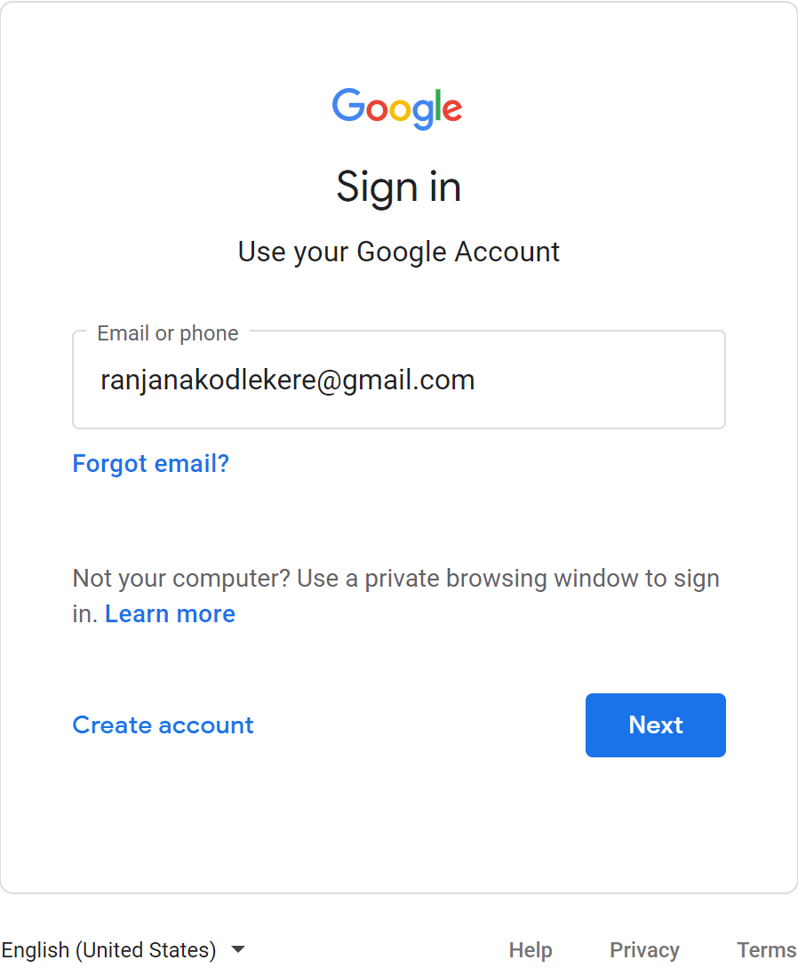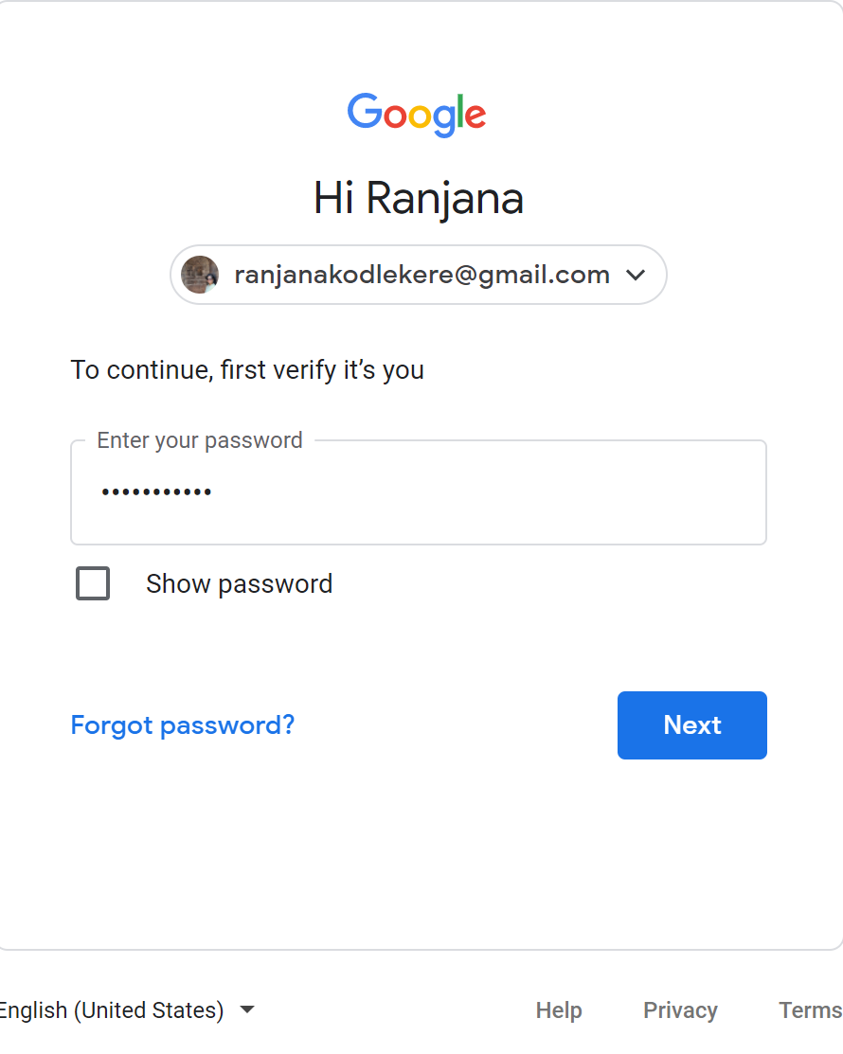

**Applying Gmail Filters-**

1. Open the email that you want to put filter on. Click the three dots on top left of your email. Select **Filter Messages like this**.

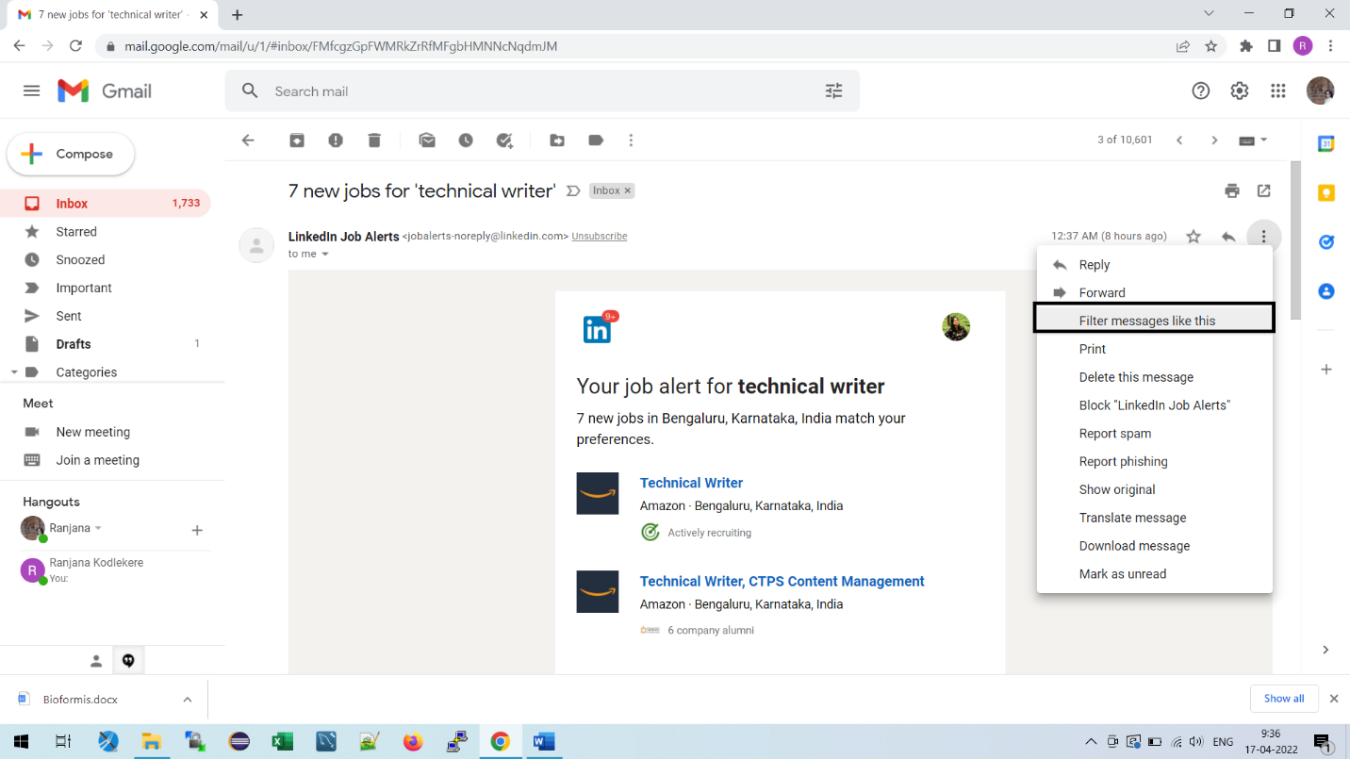

1. A pop up appears where the details to apply filter can be filled in.

* **From** can be a particular email address or just the domain name (Ex: @gmail.com).
* **To** is the email recipient to whom this email is sent.
* **Subject** is the used to filter based on the subject line of the email you receive.
* **Has the words** can be used to highlight key words that is present in the received email.

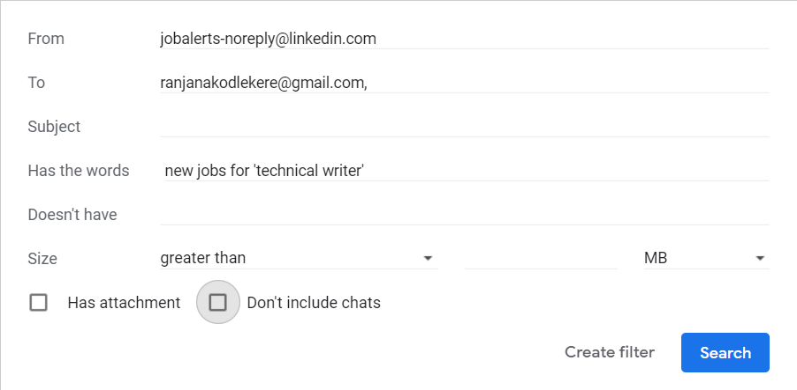

1. Click **Create Filter.** We can create a filter by using any or all the different options available**. Some of them are-**

* **Skip the Inbox (Archive it) –** The email is seen only in the filter created and not in the Inbox emails list.
* **Mark as Read** – The email is marked as read by default.
* **Apply the label –** A label can be selected from the drop down or a new label can be created in which the emails with be available.
* **Also apply filter to matching conversations –** This will move the existing emails to the designated label.

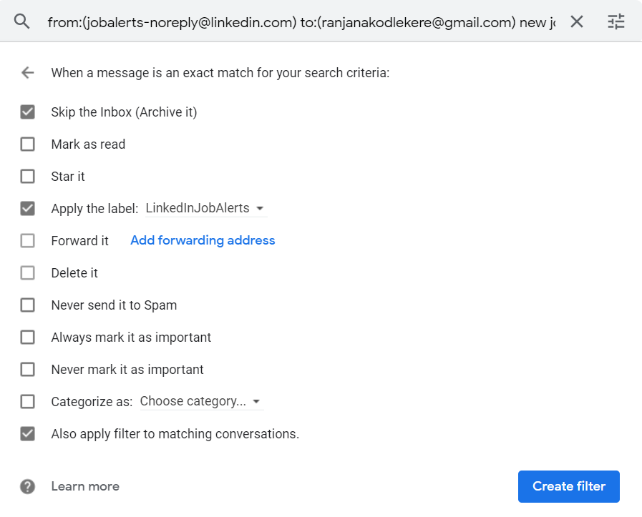

***Note:***

To create new label, choose **New Label.** Create the label by giving appropriate name.

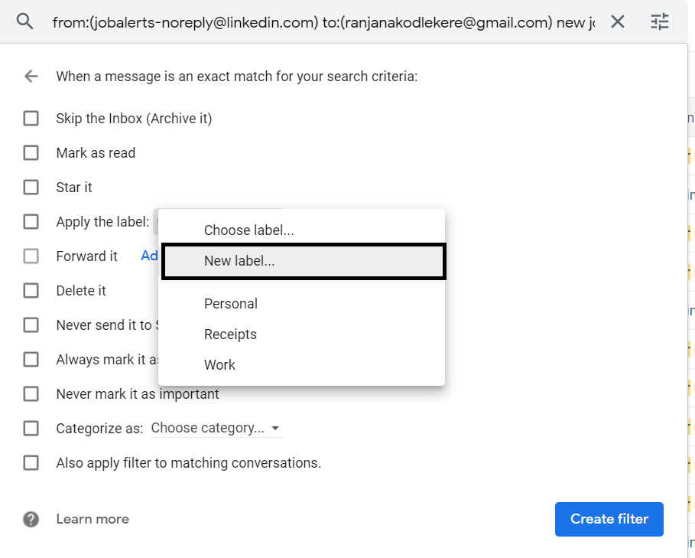

Click **Create Filter** once the desired options are selected.

1. A new folder is created where all the related emails are available together to view.

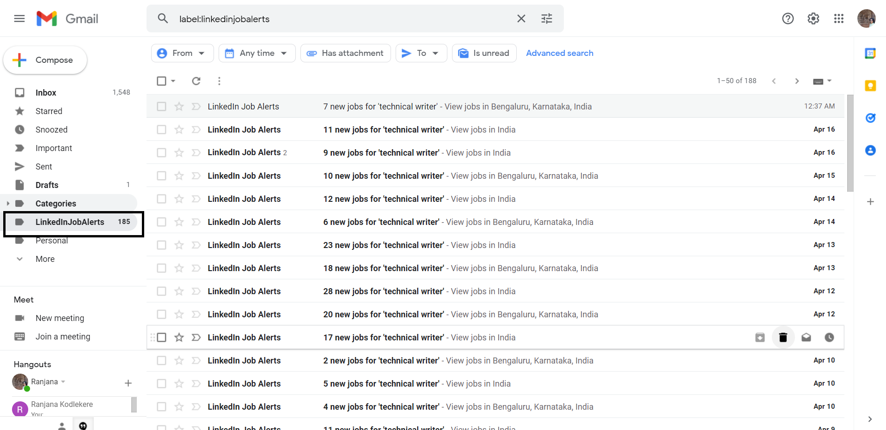

**Feature: Delete Emails**

**Web:**

Steps:

1. Select a email that you want to delete.
2. If you want to delete all emails at a time, select any one email and click on top left of your screen. Select **All** option in the drop down.
3. Click to delete the emails.

**App:**

Steps:

1. If you want to delete a particular email, long press on the email to delete.
2. To delete multiple emails at a time, long press on one particular email and select other emails to delete all together.

**2. Write about your current documentation process (include the tools and applications you use, challenges you face, suggestions/improvements, and more). (10 marks)**

**3.How do you keep yourself updated with the industry news and new trends?**

* Reading journals, newspapers and blogs.
* Keep active on social media
* Interactions with peers.

**4.What is collaborative writing and what does a collaborative writing plan include?**

Collaborative writing is a way of writing a document in groups. Individuals interest with their colleagues to develop a document. Each person is the group is responsible for the document and is authorized to give in opinions.

Collaborative Writing plan includes-

1. Planning: Questions like What is the document about? Who are the target audience? What is the purpose? needs to be answered at this stage. Also, tools to be used should be addressed.

Time required to complete the whole document or the different stages of the document.

1. Organizing: Collection the data on the document to be prepared. Peers need to decide who will write which part of the document. What are the resources available and which are the ones that will need deep understanding. Also, each individual should know how their writeup will fit into the whole document.
2. Writing: Each individual will write their assigned part of the document by interacting with resources or reading manuals if any.
3. Editing: On completion of writeup, editing can be done by individuals.
4. Review: Once the document is written, peer reviews can be done. Individuals can send their documents to their colleague and get it reviewed with respect to product understanding, grammar and word choice.

**5. Write about your hobby/interest. (5 marks)**

My interests include Singing, Dancing and reading. As a school going kid, I used to always participate in Singing and dancing competitions. We used to live a colony with around 100 houses. Ganesh Chaturthi, Deepavali, Independence Day and Republic Day celebrations were a must. As these festivals used to approach, all the colony kids would come together and start practicing dancing and singing. I also have a great inclination towards novels. I am fascinated by the novel Harry Potter. It is a 7-book series written by J K Rowling that beautifully depicts a world that we can only imagine to be in- The Wizarding World. Harry Potter, who lost his parents at a very young age, happens to be living with his Muggle (people with no wizarding powers) uncle, Vernon and Aunt, Petunia because of the circumstances. Later when he comes of age, is invited to study in Hogwarts (A school for wizards). The invitation letters are delivered by the owls (Just like we have pigeons here in India!). Hagrid, the keeper of keys at Hogwarts manages to take Harry to the wizarding school regardless of the infinite efforts by Vernon and Petunia of stopping Harry from going away! (I think they always were worried that this part of the world was not safe and sending Harry there would mean harm to them as well).