# PS07 - Answer Sheet

|  |  |
| --- | --- |
| **Assignment:** | PS 07 |
| **Name:** | <Donghyun Lee>, <lee3034> |
| **Team-ID** | 008-14 |
| **Contributor(s):** | <Ranjan Behl> , <rbehl> / <John Chapla> , <jchapla> / <Dong Lee> , <lee3034> |

## Security Camera Placement

**Paired**

### Flowchart Paired Partner

Each member of the pair will submit their own answer sheet. List your paired partner here.

|  |  |
| --- | --- |
| Flowchart Partner: | <John Chapla>, <jchapla> |

### PS07_observatory_rbehl Flowchart

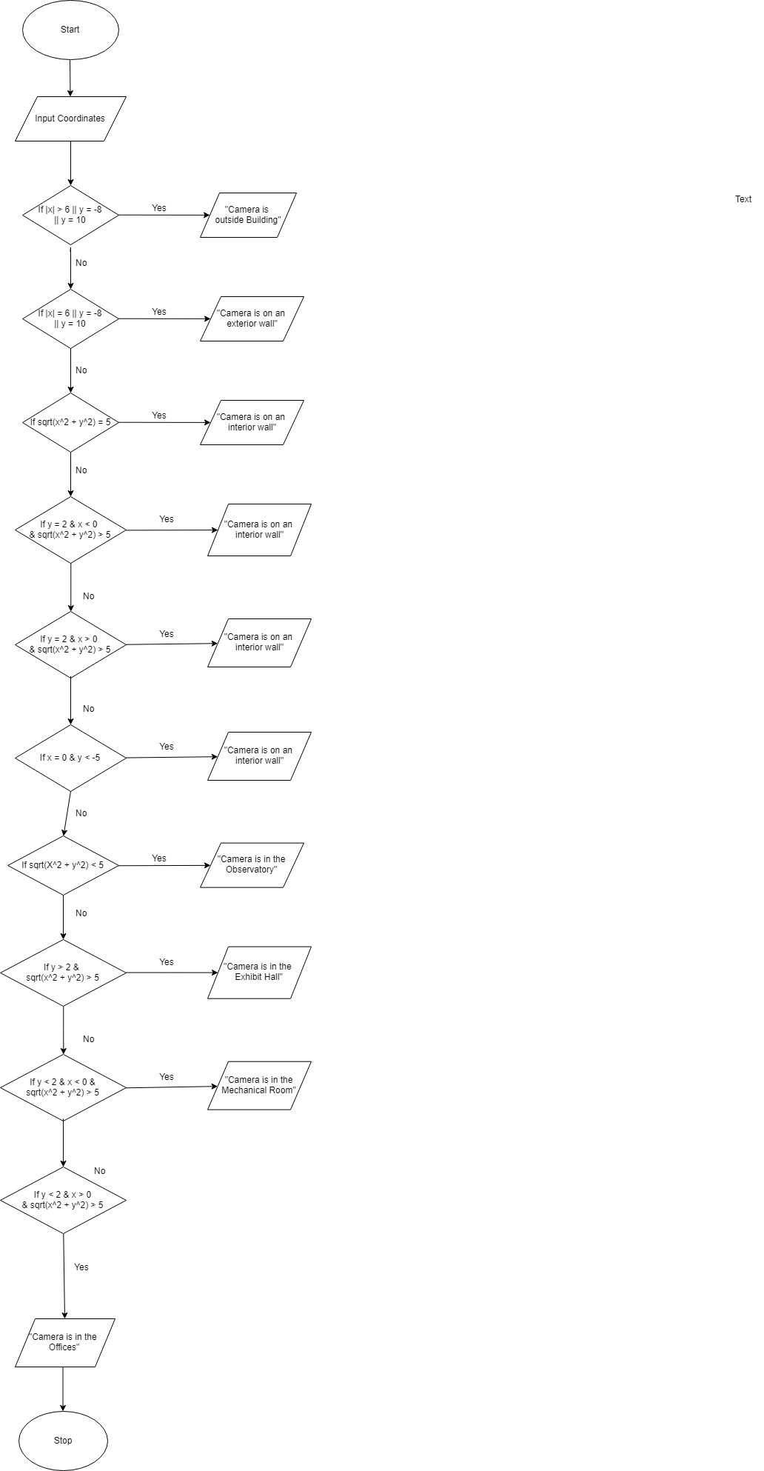

### Coding Paired Partner

Each member of the pair will submit their own answer sheet. List your paired partner here.

|  |  |
| --- | --- |
| Coding Partner: | <Dong Lee>, <lee3034> |

### Test Cases

A test case is a value or set of values that you use to test the completeness of the decisions in your code or flowchart structure. You need to select a set of test cases, with at least one test case for each decision path in your structure. You can use the test cases to help you test whether or not your structure addresses all the possible decision paths required by the problem.

Fill out the table with test case information.

* The *Test Case Description* is an English description of what path is being tested.
* The *Test Case Values* are the values you will use to test the path in the structure or flowchart.
* The *Flowchart Output* is an English description of the flowchart’s result when the test case values go through the structure; it should not be code or MATLAB generated results.
* Add as many rows as necessary to test all possible flowchart paths.
* An example test case is included.

Note: you will also use these test cases to test your completed code

|  |  |  |
| --- | --- | --- |
| **Test Case Description**  **in English** | **Test Case Values**  **(x location, y location)** | **Flowchart Output**  **in English** |
| Test a location inside the exhibit hall:  Anywhere in the rectangle defined by -6 < x < 6 and 2 < y < 10 that is also not on the overlapping observatory area | X = 0, Y = 7 | Camera is in the exhibit hall |
| outside | X = -7, y = -9 | Camera is outside building |
| Exterior wall | x = 6, y = 0 | Camera is on the exterior wall |
| Interior Wall | x = 5.5, y = 2 | Camera is on the interior wall |
| Observatory | x = 0, y = 0 | Camera is in the observatory |
| Mechanical Room | x = -5, y = -6 | Camera is in the Mechanical room |
| Office | x = 5, y = -6 | Camera is in the offices |

### Flowchart and Code Comparison

Examine how well your code follows your flowchart. Explain any differences between the code and the flowchart, and state why those changes were necessary.

|  |
| --- |
|  |

The code follows the flowchart up till the exterior wall, however we had to modify the code for the interior wall from (If y =2 & x < 0 & sqrt(x^2 + y^2) >5 ) to if (y == 2 && x > -6 && x < 6) && (sqrt(x^2 + y^2) > 5). This is because the pervious statement didn’t hold for all possible cases and was giving us wrong locations. The changed statement replaced x < 0 to x > -6 && x < 6 so we could cover all of the possible values. We also changed the statements for the exhibit hall from (x > -6 && x < 6) && (y > 2) && sqrt(x^2 + y^2) > 5 to (x > -6 && x < 6) && (y > 2 && y < 10) && sqrt(x^2 + y^2) > 5, so we could account for all values of y. Lastly we had to change the statement for the mechanical room from ((y < 2)&& (x < 0 && x > -8)) && sqrt(x^2 + y^2) > 5 to ((y < 2 && y > -8)&& (x < 0 && x > -8)) && sqrt(x^2 + y^2) > 5 ,so we could account for all values of y.

## Academic Integrity

**Individual**

### Test Cases

A test case is a value or set of values that you use to test the completeness of the decisions in your code or flowchart structure. You need to select a set of test cases, with at least one test case for each decision path in your structure. You can use the test cases to help you test whether or not your structure addresses all the possible decision paths required by the problem.

Fill out the table with test case information.

* The *Test Case Description* is an English description of what path is being tested.
* The *Test Case Values* are the values you will use to test the path in the structure or flowchart.
* The *Flowchart Output* is an English description of the flowchart’s result when the test case values go through the structure; it should not be code or MATLAB generated results.
* Add as many rows as necessary to test all possible flowchart paths.
* An example test case is included.

Note: you will also use these test cases to test your completed code

|  |  |  |
| --- | --- | --- |
| **Test Case Description**  **in English** | **Test Case Values**  ([string_array]) | **Flowchart Output** |
| Test the function with not a string | string_array = 1 | Displays the error message that the input is not a string |
| Test the function with one name | string_array = “student 1” | Displays the academic integrity statement signed by “student 1” |
| Test the function with two names | string_array = “student 1”, “student 2” | Displays the academic integrity statement signed by “student 1”, and “student 2” |
| Test the function with three names | string_array = “student 1”, “student 2”, “student 3” | Displays the academic integrity statement signed by “student 1”, “student 2”, and “student 3” |
| Test the function with four names | string_array = “student 1”, “student 2”, “student 3”, “student 4” | Displays the academic integrity statement signed by “student 1”, “student 2”, “student 3”, and “student 4” |
| Test the function with five names | string_array = “student 1”, “student 2”, “student 3”, “student 4”, “student 5” | Displays the academic integrity statement signed by “student 1”, “student 2”, “student 3”, “student 4”, and “student 5” |
| Test the function with more than five names | string_array = “student 1”, “student 2”, “student 3”, “student 4”, “student 5”, “student 6” | Displays an error message that states the number of names doesn’t match an expected value |

## Storage Tank Volume

**Individual**

**PS07_tankVolume_login.m Flowchart**

### 

### Test Cases

A test case is a value or set of values that you use to test the completeness of the decisions in your code or flowchart structure. You need to select a set of test cases, with at least one test case for each decision path in your structure. You can use the test cases to help you test whether or not your structure addresses all the possible decision paths required by the problem.

Fill out the table with test case information.

* The *Test Case Description* is an English description of what path is being tested.
* The *Test Case Values* are the values you will use to test the path in the structure or flowchart.
* The *Flowchart Output* is an English description of the flowchart’s result when the test case values go through the structure; it should not be code or MATLAB generated results.
* Add as many rows as necessary to test all possible flowchart paths.
* An example test case is included.

Note: you will also use these test cases to test your completed code

|  |  |  |
| --- | --- | --- |
| **Test Case Description**  **in English** | **Test Case Values**  **(fluid height (m), orientation)** | **Flowchart Output**  **in English** |
| Test when the tank is horizontal, and the fluid height is any value  0 m ≤ fluid height ≤ 3.25 m | Fluid height = 3  Orientation = ‘h’ | Fluid volume = 166.8532 3 |
| Test when the tank is vertical, and the fluid height is any value  19.425 m ≤ fluid height ≤ 21.1 m | Fluid height = 20  Orientation = ‘v’ | Fluid volume = 171.1623 $m^{3}$ |
| Test when the tank is vertical, and the fluid height is any value  1.675 m ≤ fluid height ≤ 19.425 m | Fluid height = 15  Orientation = ‘v’ | Fluid volume = 127.2907 $m^{3}$ |
| Test when the tank is vertical, and the fluid height is any value  0 ≤ fluid height ≤ 1.675 m | Fluid height = 1  Orientation = ‘v’ | Fluid volume = 4.2150 $m^{3}$ |
| Test when either the orientation isn’t vertical or horizontal or when the height is outside range | Fluid height = 1  Orientation = ‘s’ | Fluid volume = -1 |
|  |  |  |

### Flowchart and Code Comparison

Examine how well your code follows your flowchart. Explain any differences between the code and the flowchart, and state why those changes were necessary.

The code follows the flowchart perfectly and there was no need to have any changes to what is seen from the flowchart.

|  |
| --- |
|  |