IQR –Report

Lesser outlier=Q1-1.5*IQR

Greater outlier =Q3+1.5*IQR

Why 1.5?

Multiplying it by 1.5 is a way to identify data points that are reasonably far from this middle spread

It’s a good balance — it doesn’t consider normal differences in data as outliers.

But it does catch numbers that are **much higher or much lower** than most of the data.

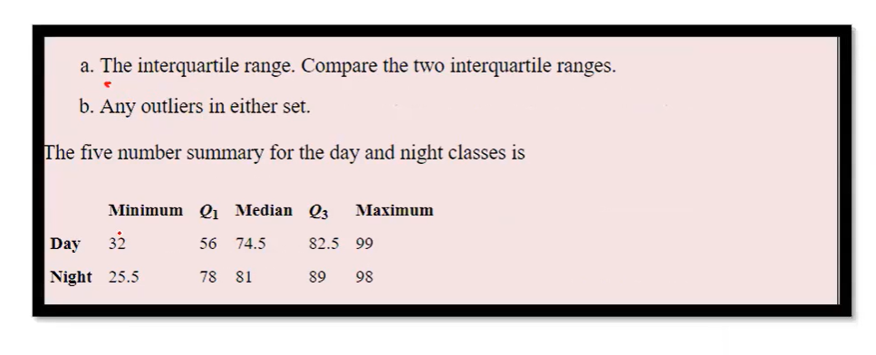

Day

Q3=82.5

Q1=56

IQR=Q3-Q1

82.5-56=26.5

Lesser outlier=Q1-1.5*IQR

56-1.5*26.5

=56-39.75

16.25

Greater outlier =Q3+1.5*IQR

82.5+1.5*26.5

82.5+39.75

122.25

None of the values are less than lesser outlier and none of the values are greater than greater outlier,Hence there is no outlier

Night

Q1=78,q3=89

Q3-q1=11

IQR

Lesser outlier=q1-1.5*IQR

78-1.5(11)=78-16.5=61.5

Greater outlier=q3+1.5*IQR

89+1.5*(11)=105.5

**The value 25.5 is lesser than lesser outlier value ,hence it is a outlier.**