Visualisation tool for electric vehicle charge and range analysis

 

Project submitted to the

**Project Based Experimental learning Naan Mudhalvan-Smart internz**

**Submitted by**

**(Team ID:NM2023TMID27118)**

**Team size:2**

**Team Leader : RANJANI E**

**Team member: Sharmila P**

Under the supervision and guidance of

**Mr.N.RAGURAMAN,M.SC.,M.Phil.,B.Ed.,**

**UG DEPARTMENT OF MATHEMATICS**

**DHIVYA ARTS AND SCIENCE COLLEGE**

**CHETPET-606 801**

**2023**

VISUALIZATION TOOL FOR ELECTRIC VEHICLE CHARGE AND RANGE ANALYSIS

INTRODUCTION:

# Overview:

A vehicle that can be powered by an electric motor that draws electricity from a battery. It is capable of being charged from an external source and have an electric motor instead of an internal combustion engine. The Electric Vehicle (EV) is not new. It has been receiving significantly more attention in recent years. Advances in both EV analytics and battery technologies have led to increased automotive market share.

**Purpose:**

The modern mechatronic vehicle marries electrical storage and propulsion systems with electronic sensors, controls, and actuators, integrated closely with software secure data transfer, and data analysis. To form a comprehensive transportation solution. Advances in all these areas have contributed to the overall rise of EVs, but the common thread that runs through all these elements is data analytics. The new EV's are combined Electrical storage and propulsion systems with electronic sensor, controls, and actuators, integrated closely with software, secure data transfer to form a comprehensive transportation solution.

# PROBLEM DEFINITION AND DESIGN THINKING

**EMPATHY MAP:**



**Ideation & Brainstorming Map:**



**RESULT:**





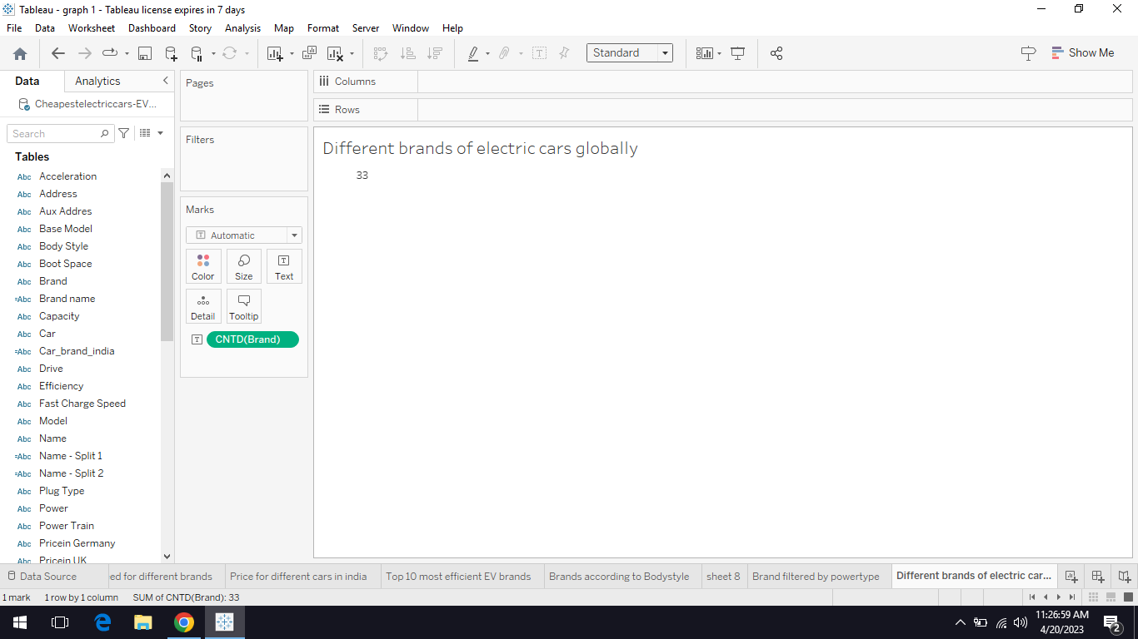

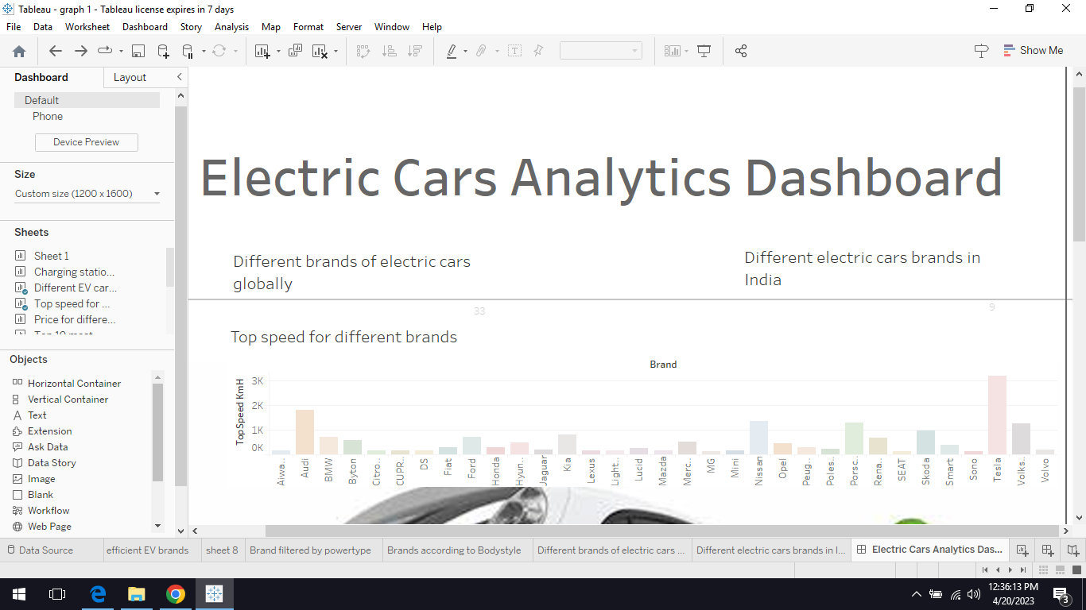





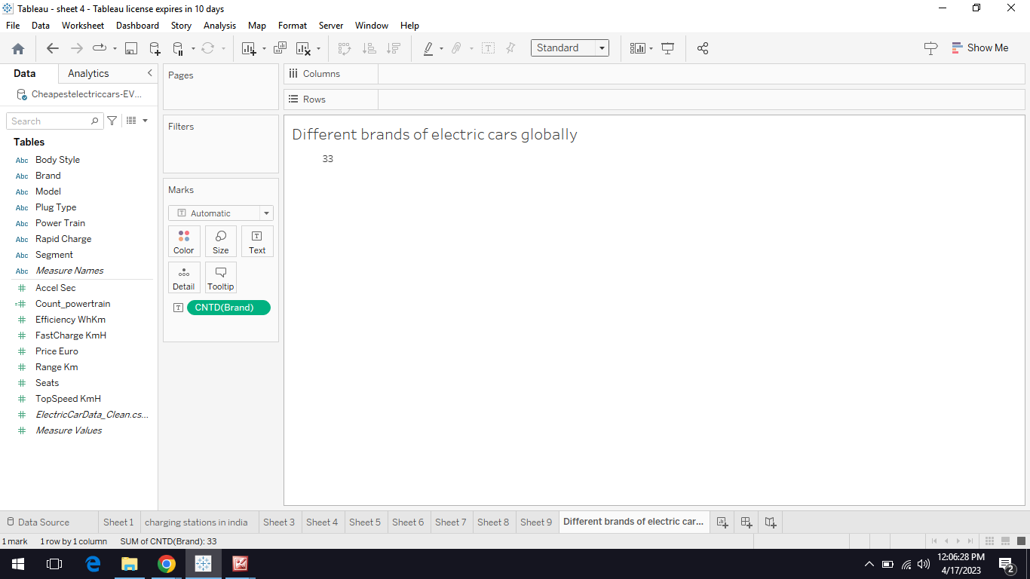







## ADVANTAGES & DISADVANTAGES:

## Advantages of Electric Vehicle:

1. Lower running cost
2. Low maintenance cost
3. Zero Tailpipe Emissions
4. Petrol and diesel use is destroying our planet

## Lower running cost:

1. The running cost of an electric vehicle is much lower than an equivalent petrol or diesel vehicle.
2. Electric vehicles use electricity to charge their battery.
3. Instead of using fossil fuels like petrol or diesel.
4. Using renewable energy sources can make the use of electric.
5. vehicles more eco-friendly.

## Low maintenance cost:

1. Electric vehicles have very low maintenance costs .
2. They don't have as many moving parts as an internal combustion vehicle.
3. The requirements for

electric vehicles are lesser than the conventional petrol or diesel vehicles.

1. The cost of running an electric vehicle is significantly low.

## Disadvantages of Electric Vehicle:

The biggest problem with Electric Vehicle. They are,

Battery problem

Climate condition. In-car electronics

## Battery issues:

Battery degradation over time. The capacity decreases overtime by approximately 2.3% every year. Battery is highly dependent on temperature. EV batteries are actually lasting much longer than originally battery.

## Climate Control:

Electric climate control system has been decreasing the range of vehicles. They are inefficient. In winter, drivers are likely to see less efficiency in their car heating systems. While the climate control system in petrol and diesel cars are generally no more efficient.

## In-Car Electronics:

Failing temperature sensors to faculty electric doors.

Many EV drivers have complained of problems with their in-car electronics. The other electronics such as temperature sensors are critical. To ensuring the battery is operating within safe limits.

## APPLICATIONS

## Applications of EV:

As the adoption of plug-in electric vehicles is affected by

consumer demand market prices availability of charging infrastructure

government policies purchase incentives long term regulatory signs.

All electric vehicles use lithium-ion battery. Electric Vehicles use electricity to charge their batteries. Electric vehicles are more efficient and combined with the electricity cost. Many European Countries are quite active in promoting their use, especially Norway. Netherland is a United States, and they also use a lot of electric cars.

**CONCLUSION:**

The progress that the electric vehicle industry has seen in recent years is not only extremely welcomed, but highly necessary considering the increasing global greenhouse gas levels. As demonstrated within the economic, social, and environmental analysis sections of this webpage, the benefits of electric vehicles far surpass the costs. The biggest obstacle to the widespread adoption of electric powered transportation is cost related, as gasoline and the vehicles that run on it are readily available, convenient, and less costly. As is demonstrated in our timeline , we hope that over the course of the next decade technological advancements and policy changes will help ease the translon from traditional fuel-powered vehicle’s. Additionally, the realization and success of this industry relies heavily on the transition from traditional fuel-powered vehicles.

Additionally, the realization and success of this industry relies heavily on the global population, and it is our hope that through mass marketing and environmental education programs people will feel incentivized and empowered to drive an electric-powered vehicle. Each person can make a difference, so go electric and help make a difference.

# FUTURE SCOPE:

**Service and Product Global Mobility forecasts:**

Service and Product Global Mobility forecasts electric vehicle sales in the United States could reach 40 percent of total passenger car sales by 2033. More optimistic projections foresee electric vehicle sales surpassing 50 percent by 2030. Occupations employed in the design and development of electric vehicles: Some of the occupations that will play pivotal roles in the design and development of electric cars are computer and development of electric cars are computer and engineering occupations. Computer occupations create or support computer applications and networks.

While engineers design and develop structures or products. Designing an electric car may involve the contribution of several types of engineers. Software developers and other computer occupations develop an electric car's software and computer hardware.

## Software developers:

Software developers create the computer

applications that run EVs such as battery management systems. EVs will become more technologically advanced over time. Employment of software developers is projected to grow by 26.0 percent from 2021 to 2031. Which is much faster than the average for all occupations.

**Electrical engineers:**

Develop EV electric systems and parts, including the

motor. These engineers work in the generation and distribution of electricity. To research and improve the performance of vehicle power electronics. The electrical circuitry that controls the flow of electrical energy from the battery to the vehicle. Electrical engineers may also work on EV battery technology or in the design.

## Electronics Engineer:

They are responsible for designing electric vehicle

control systems, such as the driver infotainment system, and the electronics. That enable advanced driver safety systems such as automatic braking and collision prevention and battery management systems. Advanced features mean more sophisticated electronics will be incorporated into new electric vehicles. Automakers will need the expertise of electronics engineers to develop and test these electronics components.

**CHEMICAL ENGINEER**

Design processes and equipment for large-scale manufacturing of electric vehicle batteries. Plan, and test production methods, and direct batter-making operations in manufacturing plan. Chemical engineers will be in demand to develop advanced battery materials. The next generation of electric batteries that can recharge faster or can store more energy. The Economic Survey 2023 predicts that India's domestic electric vehicle market will see a 49 percent Compound Annual Growth Rate (CAGR) between 2022 and 2023, with 10 million direct and indirect job by 2030. The Indian government has set a target to achieve 30 percent electrification of the country's vehicle fleet by 2030, and has introduced several incentives. The policies to support the growth of the EV industries.

The industry was given a major boost in the FY24 Union Budget for the production of electric vehicles, adoption of hydrogen fuel, and embracing changing technologies. India's electric vehicle market is poised for significant growth in the coming years. With supportive government policies, increasing consumer awareness, and advancements in technology, the country is well positioned to transition towards a more sustainable and eco-friendly mode of transportation. As the demand for EVs increases, it presents a tremendous opportunity for both local and international companies to invest in and contribute to the growth of India's EV ecosystem.

## APPENDIX:

## Source Code:

We use a many source to create the project of "Electric Vehicle Charge And Range Analysis".

Web application like Mural app, GitHub, Tableau, etc,..