**ABN Mobile Automation Assignment <Android>**

**INFOSYS -** [**Sivaranjani_s09@infosys.com**](mailto:Sivaranjani_s09@infosys.com) **[Technology Analyst]**

**Employee ID: 654799**

**Mobile Automation Exercise to validate Android Reference Page Elements on Mobile Application with the Toolset Composed of**

* **Appium – Automating Mobile Application**
* **Java – Programming Language**
* **Maven – To add project dependencies**
* **Log4J – To Log the results in Console / File**
* **TestNG – Reporting**

**PROJECT DESCRIPTION:**

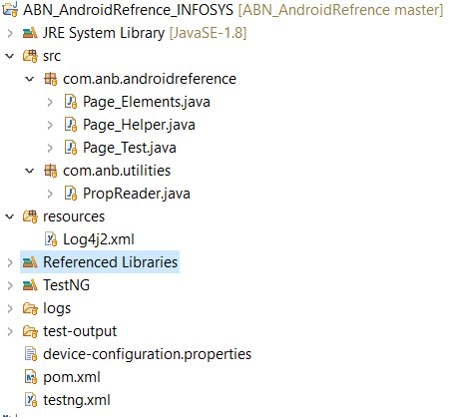

**Scenario: To Validate Android Reference Page Elements**

**Page_Test:**

* **Contains only the methods to be executed, which calls the function in helper class to validate the tests**

**Page Helper:**

* **Methods - Implementation of test steps.**
  + android_Reference_Page_Elements

**The above method contains all the validation of Android Reference Page elements. Each Test Steps returns the status pass /fail using logger.**

* **The Methods related to driver Operations used in the project** 
  + getElementPresence
  + locateElement
  + getAttribute
  + click

**The above functions can be used universally in the project for performing operation on the elements and which is implemented in such a way it handles exceptions during execution.**

* **Log4j – to log status in Console / File**
  + logStatusFail
  + logStatusPass
  + getScreenshotAs – **Captures Screenshots for Failed Test Cases.**
* **The above methods are used in each test step based on the status of the test, which logs Test Description / Actual Behaviour / Expected Behaviour /Status of the test.**
* logStatusFail **has** getScreenshotAs **function which captures screenshot for the failed test step and store it under** screenshot **folder in project directory .**
* **Log file will be generated for the generated for the failed Test Steps.**

**Page Elements:**

* **Has all the page elements of page following Page Object Model.**
* **Common methods are written to generate XPath, which returns XPathString based on the Element Type and Attribute.**
  + getXPath_lbl_ByText
  + getXPath_lbl_ByImage

**The above functions can be used to generate Xpath with similar element and Attribute type by passing the Attribute value dynamically - by this way we can have to methods written in common with combinations in the project framework and can be used universal in project.**

**Prop Reader:**

* **Property file holds all the data related to device configurations and with** getProperty **function of Properties we will be able to access the file properties be loading it.**

**How to Run the Test?**

**Right Click on testng.xml -> Run as -> TestNG Suite -> After the Test Run -> Refresh the project -> Report will be generated under test-output folder.**

* **User will be displayed with all the Test Step with Description / Actual /Expected / Status of the test – Pass / Fail**
* **Prints the XPathString or ID of each element and the operations involved without throwing any exception, which gives more understating to the tester during execution of the test.**
* **Logs the failed Test Step in Log file along with the screenshot under Screenshot folder.**