1. Display all doctors and their specializations.

SELECT doctors_name, specialization
FROM doctors;

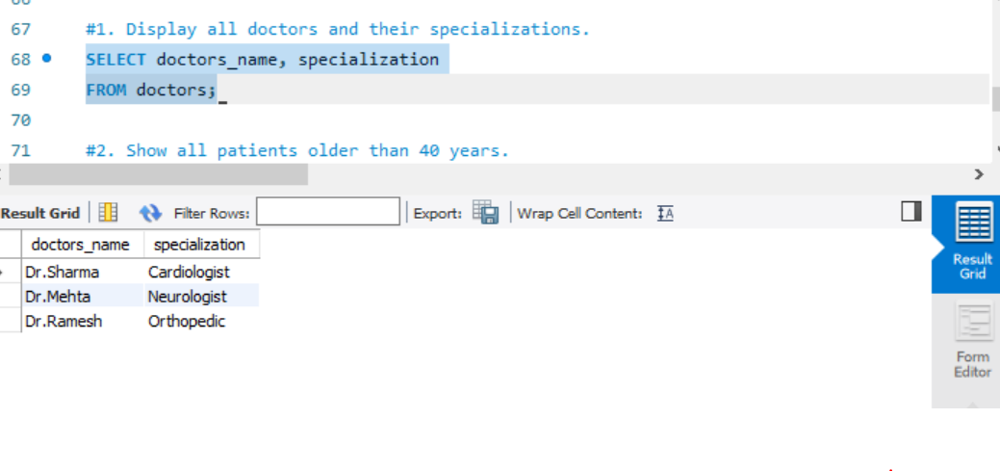SELECT doctors_name, specialization
FROM doctors;

2. Show all patients older than 40 years.
SELECT * FROM patient
WHERE patient_age>40;
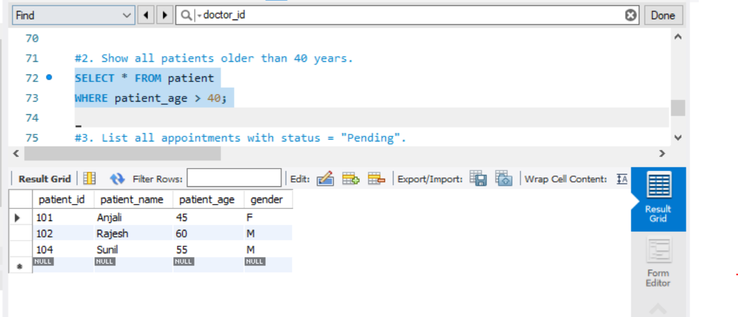

3. List all appointments with status = "Pending".

SELECT * FROM appointment
WHERE appointment_status=”Pending”;
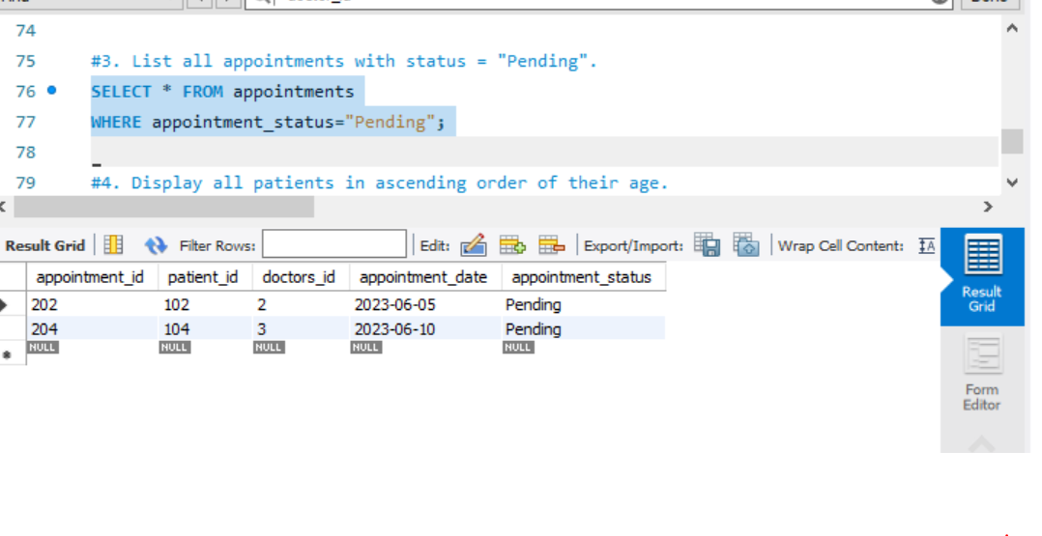

4. Display all patients in ascending order of their age.
SELECT * FROM patients
ORDER BY patients and patients_age;

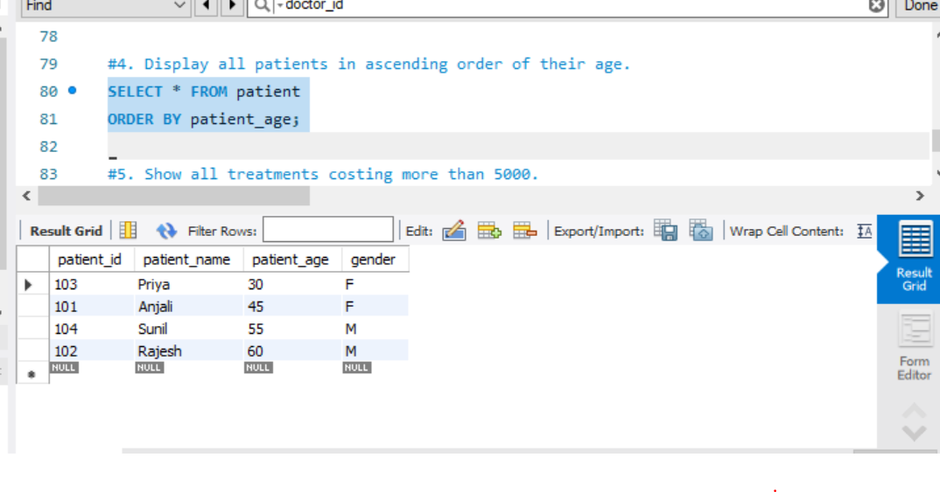

5. Show all treatments costing more than 5000.
SELECT * FROM treatment
WHERE treatment_cost > 5000;
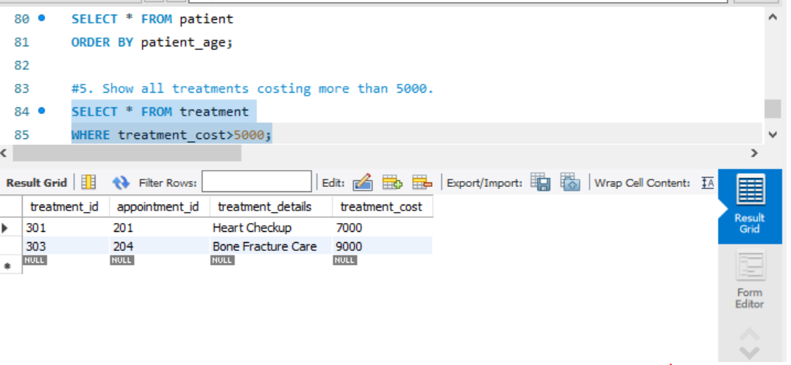
6. Display the names of doctors who have more than
10 years of experience.
SELECT doctors_name
FROM doctors
WHERE experience_year > 10;
