1. What is a test, and why do we use JUnit?
“Testing is the process of checking whether our application works as expected. In Java, we write test cases to verify that our methods produce the correct output for different inputs.
JUnit is a testing framework for Java that helps us write and execute tests automatically. It provides annotations to identify test methods and assertions to check whether the actual output matches the expected output.
We use JUnit to find bugs early, reduce manual testing, and make sure that new code changes do not break existing functionality. This is especially useful in real projects, where developers frequently modify code.”

Real-life example
Imagine we are developing an e-commerce website. When a customer purchases a product worth ₹1,000 with a 10% discount, the final price should be ₹900.
Instead of manually checking this calculation every time we change the code, we can write a JUnit test that checks the result automatically.

Java code
First, write the business logic:
DiscountCalculator.java
package com.example;

public class DiscountCalculator {

public double calculateFinalPrice(
double price, double discountPercent) {

if (price < 0) {
throw new IllegalArgumentException(
"Price cannot be negative");
}

if (discountPercent < 0 || discountPercent > 100) {
throw new IllegalArgumentException(
"Invalid discount percentage");
}

return price - (price * discountPercent / 100);
}
}
Now write the JUnit test:
DiscountCalculatorTest.java
package com.example;

import org.junit.jupiter.api.Test;

import static org.junit.jupiter.api.Assertions.*;

class DiscountCalculatorTest {

private final DiscountCalculator calculator =
new DiscountCalculator();

@Test
void shouldCalculateFinalPriceAfterDiscount() {

double actual =
calculator.calculateFinalPrice(1000, 10);

assertEquals(900.0, actual, 0.001);
}

@Test
void shouldRejectDiscountAbove100Percent() {

assertThrows(
IllegalArgumentException.class,
() -> calculator.calculateFinalPrice(1000, 150)
);
}
}
How to explain the code in an interview:
“In the first test, I pass a price of ₹1,000 and a discount of 10%. The expected result is ₹900, so I use assertEquals() to compare the expected and actual results.
In the second test, I pass an invalid discount of 150%. I use assertThrows() to verify that the method throws an IllegalArgumentException.
This way, I test both normal behaviour and invalid input automatically.” JUnit Jupiter provides test annotations and assertions for these purposes. 【turn326473view0】

Likely follow-up questions
Q. What is unit testing?
“Unit testing means testing a small, individual part of an application, such as a method or class, separately from other parts.”
Q. What is the difference between manual testing and automated testing?
“Manual testing requires a person to execute test steps, whereas automated testing uses code or tools to execute predefined tests and check the results.”
Q. Does JUnit test the entire application automatically?
“No. We have to write the test cases ourselves. JUnit provides the framework to execute them and check whether they pass or fail.”

2. What is Maven?

Interview-ready answer
“Maven is a build automation and project management tool mainly used in Java projects.
It helps us manage project dependencies, compile source code, run tests, package the application into a JAR or WAR file, and manage the overall build process.
Maven uses a configuration file called pom.xml, which stands for Project Object Model. In this file, we define project information, dependencies, and build configurations.
For example, if I want to use JUnit in my Java project, I can add the JUnit dependency in pom.xml. Maven downloads the required library and makes it available to the project, so I don't have to manage the library manually.”
Maven's standard project structure separates application code from test code, and its build lifecycle coordinates tasks such as compilation and testing. 【turn116048search0】【turn326473view1】

Real-life example
Imagine you are working on a Java project with five developers. Everyone needs the same JUnit library to run the tests.
Without dependency management, team members might have to download and configure libraries separately. With Maven, we declare the dependency in pom.xml, and Maven resolves it for the project.

Important Maven configuration
Add the following inside your project's pom.xml:
<dependencies>
<dependency>
<groupId>org.junit.jupiter</groupId>
<artifactId>junit-jupiter</artifactId>
<version>5.13.1</version>
<scope>test</scope>
</dependency>
</dependencies>

<build>
<plugins>
<plugin>
<groupId>org.apache.maven.plugins</groupId>
<artifactId>maven-surefire-plugin</artifactId>
<version>3.5.3</version>
</plugin>
</plugins>
</build>
These are example versions for a JUnit 5 project, not a claim that they are the latest releases.
What does this configuration mean?
- groupId and artifactId identify the JUnit library.
- version specifies the library version.
- scope=test means the dependency is intended for testing and isn't required as a normal runtime dependency of the packaged application.
- maven-surefire-plugin helps Maven discover and execute unit tests during the test phase.

Standard Maven folder structure
my-project/
│
├── pom.xml
└── src/
├── main/
│ └── java/
│ └── com/example/
│ └── DiscountCalculator.java
│
└── test/
└── java/
└── com/example/
└── DiscountCalculatorTest.java

Important commands to remember
Command | Purpose
mvn clean | Removes generated build files.
mvn compile | Compiles the main source code.
mvn test | Compiles test code and runs tests.
mvn package | Packages the application after the preceding required phases.
mvn install | Installs the built artifact in the local Maven repository.

Likely follow-up questions
Q. What is pom.xml?
“pom.xml is Maven's main project configuration file. It contains project details, dependencies, and build configuration.”
Q. What is a dependency in Maven?
“A dependency is an external library that our project needs. For example, JUnit is a dependency used for testing Java code.”
Q. How do you run JUnit tests using Maven?
“I open the terminal in the directory containing pom.xml and run mvn test. Maven builds the required parts of the project and executes the configured tests.” 【turn116048search1】【turn326473view1】

3. What are assertions and annotations in JUnit 5?
This question has two separate concepts, so explain them separately in the interview.

A. Assertions
Interview-ready answer
“Assertions are methods used to verify whether the actual result of a test matches the expected result. If the assertion succeeds, that check passes. If it fails, JUnit marks the test as failed and reports the mismatch.”
Think of an assertion as a quality check: Did the application produce the result we expected?

Common assertion methods
Assertion | Purpose
assertEquals(expected, actual) | Checks whether two values are equal.
assertTrue(condition) | Checks whether a condition is true.
assertFalse(condition) | Checks whether a condition is false.
assertNull(value) | Checks whether a value is null.
assertNotNull(value) | Checks whether a value is not null.
assertThrows(Exception.class, ...) | Checks whether the expected exception is thrown.
assertAll(...) | Executes multiple assertion checks in one grouped test.
These are provided by JUnit's Assertions API. 【turn326473view0】

Example
import org.junit.jupiter.api.Test;

import static org.junit.jupiter.api.Assertions.*;

class AssertionTest {

@Test
void testAssertions() {

assertEquals(900.0, 900.0, 0.001);

assertTrue(10 > 5);

assertFalse(10 < 5);

assertNotNull("JUnit");

assertNull(null);
}
}
How to explain it:
“Here, I verify equality, true and false conditions, and null values. JUnit reports the test as failed if any assertion fails.”

B. Annotations
Interview-ready answer
“Annotations are metadata that tell JUnit how to identify and execute test-related methods. We use annotations such as @Test, @BeforeEach, and @AfterEach to mark test methods and control the test lifecycle.”

Common JUnit 5 annotations
Annotation | Meaning
@Test | Marks a method as a test method.
@BeforeEach | Runs before each test method.
@AfterEach | Runs after each test method.
@BeforeAll | Runs once before all test methods in the class.
@AfterAll | Runs once after all test methods in the class.
@Disabled | Prevents a test from running.
@DisplayName | Gives a test or test class a readable name.
@ParameterizedTest | Runs a test with multiple sets of arguments.
【turn326473view0】

Example
import org.junit.jupiter.api.Test;
import org.junit.jupiter.api.DisplayName;

import static org.junit.jupiter.api.Assertions.assertEquals;

class CalculatorTest {

@Test
@DisplayName("Add two numbers")
void shouldAddNumbers() {

int result = 10 + 20;

assertEquals(30, result);
}
}
How to explain it:
“Here, @Test tells JUnit that shouldAddNumbers() is a test method. @DisplayName gives the test a human-readable name, and assertEquals() checks the result.”

Most important follow-up question
Q. What is the difference between an assertion and an annotation?
“An annotation tells JUnit what a method is or when it should run, while an assertion checks whether the program's behaviour or output is correct.”
Remember this distinction:
- Annotation = identifies or configures the test.
- Assertion = checks the result of the test.

4. Explain the JUnit 5 test lifecycle.

Interview-ready answer
“The JUnit test lifecycle is the sequence of steps performed before, during, and after test execution.
JUnit 5 provides lifecycle annotations that help us initialize test objects, prepare test data, execute test methods, and perform cleanup.
The main lifecycle annotations are @BeforeAll, @BeforeEach, @Test, @AfterEach, and @AfterAll.
For example, if I am testing a login service, I can use @BeforeEach to prepare the test data before every test and @AfterEach to clean up any resources used by that test.”

Test lifecycle order
1. @BeforeAll
Runs once before all tests in the class.
2. @BeforeEach
Prepares the test before each test method.
3. @Test
Executes the test logic and assertions.
4. @AfterEach
Cleans up after each test method.
5. @AfterAll
Runs once after all tests in the class.
Steps 2–4 repeat for each test method. The order in which multiple test methods run is not guaranteed by default, so tests should not depend on a particular order. 【turn326473view0】

Java code example
import org.junit.jupiter.api.*;

class LifecycleTest {

@BeforeAll
static void beforeAll() {
System.out.println("Before all tests");
}

@BeforeEach
void beforeEach() {
System.out.println("Before each test");
}

@Test
void testOne() {
System.out.println("Executing test one");
}

@Test
void testTwo() {
System.out.println("Executing test two");
}

@AfterEach
void afterEach() {
System.out.println("After each test");
}

@AfterAll
static void afterAll() {
System.out.println("After all tests");
}
}

What will happen when this code runs?
Conceptually, the output follows this sequence:
Before all tests

Before each test
Executing test one
After each test

Before each test
Executing test two
After each test

After all tests
The two test methods could execute in the opposite order; their default order is not guaranteed.
Important interview detail: In JUnit 5, @BeforeAll and @AfterAll methods are normally static. They can be non-static when the test class uses @TestInstance(TestInstance.Lifecycle.PER_CLASS).

Real-life example
Suppose we are testing an online shopping application:
- @BeforeAll: Initialize expensive shared test infrastructure.
- @BeforeEach: Prepare a fresh shopping cart for a test.
- @Test: Check adding a product to the cart.
- @AfterEach: Clear test data or close resources.
- @AfterAll: Shut down shared test infrastructure.
The exact setup depends on the application; for example, database cleanup belongs in the appropriate cleanup method only when the test actually uses a database.

Likely follow-up questions
Q. What is the difference between @BeforeAll and @BeforeEach?
“@BeforeAll runs once for the whole test class, whereas @BeforeEach runs before every test method.”
Q. Why do we use @AfterEach?
“To clean up test-specific state and resources, which helps prevent one test from affecting another.”

5. Explain the architecture of JUnit 5.

Interview-ready answer
“JUnit 5 architecture consists of three main components: JUnit Platform, JUnit Jupiter, and JUnit Vintage.
The JUnit Platform provides the foundation for discovering and launching tests. JUnit Jupiter provides the programming model, annotations, and test engine used to write and execute JUnit 5-style tests. JUnit Vintage provides an engine for running older JUnit 3 and JUnit 4 tests on the JUnit Platform.
Together, these components allow modern and legacy tests to run through a common testing platform.” 【turn326473view0】

Understand the three components

JUnit Platform
Foundation for discovering, launching, and executing tests through test engines.
JUnit Jupiter
Modern JUnit 5-style tests, annotations, assertions, and the Jupiter test engine.
JUnit Vintage
A test engine for legacy JUnit 3 and JUnit 4 tests.
Both engines can be used through the Platform when the necessary dependencies are present.

1. JUnit Platform
“The Platform is the foundation that test-launching tools use to discover and run supported tests. For example, Maven or an IDE can use the Platform to execute tests.”

2. JUnit Jupiter
“Jupiter is what I mainly use when writing tests with JUnit 5. It provides annotations such as @Test, lifecycle annotations, and a test engine that executes those tests.”
Example:
@Test
void shouldReturnCorrectPrice() {
assertEquals(900.0, 900.0, 0.001);
}
This uses the Jupiter programming model and assertion API.

3. JUnit Vintage
“Vintage is useful when an existing project has older JUnit 3 or JUnit 4 tests that need to run on the JUnit Platform. We need the appropriate Vintage and legacy JUnit dependencies for that.”

How do they work together in a real project?
For example, when you execute mvn test in a configured Maven project:
- Maven's test plugin discovers and launches the configured tests.
- The JUnit Platform provides the test execution foundation.
- The Jupiter engine executes JUnit 5-style tests.
- If Vintage is configured, its engine can execute compatible JUnit 3 or JUnit 4 tests as well.
- Maven reports the results, including failures.
Remember the architecture as:
- Platform: Launching and execution foundation.
- Jupiter: Writing and running modern JUnit tests.
- Vintage: Running legacy JUnit 3 and JUnit 4 tests.

Final interview revision
Question | One-line answer to remember
What is testing, and why JUnit? | Testing checks expected behaviour; JUnit automates Java test execution and result verification.
What is Maven? | A Java build automation and project management tool that manages dependencies and build tasks.
What are assertions? | Methods that verify test results and expected behaviour.
What are annotations? | Metadata that identifies or configures test methods and lifecycle behaviour.
What is the test lifecycle? | Setup, test execution, and cleanup managed through lifecycle annotations.
What is JUnit 5 architecture? | JUnit Platform + JUnit Jupiter + JUnit Vintage.
My interview tip: Learn the spoken answer first, then practise the DiscountCalculator example without looking at the code. If the interviewer asks you to demonstrate JUnit, explain @Test, assertEquals(), and assertThrows() while writing the test. These demonstrate both the concept and practical usage.
For reference, use the official JUnit 5 User Guide and Apache Maven Getting Started Guide.

JUnit 5 Interview Questions — To the Point

1. What is testing, and why do we use JUnit?
Interview answer:
“Testing means checking whether our code works as expected. JUnit is a Java testing framework that helps us test our code automatically, find bugs early, and ensure that changes do not break existing functionality.”
Real-life example: In an online shopping application, a ₹1,000 product with a 10% discount should cost ₹900.
import org.junit.jupiter.api.Test;
import static org.junit.jupiter.api.Assertions.assertEquals;

class DiscountTest {

@Test
void testDiscount() {
double finalPrice = 1000 - (1000 * 10 / 100.0);

assertEquals(900.0, finalPrice, 0.001);
}
}
Explain the code: @Test marks the test method, and assertEquals() checks whether the actual result matches the expected result.

2. What is Maven?
Interview answer:
“Maven is a Java build automation and project management tool. It manages dependencies, compiles code, runs tests, and packages applications. We configure Maven using the pom.xml file.”
Real-life example: Instead of manually downloading the JUnit library, we add its dependency to pom.xml, and Maven manages it for our project.
<dependency>
<groupId>org.junit.jupiter</groupId>
<artifactId>junit-jupiter</artifactId>
<version>5.13.1</version>
<scope>test</scope>
</dependency>
Run tests using:
mvn test

3. What are assertions and annotations in JUnit?
Interview answer:
“Annotations tell JUnit which methods to execute and when to execute them. Assertions check whether the actual result matches the expected result.”
Common annotations: @Test, @BeforeEach, @AfterEach, @BeforeAll, @AfterAll.
Common assertions: assertEquals(), assertTrue(), assertFalse(), assertNotNull(), assertThrows().
Code example:
import org.junit.jupiter.api.Test;
import static org.junit.jupiter.api.Assertions.*;

class LoginTest {

@Test
void testLogin() {
boolean loginSuccessful = true;

assertTrue(loginSuccessful);
assertEquals(true, loginSuccessful);
}
}
Real-life example: In a login application, @Test marks the login test, and assertTrue() checks whether login succeeds.
Remember: Annotation = identifies/configures a test; assertion = checks the result.

4. Explain the JUnit test lifecycle.
Interview answer:
“The JUnit test lifecycle defines the sequence of setup, test execution, and cleanup. @BeforeAll runs once before all tests, @BeforeEach runs before every test, @Test executes the test, @AfterEach runs after each test, and @AfterAll runs once after all tests.”
Code example:
import org.junit.jupiter.api.*;

class LifecycleTest {

@BeforeAll
static void setupAll() {
System.out.println("Start testing");
}

@BeforeEach
void setup() {
System.out.println("Prepare test data");
}

@Test
void testOne() {
System.out.println("Run test");
}

@AfterEach
void cleanup() {
System.out.println("Clean test data");
}

@AfterAll
static void finishAll() {
System.out.println("Testing completed");
}
}
Real-life example: When testing a shopping cart, we prepare a fresh cart before each test and clean it up afterward.
Order to remember:
@BeforeAll → @BeforeEach → @Test → @AfterEach → @AfterAll

5. Explain JUnit 5 architecture.
Interview answer:
“JUnit 5 has three main components: JUnit Platform, JUnit Jupiter, and JUnit Vintage.
- JUnit Platform: Provides the foundation for discovering and launching tests.
- JUnit Jupiter: Provides the programming model, annotations, assertions, and test engine for modern JUnit tests.
- JUnit Vintage: Supports running older JUnit 3 and JUnit 4 tests on the Platform.”
Real-life example: When I run tests through Maven, the Platform provides the execution foundation, Jupiter runs my JUnit 5 tests, and Vintage can run legacy tests if configured.
Remember: Platform = foundation; Jupiter = modern tests; Vintage = legacy tests.
Official reference: JUnit 5 User Guide.

Maven Commands — Must Remember
Command | Use
mvn -v | Check Maven version.
mvn clean | Delete previous build files.
mvn compile | Compile main Java code.
mvn test | Run test cases.
mvn clean test | Clean files and run tests.
mvn package | Create a JAR/WAR package.
mvn install | Install the built project in the local Maven repository.
mvn dependency:tree | Show project dependencies.
mvn -Dtest=DiscountCalculatorTest test | Run one test class.

JUnit 5 — Annotations
- @Test — Marks a test method.
- @BeforeEach — Runs before every test.
- @AfterEach — Runs after every test.
- @BeforeAll — Runs once before all tests.
- @AfterAll — Runs once after all tests.
- @Disabled — Disables a test.
- @ParameterizedTest — Runs a test with multiple input values.

JUnit 5 — Assertions
- assertEquals(expected, actual) — Checks equality.
- assertTrue(condition) — Checks whether true.
- assertFalse(condition) — Checks whether false.
- assertNull(value) — Checks for null.
- assertNotNull(value) — Checks for non-null.
- assertThrows(Exception.class, ...) — Checks whether an exception is thrown.
Interview priority: Remember mvn test, mvn clean, @Test, @BeforeEach, @AfterEach, assertEquals(), and assertThrows().
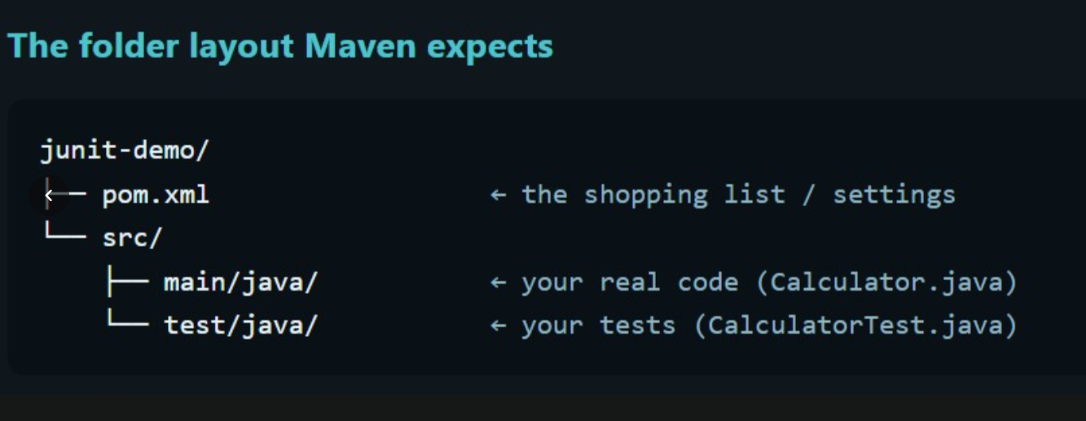
Follow this 4-step development and testing process:
Step 1: Understand and Design Understand the problem statement, identify inputs, expected outputs, constraints, and design the solution.
Step 2: Write Pseudocode Write the solution logic in simple, step-by-step language before coding.
Step 3: Write Code and Test Cases Implement the solution in Java, then write JUnit test cases for normal inputs, edge cases, and invalid inputs.
Step 4: Run the Tests Run the test cases using mvn test, check the results, fix any failures, and rerun the tests.
Remember: Understand → Pseudocode → Code + Tests → Run Tests.

JUnit 5 Architecture — Explain This Diagram in an Interview
Interview answer:
“JUnit 5 architecture has three main components: JUnit Platform, JUnit Jupiter, and JUnit Vintage. It also supports extensions for customized testing.
- JUnit Jupiter API: Provides annotations such as @Test, @BeforeEach, and assertions to write JUnit 5 tests.
- JUnit Vintage: Allows older JUnit 3 and JUnit 4 tests to run on the JUnit Platform.
- Extensions: Allow developers to customize test behaviour, such as setting up test data or managing resources.
- JUnit Platform: Provides the foundation to discover and launch tests through test engines.
- IDEs and tools: Tools such as IntelliJ IDEA, Eclipse, and Maven can launch tests through the Platform.”

How the diagram works
Developers write tests using Jupiter or legacy JUnit APIs → the appropriate test engine runs them through the JUnit Platform → IDEs and build tools can launch the tests and display the results.
Remember for interviews: Jupiter = modern JUnit tests; Vintage = legacy tests; Platform = test execution foundation.

Remember for your interview:
- Jupiter API: Write modern JUnit 5 tests.
- Vintage Engine: Run legacy JUnit 3 and JUnit 4 tests.
- Platform: Provides the foundation for launching and coordinating tests.
- IDE/Maven: Launch tests and display results.
- Extensions: Customize test execution, especially with Jupiter.

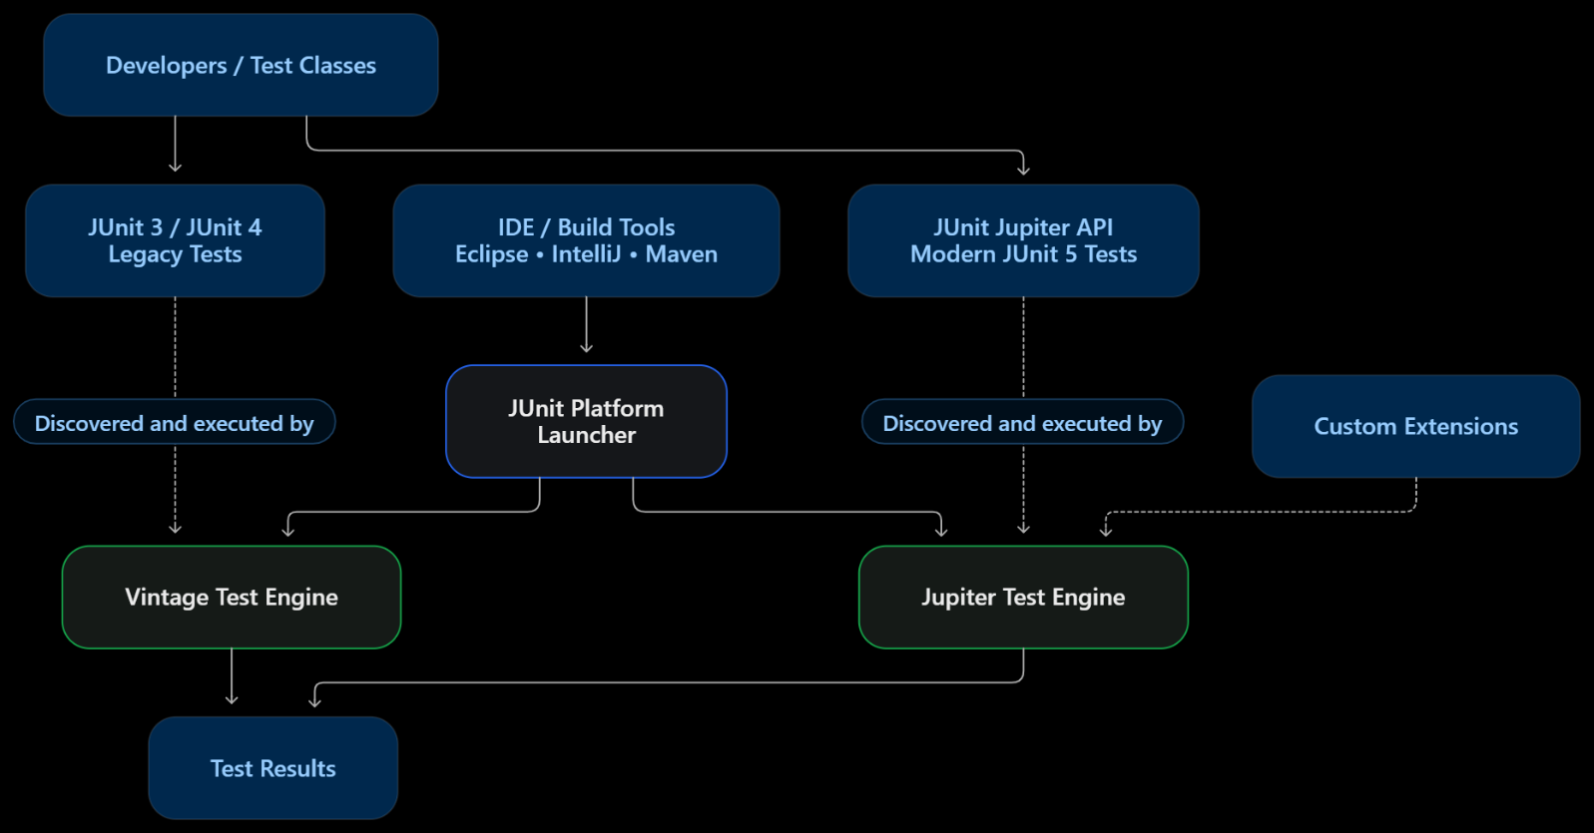

JUnit 5 Architecture — Cinema Analogy 🎬
“Imagine JUnit 5 as a cinema.”
- JUnit Platform = Cinema building: It provides the common infrastructure to run different types of tests.
- IDE/Maven = Ticket counter: You use it to request and launch tests.
- JUnit Jupiter = Modern movie system: It handles modern JUnit 5 tests.
- JUnit Vintage = Old movie system: It allows older JUnit 3 and JUnit 4 tests to run in the same cinema.
- Test Engine = Movie player: It knows how to discover and execute its type of tests.
The main idea: The cinema building supports different movie systems. Similarly, the JUnit Platform supports different test engines and delegates test execution to the appropriate engine.
Remember: Platform = building, Maven/IDE = ticket counter, Jupiter = modern tests, Vintage = legacy tests, Test Engine = movie player.
JUnit 5: mvn test — Each Step Explained
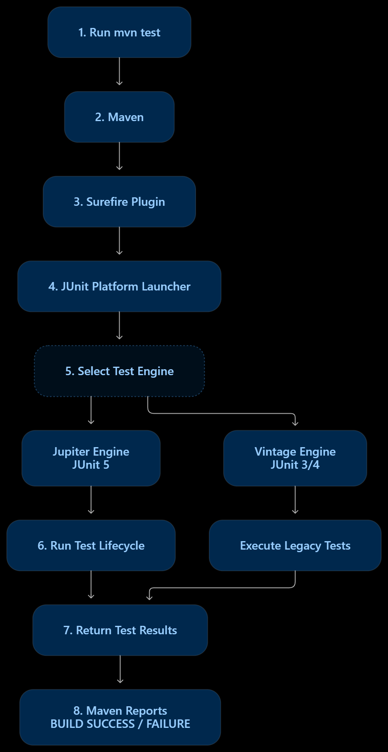

Each step: simple meaning + interview answer
1. mvn test — Command
- Understand: You tell Maven to run the project's tests.
- Interview: “I execute mvn test from the directory containing pom.xml to build and run the configured tests.”
2. Maven — Build tool
- Understand: Reads pom.xml, manages dependencies, and runs the build lifecycle up to the test phase.
- Interview: “Maven manages the project build and coordinates compilation and test execution.”
3. Maven Surefire Plugin — Test runner integration
- Understand: Finds eligible test classes and arranges for them to run.
- Interview: “Surefire integrates test execution into Maven's test phase and reports the results.”
4. JUnit Platform Launcher — Test launcher
- Understand: Coordinates test discovery and execution through compatible test engines.
- Interview: “The JUnit Platform provides the infrastructure for launching tests using the appropriate test engine.”
5. Test Engine — Selects how tests run
- Jupiter Engine: Executes modern JUnit 5 tests.
- Vintage Engine: Executes legacy JUnit 3 and JUnit 4 tests when configured.
- Interview: “The engine understands the test framework and executes its tests.”
6. Test Lifecycle — Executes each test
For Jupiter tests, the lifecycle is:
@BeforeAll → @BeforeEach → @Test → @AfterEach → @AfterAll
- Understand: Prepare, run, and clean up tests.
- Interview: “Jupiter invokes lifecycle methods around the test methods so that setup and cleanup happen at the right time.”
7. Test Results — Pass or fail
- Understand: JUnit records whether assertions passed or tests failed.
- Interview: “The test engine returns execution results to the test runner.”
8. Maven Report — Final status
- Understand: Maven displays the build result and test summary.
- Interview: “Maven reports BUILD SUCCESS when the build succeeds, or BUILD FAILURE when a failure causes the build to fail.”
Remember: BUILD SUCCESS does not necessarily mean every test passed if the build has been configured to tolerate test failures.

Complete answer to speak in the interview
“When I run mvn test, Maven reads pom.xml and executes the build lifecycle up to the test phase. The Surefire Plugin discovers the test classes and integrates with JUnit to execute them. The JUnit Platform coordinates test execution through the appropriate engine. The Jupiter Engine runs JUnit 5 tests, while Vintage can run older JUnit tests if configured. The engine executes the tests and their lifecycle methods, and finally Maven displays the test results and build status.”

Types of Testing — Understand the Diagram
The diagram shows testing from small scope to broad scope.
┌──────────────────────────────┐
│ FUNCTIONAL TESTING │
│ ┌──────────────────────┐ │
│ │ INTEGRATION TESTING │ │
│ │ ┌──────────────┐ │ │
│ │ │ UNIT TESTING │ │ │
│ │ └──────────────┘ │ │
│ └──────────────────────┘ │
└──────────────────────────────┘

1. Unit Testing
Interview answer: “Unit testing checks a single method or component independently.”
Example: Test whether a discount method correctly calculates a 10% discount.
Tool: JUnit.

2. Integration Testing
Interview answer: “Integration testing checks whether multiple components work correctly together.”
Example: Check whether the order service correctly communicates with the database to save an order.

3. Functional Testing
Interview answer: “Functional testing checks whether an application feature behaves according to its requirements.”
Example: Verify that a customer can log in, add a product to the cart, and place an order as expected.

Real-life example: Online shopping
Type | What you test
Unit | Does the discount calculation work?
Integration | Does the order service save the order in the database?
Functional | Can the customer successfully place an order?
Remember: Unit = individual component; Integration = components working together; Functional = required application behaviour.
Note: The nested-circle diagram is a simplified illustration. These testing categories can overlap; functional testing is not strictly a larger level that always contains unit and integration testing.
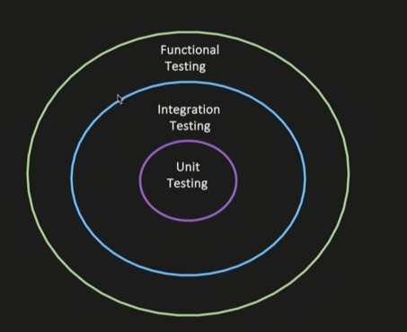

2. Integration Testing
Interview answer:
“Integration testing verifies whether different components or dependencies work correctly together. For example, I check whether the service communicates with the database correctly and whether the data is successfully saved.”
Example 1: Database integration
Service → Database → Verify saved data
- Verify that the service reaches the database layer.
- Check that the database operation succeeds.
- Assert that the data is persisted correctly.
Example 2: Kafka integration
Service A → Publish message → Kafka Topic
↓
Verify message received
Interview answer: “If Service A publishes a message to Kafka, I verify that the message is successfully published to the expected topic and contains the correct data.”

3. Functional Testing
Interview answer:
“Functional testing verifies whether a feature or business functionality works according to the business requirements and expected behaviour.”
Real-life example: Online shopping
Customer selects product
↓
Adds product to cart
↓
Completes checkout
↓
Order is successfully placed
We verify that the complete feature behaves as expected from the user's or business's perspective.

Difference to Remember
Integration testing | Functional testing
Checks whether components work together. | Checks whether the feature meets requirements.
Example: Service successfully publishes a Kafka message. | Example: Customer successfully places an order.
Focuses on interactions and data flow. | Focuses on expected business behaviour.
Remember for interviews: Integration testing = Do the components work together? Functional testing = Does the feature do what the business expects?

