ONLINE RESUME BUILDER

A Project Submitted

In Partial Fulfillment of the Requirements
for the Degree of

BACHELOR OF TECHNOLOGY
In
Computer Science & Engineering

by

RANJAN SAH (170120101072)
RAUSHAN YADAV (170120101074)
RAJAN KUMAR JAISWAL (170120101068)

Under the Supervision of
Ms. NEHA BARTHWAL



FACULTY OF COMPUTER SCIENCE & ENGINEERING

TULA’S INSTITUTE
THE ENGINEERING AND MANAGEMENT COLLEGE
(DEHRADUN)
Jan, 2021

UTTARAKHAND TECHNICAL UNIVERSITY

CERTIFICATE

Certified that this project report “ONLINE RESUME BUILDER” is the bonafide work of “RANJAN SAH, RAUSHAN YADAV, RAJAN KUMAR JAISWAL” who carried out the project work under my supervision.

SIGNATURE SIGNATURE
Mr. Lokesh Kumar Ms. Neha Barthwal
HEAD OF THE DEPARTMENT Assistant Professor
Department of Computer Science & Department of Computer Science &
Engineering Engineering

UTTARAKHAND TECHINCAL UNIVERSITY

CERTIFICATE DECLARATION

I declared that this written submission represents my work and ideas in my own words and where other idea and work are also have been included, I have adequately citied and referenced the source. I also declare that I have adhered to all principle of academic honesty and integrity and have not misrepresented or fabricated or falsified any idea/data/facts/source in my submission. I understand that any violation of the above will be cause for disciplinary action by the University and can also evoke penal action from the sources which have thus not been properly cited or from whom proper permission has not been taken when needed.

NAME SIGNATURE
RANJAN SAH
Roll No.170120101072 ……………………….

RAUSHAN YADAV
Roll No.170120101074 …………………………

RAJAN KUMAR JAISWAL
Roll No.170120101068 ………………………….

ACKNOWLEDGMENT

I take this opportunity to remember the Almighty and my parents, who bestowed strength, courage to perseverance to undertake the present course of study and complete it successfully.
First and Foremost, I would like to express a deep sense of gratitude and sincere regard toward Director, for his sustained guidance, meticulous supervision, and constant encouragement during my dissertation work.
My special thanks to Mr. Lokesh Kumar (HOD, CSE) , Mr. Sachin Kumar (Project Coordinator, CSE) and Ms. Akansha Singh (Project Co-coordinator, CSE) who help me in the execution of this work and for providing necessary facilities with full cooperation, bestowing his excellent guidance, encouragement, inspiring motivation, valuable suggestion and painstaking help throughout this project work.
I express my heartfelt and sincere thanks to my project guide Ms. Neha Barthwal (Assistant Professor, Tula’s Institute of Engineering and Management, Dehradun) for her excellent guidance, caring, patience, and providing me an excellent atmosphere for completion of this dissertation project.
I also thank my teaching and non-teaching staff members of the department for their kind cooperation and others who helped me through the course of the minor project work.

Concerning this venture without their encouragement, patience, and moral support it would not have been possible for me to complete my dissertation.

Date: 10/01/2021
Submitted By
RANJAN SAH
RAUSHAN YADAV
RAJAN KUMAR JAISWAL

ABSTRACT

An Online Resume Builder is an internet-based application that can help students and other professionals to get instant resume template in which they can fill easily with their credentials.
An Online Resume Builder provides different standard templates that can be downloaded in different formats like pdf and others. A user will not have to spend a lot of time on formatting and designing his/her resume.
It is an application that simplifies the task of creating a resume for individuals. The system is flexible to be used and reduces the need of thinking and designing an appropriate resume according to qualifications. The system is developed to provide an easy means for creating a professional looking resume.
Individuals just have to fill up a form that specifies questions from all required fields such as personal questions, educational, qualities, interest, skills and so on. The answers provided by the users are stored and the system automatically generates a well-structured resume. Users have option to create resume in any format and file.

Keywords: DFD, SQL,CSS

TABLE OF CONTENTS

CHAPTER NO. TITLE PAGE NO.

ABSTRACT iii
LIST OF TABLE xvi

1. INTRODUCTION 1

1.1 Purpose 1
1.2 Scope 2
1.3 Overview 2
1.4 Goals of Proposed System 3
1.5 Background 4
1.6 Technologies Used 5
1.7 User Characteristics 5
1.8 Constraints 5
1.9 Definitions of Problems 6

2. REVIEW

2.1 FEASIBILITY STUDY 6
2.1.1 Technical Feasibility 7
2.1.2 Economical Feasibility 9
21.3 Operational Feasibility 10
2.1.4 Schedule Feasibility 10

2.2 SYSTEM ANALYSIS 10
2.2.1 Working of Present System 10
2.2.2 Disadvantage of Present System 11
2.2.3 Proposed System 11
2.2.4 Architectural Design 14
2.2.5 E-R Diagram 15
2.2.6 Data Flow Diagram 16
2.2.7 Use Case Model 18
2.2.8 Class Diagram 20

2.3 SYSTEM DESIGN 21
2.3.1 Database Tables 24

2.4 SNAPSHOTS 24
2.4.1 Registering New User 24
2.4.2 Login Validation 25
2.4.3 First Page 25
2.4.4 Templates 26
2.4.4.1 Template1 27 2.4.4.2 Template2 27
2.4.4.3 Template3 28
2.4.5 Guidelines 28

3. CONCLUSION
3.1 Conclusion 29

LIST OF TABLES

Table No.  4.1  2.3.1  2.3.2  2.3.3  2.3.3 | Description  User Table  Resume Table  Profile Table  Administrator Table  Contact_Request Table | Pg.  23  23  24  24  25

LIST OF FIGURES

Figure No.  2.2.4  2.2.5  2.2.6  2.2.6  2.2.7  2.2.8  2.4.1  2.4.2  2.4.3  2.4.4  24.4.1  2.4.4.2  2.4.4.3  2.4.5 | Description  Architectural Design  Entity-Relationship Diagram  Context Level Data Flow Diagram  Level Data Flow Diagram  Use Case Diagram  Class Diagram  User Validation  Login Validation  First Page  Templates  Template1  Template2  Template3  Guidelines | Pg.  15  16  17  18  20  22  25  26  27  27  28  28  29  29

- Introduction

Resume is the first meeting between you and a prospective employer more often now than ever. So, how do you want to be remembered? Wrinkled and unorganized. Neat and structured. Long and boring. Precise and interesting. Companies do not have the time to interview every applicant that is interested in the job. If they did, there would not be a company to work for. They use an eliminating process. That' right - resumes.
When a job seeker wants to apply for a job online then generally he/she needs to attach his/her resume with the email. Online Resume Building System provides the users the popular resume formats & a better way to show their resumes to the recruiters. A job seeker does not need to attach a resume with every email, he/she just have to include the URL of his/her resume and the recruiter can view the resume online by clicking on the link and can download as well.

1.1 Purpose

Purpose of Online Resume Builder is to provide a way to the customers to design their resumes according to their requirements.
a) Creating resumes online.
b) Customizing the look and details.
c) Keeping track of the customers and their resumes.

1
1.2 Scope
Online Resume Builder can be used in accordance with the requirements of the customers. Customers can customize their resumes with their choice of themes & details. The services are hard to be defeated by the competitors as the system is providing the customers exactly what they want.

1.3 Overview
- Project is related to Online Resume Building.
- This project maintains 3 types of users.
    - Administrator User
    - Users (Customers)
    - Viewers
- Facilities provided by this projects are as follows
 Details of customers are recorded.
 Update of data is easy.
 Flow of information is fast and easy.
 Customers can login to their accounts and view & update their data.
 Notifications about resume views & downloads.

2
1.4 Goals of Proposed System

1) Planned approach towards working: -
The working of the system will be well planned and organized. The data will be stored properly in data stores, which will help in retrieval of information as well as its storage.

2) Accuracy: -
The level of accuracy in the proposed system will be higher. All operation would be done correctly and it ensures that whatever information is coming from the system is accurate.

3) Reliability: -
The reliability of the proposed system will be high due to the above stated reasons. The reason for the increased reliability of the system is that now there would be proper storage of information.

4) No redundancy: -
In the proposed system utmost care would be that no information is repeated anywhere, in storage or otherwise. This would assure economic use of storage space and consistency in the data stored.
5) Immediate Retrieval of Information: -
The main objective of proposed system is to provide for a quick and efficient retrieval of information. Any type of information would be available whenever the user requires.
3
6) Immediate storage of information: -
In manual system there are many problems to store & update the large amount of information.

7) Easy to operate: -
The system should be easy to operate and should be such that it can be easily understood by a new user.

1.5 Background
Online Resume Builder is a system which allows the customers to design their resumes in accordance with their requirements.

System provides facilities like…

 Customizing the resumes according to the user requirements.
 Editing the design.
 Choosing from latest professional designers.
 Viewed resume notification for the customers.

Various operations done in the system are as follows…
 Registering customers.
 Access to viewers/employers is allowed for public/shared data only.
 Writing resumes.
 Editing in design.
 Keeping track of latest formats of resumes.
 Viewed resume notification.
4
1.6 Technologies Used
This project will be an Internet application to be developed in following tools and technologies.

a) CSS (Cascading Style Sheets) – It is used to create stylish web pages.

b) DHTML (Dynamic Hyper Text Markup Language) – It is used to create dynamic web pages.

c) HTML (Hyper Text Markup Language) – It is used to describe web pages.

d) JAVASCRIPT – It is used improve the design, validate forms, detect browsers, create cookies, and much more.

e) SQL (Structured Query Language) – It is a standard language for accessing and manipulating databases.

1.7 User Characteristics
Every user should be:
 Comfortable in working with computer.
 He must have knowledge of resume writing.
 He must also have basic knowledge of English language.

1.8 Constraints
 GUI is only in English.
 Login and password is used for identification of user.

5
1.9 Definition of Problems
Problems with conventional system are as follows.

 Lack of immediate retrievals: The information is very difficult to retrieve and to find particular information. This results in inconvenience and wastage of time.

 Lack of immediate information storage: The information generated by various transactions takes time and efforts to be stored at right place.

 Lack of prompt updating: - Various changes to information are difficult to make as paper work is involved.

Error prone manual calculation: Manual calculations are error prone and take a lot of time this may result in incorrect information.

 Preparation of accurate and prompt reports: This becomes a difficult task as information is difficult to collect from various registers.

2.1 Feasibility Study:
Depending on the results of the initial investigation the survey is now expanded to a more detailed feasibility study.

“FEASIBILITY STUDY ” is a test of system proposal according to its workability, impact of the organization, ability to meet needs and effective use of the resources. It focuses on these major questions:
 What are the user’s demonstrable needs and how does a system meet them?
 What resources are available for given system?
6
 What are the likely impacts of the system on the organization?
 Whether it is worth to solve the problem?
During feasibility analysis for this project, following primary areas of interest are to be considered. Investigation and generating ideas about a new system does this.

Steps in feasibility analysis
Eight steps involved in the feasibility analysis are:
 Form a project team and appoint a project leader.
 Prepare system flowcharts.
 Enumerate potential proposed system.
 Define and identify characteristics of proposed system.
 Determine and evaluate performance and cost effectiveness of each proposed system.
 Weight system performance and cost data.
 Select the best-proposed system.
 Prepare and report final project directive to management.

2.1.1 Technical Feasibility
Technical feasibility is the study of resource availability that may affect the ability to achieve an acceptable system. This evaluation determines whether the technology needed for the proposed system is available or not.
 Can the work for the project be done with current equipment existing software technology & available personal?
 Can the system be upgraded if developed?
 If new technology is needed then what can be developed?
This is concerned with specifying equipment and software that will successfully satisfy the user requirement. The technical needs of the system may include:
7
Front-end and back-end selection
An important issue for the development of a project is the selection of suitable front-end and back-end. When we decided to develop the project we went through an extensive study to determine the most suitable platform that suits the needs of the academy as well as helps in development of the project. The aspects of our study included the following factors.

Front-end selection:
 It must have a graphical user interface that assists users that are not an advanced user of computer.
 Scalability and extensibility.
 Flexibility.
 Robustness.
 According to the organization requirement and the culture.
 Must provide excellent reporting features with good printing support.
 Platform independent.
 Easy to debug and maintain.
 Event driven programming facility.
 Front end must support some popular back end like MS Access.
According to the above stated features we selected Web Browser as the front-end for developing our project.

Back-end Selection:
 Multiple user support.
 Efficient data handling.
 Provide inherent features for security.
 Efficient data retrieval and maintenance.
8
 Stored procedures.
 Popularity.
 Operating System compatible.
 Easy to install.
 Various drivers must be available.
 Easy to implant with the Front-end.
According to above stated features we selected MY SQL as the backend.
The technical feasibility is frequently the most difficult area encountered at this stage. It is essential that the process of analysis and definition be conducted in parallel with an assessment to technical feasibility.
It centers on the existing computer system (hardware, software etc.) and to what extent
it can support the proposed system.

2.1.2 Economical Feasibility
Economic justification is generally the “Bottom Line” consideration for most systems. Economic justification includes a broad range of concerns that includes cost benefit analysis. In this we weight the cost and the benefits associated with the candidate system and if it suits the basic purpose of the organization i.e. profit making, the project is making to the analysis and design phase.
The financial and the economic questions during the preliminary investigation are verified to estimate the following:
 The cost to conduct a full system investigation.
 The cost of hardware and software for the class of application being considered.  The benefits in the form of reduced cost.
 The proposed system will give the minute information, as a result the performance is improved which in turn may be expected to provide increased profits.
 This feasibility checks whether the system can be developed with the available
9
funds. Online Resume Builder does not require enormous amount of money to be developed. This can be done economically if planned judicially, so it is economically feasible. The cost of project depends upon the number of man-hours required.

2.1.3 Operational Feasibility:
It is mainly related to human organizations and political aspects. The points to be considered are:
 What changes will be brought with the system?
 What organization structures are disturbed?
 What new skills will be required? Do the existing staff members have these skills? If not, can they be trained in due course of time. The system is operationally feasible as it very easy for the End users to operate it.

2.1.4 Schedule Feasibility:
Time evaluation is the most important consideration in the development of project. The time schedule required for the development of this project is very important since more development time effect machine time, cost and cause delay in the development of other systems.
Online Resume Builder can be developed in the considerable amount of time.

2.2 System Analysis:
System analysis uses a combination of text and diagrammatic forms to depict requirements for data, function and behavior in a way that is relatively easy to understand, and more important, straightforward to review for correctness, completeness and consistency.
10

2.2.1 Working of Present System:
Present system is the manual system where every task is performed again & again. We need to manually change the format of the resume. Sending of resumes is done
manually. All the activities in the system, which can be done by using automated
methods, are being done manually. Since all tasks are being performed manually so it needs a lot of work force.
2.2.2 Disadvantages of Present System:
Since, our present system is a manual system it has several disadvantages described below:

Lack of immediate retrievals: The information is very difficult to retrieve (download) and to find particular information. This results in inconvenience and wastage of time.
 Lack of immediate information storage: The information takes time and efforts to be attached again & again with mails or to be sent by post.
 Lack of prompt updating: Various changes to information are difficult to make if resume is sent.
 Error prone manual calculation: Manual calculations are error prone and take a lot of time this may result in incorrect information.
 Preparation of accurate and prompt reports: This becomes a difficult task as information is difficult to collect from various registers.

2.2.3 Proposed System:
Our proposed system provides automation to Resume Building. This system provides online storage/ updates and retrieval facility. This system promises very less or no paper work and also provides help to customers and viewers/employers. In this system

11
everything is stored electronically so very less amount of paper work is required and information can be retrieved very easily without searching here and there into registers.
This system ensures certain features that are not available with present manual system. These are described below:
a) Planned approach towards working:
The working in the system will be well planned and organized. The data will be stored properly in data stores, which will help in retrieval of information as well as its storage.
b) Accuracy:
The level of accuracy in the proposed system will be higher.All operation would be done correctly and it ensures that whatever information is coming from the server is accurate.

c) Reliability:
The reliability of the proposed system will be high due to the above stated reasons. The reason for the increased reliability of the system is that now there would be proper storage of information.

d) No Redundancy:
In the proposed system utmost care would be that no information is repeated anywhere, in storage or otherwise. This would assure economic use of storage space and consistency in the data stored.
e) Immediate Retrieval of Information:
of data and program components that are required to build a computer based system. It considers the architectural style that the system will take, the structure and properties
of the components that constitute the system, and the interrelationships that occur
12

among all architectural The main objective of proposed system is to provide for a
quick and efficient retrieval of information. Any type of information would be
available whenever the viewer or customer requires. f) Immediate storage of information: - In manual system
there are many problems to store & update the large amount of Information.

f) Immediate storage of information:
In manual system there are many problems to store & update the large amount of information.
g) Easy to Operate:
The system should be easy to operate and should be such that it can be developed within a short period of time and fit in the limited budget of the user.

13
2.2.4 Architectural Design

Architectural design represents the structure components of a system.

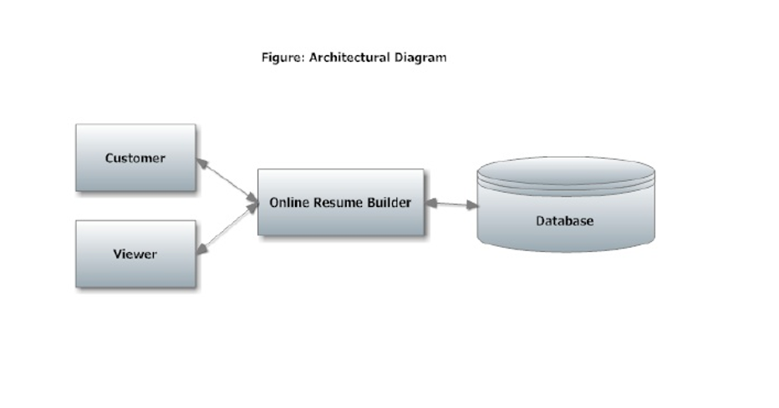

14
2.2.5 E-R Diagram:
The object/relationship pair is the cornerstone of the data model. These pairs are represented graphically using E-R diagrams. A set of primary components are identified for the ERD: data objects, attributes, relationships and various type indicators. The primary purpose of ERD is to represent data objects and their relationships.

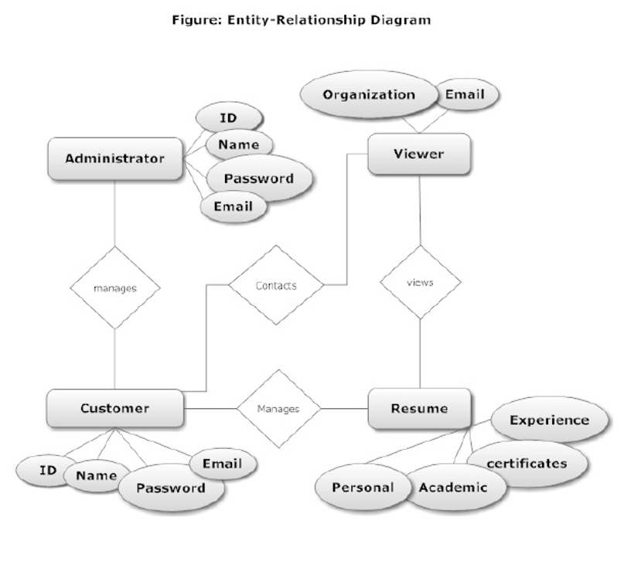

15
2.2.6 DFD
The data flow diagram enables the software engineer to develop models of the information domain and functional domain at the same time. As the DFD is refined into greater level of detail, the analyst performs an implicit functional decomposition of the system. At the same time, the DFD refinement results in corresponding refinement of data as it moves through the processes that embody the application.

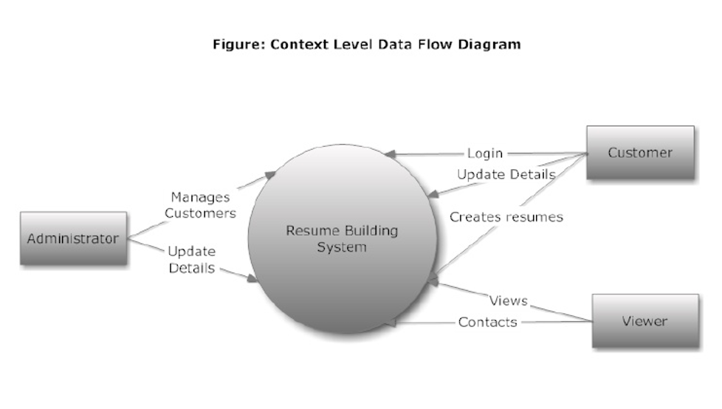

16
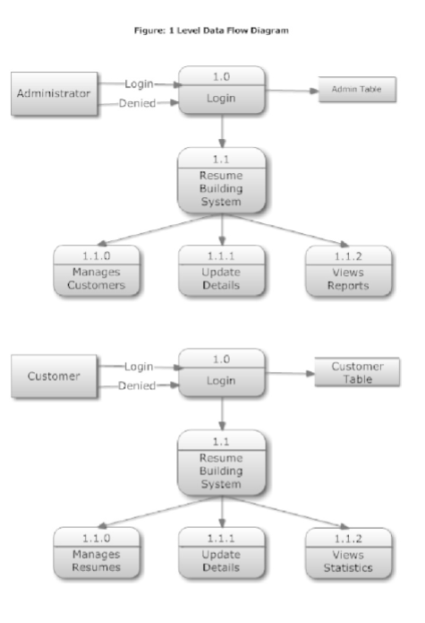

17

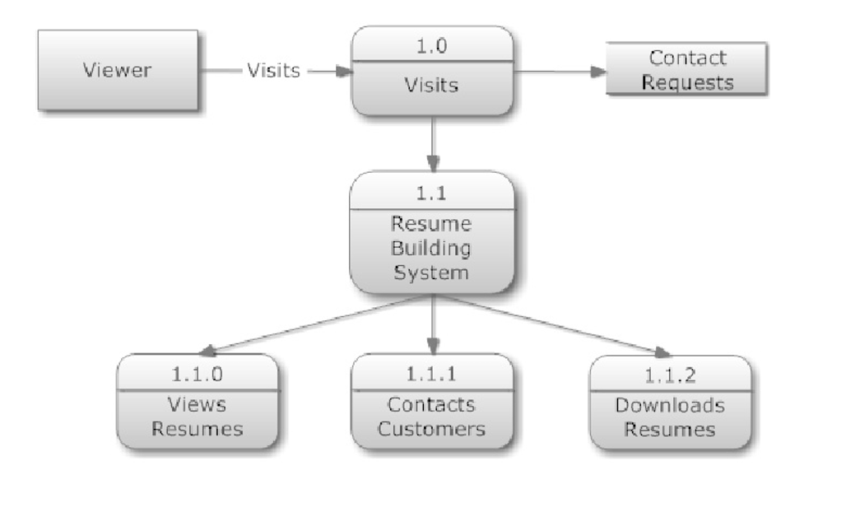
2.2.7 Use Case Model
Use Case Model is an approach that is a combination of text and pictures in order to improve the understanding of requirements. A use case model' is describes the complete functionality of a system by identifying how everything that is outside the system interacts with it. A Use Case Diagram is given below that relates to this application.

 Description:
This project is a web application that manages a system of building resumes online.

18
 Actors:
It has 3 actors.
1) Administrator
2) Customer
3) Viewer

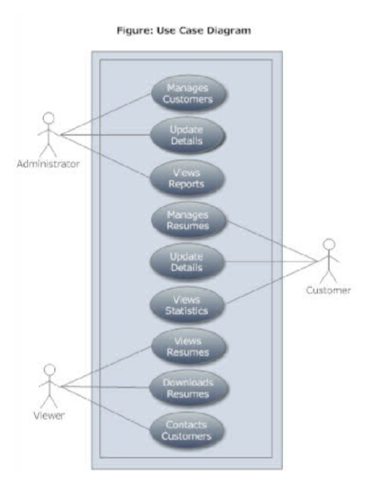

19
 Flow of Events :

i) User logins into the system using ID and password.
ii)If user is an authorized user then access is granted otherwise denied.
iii)User selects any tasks to do and task is performed.

 Special Requirements:

i)Data will flow from one user to another.
ii)Data generated by one user can’t be altered by another user.
iii)One user can’t change the status of another user.

 Pre Condition:
.)All customers should have their account created on the system.

 Post Condition:

.)Details are available to users.
.) Details and information are intact and valid.

2.2.8 Class Diagram:
A class diagram shows relationship among classes used in the system. Every class has some contents, attributes and objects associated with it. Every class produces some outputs and uses some inputs. Outputs generated are consumed by other classes and inputs consumed are generated by other classes. Class diagram shows which class is producing what and consuming what.

20
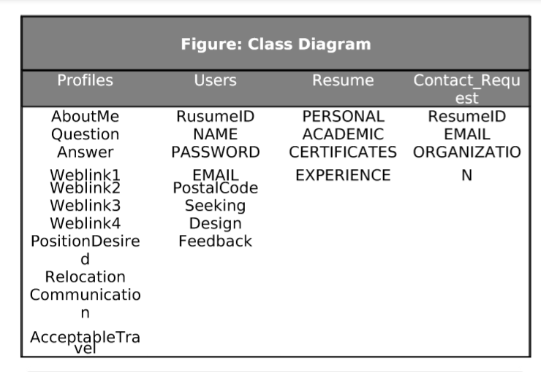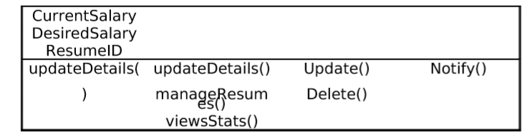

2.3 System Design

System design is a solution, a ‘how to’ approach to the creation of a new system. It provides the understanding and procedural details necessary for implementing the system recommended in the feasibility study. Emphasis is on translating the performance requirements into design specifications. Design goes through logical and physical stages of development. Logical design reviews the present physical system; prepared input and output specifications; details the implementation plan; and prepares a logical design walkthrough. The physical design maps out the details of the physical system, plans the system implementation, devises a test and implementation plan, and specifies any new hardware and software.

21
2.3.1 Database Tables

 Users Table

FIELDNAME | DATATYPE
ID | VARCHAR
NAME | VARCHAR
PASSWORD | VARCHAR
EMAIL | VARCHAR
PHONE | VARCHAR
ADDRESS | VARCHAR

 Resume Table

FIELDNAME | DATATYPE
PERSONAL | VARCHAR
ACADEMICS | VARCHAR
CERTIFICATES | VARCHAR
EXPERIENCES | VARCHAR
SKILLS | VARCHAR
VIEWS | INTEGER

22
 Profile Table

FEILDNAME | DATATYPE
QUESTION | VARCHAR
ANSWER | VARCHAR
WEBLINK1 | VARCHAR
WEBLINK2 | VARCHAR
WEBLINK3 | VARCHAR
WEBLINK4 | VARCHAR
POSITIONDESIRED | VARCHAR
RELOCATION | VARCHAR
COMMUNICATION | VARCHAR
ACCEPTABLE RAVEL | VARCHAR
CURRENTSALARY | VARCHAR
DESIRED SALARY | VARCHAR
RESUMEID | VARCHAR
ABOUTME | VARCHAR

 Administrator Table

FIELDNAME | DATATYPE
ID | VARCHAR
NAME | VARCHAR
EMAIL | VARCHAR
PASSWORD | VARCHAR

23

 Contact_Request Table

FIELDNAME | DATATYPE
RESUMEID | VARCHAR
EMAIL | VARCHAR
ORGANISATION | VARCHAR

2.4 PROJECT SNAPSHOTS

2.4.1 Registering New User

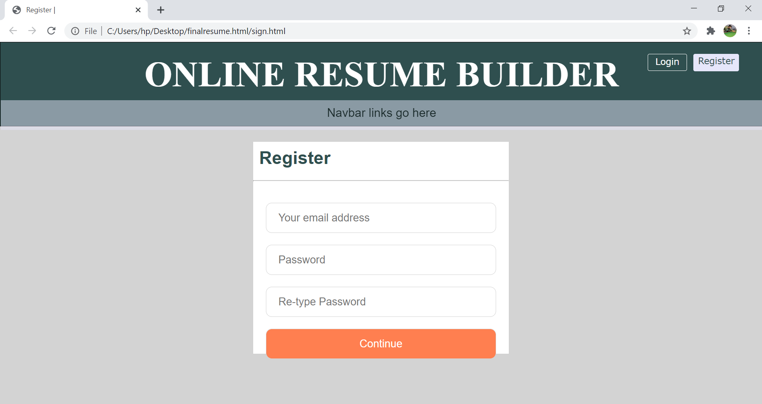

24

2.4.2 Login Validation

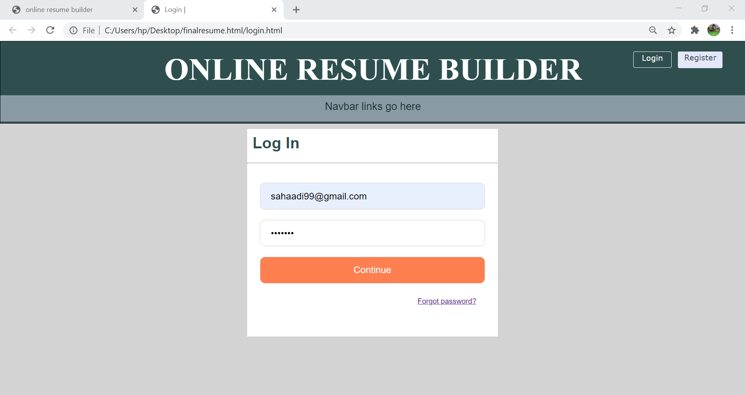

2.4.3 First Page

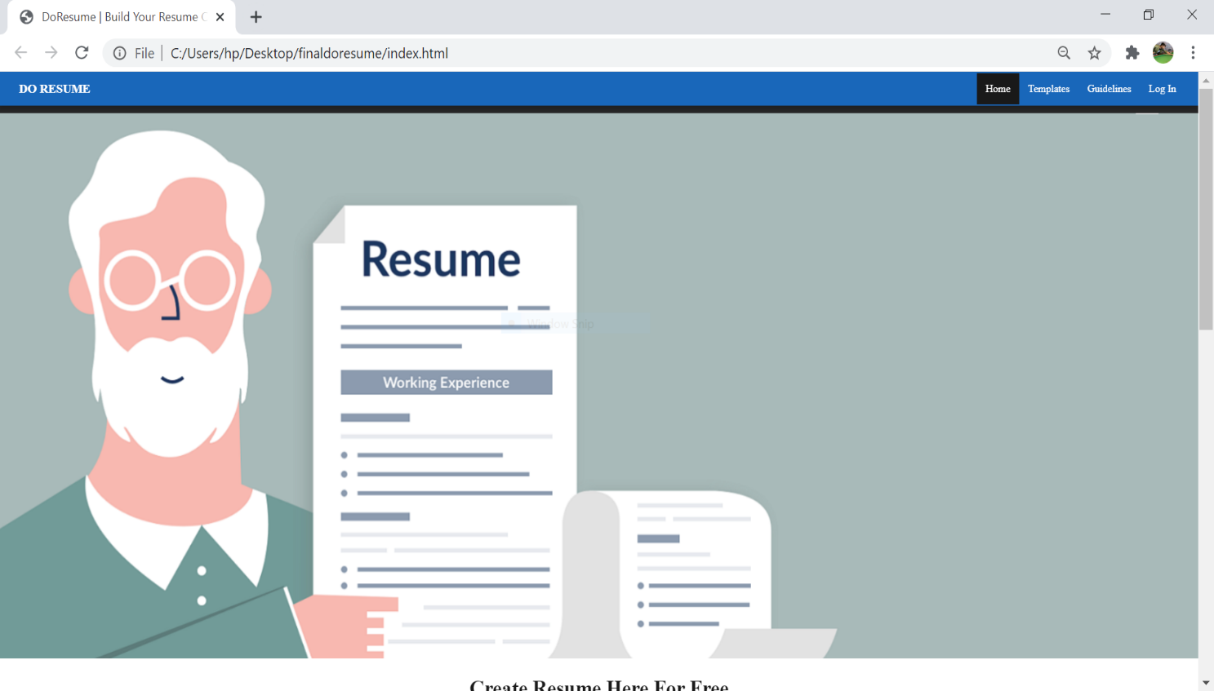25

2.4.4 Templates

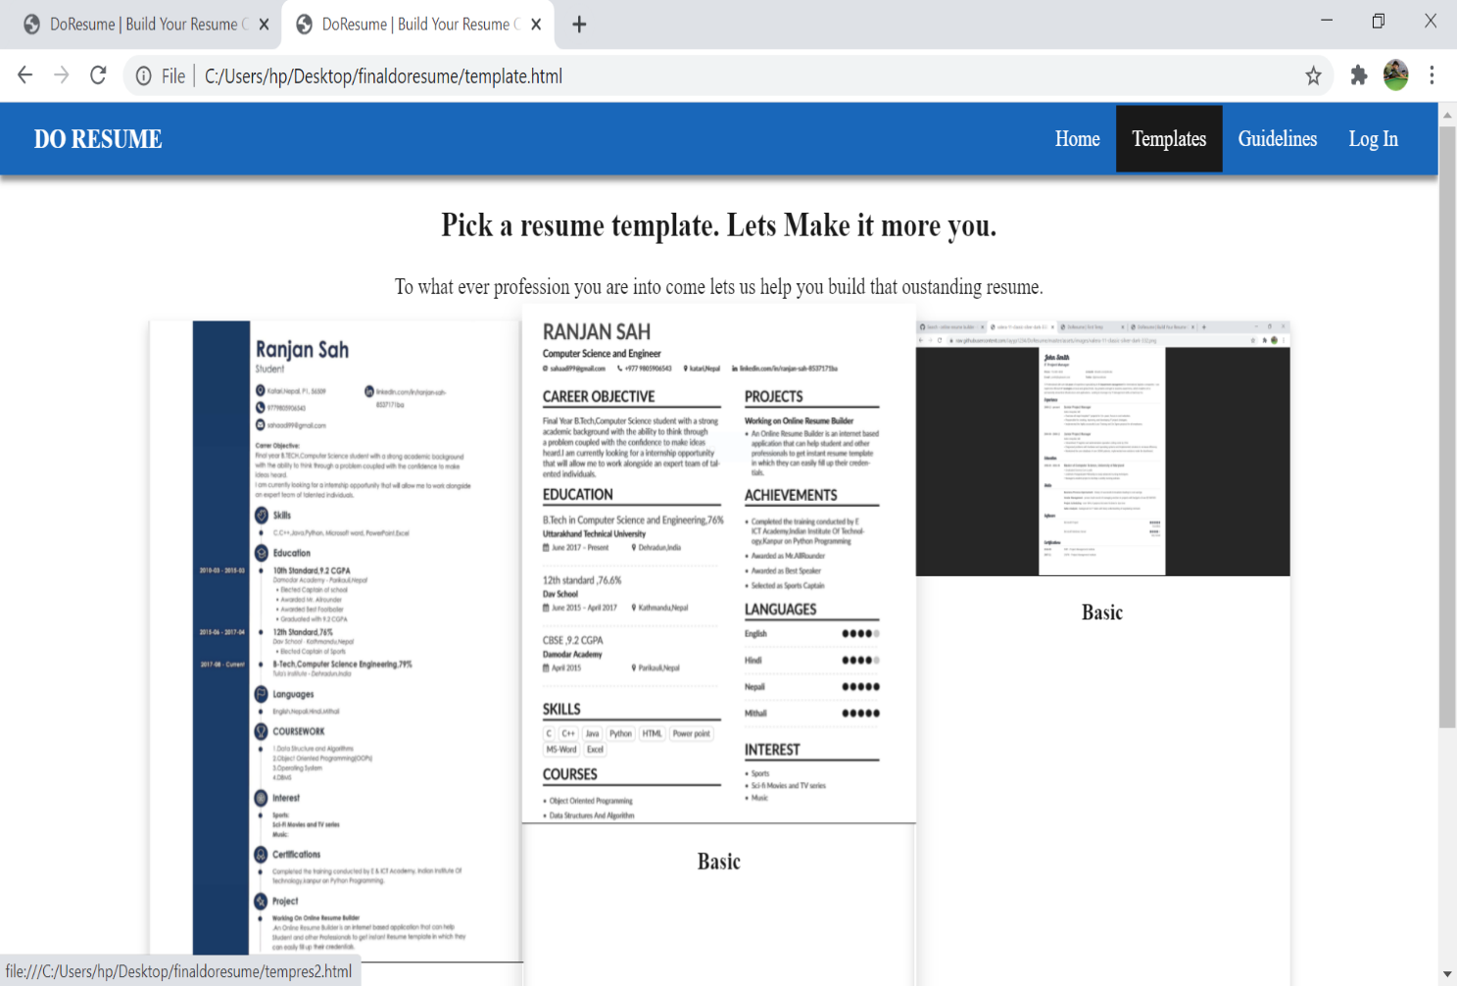

26

2.4.4.1 Template1:

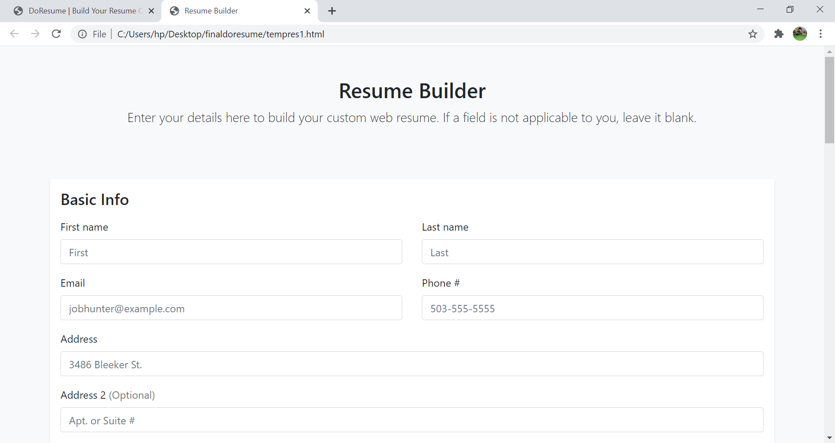

2.4.4.2 Template2:

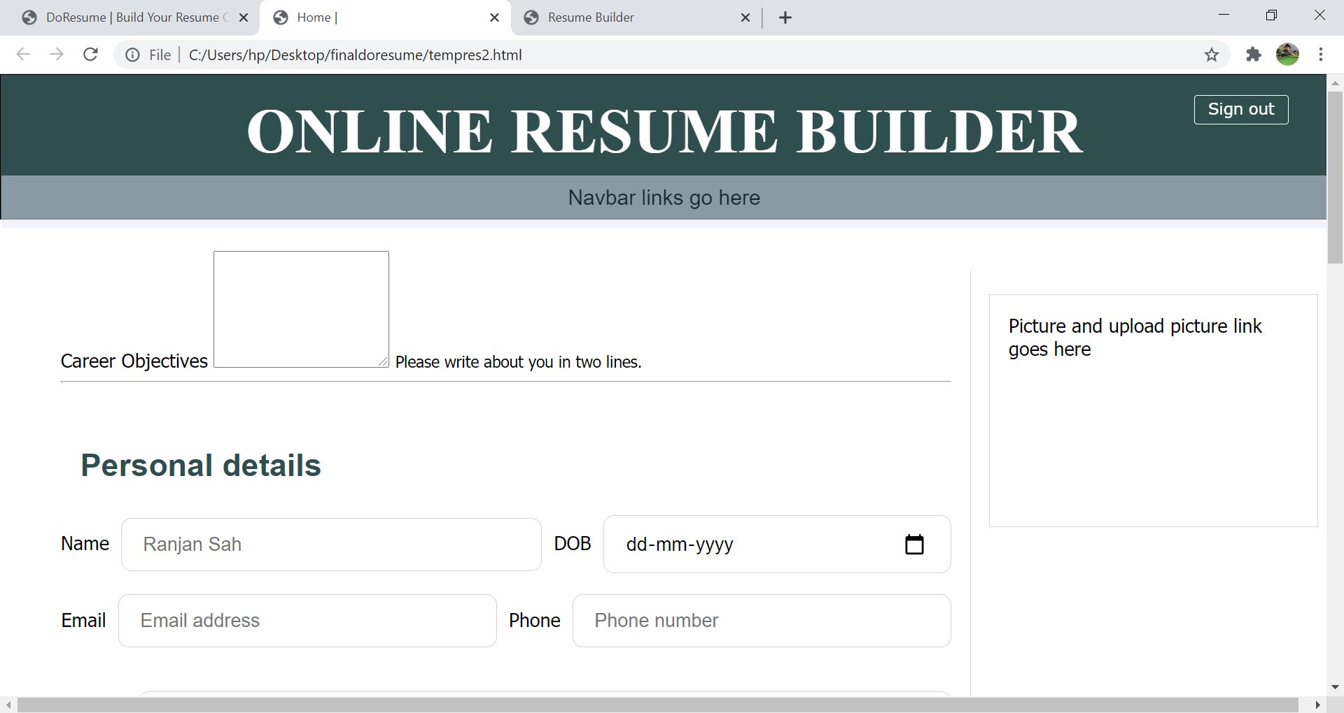

27
2.4.4.3 Template3:

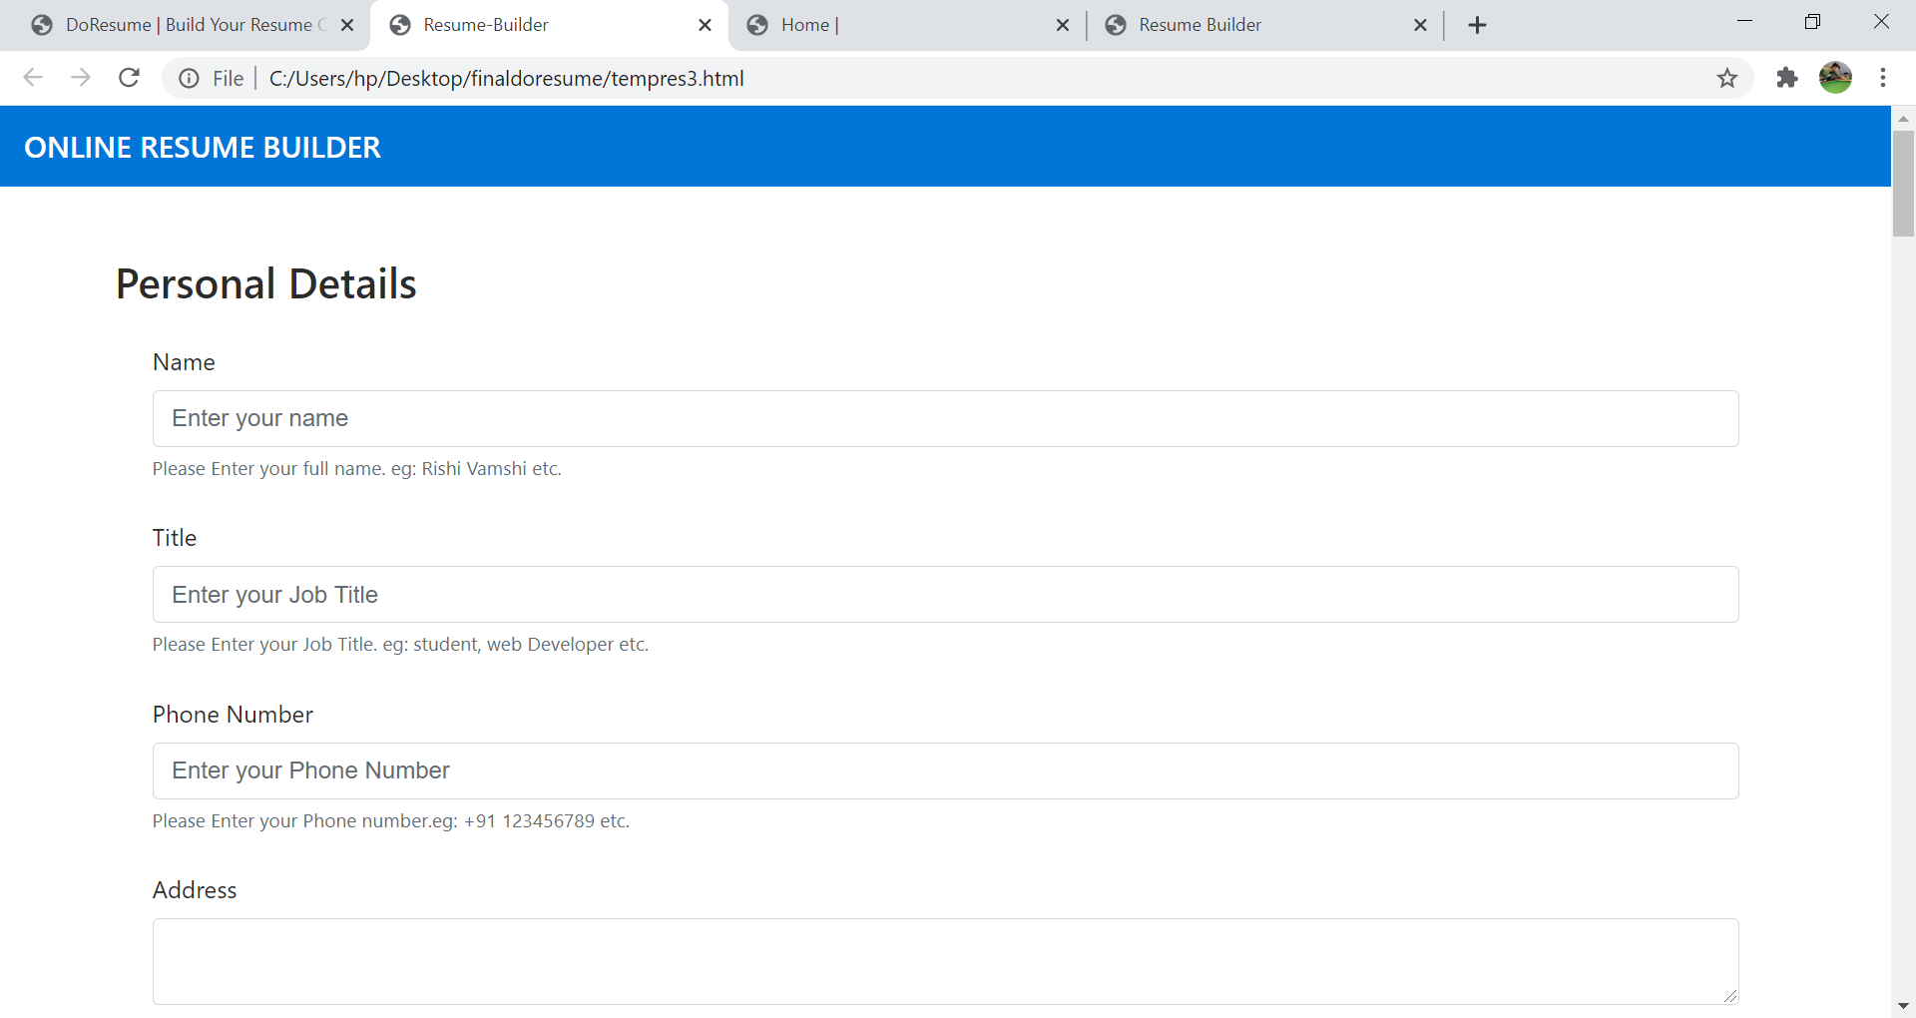

2.5.5 Guidelines:
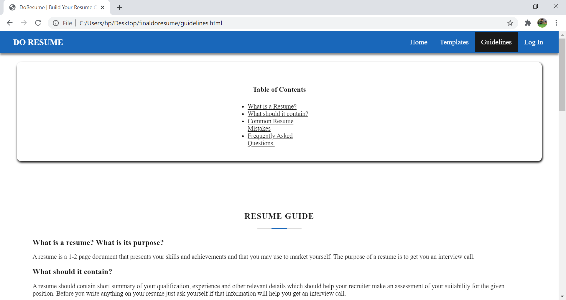

28
3.1 Conclusion:

The project Online Resume Builder is for computerizing the working of building resumes. The software takes care of all the requirements of the process and is capable to provide easy and effective storage of information related to customers and resumes that come up to the system. It generates reports for customers & administrators. Provides easy designing tools and other interesting features. The system also provides the facility to contact the customer.
This system provides online storage/ updates and retrieval facility. This system promises very less or no paper work and also provides help to customers and viewers. In this system everything is stored electronically so very less amount of paper work is required and information can be retrieved very easily without searching here and there into registers.

29

REFERENCES

- www.emurse.com
- www.wikipedia.org
- www.webreference.com
- www.dynamicajax.com
- www.webdesign.org
- www.csstutorial.net
- www.photoshopsupport.com
- www.learn-sql-tutorial.com
- SQL School: http://www.w3schools.com/sql

30

