PROJECT FORESIGHT
Demand & Inventory Intelligence
Final Submission Report
Client: NorthBay Living
Role: Data Scientist & Analytics
Program: Zidio Internship
Engagement: 4 Weeks
Dataset: NorthBay Living Synthetic FORESIGHT Dataset v1.0

1. Executive Summary
Project FORESIGHT responds to the inventory planning problem faced by NorthBay Living by turning sales and inventory data into SKU-level forecasts of demand and well-publicized decisions regarding inventory actions at the weekly level. Completed system, with a reproducible data pipeline, eight-week forecasting model, stockout risk scoring and over stock risk scoring, a streamlit planning dashboard and a fastapi scoring service.
The final model used for forecasting is a HistGradientBoostingRegressor with Poisson loss, lag, rolling, calendar and promotion features. The model had a mean WAPE of 14.44% against the 23.17% of the introduced seasonal-naive baseline as demonstrated from three backtest folds which are performed in a rolling origin manner. This is an approximate relative decrease in WAPE of 37.7% and gives a measure of the efficacy of the model in comparison with the designated baseline for the generated data set.
The last risk layer marked 122 SKUs as Healthy, 51 SKUs as Markdown / clear and 7 SKUs as reorder now. The portfolio modelled exposure was around Rs 7.02 million in sales at risk, and Rs 11.92 million in locked capital. The outputs are exposed via the dashboard and can be accessed programatically via the scoring API.
Headline KPI | Result
Forecast horizon | 8 weeks
Mean model WAPE | 14.44%
Mean seasonal-naive WAPE | 23.17%
Relative WAPE improvement | Approximately 37.7%
Mean forecast bias | -0.30%
Healthy SKUs | 122
Markdown / clear SKUs | 51
Reorder now SKUs | 7
Sales at risk | Rs 7,016,475.04
Locked capital | Rs 11,924,635.65

2. Dataset Used
The data used in the project is from the NorthBay Living Synthetic FORESIGHT Dataset v1.0. The engagement brief includes a description of four simulated client extracts but no CSI file of the same extracts was supplied with the provided brief. Thus, the data was synthetically created matching the schema and business context documented. This dataset is reproducible with random seed 42, and consists of 180 unique SKUs spanning 1 January 2024 through to 31 August 2026.
Table | Purpose
sales_daily.csv | Daily SKU sales, units sold, revenue, selling price and promotion flag
sku_master.csv | SKU category, subcategory, launch date, unit cost and list price
calendar.csv | Date, week, month, season, holiday and promotion-event attributes
inventory_snapshots.csv | Periodic on-hand, on-order, lead time and reorder-point data

3. Data Pipeline and Data Quality
The entire workflow is run through src/run_all.py. It restores raw extracts, cleans and unifies data, generates seven-week analysis ready features, performs forecasting and backtesting, generates 8-week forecast and adds inventory risk scoring. This provides an end to end reproducible process instead of manually editing spreadsheets.
Data-quality check | Observed / handled
Raw sales rows | 138,578
Sales duplicates removed | 207
SKU duplicates removed | 1
Inventory duplicates removed | 1
Missing unit prices filled | 553
Missing revenue values filled | 276
Missing reorder points filled | 59
Final weekly rows | 20,002

4. Exploratory Data Analysis and Business Insights
Exploratory analysis was conducted to get insights into the distributions of demand, SKU level
variations, seasonality and promotions, high volume products, and low demand inventory. The
analysis validates the forecasting design, which assumes that there are product-specific changes in
demand, and suggests that calendar and promotional signals can explain some of the short horizon
forecasting.
- Demand is highly SKU differentiated; a small number of SKUs move lots of units and generate a high proportion of revenues, with lots of SKUs with low weekly volume sales.
- Some shifts in demand (e.g., promotions) provide only short-term changes that should be captured in the feature set not as random fluctuations.
- Inventory Exposure is a Two Way: There are products that have been sold in high volumes that can become replenishment problems, and there are products that are in stock but not making desired sales which can be low margin products ripe for sale or clearance.
- The Decision value is not independent decision based forecasting, but instead relates to the combination of demand forecasting along with the existing stock position.
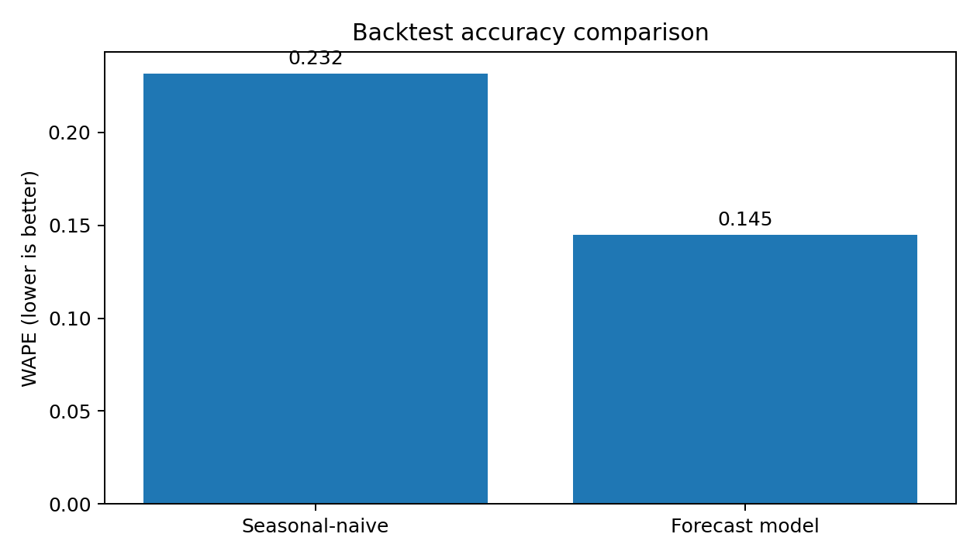
Figure 1. Model WAPE compared with the seasonal-naive baseline.

5. Forecasting Methodology and Results
The forecast horizon is SKU-week of 8 weeks. WAPE is the primary accuracy measure and signed bias is used as a secondary diagnostic. The initial Seasonal naïve forecast of the time series is set as the benchmark. In the final model, the HistGradientBoostingRegressor model will be used with Poisson loss, and only features available at the point of origin of the forecast in history will be used before the model is run, avoiding the problem of future-information leakage.

Feature group | Variables
Lag demand | lag_1, lag_2, lag_4, lag_13, lag_52
Rolling demand | roll_4, roll_13
Seasonality | week_sin, week_cos, month
Commercial signal | promo_flag

The validation is based on three folds with different test sets and train sets, rolling in the origin, instead of a random train test split. This will be closer to how the model will behave when predicting weeks it hasn't seen before.
Fold | Test period | Model WAPE | Baseline WAPE
1 | 16 Mar 2026 - 4 May 2026 | 15.00% | 23.23%
2 | 11 May 2026 - 29 Jun 2026 | 13.41% | 22.20%
3 | 6 Jul 2026 - 24 Aug 2026 | 15.01% | 24.08%
Mean | - | 14.44% | 23.17%

During the back test, the model can outperform of the seasonal-naive baseline, meeting the central modelling criterion. At the overall level, mean bias is close to zero, -0.003, suggesting only a minimal overall over or under forecasting. Forecast intervals are presented as empirical, 80%-type bands to be interpreted as practical uncertainty measures; they are not fully calibrated probabilistic intervals.

6. Stockout and Overstock Risk Scoring
The risk layer translates demand forecasting into decisions on inventory. Stockout risk takes into account the forecast demand for a specific store, location and time horizon, typically measured by the supplier lead time, and the safety requirement of each SKU, which consists of both the quantity on-hand and on-order. Overstock risk is the ratio of on hand inventory to future forward demand. The logic behind the scoring is intentionally clearly expressed, so that the operations team can easily follow why they are placing a SKU into a SKU action group.
Action | Interpretation | SKU count
Reorder now | High stockout risk and low overstock risk | 7
Markdown / clear | High overstock risk and low stockout risk | 51
Healthy | No immediate intervention required | 122
Watch / volatile | High stockout and overstock indicators; manual review | 0 in final run

In the last run, total modelled sales at risk were Rs 7,016,475.04 and total locked capital were Rs 11,924,635.65. These values provide the operations and finance function with an ability to prioritise the actions based on the potential value to the business.
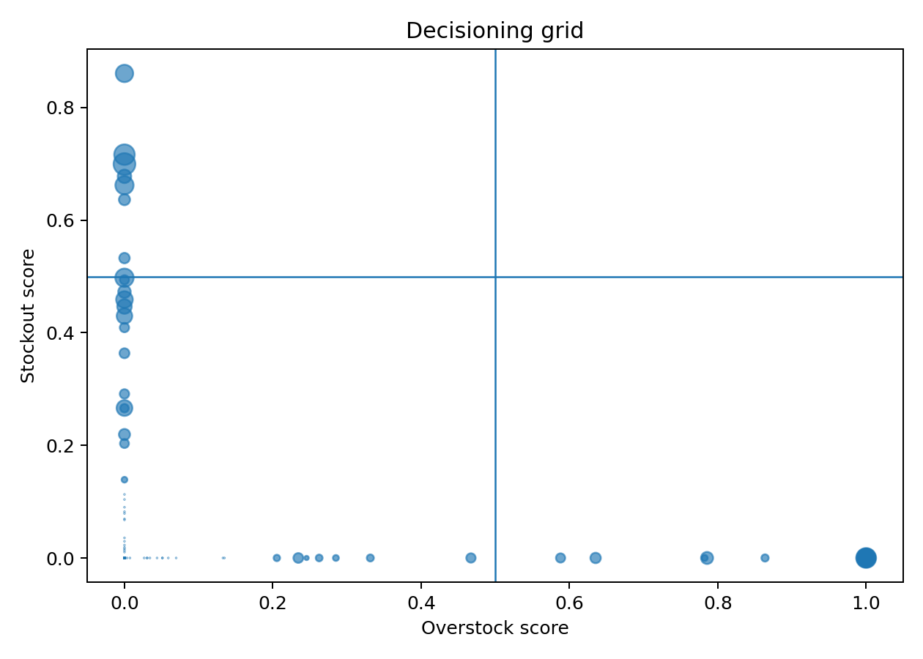
Figure 2. Stockout-versus-overstock decision grid.

7. Scoring Service Verification
The FastAPI scoring service makes health and SKU-scoring endpoints available. Service was successfully deployed to Uvicorn and interactive OpenAPI/Swagger documentation deployed to /docs. Successful end-to-end retrieval of forecast and risk information was achieved by the tested endpoint GET /score/{sku_id} returning an HTTP 200 response for SKU-0084.
API element | Verified result
Service startup | Application startup completed successfully
Documentation | /docs returned HTTP 200
Health endpoint | GET /health available
Scoring endpoint | GET /score/{sku_id} available
Test SKU | SKU-0084
HTTP result | 200 Successful Response
Returned action | Markdown / clear
8-week forecast | Approximately 15 units in tested response
Risk result | Stockout score 0; overstock score 1

The tested response additionally remoted week by week speculation values, the 80% lower bound, the 80% upper bound, data on categories and subcategories, stock and value of the products going to money, locked capital and full value at risk. This shows that API is not only online but also linked with outputs from forecast and risk that is generated.
Local launch command: uvicorn service.main:app --reload
The local API is suitable for the demonstration. If the submission form explicitly requests a live-deployed endpoint then a public scoring-service URL is still necessary.

8. System Architecture and Reproducibility
Layer | Implementation
Data | Four synthetic raw CSV extracts matching the project schema
Pipeline | Python/pandas cleaning, joins, weekly aggregation and feature engineering
Forecasting | scikit-learn HistGradientBoostingRegressor with rolling-origin validation
Decisioning | Transparent stockout and overstock scoring rules
Dashboard | Streamlit
Scoring service | FastAPI + Uvicorn
Outputs | Backtest metrics, eight-week forecast and risk-score CSV files

9. Conclusion
Project FORESIGHT successfully shows an end-to-end demand forecasting and inventory intelligence solution for NorthBay Living. The project operationalized raw synthetic sales, product, calendar, and inventory data and provided a reproducible pipeline that transformed these raw data into a clean, analysis-ready data set. The forecasting model has a mean WAPE of 14.44%, while the seasonal naive baseline had 23.17%, showing the model's competence in delivering more accurate forecasts of demand up to the horizon of 8 weeks. The risk-scoring framework did more than just bring forecasted results to life, as it helped businesses determine which products to mark down, put on clearance or reorder, based on an identification of 122 healthy SKUs, 51 candidates for mark-down or clearance and 7 SKUs that needed to be reordered. The business was also dollar valued at sales at risk and locked capital worth of approximately Rs 7.02 million and Rs 11.92 million respectively. The analytical outputs were subsequently used to build a Streamlit dashboard and FastAPI scoring service, transforming the analytical outputs into usable tools for non-technical stakeholders. Summarizing, the project gives a real practical and transparent reproducible decision support system for better inventory planning and minimising financial risks related to inventory.

