1.Write a program that describes the hierarchy of an organization. Here we need to write 3 classes Employee, Manager & Labour where Manager & Labour are the sub classes of the Employee. Manager has incentive &Labour has over time. Add the functionality to calculate total salary of all the employees. Use polymorphism i.e. method overriding.

**Employee.java**

**package** com.zensartraining;

**public** **class** Employee {

**private** **int** id;

**private** String name;

**private** String role = "Employee";

**private** **int** baseSalary = 25000;

**public** Employee(**int** id, String name) {

**this**.id = id;

**this**.name = name;

}

**public** String getDetails() {

**return** " \n Id: " + getId() +

" \n Name: " + name +

" \n Role: " + role +

" \n Total Salary: " + baseSalary;

}

**public** **int** getId() {

**return** id;

}

**public** String getName() {

**return** name;

}

**public** **static** **void** main(String[] args) {

Employee e = **new** Employee (1,"Annie");

System.***out***.println(" Details:: "+e.getDetails());

}

}

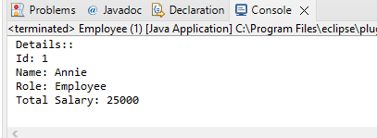

**Manager.java**

**package** com.zensartraining;

**public** **class** Manager **extends** Employee

{

**private** **int** incentive=7000;

**private** **int** salary=50000;

**private** String role="Manager";

**public** Manager(**int** id,String name)

{

**super**(id,name);

}

**public** String getDetails()

{

**return** "\n Id: "+getId()+

" \n Name: "+getName()+

" \n Role: "+role+

" \n Total Salary: "+(incentive+salary);

}

**public** **static** **void** main(String[] args) {

Manager m = **new** Manager(2,"Priti");

System.***out***.println("Details:: "+m.getDetails());

}

}

**package** com.zensartraining;

**public** **class** Manager **extends** Employee

{

**private** **int** incentive=7000;

**private** **int** salary=50000;

**private** String role="Manager";

**public** Manager(**int** id,String name)

{

**super**(id,name);

}

**public** String getDetails()

{

**return** "\n Id: "+getId()+

" \n Name: "+getName()+

" \n Role: "+role+

" \n Total Salary: "+(incentive+salary);

}

**public** **static** **void** main(String[] args) {

Manager m = **new** Manager(2,"Priti");

System.***out***.println("Details:: "+m.getDetails());

}

}

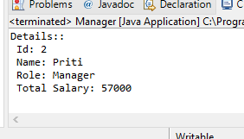

Labour.java

**package** com.zensartraining;

**public** **class** Labour **extends** Employee{

**private** **int** overTimeWage = 1000;

**private** **int** wage = 5000;

**private** String role = "Labour";

**public** Labour(**int** id, String name) {

**super**(id, name);

}

**public** String getDetails() {

**return** "\n Id: " + getId() +

" \n Name: " + getName() +

" \n Role: " + role +

" \n Total Salary: " + (overTimeWage + wage);

}

**public** **static** **void** main(String[] args) {

Labour l = **new** Labour(3,"Crety");

System.***out***.println("Details :: "+l.getDetails());

}

}

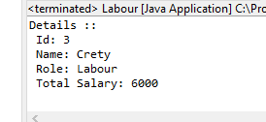

2.Write a program to consider saving & current account in the bank. Saving account holder has ‘Fixed Deposits’ whereas Current account holder has cash credit. Apply polymorphism to find out total cash in the bank.

**package** com.zensartraining;

**public** **class** BankAccount {

**public** **static** **void** main(String[] args) {

Savings s = **new** Savings();

s.displayDetails("Pooja");

s.displayDetails1(30000);

s.calculatebalance(2);

Current c = **new** Current();

c.displayDetails("Priya");

c.displayDetails1(20000);

c.calculatebalance(3);

}

}

**class** Savings

{

**double** amount;

**void** displayDetails(String name)

{

System.***out***.println("AccountHolder Name " +name);

}

**void** displayDetails1(**double** amt)

{

System.***out***.println("Current amount =" + amt );

amount = amt;

}

**void** calculatebalance(**int** year)

{

**double** interest = 4.00;

System.***out***.println("Saving Account Total Balance = " + amount*interest*year);

}

}

**class** Current

{

**double** amount;

**void** displayDetails(String name)

{

System.***out***.println("AccountHolder Name " +name);

}

**void** displayDetails1(**double** amt)

{

System.***out***.println("Current amount =" + amt );

amount = amt;

}

**void** calculatebalance(**int** year)

{

**double** interest = 3.00;

System.***out***.println("Current Account Total Balance = " + amount*interest*year);

}

}

