1. Write a program to consider saving & current account in the bank. Saving account holder has ‘Fixed Deposits’ whereas Current account holder has cash credit. Apply polymorphism to find out total cash in the bank.

**package** bank;

**public** **class** Bankacc

{

**public** **static** **void** main(String[] args)

{

Saving s = **new** Saving();

s.displayDetails("ABC");

s.displayDetails1(20000);

s.calculatebalance(5);

Current c = **new** Current();

c.displayDetails("XYZ");

c.displayDetails1(10000);

c.calculatebalance(5);

}

}

**class** Saving

{

**double** amount;

**void** displayDetails(String name)

{

System.***out***.println(name + " ");

}

**void** displayDetails1(**double** amt)

{

System.***out***.println("Current amount =" + amt );

amount = amt;

}

**void** calculatebalance(**int** year)

{

**double** interest = 4.00;

System.***out***.println("Saving Account Total Balance = " + amount*interest*year);

}

}

**class** Current

{

**double** amount;

**void** displayDetails(String name)

{

System.***out***.println(name + " ");

}

**void** displayDetails1(**double** amt)

{

System.***out***.println("Current amount =" + amt );

amount = amt;

}

**void** calculatebalance(**int** year)

{

**double** interest = 2.00;

System.***out***.println("Current Account Total Balance = " + amount*interest*year);

}

}

**Output:**

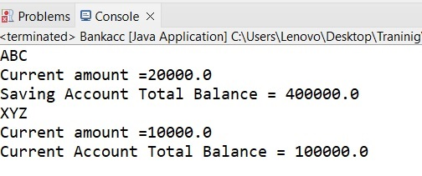

1. Write a program that describes the hierarchy of an organization. Here we need to write 3 classes Employee, Manager & Labour where Manager & Labour are the sub classes of the Employee. Manager has incentive & Labour has over time. Add the functionality to calculate total salary of all the employees. Use polymorphism i.e. method overriding.

**Employee.java**

**package** ass2;

**public** **class** Employee

{

**private** **int** id;

**private** String name;

**private** String role="Employee";

**private** **int** baseSalary=20000;

**public** Employee (**int** id, String name)

{

**this**.id = id;

**this**.name = name;

}

**public** String getDetails()

{

**return** "Id: "+getId()+

" Name: "+name+

" Role: "+role+

" Total Salary: "+baseSalary;

}

**public** **int** getId()

{

**return** id;

}

**public** String getName()

{

**return** name;

}

**public** **static** **void** main(String[] args)

{

Employee e = **new** Employee (10,"XYZ");

System.***out***.println("****Details****: "+e.getDetails());

}

}

**Output:**

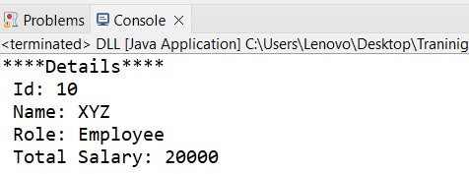

**Manager.java:**

**package** ass2;

**public** **class** Manager **extends** Employee

{

**private** **int** incentive=7000;

**private** **int** salary=50000;

**private** String role="Manager";

**public** Manager(**int** id,String name)

{

**super**(id,name);

}

**public** String getDetails()

{

**return** "Id: "+getId()+

" \n Name: "+getName()+

" \n Role: "+role+

" \n Total Salary: "+(incentive+salary);

}

**public** **static** **void** main(String[] args)

{

Manager m = **new** Manager(20,"ABC");

System.***out***.println("****Details****\n "+m.getDetails());

}

}

**Output:**

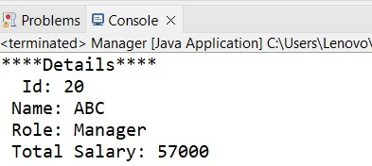

**Labour.java:**

**package** ass2;

**public** **class** Labour **extends** Employee

{

**private** **int** overTimeWage=1000;

**private** **int** wage=5000;

**private** String role="Labour";

**public** Labour(**int** id,String name)

{

**super**(id,name);

}

**public** String getDetails()

{

**return** "Id: " +getId()+

" \n Name: "+getName()+

" \n Role: "+role+

" \n Total Salary: "+(overTimeWage+wage);

}

**public** **static** **void** main(String[] args)

{

Labour l = **new** Labour(30,"PQR");

System.***out***.println("****Details****\n "+l.getDetails());

}

}

**Output:**

