Day2 – Continue Learning MySQL

1. ER Diagram using workbench
2. Sub Query
3. Joins
4. Clause (Group by, order by asc, desc)
5. Database Normalization
6. Built-in Functions
7. Assignments

Assignment 1

1. Create two tables with the name “EMP” & “DEPT”
2. EMP table column names are ID – INT(4), NAME – VARCHAR(30), COMMISSION FLOAT(8,2), ROLE VARCHAR(30), DEPT_NO INT(3), HIRED_DATE DATE,MANAGER_ID Int(4)
3. DEPT table columns are ID – INT(4), NAME – VARCHAR(30)

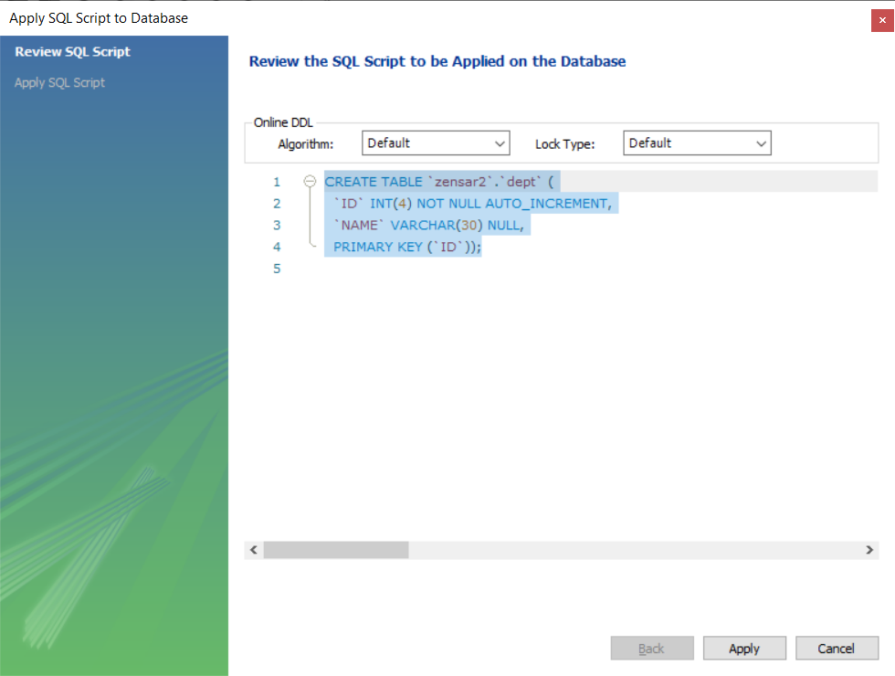

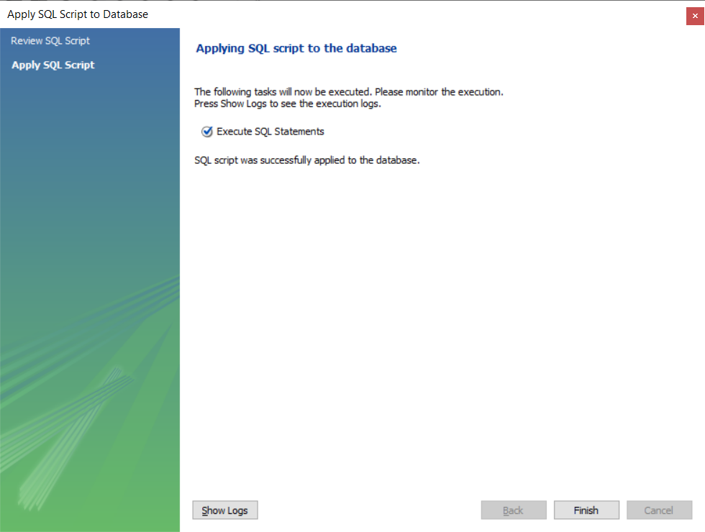

CREATE TABLE `zensar2`.`dept` (

`ID` INT(4) NOT NULL AUTO_INCREMENT,

`NAME` VARCHAR(30) NULL,

PRIMARY KEY (`ID`));

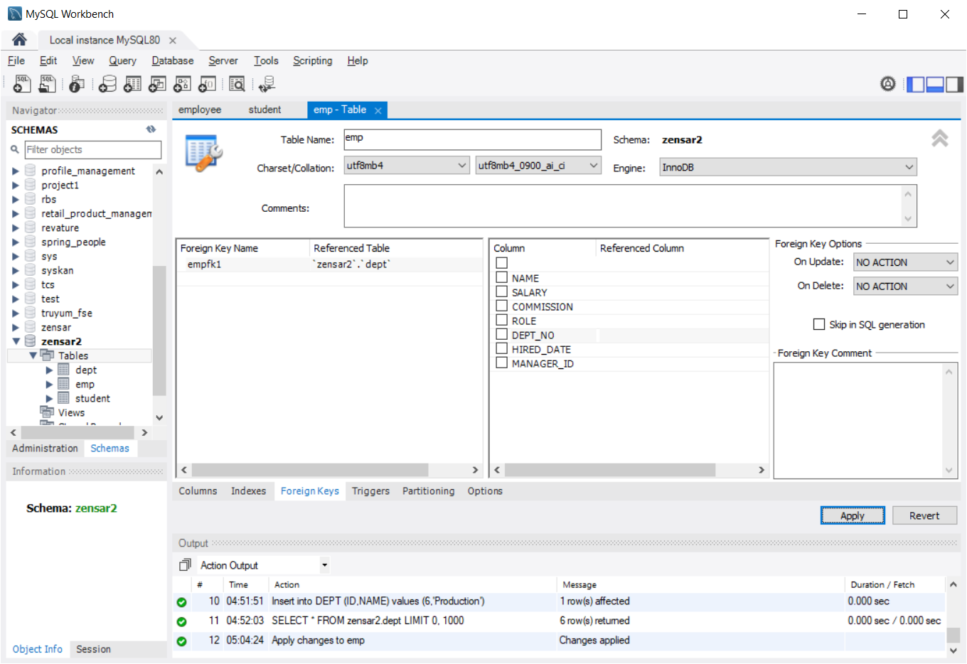

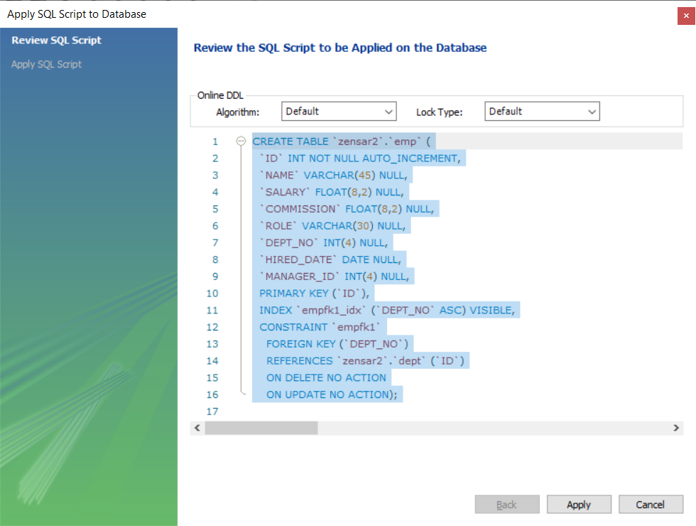

CREATE TABLE `zensar2`.`emp` (

`ID` INT NOT NULL AUTO_INCREMENT,

`NAME` VARCHAR(45) NULL,

`SALARY` FLOAT(8,2) NULL,

`COMMISSION` FLOAT(8,2) NULL,

`ROLE` VARCHAR(30) NULL,

`DEPT_NO` INT(4) NULL,

`HIRED_DATE` DATE NULL,

`MANAGER_ID` INT(4) NULL,

PRIMARY KEY (`ID`),

INDEX `empfk1_idx` (`DEPT_NO` ASC) VISIBLE,

CONSTRAINT `empfk1`

FOREIGN KEY (`DEPT_NO`)

REFERENCES `zensar2`.`dept` (`ID`)

ON DELETE NO ACTION

ON UPDATE NO ACTION);

Reading/Retrieving the data from Database Table

Select * from <table_name> -- All column /Full reading

“*” – represents all the column

Select id,name from emp; -- partial Reading / Selected Reading

Cluses that can be used with select query --- “where” condition, group by & order by

SELECT * FROM zensar2.emp;

select id,name from emp;

select * from emp where id>4 order by name desc

Generating SQL from ER Diagram

CREATE TABLE IF NOT EXISTS `mydb`.`employee` (

`id` INT NOT NULL AUTO_INCREMENT,

`name` VARCHAR(45) NULL,

`salary` FLOAT NULL,

`commission` FLOAT NULL,

`role` VARCHAR(45) NULL,

`dept_no` INT NULL,

`hired_date` DATE NULL,

`manager_id` INT NULL,

`department_id` INT NOT NULL,

PRIMARY KEY (`id`, `department_id`),

INDEX `fk_employee_department_idx` (`department_id` ASC) VISIBLE,

CONSTRAINT `fk_employee_department`

FOREIGN KEY (`department_id`)

REFERENCES `mydb`.`department` (`id`)

ON DELETE NO ACTION

ON UPDATE NO ACTION)

ENGINE = InnoDB

CREATE TABLE IF NOT EXISTS `mydb`.`department` (

`id` INT NOT NULL AUTO_INCREMENT,

`name` VARCHAR(45) NULL,

PRIMARY KEY (`id`))

ENGINE = InnoDB