**NATIONAL INSTITUTE OF** **TECHNOLOGY, TIRUCHIRAPPALLI**

**Tamil Nadu-620015**



# *‘OBJECT ORIENTED PROGRAMING’*

**PROJECT REPORT**

Submitted To: Submitted By:

**Dr. P. Chitra RANJEET KURMI 205119077**

**SUMIT PATIL 205119101**

**NATIONAL INSTITUTE OF TECHNOLOGY,**

**TIRUCHIRAPPALLI-15**



## **CERTIFICATE**

*This is to certify that* ***Mr. SUMIT PATIL,RANJEET KUMRI****student of 2nd semester MCA (batch 2019-2022) of National Institute of Technology, Tiruchirappalli has successfully completed the project* ***ONLINE QUIZ*** *in* ***ONJECT ORIENTED PROGRAMING****(C++)**under the guidance of* **Dr. P. Chitra*.***

Signature

**Dr. P. Chitra**

## **Abstract**

The main aim of **Online quiz** is to create healthy competition within the student and to test their knowledge of technical as well as non-technical by providing various types of question of different subjects and also to learn more about the working with the various types of subject to learn.We have used various type of function in this project to perform various types of operation like to manage the total marks obtained by the participant and to display their result some of the function used only for calculating the total marks and others to show the questions to the students.

The main objective of this project is to familiar with

The various types of concept used in the object oriented programing and to used them in the practical situation and to implement those concept in the program.

**Concept the used**

**1.Functions**

**int maths();**

**int gk();**

**int history();**

**int film();**

**int sports();**

**int nitt();**

**void menu();**

**void display();**

**2.system calls**

**Cls**

**Pause**

**Beginning of program**

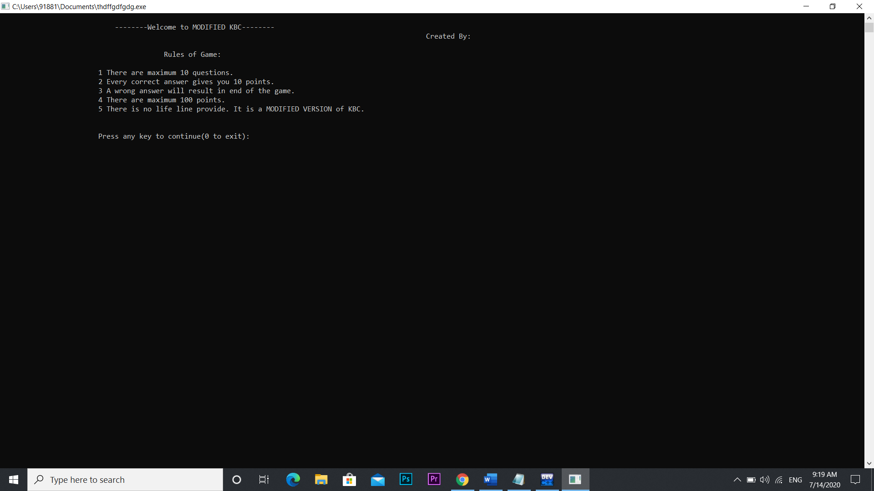

**Press any key to play**

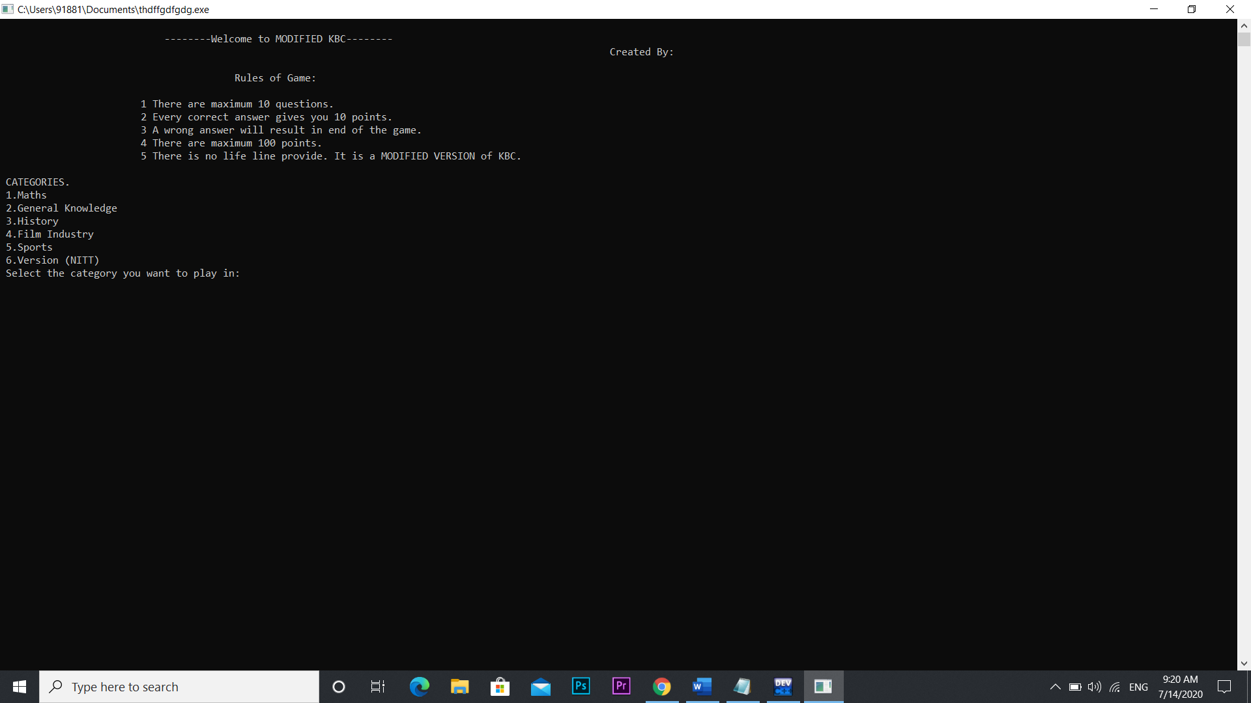

**Want to play mathematics**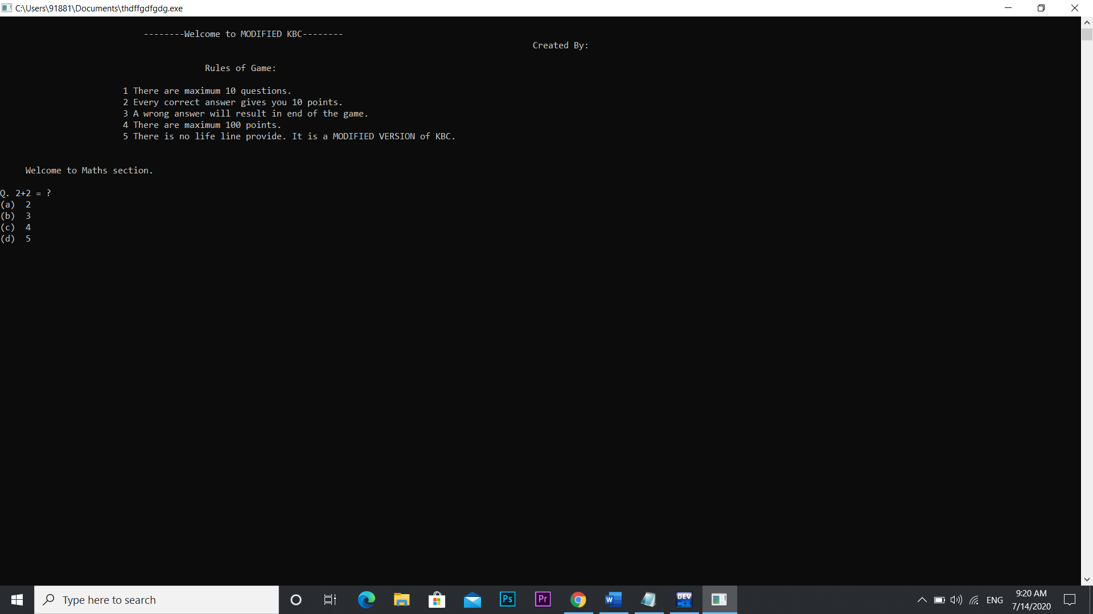

**Press c to answer**

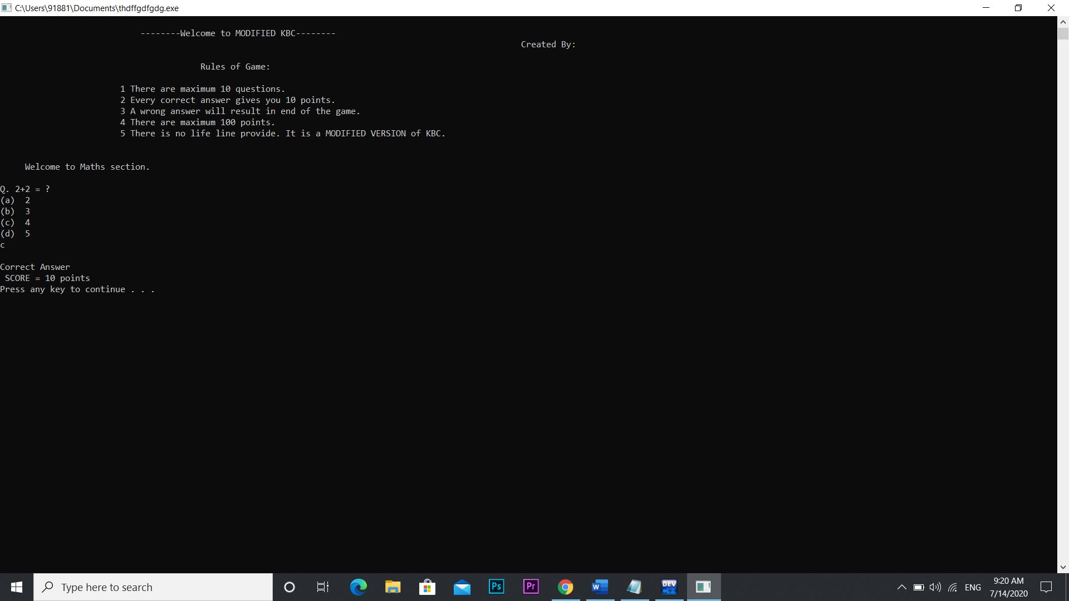

**Press any key to further continue**

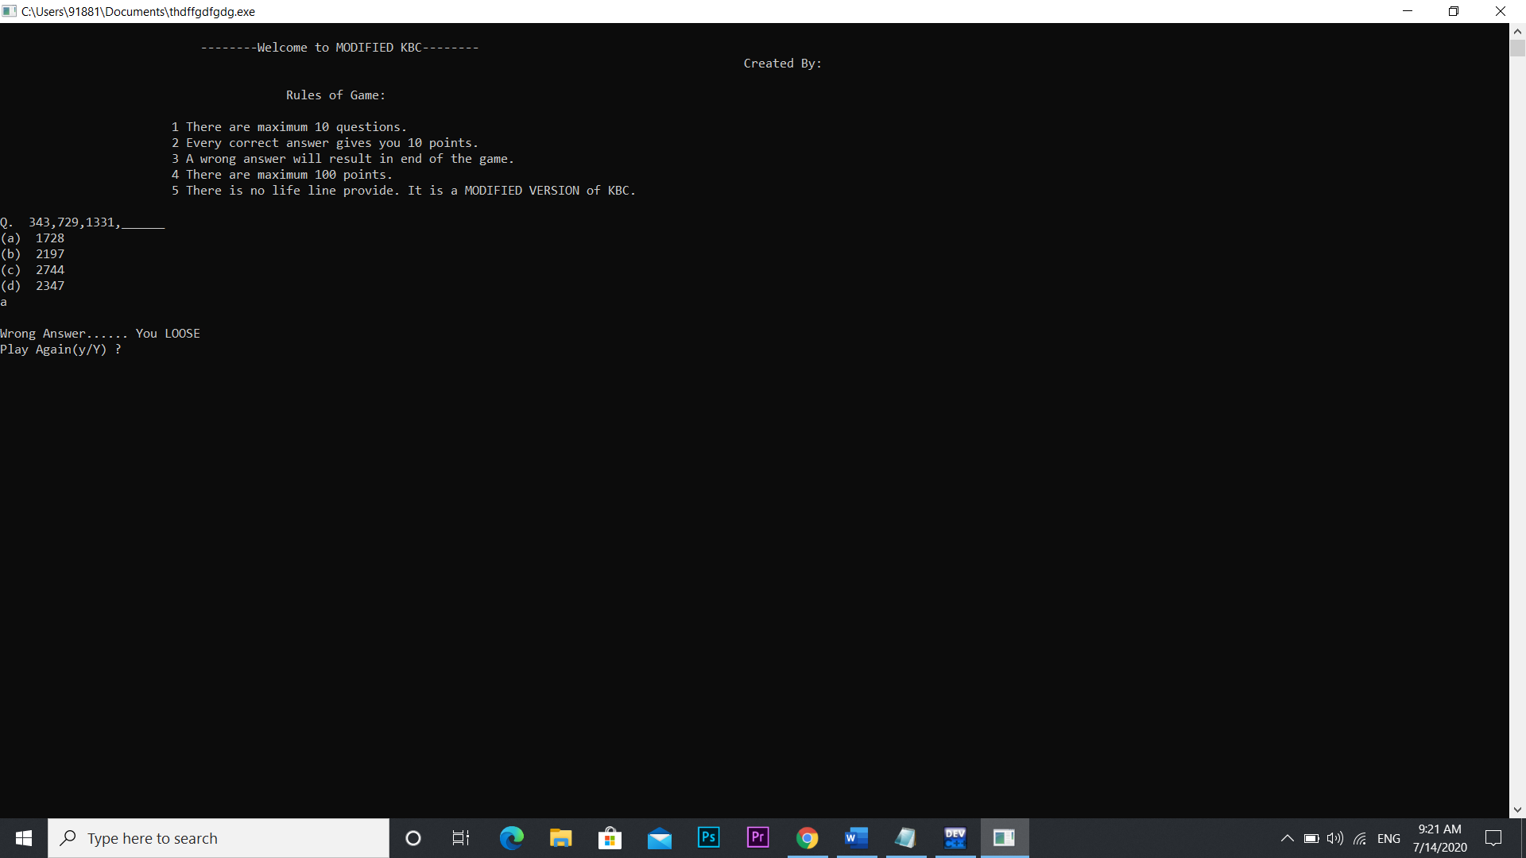

**Like wise different subject can be play**

**Thank You**

**END**