**WEEK-7**

**ReactJs**

**9. ReactJS-HOL**

**CODE:**

**ListOfPlayers.js**

import React from 'react';

const ListOfPlayers = () => {

  const players = [

    { name: "Virat", score: 85 },

    { name: "Rohit", score: 90 },

    { name: "Rahul", score: 55 },

    { name: "Hardik", score: 75 },

    { name: "Pant", score: 65 },

    { name: "Bumrah", score: 45 },

    { name: "Jadeja", score: 95 },

    { name: "Ashwin", score: 60 },

    { name: "Dhoni", score: 100 },

    { name: "Gill", score: 72 },

    { name: "Surya", score: 68 }

  ];

  const lowScorers = players.filter(player => player.score < 70);

  return (

    <div>

      <h2>All Players</h2>

      <ul>

        {players.map((player, index) => (

          <li key={index}>{player.name} - {player.score}</li>

        ))}

      </ul>

      <h2>Players with Score Below 70</h2>

      <ul>

        {lowScorers.map((player, index) => (

          <li key={index}>{player.name} - {player.score}</li>

        ))}

      </ul>

    </div>

  );

};

export default ListOfPlayers;

**IndianPlayers.js**

import React from 'react';

const IndianPlayers = () => {

  const oddTeam = ["Virat", "Rahul", "Pant", "Jadeja", "Dhoni"];

  const evenTeam = ["Rohit", "Hardik", "Bumrah", "Ashwin", "Gill", "Surya"];

  const [firstOdd, ...restOdd] = oddTeam;

  const [firstEven, ...restEven] = evenTeam;

  const T20Players = ["Virat", "Rohit", "Pant"];

  const RanjiTrophyPlayers = ["Rahane", "Pujara", "Saha"];

  const mergedPlayers = [...T20Players, ...RanjiTrophyPlayers];

  return (

    <div>

      <h2>Odd Team</h2>

      <p>First Player: {firstOdd}</p>

      <p>Others: {restOdd.join(', ')}</p>

      <h2>Even Team</h2>

      <p>First Player: {firstEven}</p>

      <p>Others: {restEven.join(', ')}</p>

      <h2>Merged Team (T20 + Ranji Trophy)</h2>

      <p>{mergedPlayers.join(', ')}</p>

    </div>

  );

};

export default IndianPlayers;

**App.js**

import React from 'react';

import ListOfPlayers from './components/ListOfPlayers';

import IndianPlayers from './components/IndianPlayers';

function App() {

  const flag = true;

  return (

    <div className="App">

      <h1>Cricket App</h1>

      {flag ? <ListOfPlayers /> : <IndianPlayers />}

    </div>

  );

}

export default App;

**OUTPUT:**

**When flag==true;**

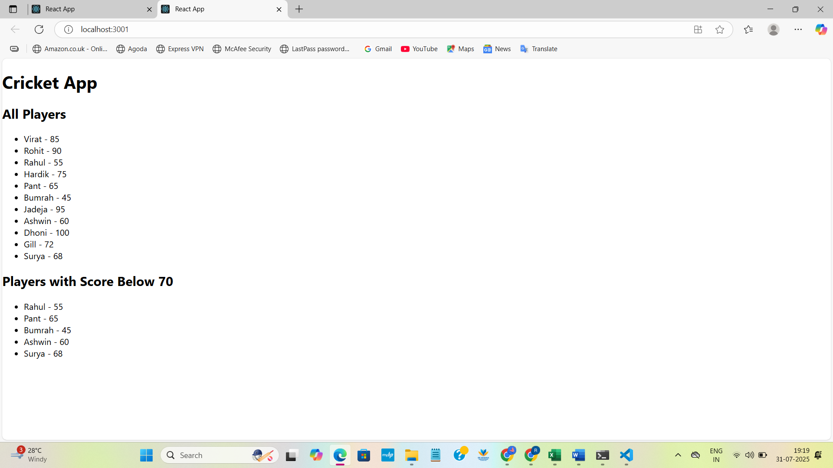

**When Flag=false**

**OUTPUT:**

import React from 'react';

import ListOfPlayers from './components/ListOfPlayers';

import IndianPlayers from './components/IndianPlayers';

function App() {

  const flag = false;

  return (

    <div className="App">

      <h1>Cricket App</h1>

      {flag ? <ListOfPlayers /> : <IndianPlayers />}

    </div>

  );

}

export default App;

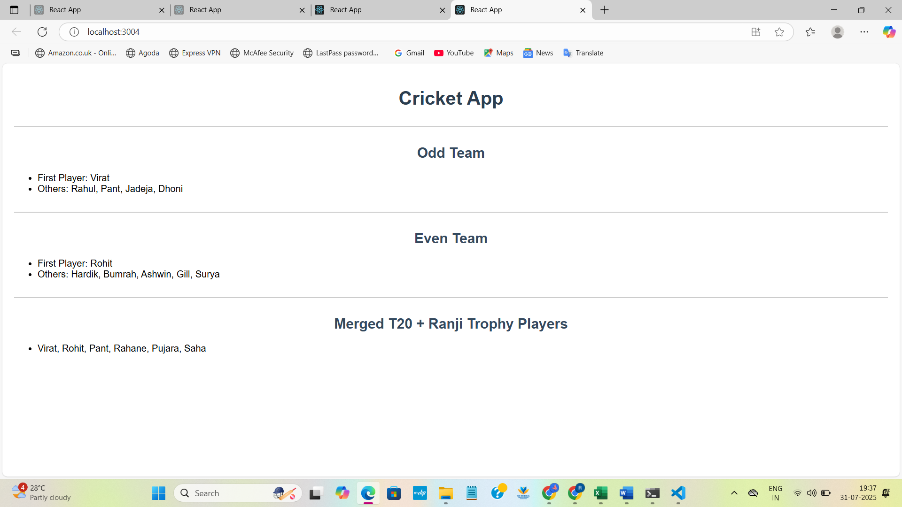

**10. ReactJS-HOL**

**CODE:**

**App.js**

import React from 'react';

function App() {

  const office = {

    name: 'Premium WorkSpace',

    rent: 55000,

    address: 'Indiranagar, Bangalore',

    image: 'https://convene.com/wp-content/uploads/2024/11/HEADER-IMAGE.png'

  };

  const rentStyle = {

    color: office.rent < 60000 ? 'red' : 'green'

  };

  const containerStyle = {

    textAlign: 'center',

    marginTop: '50px'

  };

  return (

    <div style={containerStyle}>

      <h1>Office Space Rental</h1>

      <img src={office.image} alt="Office" width="300" height="180" />

      <p><strong>Name:</strong> {office.name}</p>

      <p><strong>Address:</strong> {office.address}</p>

      <p style={rentStyle}><strong>Rent:</strong> ₹{office.rent}</p>

    </div>

  );

}

export default App;

**App.css**

.App {

  padding: 20px;

  font-family: Arial, sans-serif;

}

.office-container {

  display: flex;

  justify-content: center;

  margin-top: 30px;

}

.card {

  border: 1px solid #ccc;

  padding: 15px;

  width: 300px;

  box-shadow: 0 0 10px #ddd;

  border-radius: 8px;

  background-color: #f9f9f9;

  text-align: center;

}

.card img {

  width: 100%;

  height: auto;

  border-radius: 4px;

}

**OUTPUT:**

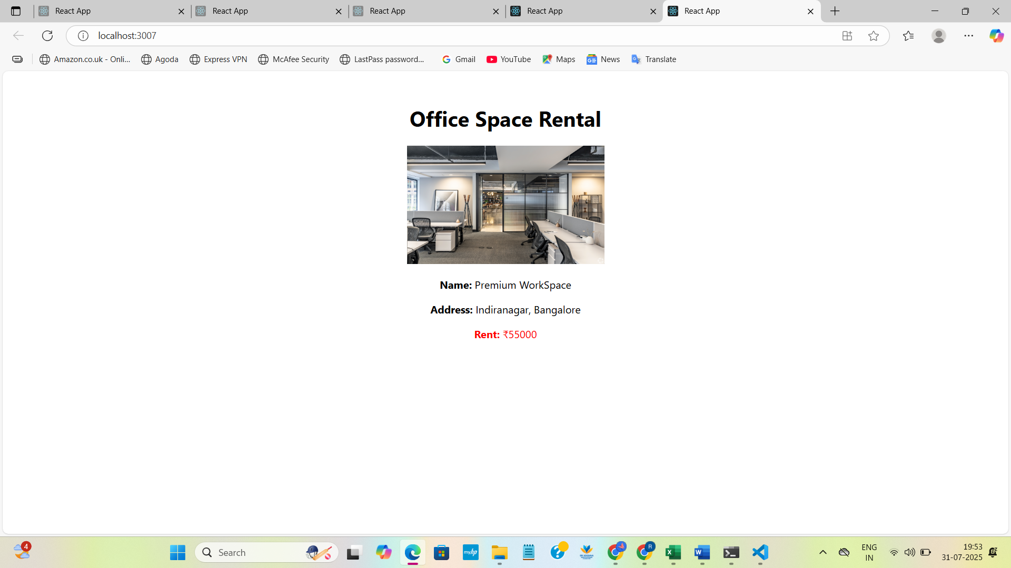

**11. ReactJS-HOL**

**CODE:**

**App.js**

import React, { Component } from 'react';

import CurrencyConvertor from './CurrencyConvertor';

class App extends Component {

  constructor(props) {

    super(props);

    this.state = {

      count: 0

    };

    this.increment = this.increment.bind(this);

    this.sayHello = this.sayHello.bind(this);

  }

  increment() {

    this.setState({ count: this.state.count + 1 });

    this.sayHello();

  }

  sayHello() {

    alert("Hello! You clicked Increment.");

  }

  decrement = () => {

    this.setState({ count: this.state.count - 1 });

  };

  sayWelcome = (msg) => {

    alert(msg);

  };

  handleSyntheticEvent = (e) => {

    e.preventDefault();

    alert("I was clicked");

  };

  render() {

    return (

      <div style={{ textAlign: 'center', marginTop: '50px' }}>

        <h1>React Event </h1>

        <h2>Counter: {this.state.count}</h2>

        <button onClick={this.increment}>Increment</button>

        <button onClick={this.decrement}>Decrement</button>

        <br /><br />

        <button onClick={() => this.sayWelcome("Welcome to React Events!")}>Say Welcome</button>

        <br /><br />

        <button onClick={this.handleSyntheticEvent}>Click Me </button>

        <br /><br />

        <CurrencyConvertor />

      </div>

    );

  }

}

export default App;

**CurrencyConvertor.js**

import React, { Component } from 'react';

class CurrencyConvertor extends Component {

  constructor(props) {

    super(props);

    this.state = {

      rupees: ''

    };

  }

  handleChange = (e) => {

    this.setState({ rupees: e.target.value });

  };

  handleSubmit = (e) => {

    e.preventDefault();

    const euro = this.state.rupees / 90;

    alert(`Converted amount: €${euro.toFixed(2)}`);

  };

  render() {

    return (

      <div>

        <h2>Currency Convertor</h2>

        <form onSubmit={this.handleSubmit}>

          <input

            type="number"

            value={this.state.rupees}

            onChange={this.handleChange}

            placeholder="Enter ₹"

          />

          <button type="submit">Convert</button>

        </form>

      </div>

    );

  }

}

export default CurrencyConvertor;

**OUTPUT:**

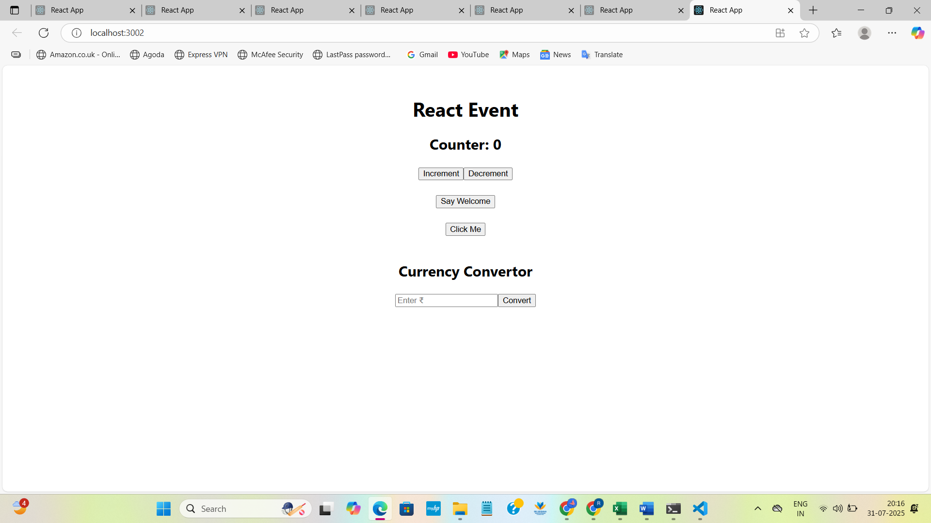

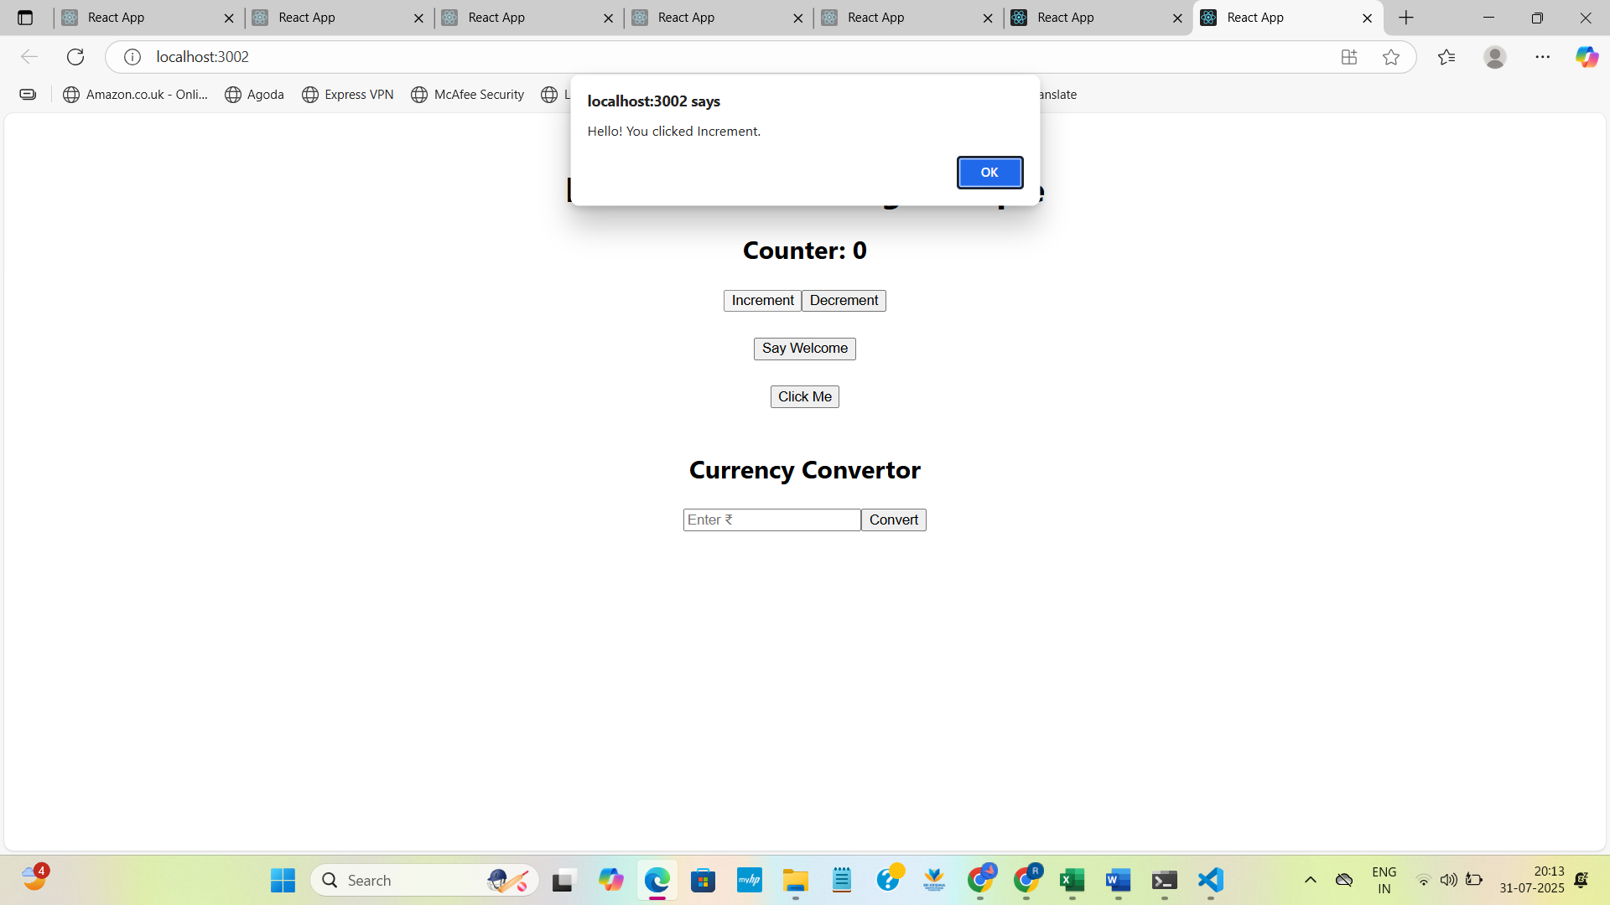

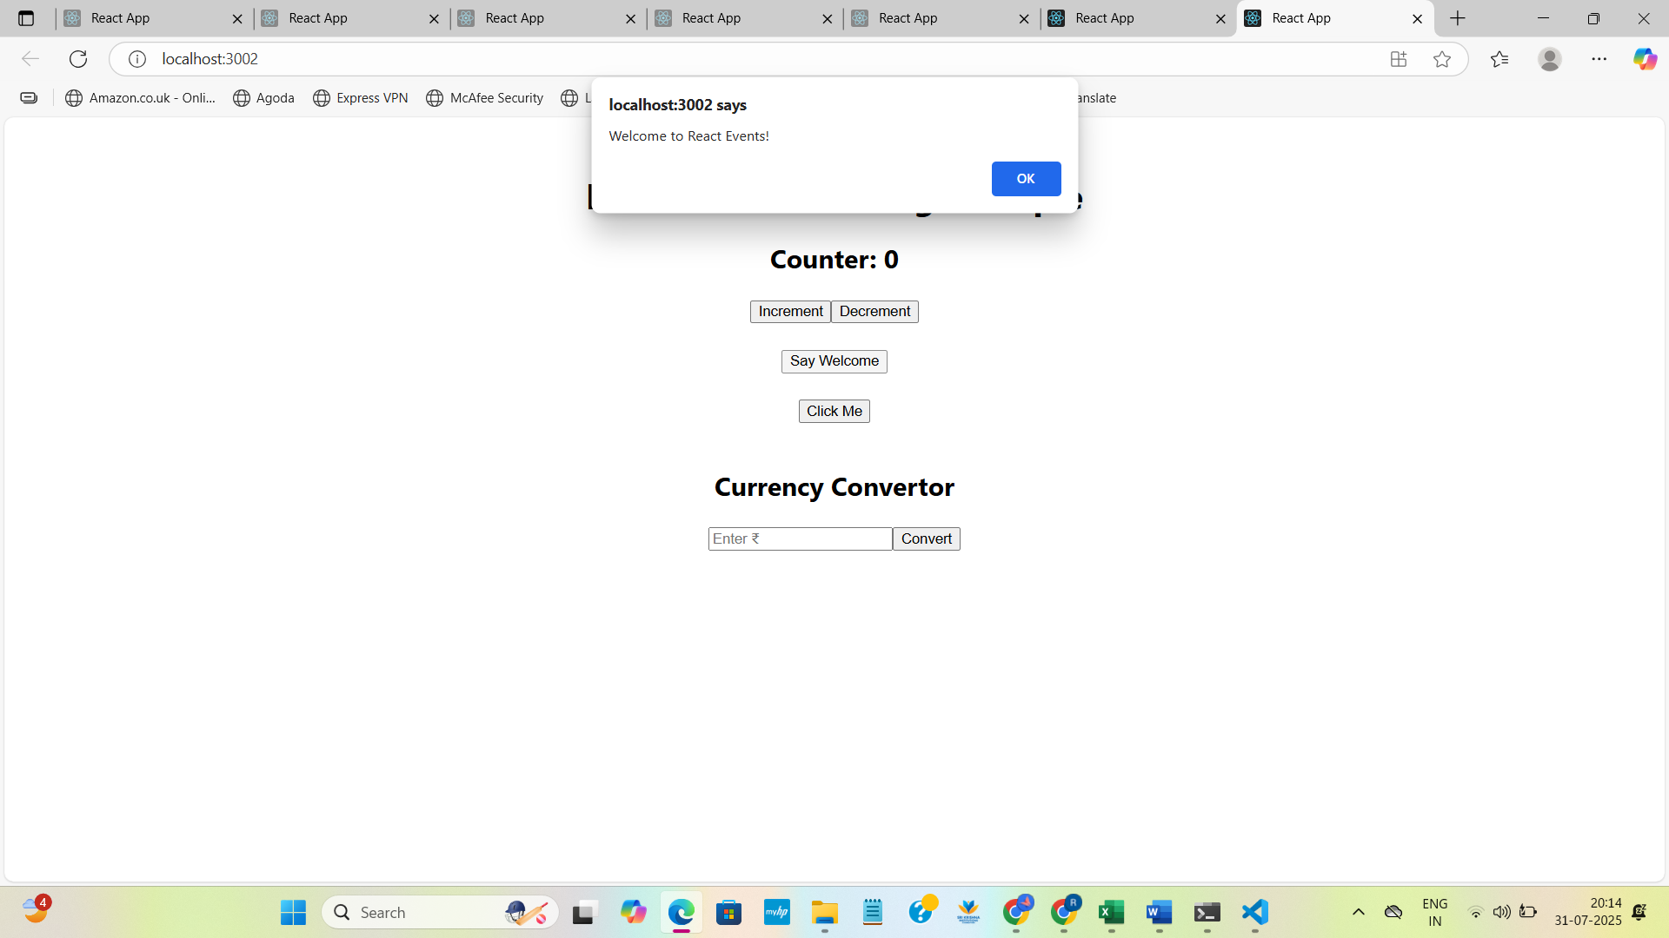

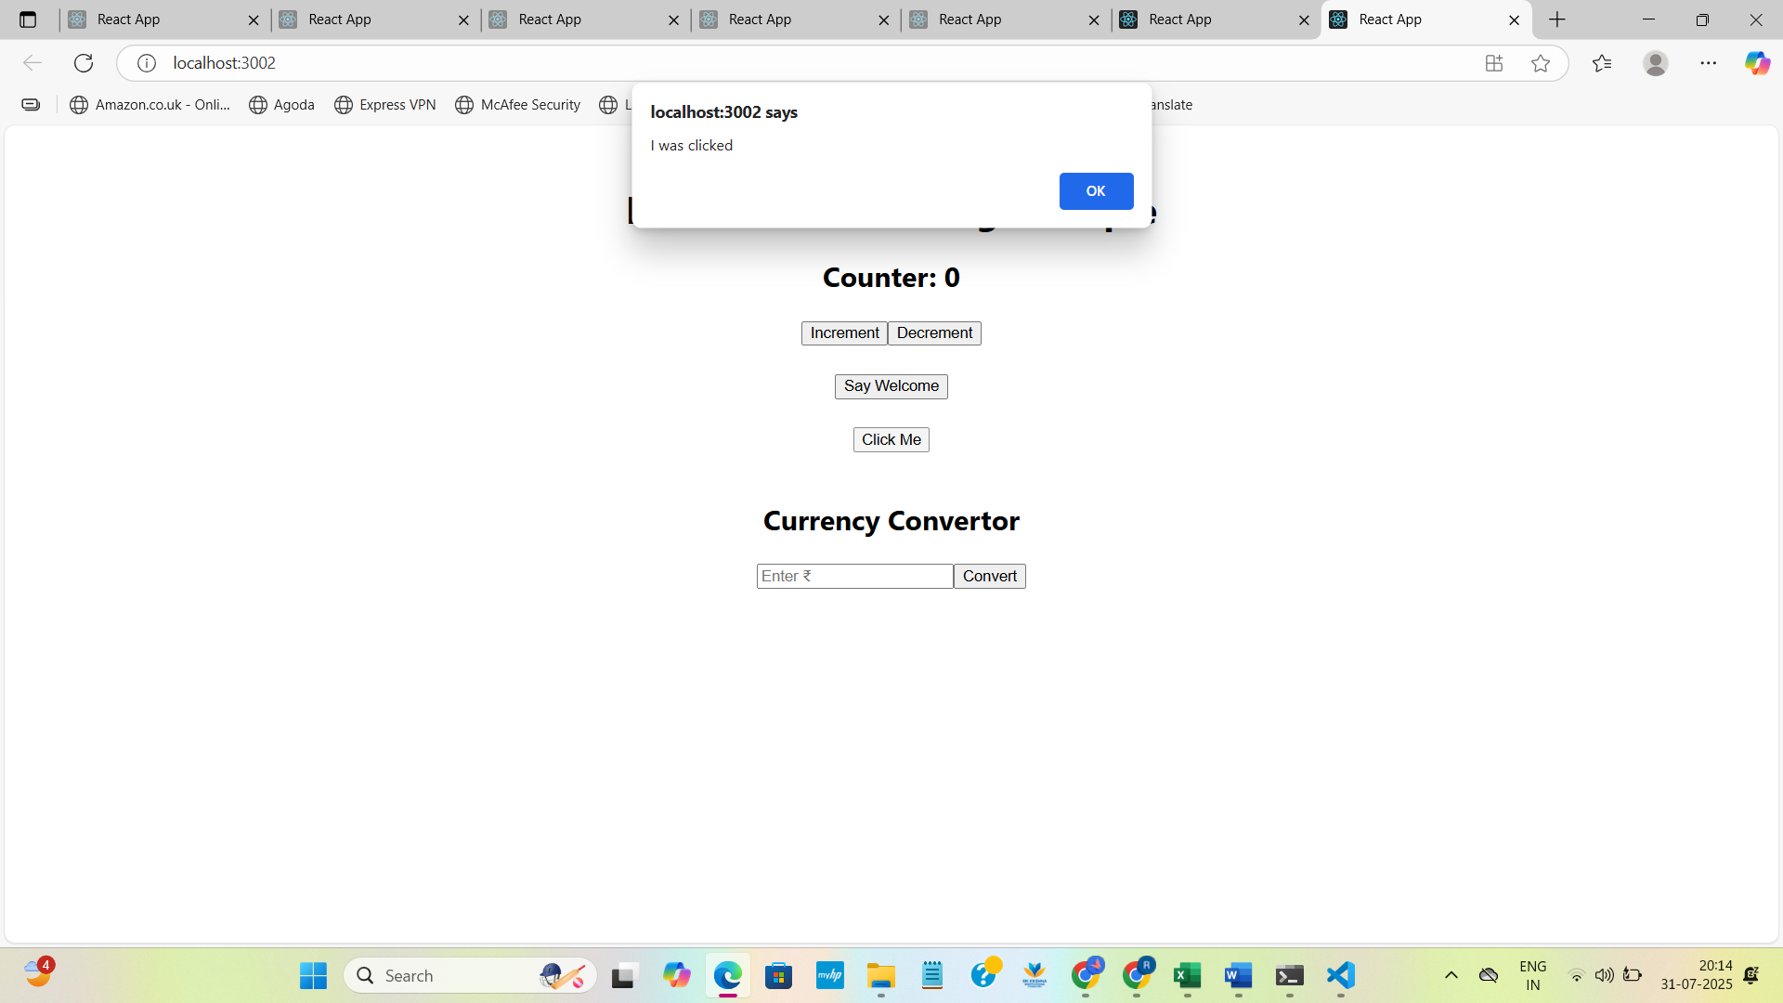

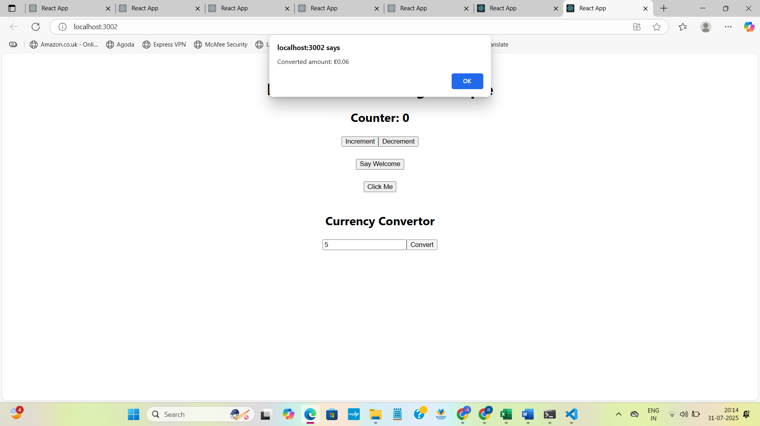

**12. ReactJS-HOL**

**CODE:**

**App.js**

import React, { Component } from 'react';

import GuestPage from './GuestPage';

import UserPage from './UserPage';

class App extends Component {

  constructor(props) {

    super(props);

    this.state = {

      isLoggedIn: false

    };

  }

  handleLogin = () => {

    this.setState({ isLoggedIn: true });

  };

  handleLogout = () => {

    this.setState({ isLoggedIn: false });

  };

  render() {

    let page;

    let button;

    if (this.state.isLoggedIn) {

      page = <UserPage />;

      button = <button onClick={this.handleLogout}>Logout</button>;

    } else {

      page = <GuestPage />;

      button = <button onClick={this.handleLogin}>Login</button>;

    }

    return (

      <div style={{ textAlign: 'center', marginTop: '50px' }}>

        <h1>Ticket Booking App</h1>

        {button}

        <hr />

        {page}

      </div>

    );

  }

}

export default App;

**UserPage.js**

import React from 'react';

function UserPage() {

  return (

    <div>

      <h2>Welcome User</h2>

      <p>You are now logged in. You can proceed to book your tickets.</p>

      <button>Book Tickets</button>

    </div>

  );

}

export default UserPage;

**GuestPage.js**

import React from 'react';

function GuestPage() {

  return (

    <div>

      <h2>Welcome Guest</h2>

      <p>Here are some available flight details:</p>

      <ul>

        <li>Flight: AI202 - Delhi to Mumbai - 8:00 AM</li>

        <li>Flight: AI305 - Bangalore to Chennai - 10:00 AM</li>

        <li>Flight: AI407 - Kolkata to Hyderabad - 1:00 PM</li>

      </ul>

    </div>

  );

} export default GuestPage;

**OUTPUT:**

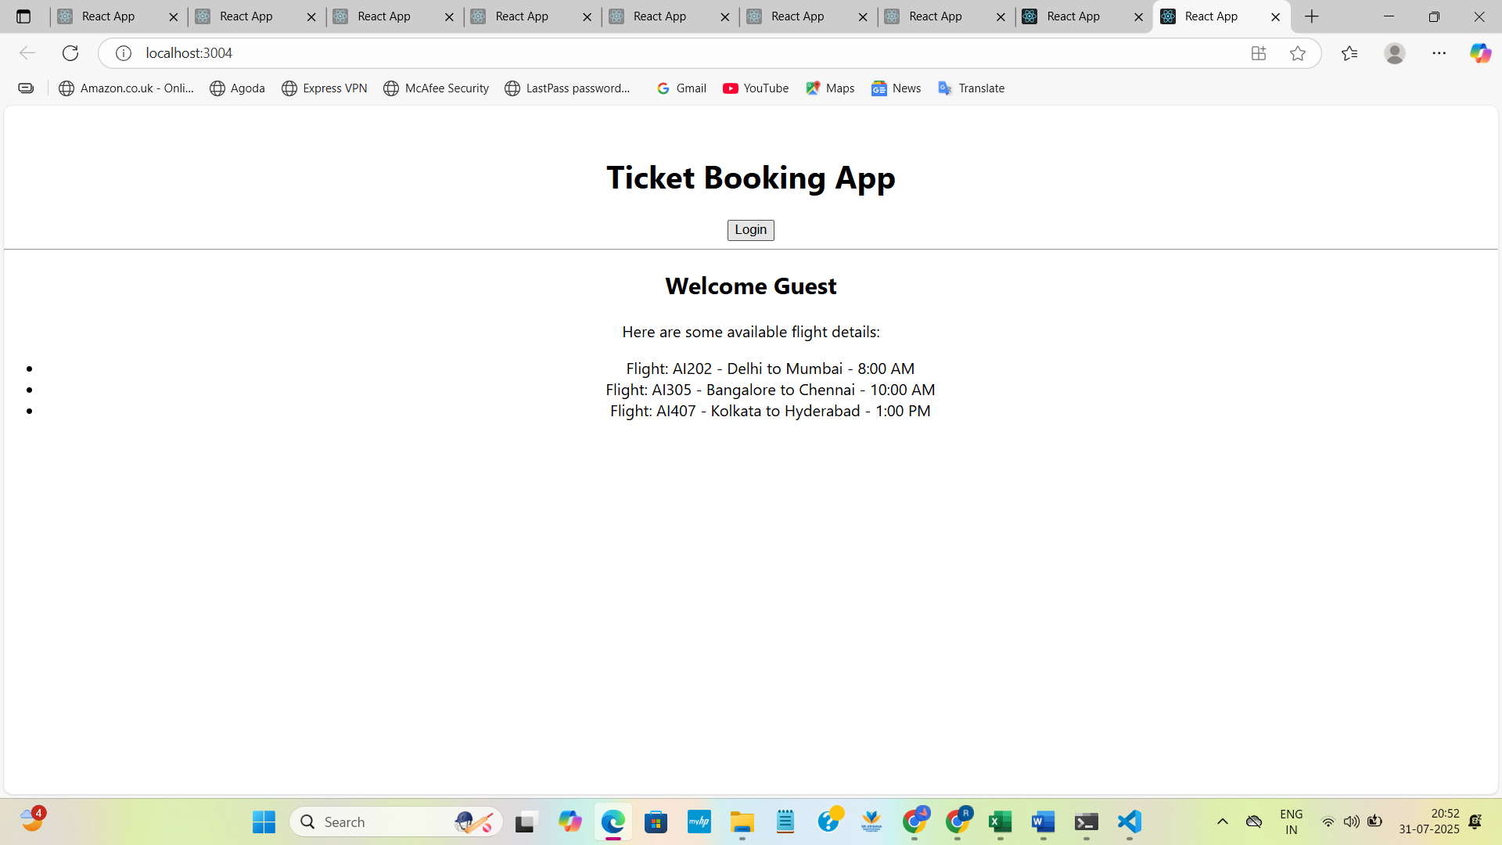

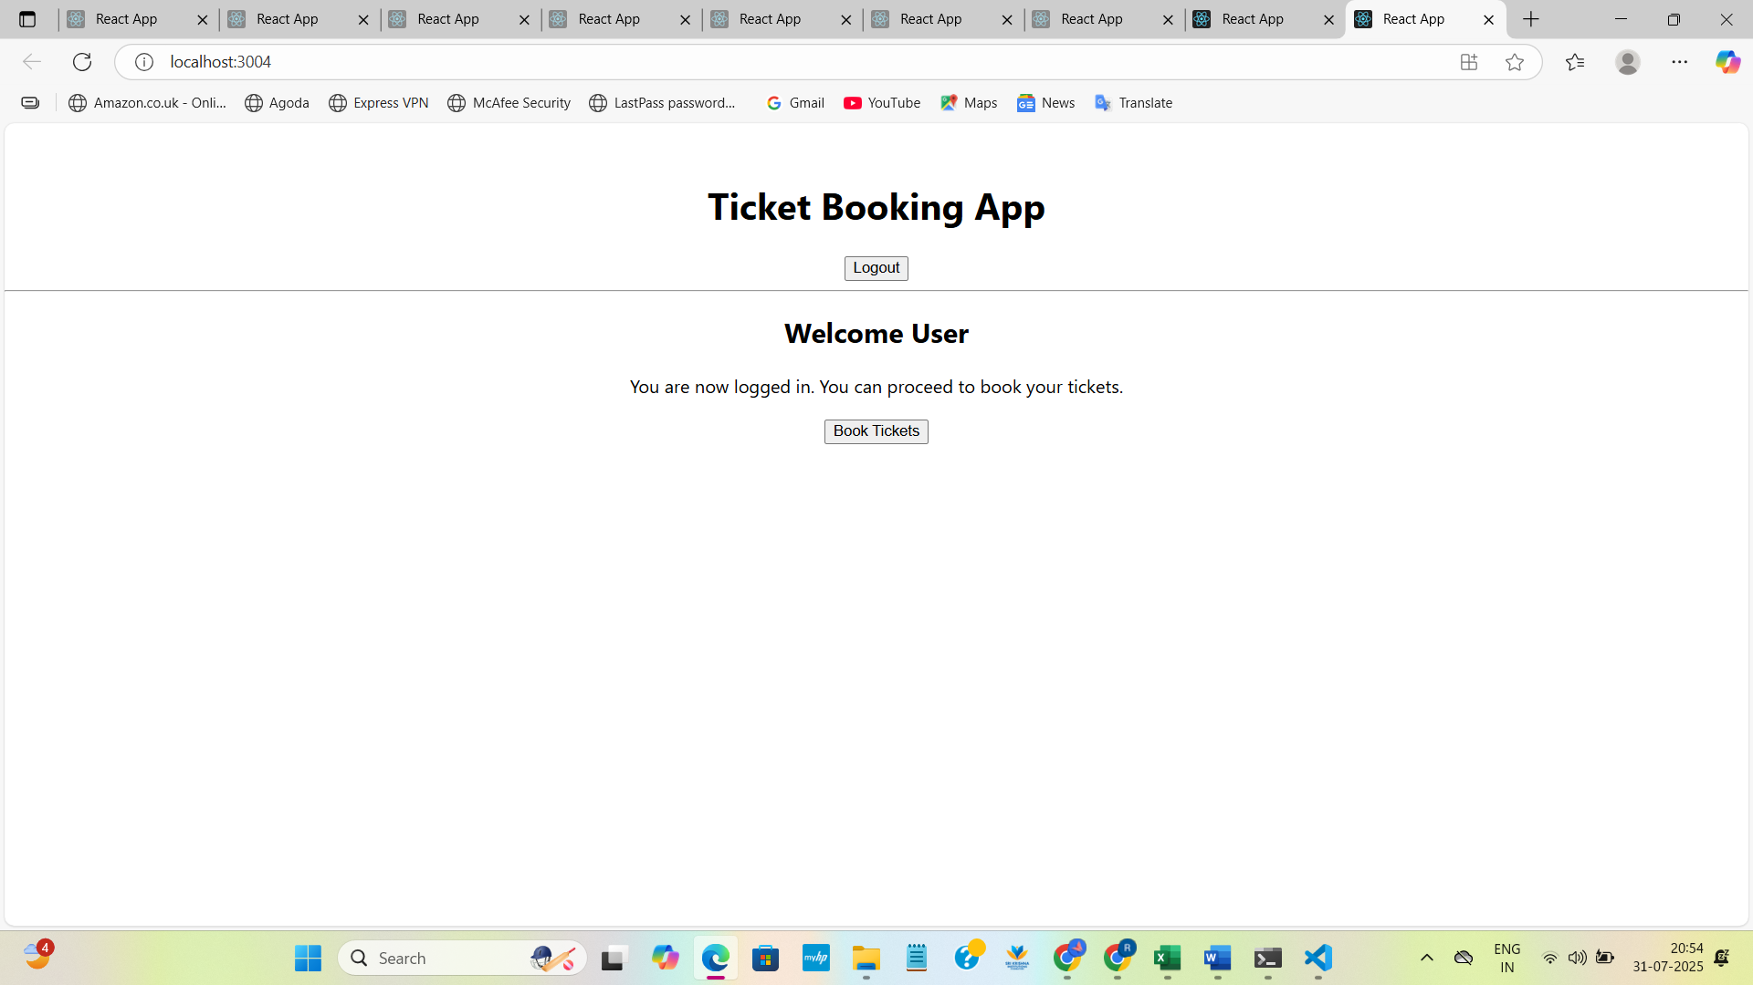

**13. ReactJS-HOL**

**CODE:**

**App.js**

import React, { Component } from 'react';

import BookDetails from './BookDetails';

import BlogDetails from './BlogDetails';

import CourseDetails from './CourseDetails';

class App extends Component {

  constructor(props) {

    super(props);

    this.state = {

      showBooks: true,

      showBlogs: false,

      showCourses: false

    };

  }

  render() {

    let component;

    if (this.state.showBooks) {

      component = <BookDetails />;

    } else if (this.state.showBlogs) {

      component = <BlogDetails />;

    } else if (this.state.showCourses) {

      component = <CourseDetails />;

    }

    return (

      <div style={{ textAlign: 'center', padding: '20px' }}>

        <h1>Blogger App</h1>

        <div style={{ marginBottom: '20px' }}>

          <button onClick={() => this.setState({ showBooks: true, showBlogs: false, showCourses: false })}>

            Show Books

          </button>

          <button onClick={() => this.setState({ showBooks: false, showBlogs: true, showCourses: false })}>

            Show Blogs

          </button>

          <button onClick={() => this.setState({ showBooks: false, showBlogs: false, showCourses: true })}>

            Show Courses

          </button>

        </div>

        {/* Render using element variable */}

        {component}

        <hr />

        {/* Render using ternary operator */}

        {this.state.showBooks ? <p>You are viewing Book section.</p> : null}

        {/* Render using short-circuit && */}

        {this.state.showCourses && <p>Explore top programming courses below.</p>}

      </div>

    );

  }

}

export default App;

**BlogDetails.js**

import React from 'react';

function BlogDetails() {

  const blogs = [

    { id: 1, title: 'Understanding React Hooks' },

    { id: 2, title: 'Mastering JSX' },

    { id: 3, title: 'React vs Angular' }

  ];

  return (

    <div>

      <h2>Blog Details</h2>

      <ul>

        {blogs.map(blog => (

          <li key={blog.id}>{blog.title}</li>

        ))}

      </ul>

    </div>

  );

}

export default BlogDetails;

**BookDetails.js**

import React from 'react';

function BookDetails() {

  const books = ['React in Action', 'Eloquent JavaScript', 'You Don’t Know JS'];

  return (

    <div>

      <h2>Book Details</h2>

      <ul>

        {books.map((book, index) => (

          <li key={index}>{book}</li>

        ))}

      </ul>

    </div>

  );

}

export default BookDetails;

**CourseDetails.js**

import React from 'react';

function CourseDetails() {

  const courses = [

    'Frontend Development',

    'Backend with Node.js',

    'Full Stack Web Development'

  ];

  return (

    <div>

      <h2>Course Details</h2>

      <ul>

        {courses.map((course, index) => (

          <li key={index}>{course}</li>

        ))}

      </ul>

    </div>

  );

}

export default CourseDetails;

**OUTPUT:**

