**WEEK-8**

**GIT**

1. **Git-HOL**

OUTPUT:

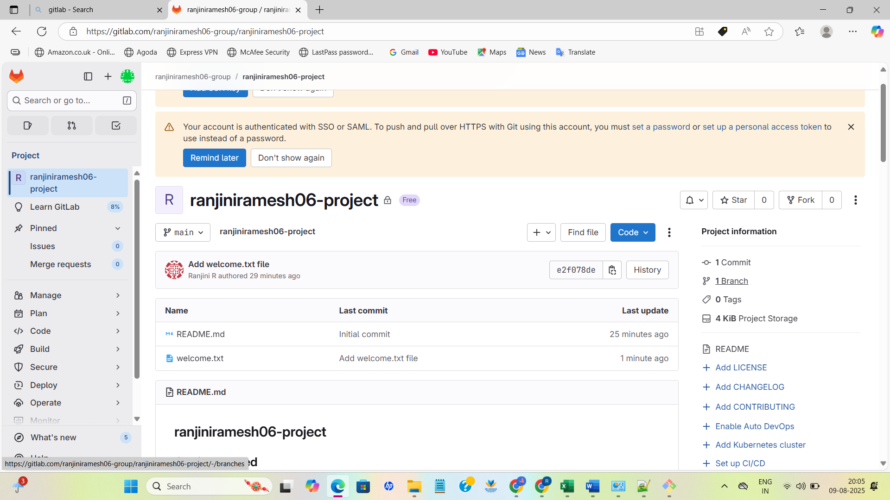

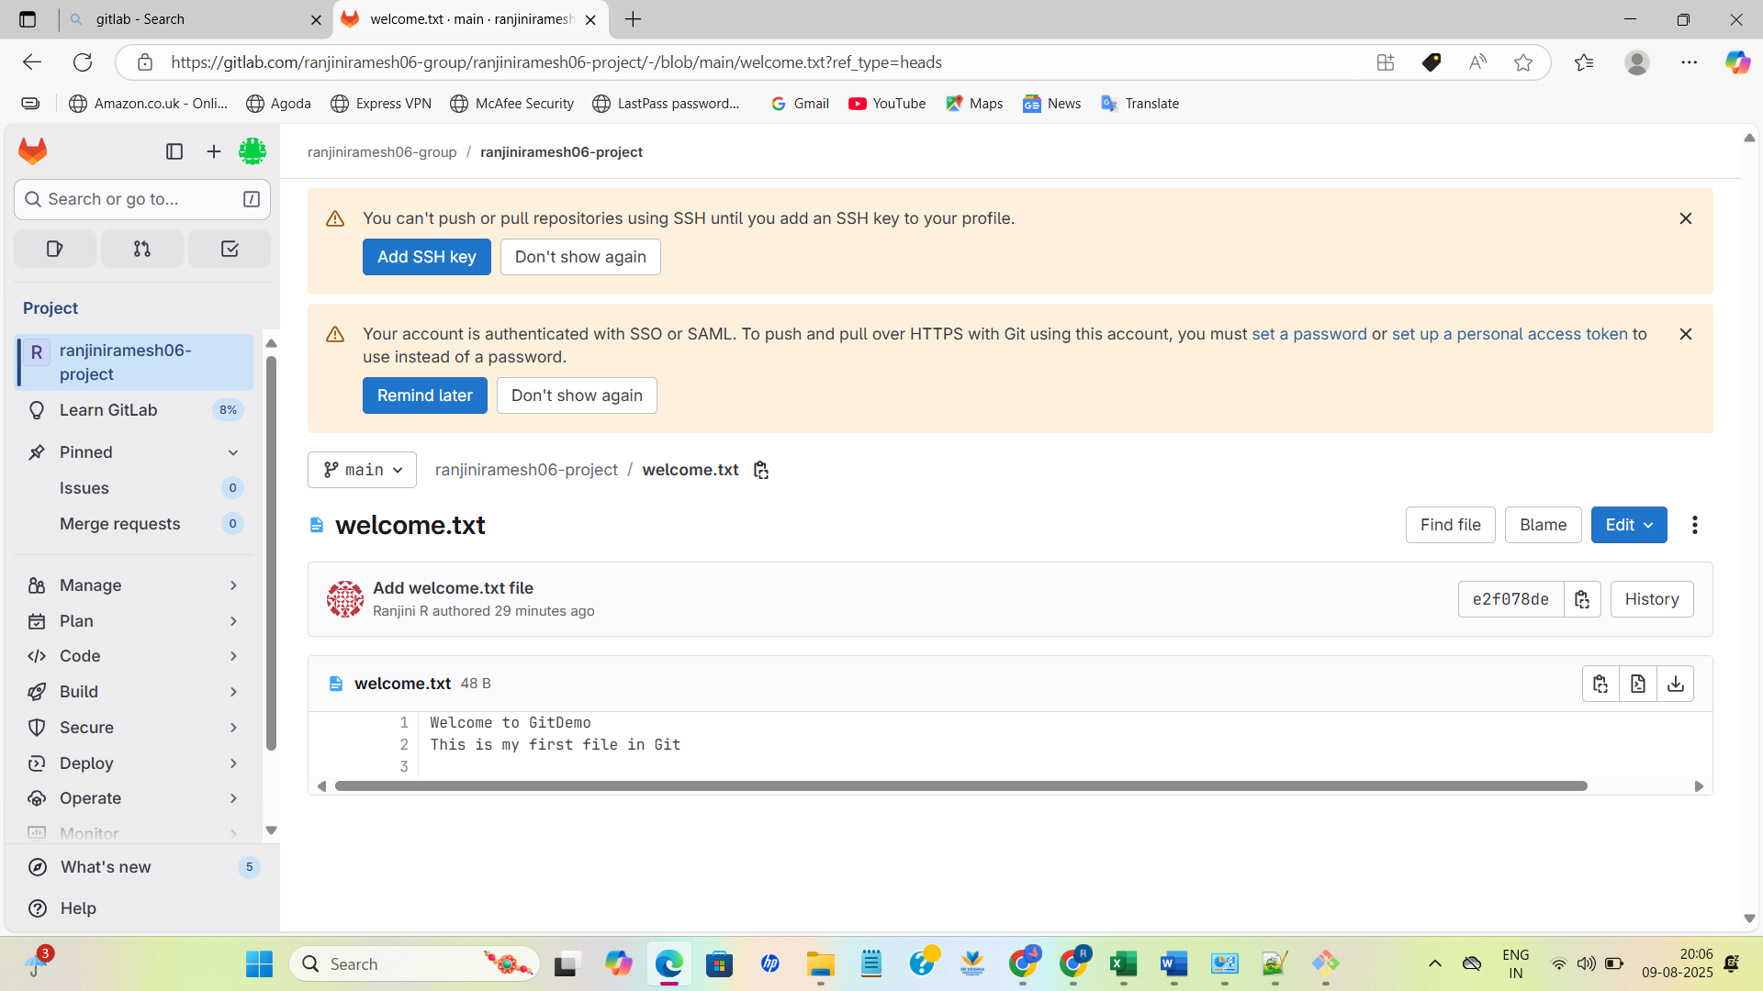

1. **Git-HOL**

OUTPUT:

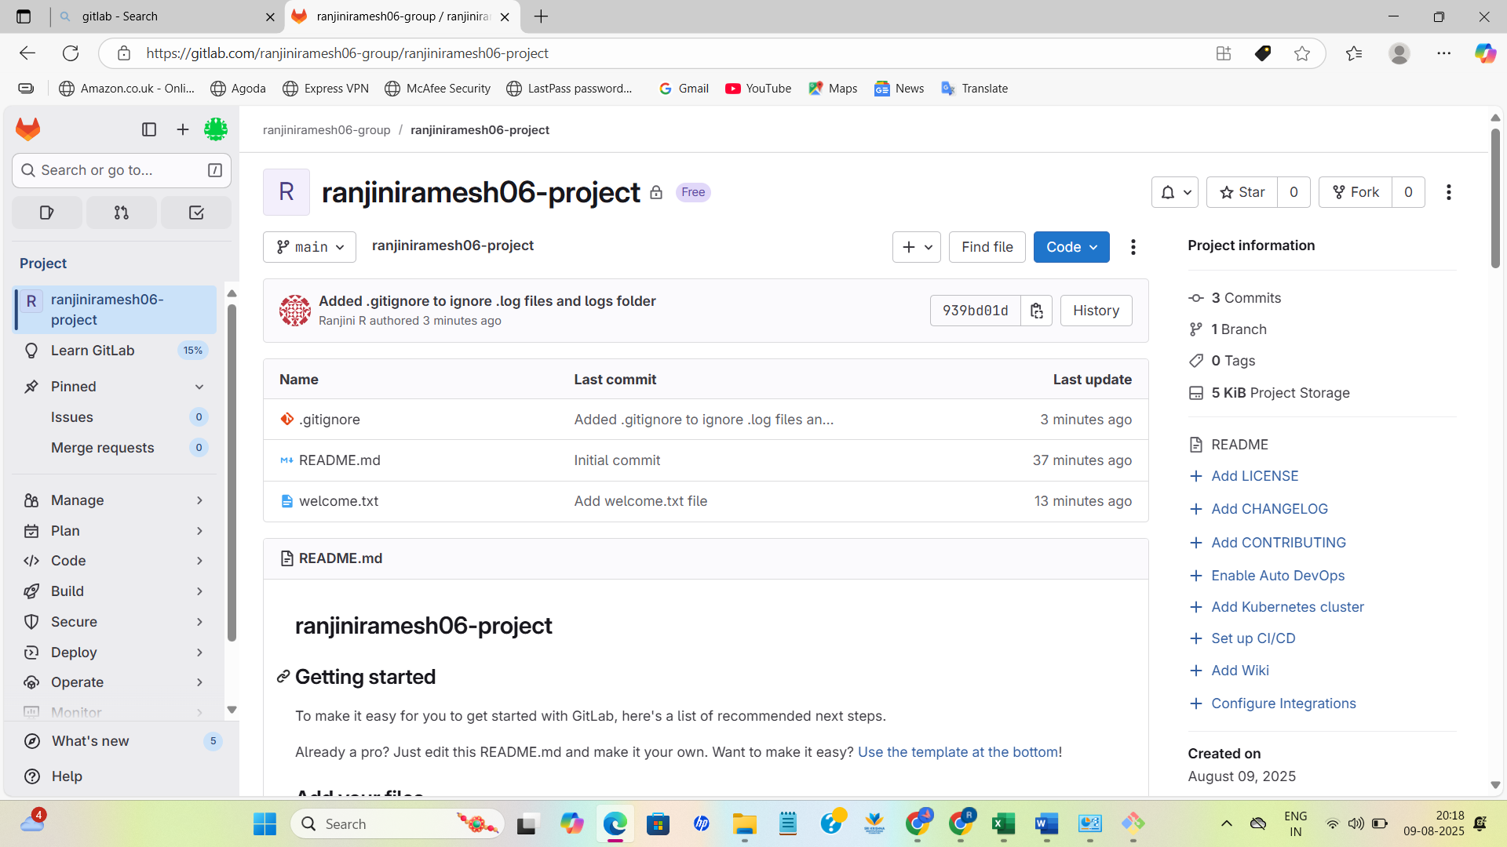

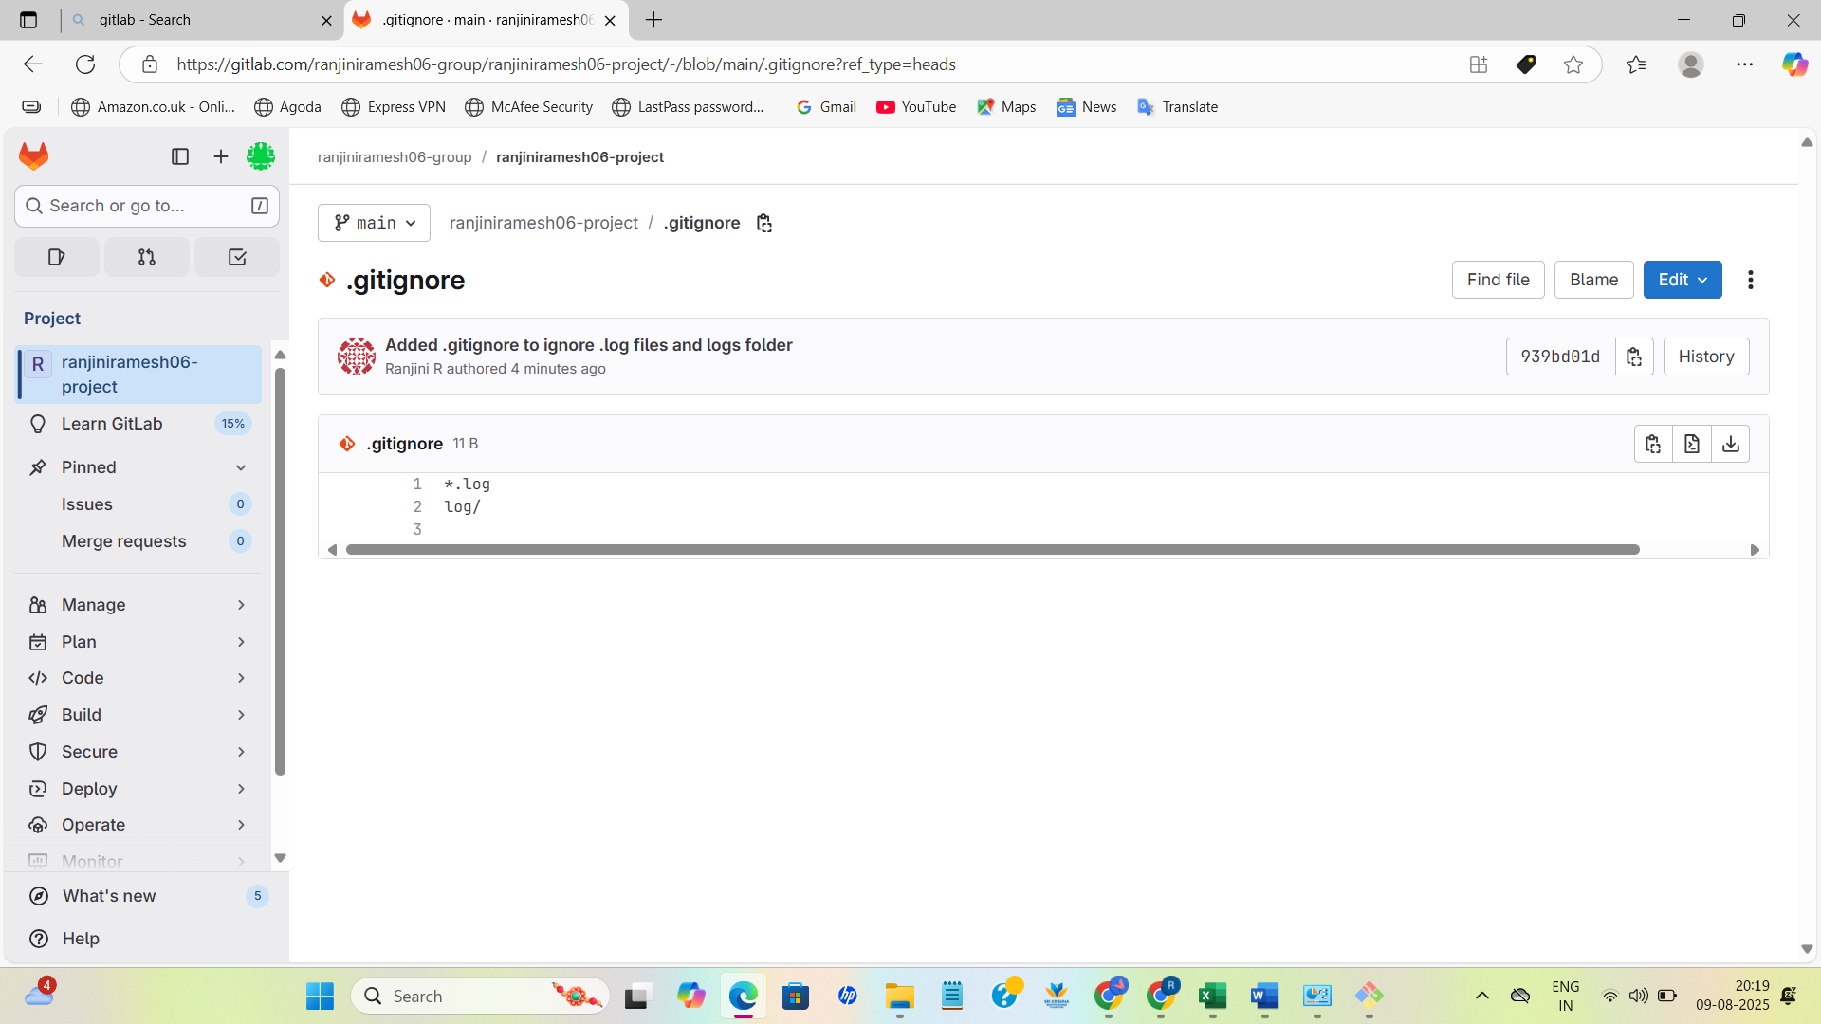

**3. Git-HOL**

OUTPUT:

ranji@RANJINI_R MINGW64 ~/GitDemo (main)

$ git branch -d GitNewBranch

Deleted branch GitNewBranch (was 84d36c7).

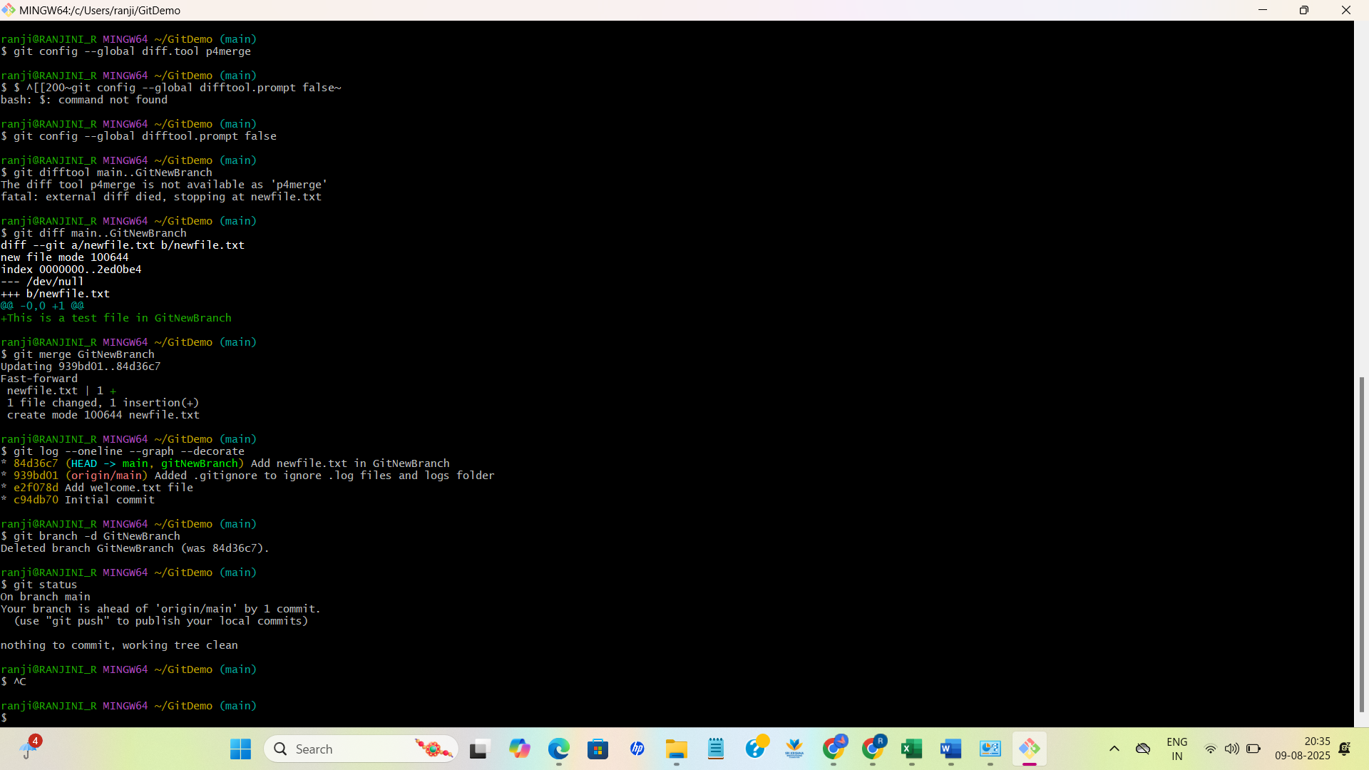

**4.Git-HOL**

OUTPUT: 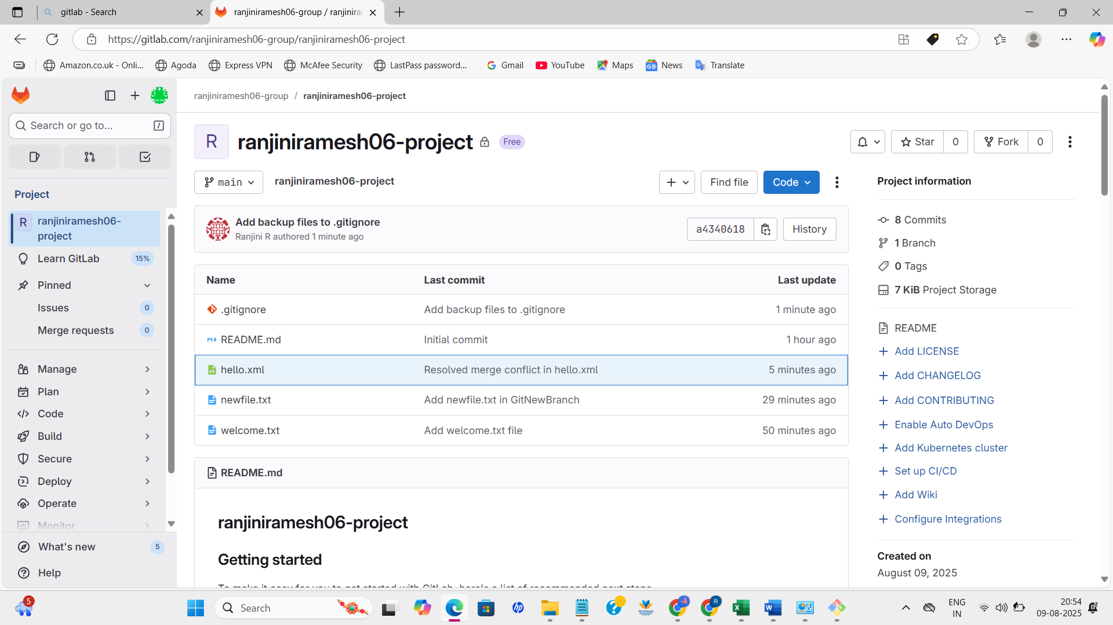

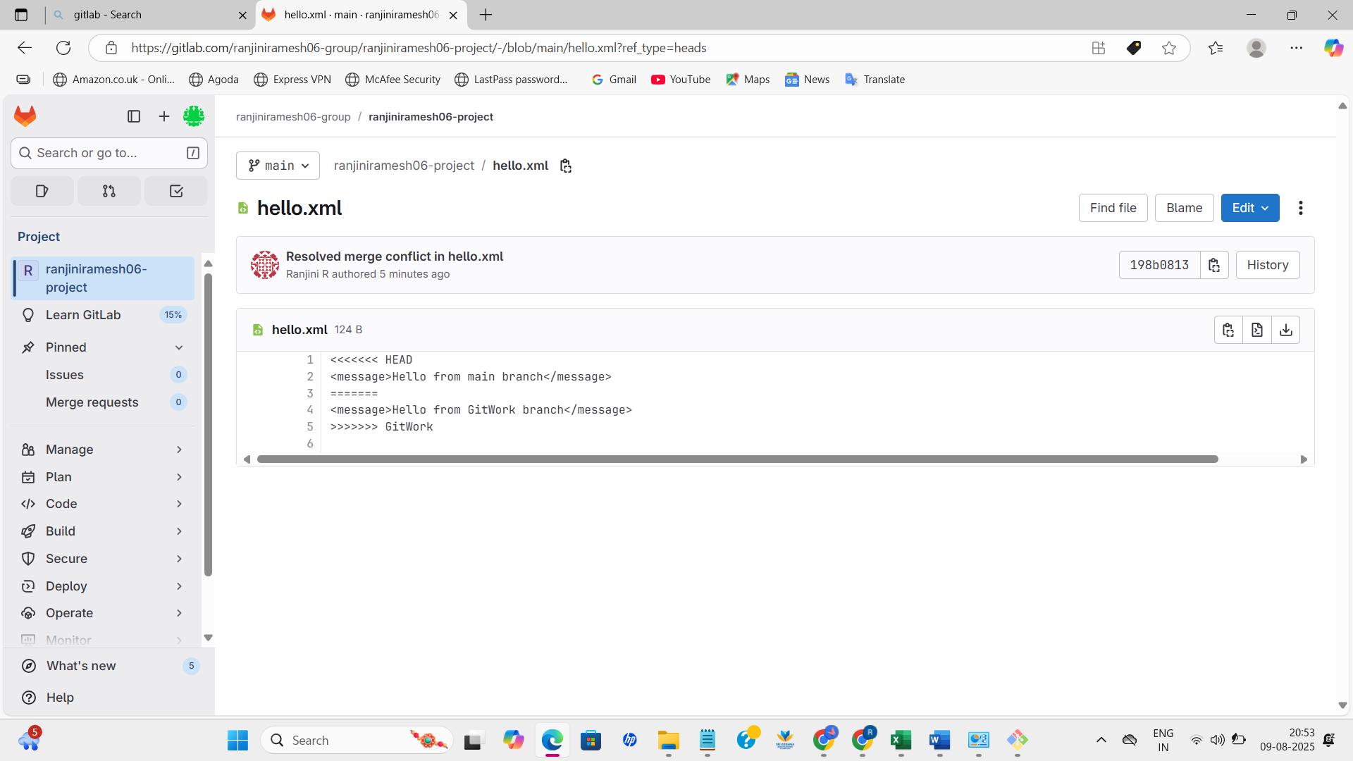

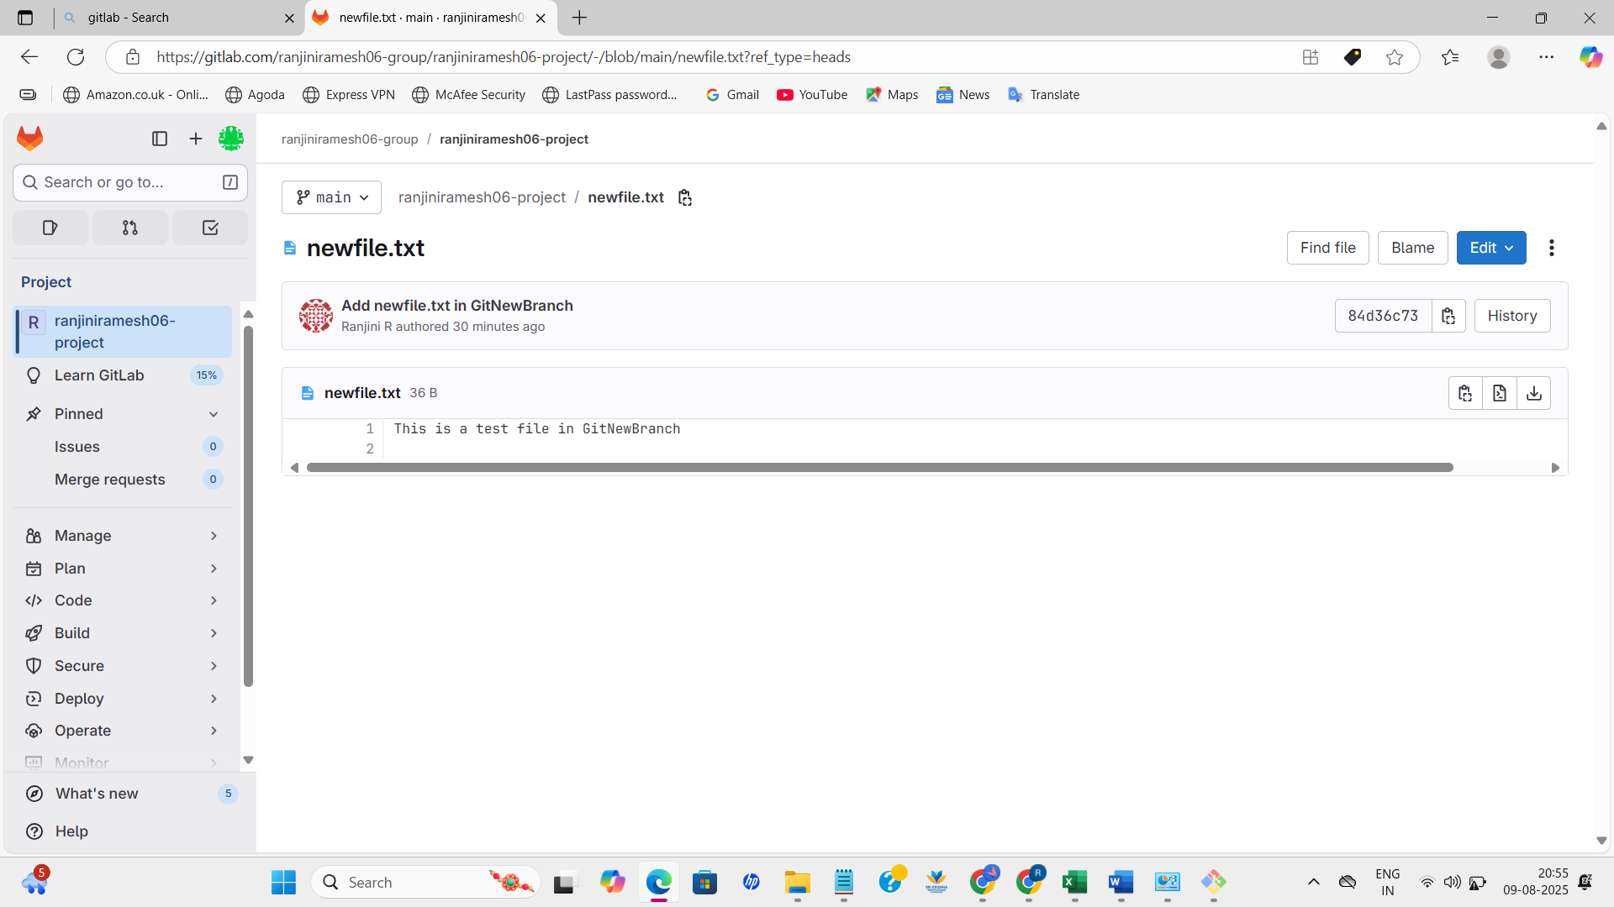

ranji@RANJINI_R MINGW64 ~/GitDemo (main)

$ git status

On branch main

Your branch is ahead of 'origin/main' by 4 commits.

(use "git push" to publish your local commits)

nothing to commit, working tree clean

**5. Git-HOL**

OUTPUT:

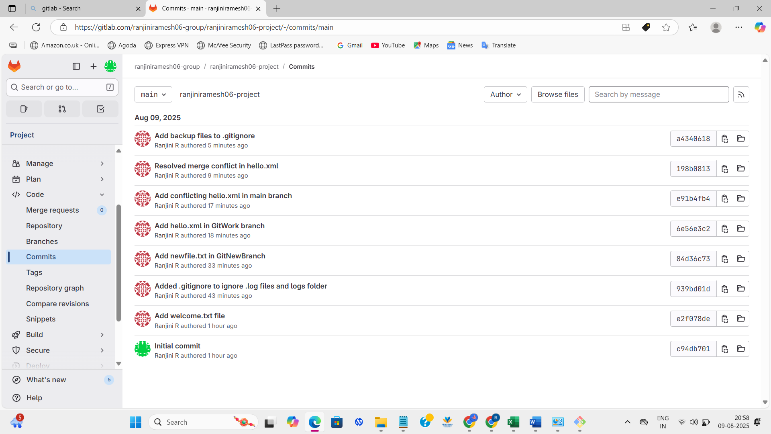

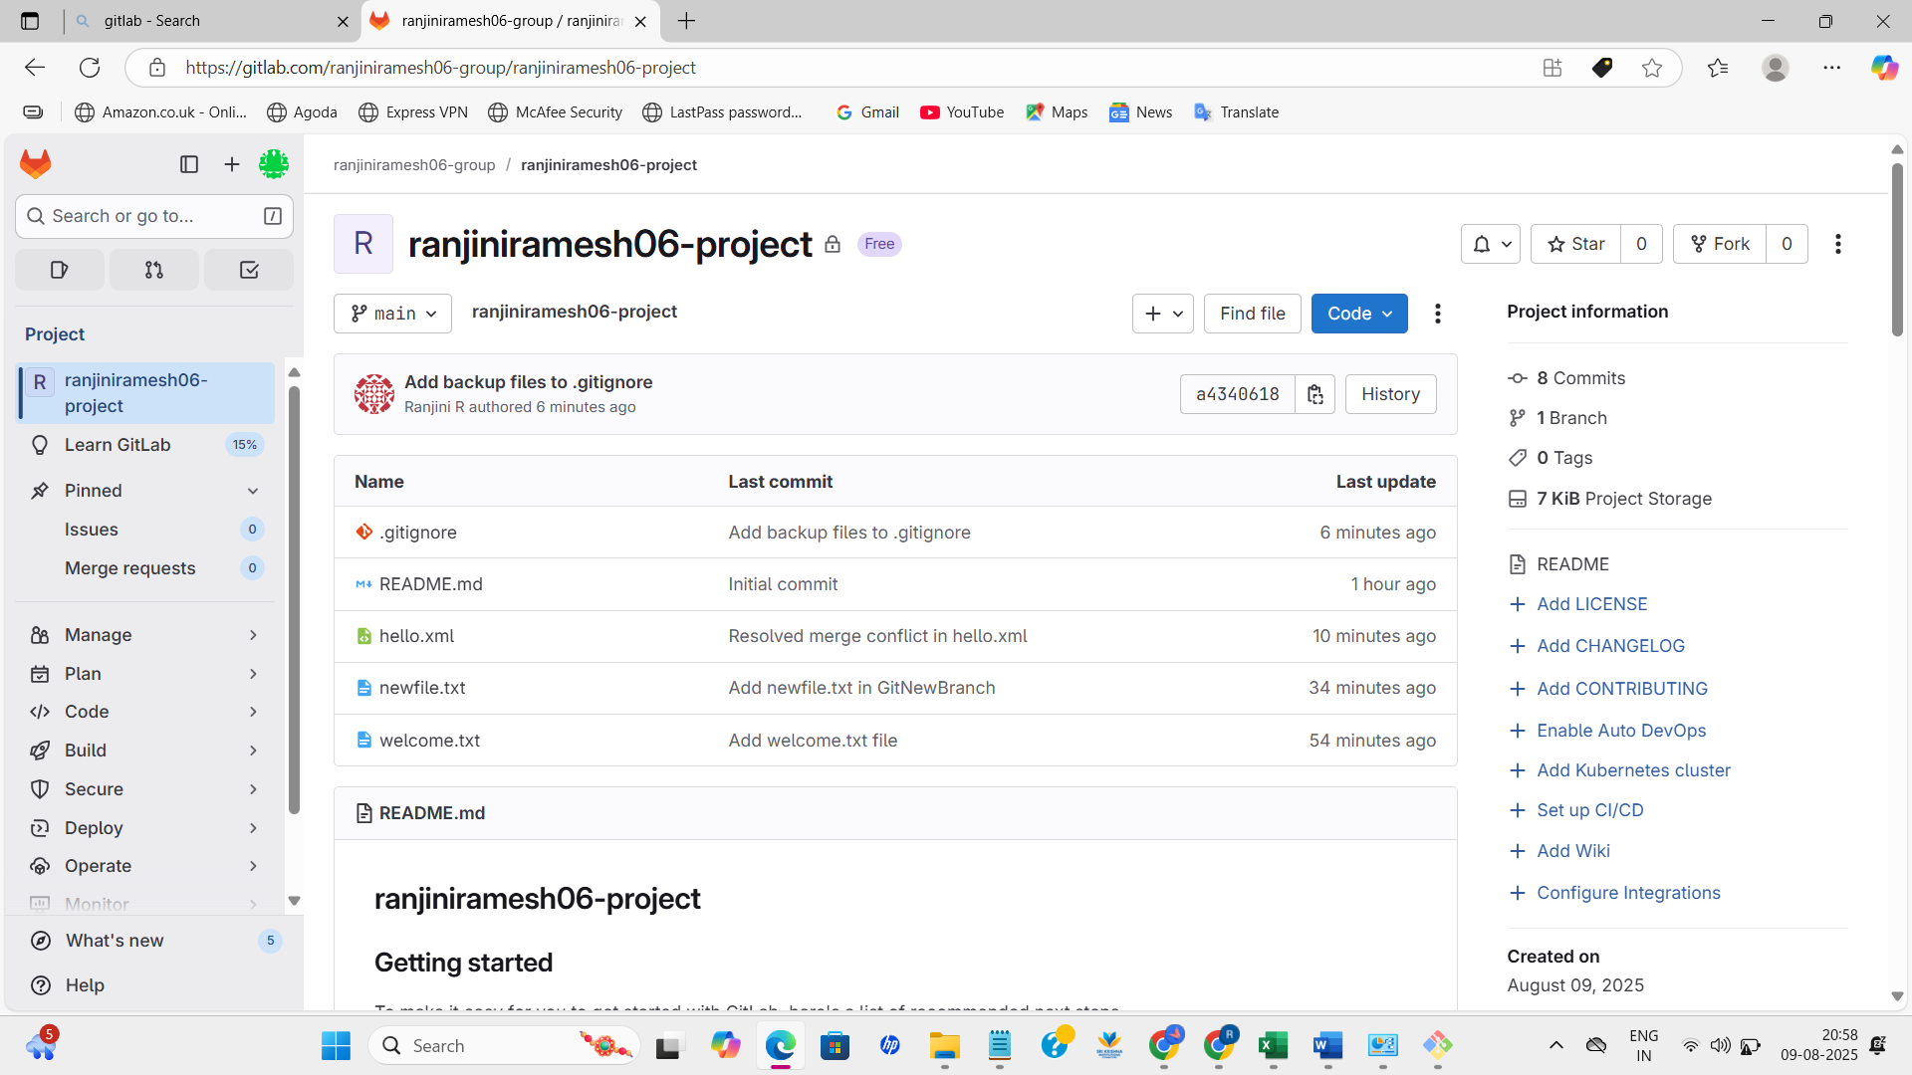

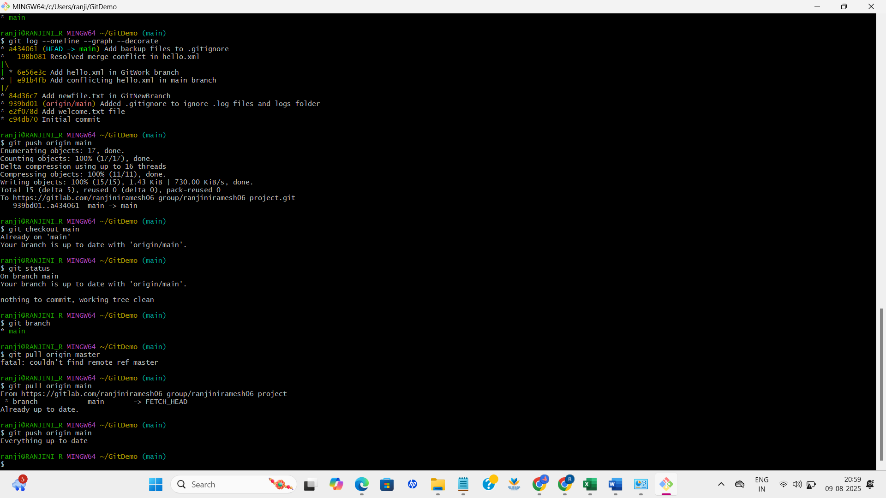

ranji@RANJINI_R MINGW64 ~/GitDemo (main)

$ git pull origin main

From https://gitlab.com/ranjiniramesh06-group/ranjiniramesh06-project

* branch main -> FETCH_HEAD

Already up to date.

ranji@RANJINI_R MINGW64 ~/GitDemo (main)

$ git push origin main