**Dominos - Predictive Purchase Order System**

**Problem Statement:**

Dominos faces challenges in optimizing its ingredient ordering process. Without accurate sales forecasts, there is a risk of either overstocking (leading to waste) or stockouts (resulting in missed sales). Efficient inventory management is crucial to ensure the right amount of ingredients are ordered at the right time.

**Aim:**

The goal of this project is to develop a predictive model that uses historical sales data and ingredient information to forecast future sales. This will enable Dominos to generate accurate purchase orders, ensuring optimal stock levels, reducing waste, and preventing stockouts.

**Business Use Cases:**

• **Inventory Management:** Maintain optimal stock levels to avoid overstocking or running out of ingredients.

• **Cost Reduction:** Reduce waste and costs from excess or expired inventory.

• **Sales Forecasting:** Predict future sales to guide strategic decisions and promotions.

• **Supply Chain Optimization:** Align ordering processes with predicted demand to avoid disruptions.

**Approach:**

**Data Preprocessing and Exploration:**

1. **Data Cleaning:**

Load the data into the respective df and analyze the missing values.

1. Remove any missing or inconsistent data entries

Fill in the missing values for pizza_category, pizza_ingredients, total_price, pizza_name, pizza_name_id in sales_df and item_quantity in ingredients_df.

1. Format the data

Change order_date into appropriate format.

1. **Exploratory Data Analysis (EDA):** Analyze sales trends, seasonality, and patterns in the historical sales data. Visualize the data to identify significant features.

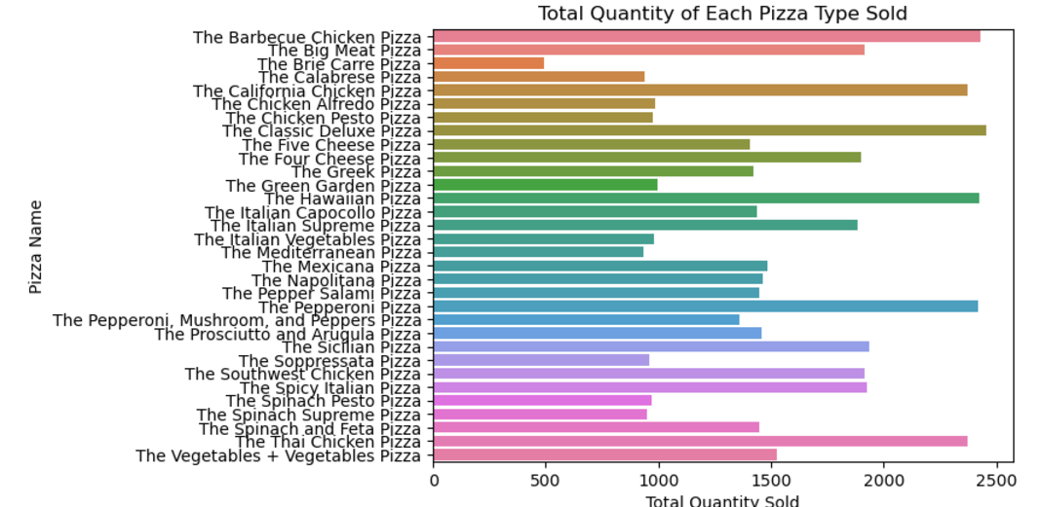

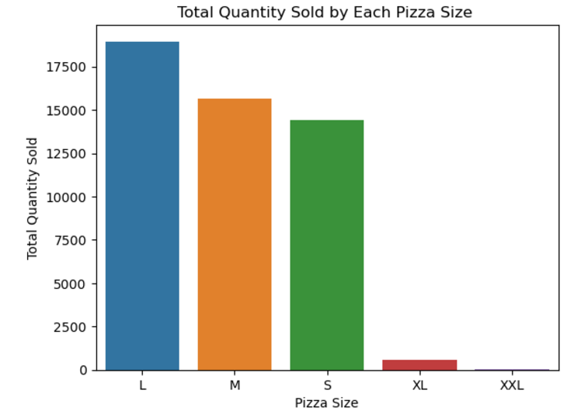

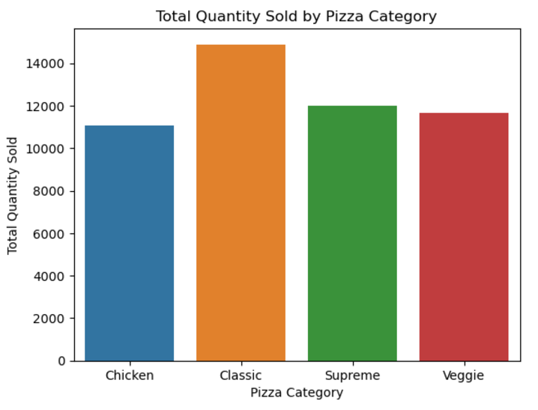

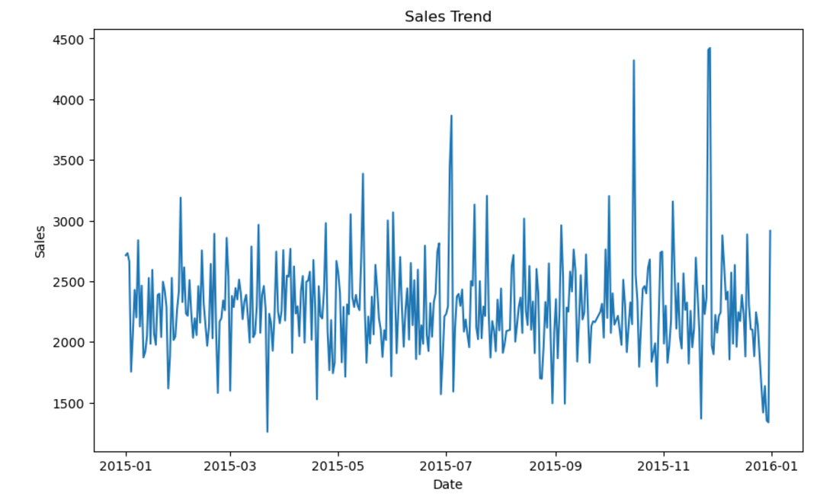

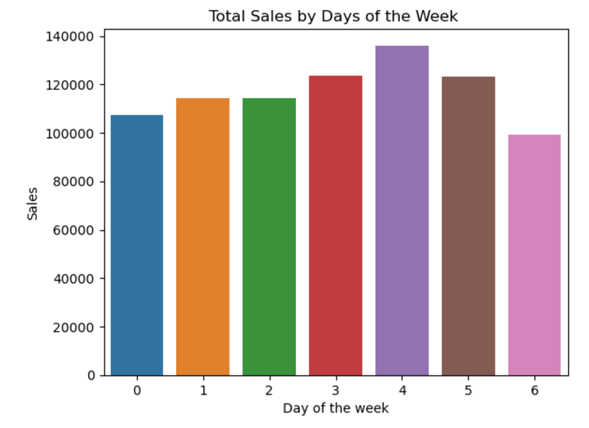

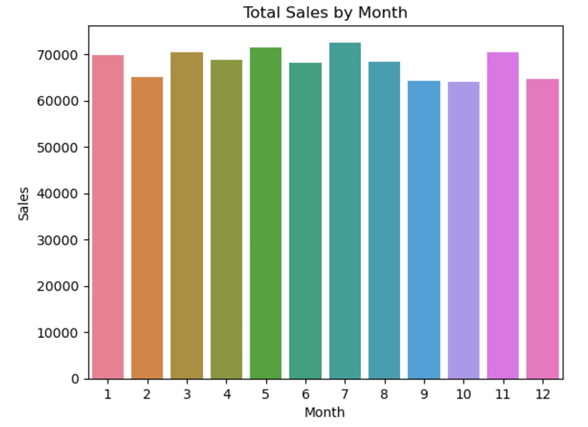

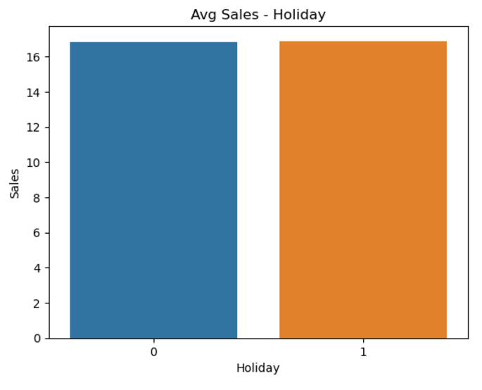

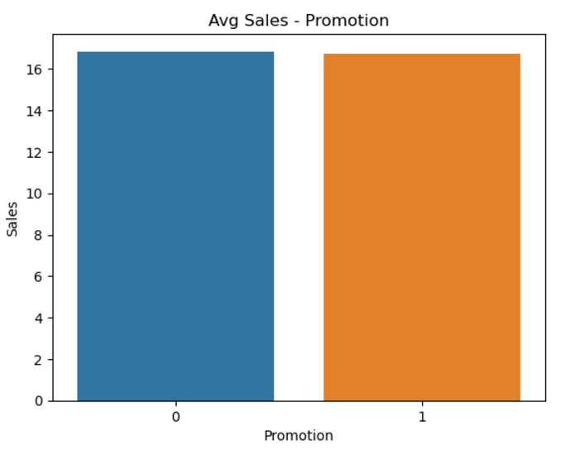

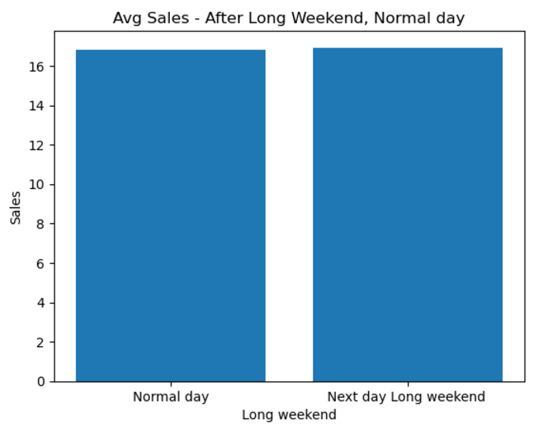

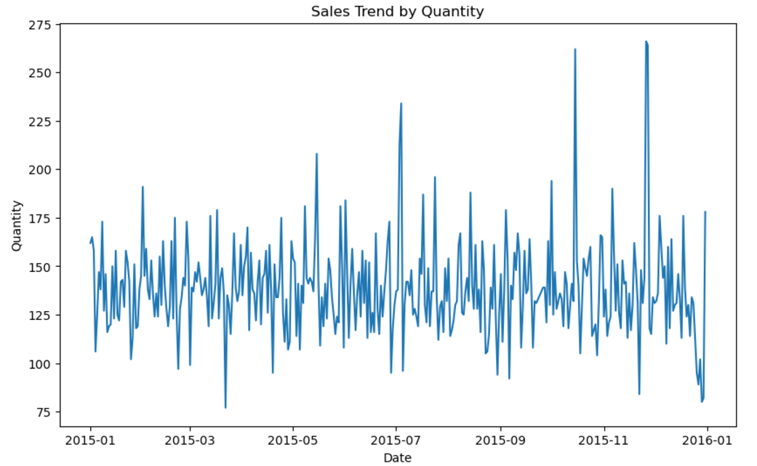

**Sales Prediction**

1. **Feature Engineering:** Create relevant features from the sales data, such as day of the week, month, promotional periods, and holiday effects.(done before step 2)
2. **Model Selection:** Choose an appropriate time series forecasting model (e.g., ARIMA, SARIMA, Prophet, LSTM, Regression Model).

ARIMA model: Stationary, order =(2,0,3)

SARIMA model: Stationary, order=(2, 0, 2), seasonal_order=(1, 0, 1, 30)

Prophet: ds, y

LSTM: TimeseriesGenerator (30), LSTM(100,activation='relu'

Regressions: XGBoost, lag = 30

1. **Model Training:** Train the predictive model on the historical sales data.
2. **Model Evaluation:** Use metric Mean Absolute Percentage Error (MAPE) to evaluate model performance.

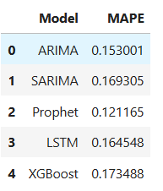

### Purchase Order Generation

1. **Sales Forecasting:** Predict pizza sales for the next one using the Prophet model.( total_forecasted_sales_df)
2. **Ingredient Calculation:** Calculate the required quantities of each ingredient based on the predicted sales and the ingredient dataset. Merge ingredients_df and total_forecasted_sales_df and perform the calculation.
3. **Purchase Order Creation:** Generate a detailed purchase order listing the quantities of each ingredient needed for the predicted sales period. Groupby similar ingredients in purchase_order dataframe and print the required columns in the csv format.