Stage 2 Clustering Analysis Documentation
Customer Churn Analysis for Telecommunications Company

Purpose
This document explains the clustering analysis completed for Stage 2. The aim was to identify customer segments using the prepared dataset and explain the resulting groups in a simple business-friendly way.

Team Contribution
Member | Role | Contribution
Muhammad Fahad Nazir | Data Analyst - Clustering | Ran the elbow method, trained K-Means, labelled clusters, and prepared visualisations.
Pratima Kandel | Data Engineer | Provided the encoded and scaled dataset needed for clustering.
SahilKumar Pravinbhai Patel | Business Analyst | Reviewed cluster profiles so findings can support future retention recommendations.
Ranjit Mishra | Project Manager | Checked that clustering outputs match the Stage 2 assessment requirements.

Method
K-Means clustering was used because it is a clear and common method for grouping customers with similar features. The Churn column was not used as an input feature. It was kept only for interpretation after the clusters were created.

Optimal Number of Clusters
k | Inertia | Silhouette Score
2 | 32418.16 | 0.270
3 | 27098.03 | 0.197
4 | 24293.01 | 0.172
5 | 22653.88 | 0.166
6 | 21548.17 | 0.157
7 | 20523.24 | 0.154
8 | 19676.45 | 0.149

The elbow method selected 4 clusters. This gives a simple and explainable segmentation for the Stage 2 deliverable.
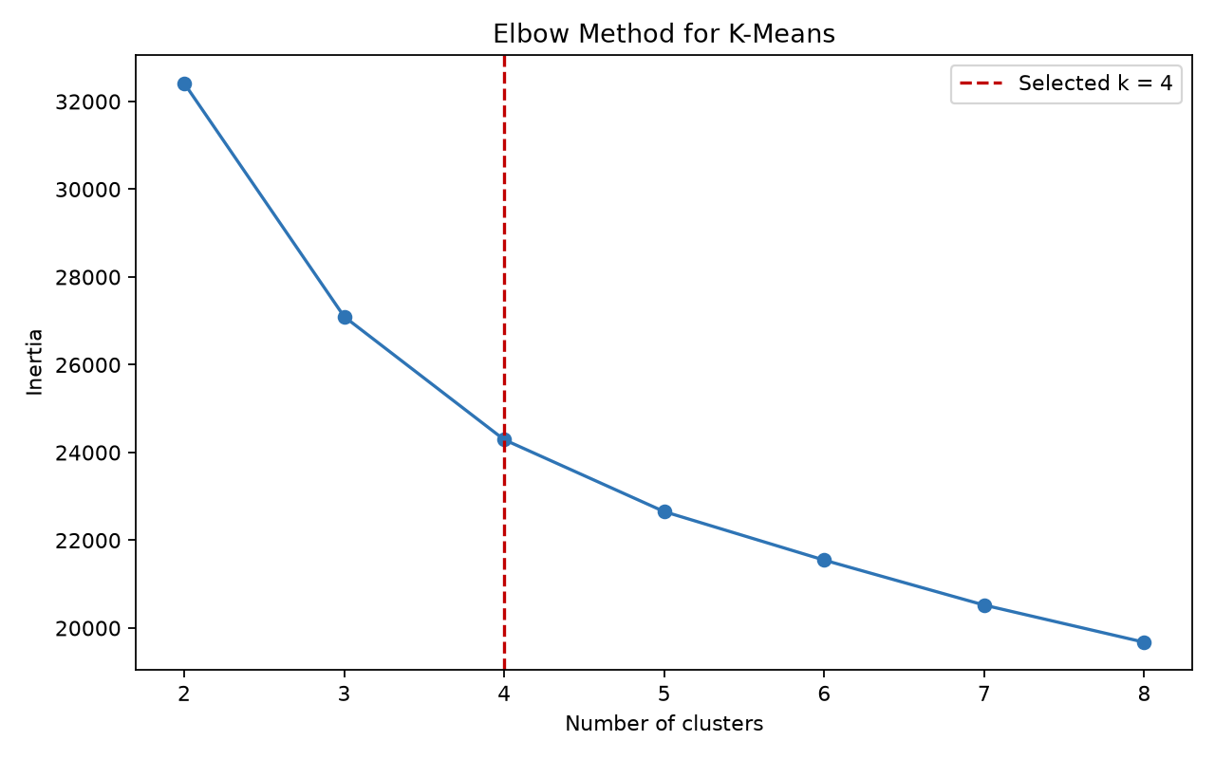

Cluster Profiles
Cluster | Customers | Churn Rate | Average Tenure | Average Monthly Charges | Segment Label
0 | 2058 | 0.448 | 12.474 | 73.752 | High-risk newer customers
1 | 2037 | 0.112 | 29.059 | 26.463 | Standard service customers
2 | 1806 | 0.135 | 58.195 | 88.183 | Loyal long-term customers
3 | 1142 | 0.417 | 33.296 | 79.817 | Higher-value service customers

Visualisations
Churn rate by cluster.
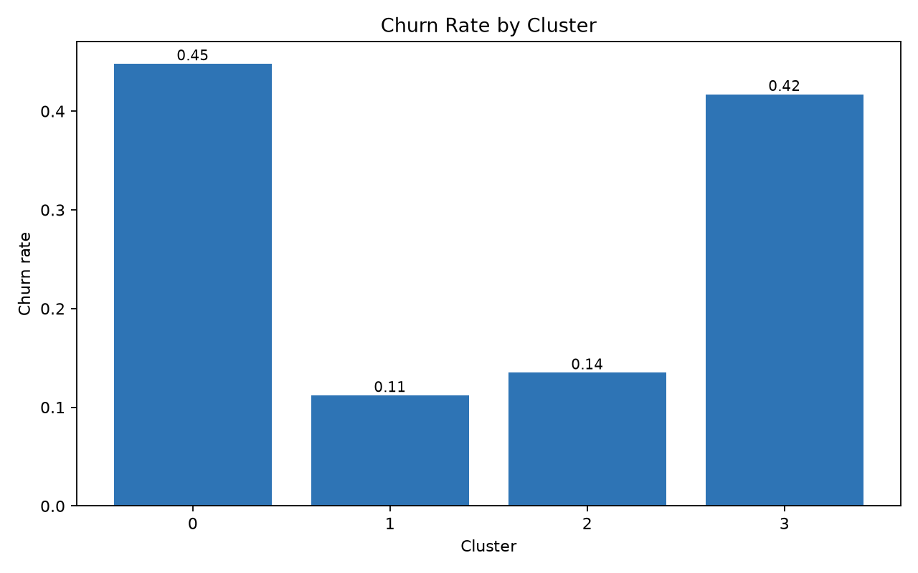
Number of customers in each cluster.
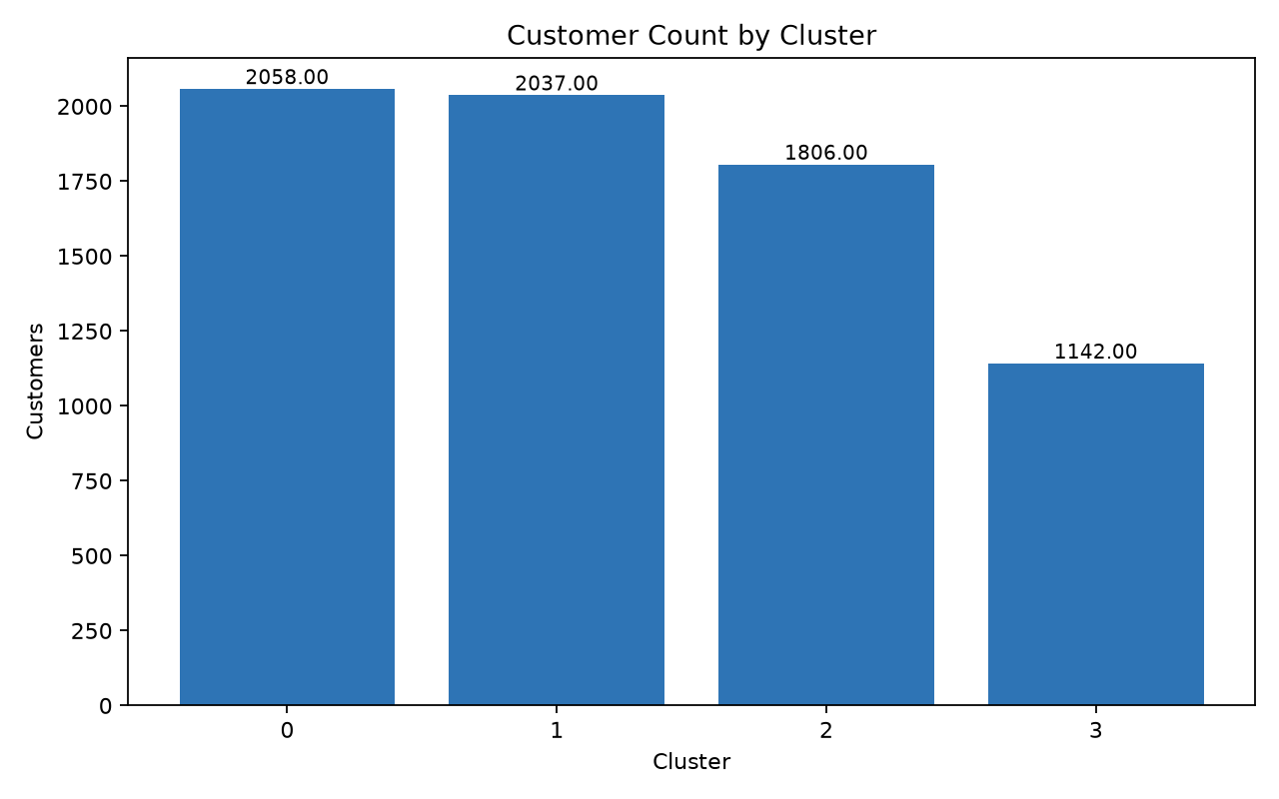
Customer segments by tenure and monthly charges.
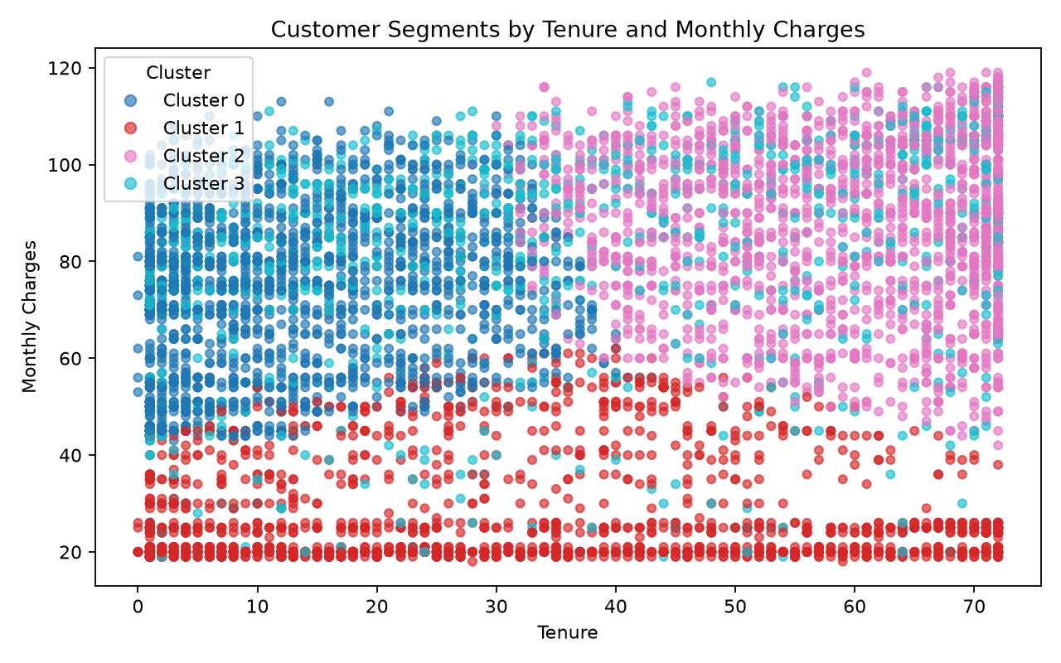

Simple Interpretation
- Cluster 0 has newer customers and the highest churn rate, so this group may need early retention support.
- Cluster 1 has lower monthly charges and a lower churn rate, so this group appears more stable.
- Cluster 2 has long-tenure customers and low churn, so this group is a loyal customer segment.
- Cluster 3 contains senior citizen customers with higher monthly charges and high churn, so this group may need targeted support.

Output Files
File | Purpose
models/kmeans_model.pkl | Saved trained K-Means model.
docs/optimal_clusters_summary.csv | Elbow and silhouette results for k values from 2 to 8.
docs/cluster_profile_summary.csv | Summary table of cluster size, churn rate, tenure, charges, and segment labels.
docs/customers_with_cluster_labels.csv | Original customer records with assigned cluster labels.
visualisations/elbow_method.png | Elbow method chart.
visualisations/tenure_monthlycharges_clusters.png | Scatter plot of customer clusters.

Limitation
K-Means is useful for segmentation, but it does not directly predict churn. The predictive modelling role is currently unassigned, so this Stage 2 submission focuses on the required data preparation and clustering outputs.

