Customer Churn Analysis Final Report
Data preparation customer segmentation predictive modelling and retention strategy
Organisation | Advanced Telecommunications Solutions
Team | Group 12
Project manager | Ranjit Mishra
Submission stage | Stage 3 Final Deliverables
Report date | 20 October 2026
Repository | https://github.com/Ranjit-Mishra/customer-churn-stage2-deliverables

Prepared by Ranjit Mishra, Pratima Kandel, Muhammad Fahad Nazir and SahilKumar Pravinbhai Patel

Executive Summary
This project analysed 7,043 telecommunications customer records to identify customer segments, predict churn and recommend targeted retention actions. The team prepared and validated the data, produced four K-Means customer segments, trained a feed-forward artificial neural network and translated the evidence into a practical retention plan.
The clustering analysis identified two high-risk groups: 2,058 newer customers with 44.8% churn and 1,142 higher-value senior customers with 41.7% churn. The ANN was trained on 5,634 records and evaluated on 1,409 reserved records. It achieved ROC-AUC 0.807 and churn recall 0.693, meeting both targets. Accuracy 0.731 and F1-score 0.578 did not meet their targets, mainly because the model favours identifying churn risk and therefore produces more false alerts.
The main recommendation is a tiered retention program. Newer high-risk customers should receive early onboarding and service checks. Higher-value senior customers should receive accessible support and a bill or plan-value review. Loyal customers should receive recognition and relevant benefits. ANN risk scores should support human review, controlled pilots and measurement, not automatic decisions.
Outcome | Result | Business meaning
Customer segments | 4 labelled clusters | Different groups require different retention actions
Highest segment churn | 44.8% | Early-tenure customers are the first intervention priority
ANN ROC-AUC | 0.807 | Useful ranking performance on the reserved test set
ANN churn recall | 0.693 | Most actual churn cases are detected, with trade-offs
Implementation decision | Controlled pilot | Measure retained revenue, cost, fairness and customer outcomes

1 Business Problem and Objectives
Customer churn reduces recurring revenue, increases acquisition pressure and weakens long-term customer value. The project was designed to help the telecommunications company identify meaningful customer groups, estimate churn risk and focus retention resources where they can create the greatest value.

Project Objectives
- Prepare a clean, encoded, scaled and leakage-controlled dataset for analysis and modelling.
- Segment customers with K-Means and explain the resulting groups in business language.
- Define, train and evaluate an ANN that predicts customer churn from available customer attributes.
- Identify predictive churn and retention factors without presenting predictive associations as proven causes.
- Recommend targeted and measurable retention actions, with clear limitations and implementation controls.

Success Measures
Measure | Target | Final result
ROC-AUC | At least 0.75 | 0.807, met
Churn recall | At least 0.65 | 0.693, met
Churn F1-score | At least 0.60 | 0.578, not met
Accuracy | At least 0.75 | 0.731, not met
Business output | Segment-specific recommendations | Completed with measures and pilot controls

2 Team Roles and Delivery Method
Member | Role | Primary contribution
Ranjit Mishra | Project Manager | Planning, Jira and Confluence, evidence integration, quality review, final report, demonstration and submission
Pratima Kandel | Data Engineer | Data preparation, ANN input validation, preprocessing, leakage controls, feature alignment and class-balance evidence
Muhammad Fahad Nazir | Clustering Analyst and ANN Technical Lead | K-Means analysis, ANN architecture, training, predictions, evaluation and model visualisations
SahilKumar Pravinbhai Patel | Business Analyst | Churn and retention interpretation, targeted recommendations, business measures, limitations and proposed solutions

The original predictive-modelling role became unavailable. The four active members redistributed the work: Pratima validated the model inputs, Fahad led the ANN implementation, Sahil completed the business interpretation, and Ranjit coordinated integration and quality control. Jira recorded owners, deadlines, progress, blockers and completion evidence.

3 Data Preparation and Validation
The supplied dataset contains 7,043 rows, nine customer attributes and the Churn target. No missing values were found. Categorical variables were one-hot encoded and numeric variables were standardised. An 80/20 stratified split produced 5,634 training rows and 1,409 testing rows.
Control | Result
Missing data | No missing values in the supplied data or final model inputs
Train and test separation | Split completed before fitting the encoder or scaler
Numeric scaling | StandardScaler fitted on training data only
Categorical encoding | OneHotEncoder fitted on training data with unknown-category handling
Leakage prevention | Churn target and generated identifiers excluded from model inputs
Feature alignment | 16 input features with identical names and order across training and testing sets
Class balance | 26.54% churn in both splits; balanced training weights used

A key data limitation is that 302 rows are identical. They were retained because the dataset has no true customer identifier, so identical profiles cannot be proven to be accidental duplicates.

4 Customer Segmentation
K-Means clustering was applied to the prepared feature set without using Churn as an input. The elbow method tested cluster counts from two to eight, and four clusters were selected as an explainable balance between model fit and business usefulness.
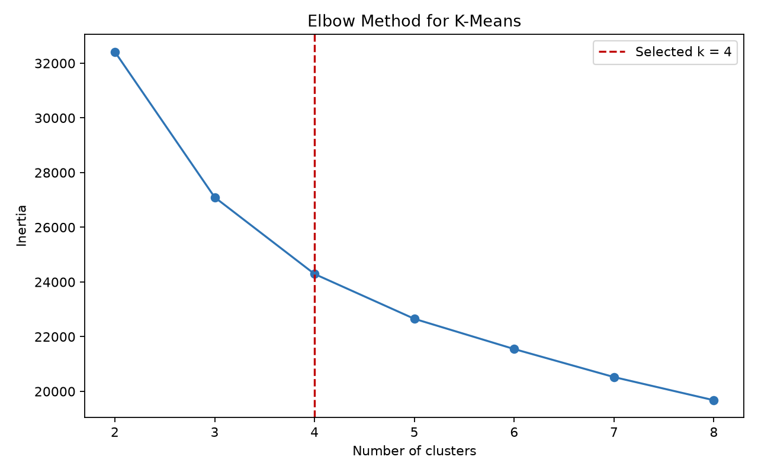
Figure 1. Elbow-method evidence supporting four customer clusters.
Segment | Customers | Churn | Avg tenure | Avg charge | Interpretation
High-risk newer | 2,058 | 44.8% | 12.5 mo | $73.75 | Early-life retention priority
Standard service | 2,037 | 11.2% | 29.1 mo | $26.46 | Low-cost, lower-risk group
Loyal long-term | 1,806 | 13.5% | 58.2 mo | $88.18 | Strong relationship despite higher charges
Higher-value senior | 1,142 | 41.7% | 33.3 mo | $79.82 | High-value support and affordability priority

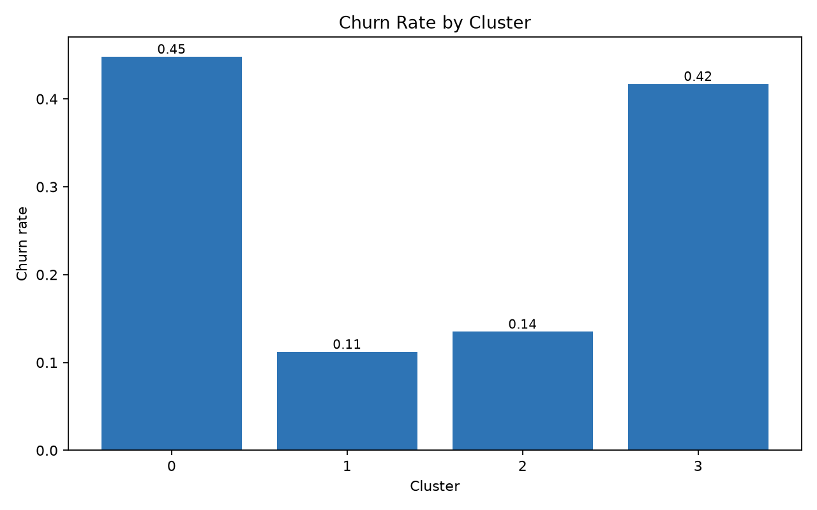
Figure 2. Churn rate differs substantially across the four customer segments.
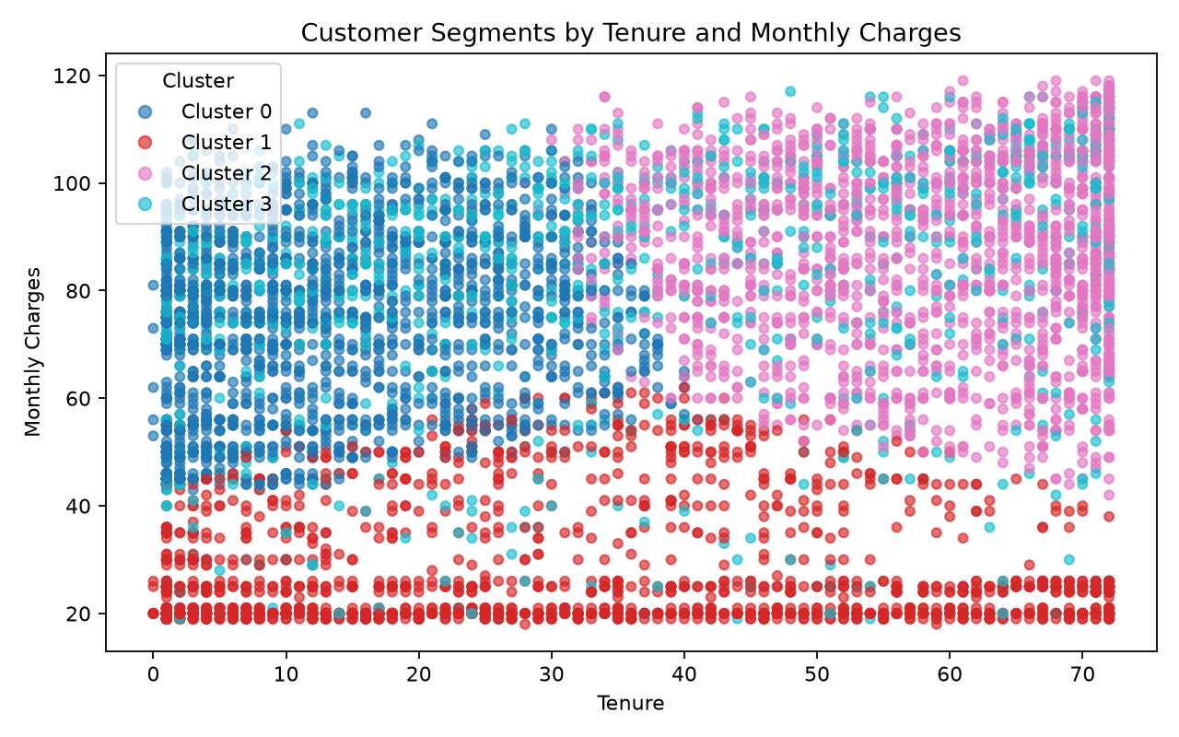
Figure 3. Customer segments by tenure and monthly charges.

5 ANN Architecture and Training
The implemented model is a feed-forward MLPClassifier with 16 inputs, hidden layers of 32 and 16 ReLU neurons, and a binary churn-probability output. Adam optimisation used a learning rate of 0.001. L2 regularisation, a 20% validation split and early stopping controlled overfitting. Balanced sample weights addressed the minority churn class.
Stage | Configuration
Input | 16 validated and aligned customer features
Hidden layer 1 | 32 ReLU neurons
Hidden layer 2 | 16 ReLU neurons
Output | Binary churn probability; threshold 0.50
Training | Adam, learning rate 0.001, maximum 100 epochs
Controls | L2 alpha 0.001, 20% validation, patience 10, early stopping
Final convergence | 19 completed epochs

The original plan included dropout. The implemented scikit-learn library does not expose dropout, so L2 regularisation replaced it. This controlled change is documented rather than hidden.
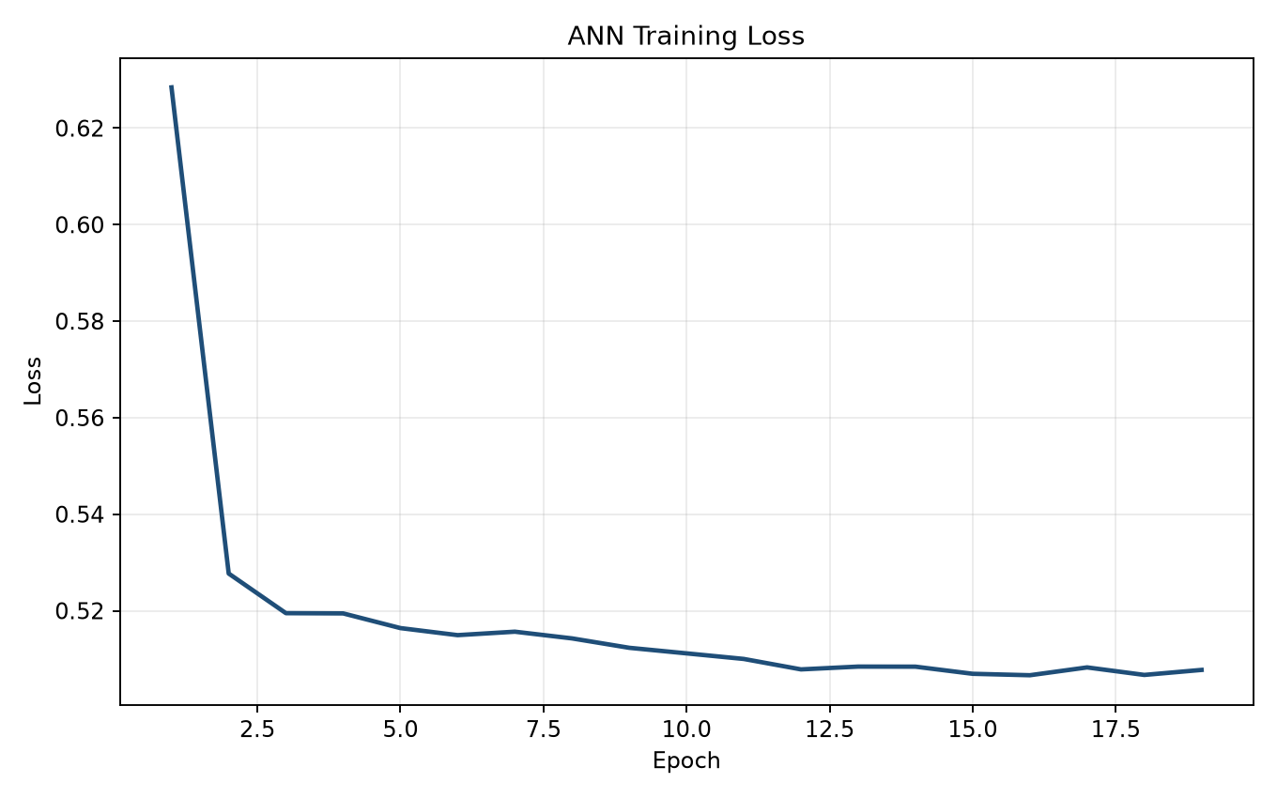
Figure 4. Training and validation loss used to review convergence.

6 ANN Performance and Predictions
Metric | Result | Target | Status
Accuracy | 0.731 | 0.750 | Not met
Balanced accuracy | 0.719 | Not set | Reported
Churn precision | 0.495 | Not set | Reported
Churn recall | 0.693 | 0.650 | Met
Churn F1-score | 0.578 | 0.600 | Not met
ROC-AUC | 0.807 | 0.750 | Met
Average precision | 0.606 | Not set | Reported

On the reserved test set, the model correctly predicted 771 non-churn customers and 259 churn customers. It produced 264 false churn alerts and missed 115 churn cases. Recall and ROC-AUC met target, showing useful risk-ranking ability. The lower precision and F1-score mean that model flags require human review.
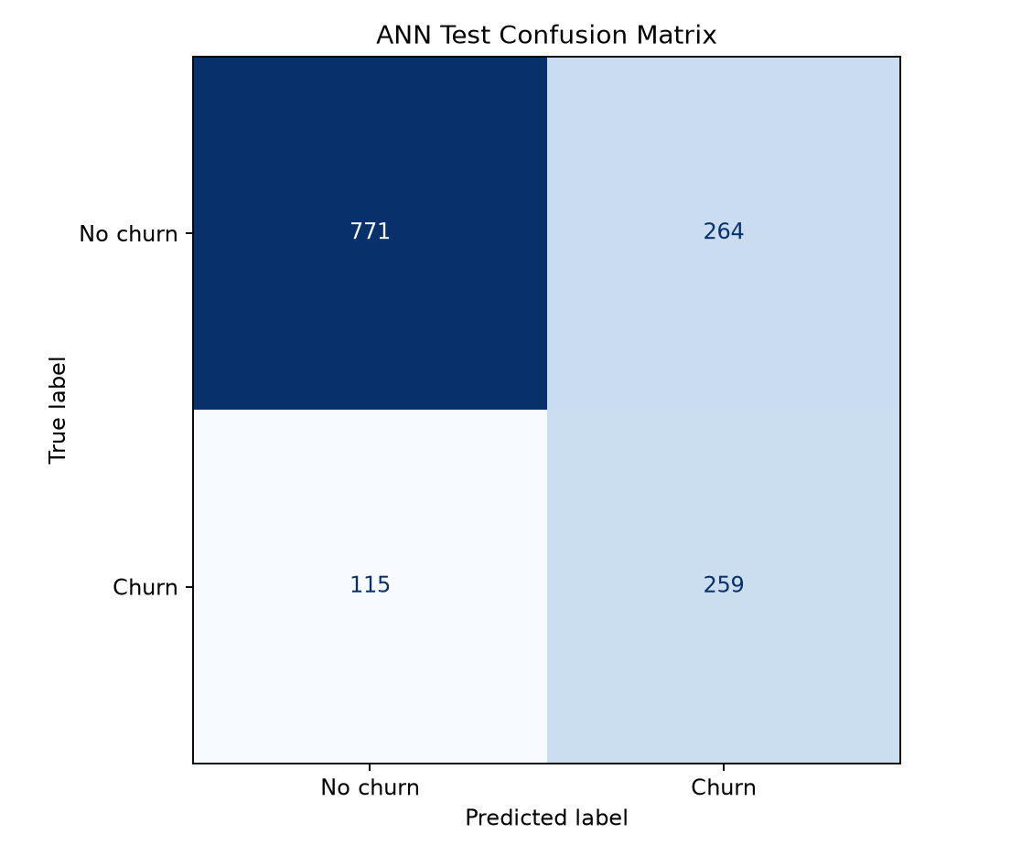
Figure 5. ANN confusion matrix on the reserved testing set.
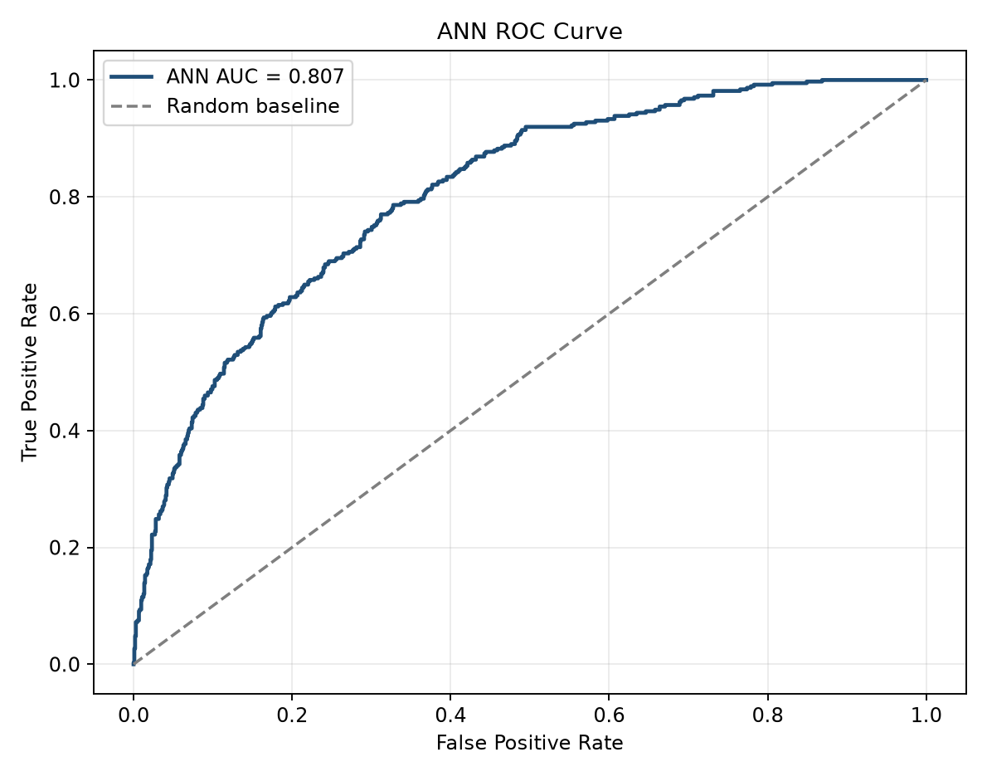
Figure 6. Test ROC curve with ROC-AUC of 0.807.

7 Churn and Retention Factors
The segmentation and ANN results point to a consistent set of predictive patterns. These findings support retention decisions but do not prove that any single factor causes churn.
Factor | Evidence | Interpretation
Short tenure | Strongest permutation signal; high-risk newer segment averages 12.5 months | Early customer experience is the first retention priority
Higher monthly charges | Second strongest signal; high-risk groups average $73.75 and $79.82 | Price and perceived value should be reviewed together
Contract type | Two-year contract indicator is among the stronger model signals | Suitable contract conversion may improve retention
Senior-customer needs | Higher-value senior segment has 41.7% churn | Accessible support and billing clarity should be tested
Long tenure | Loyal segment averages 58.2 months with 13.5% churn | Established relationship is a strong retention pattern
Lower-cost service | Standard segment averages $26.46 with 11.2% churn | Broad discounts are unlikely to be efficient for this group

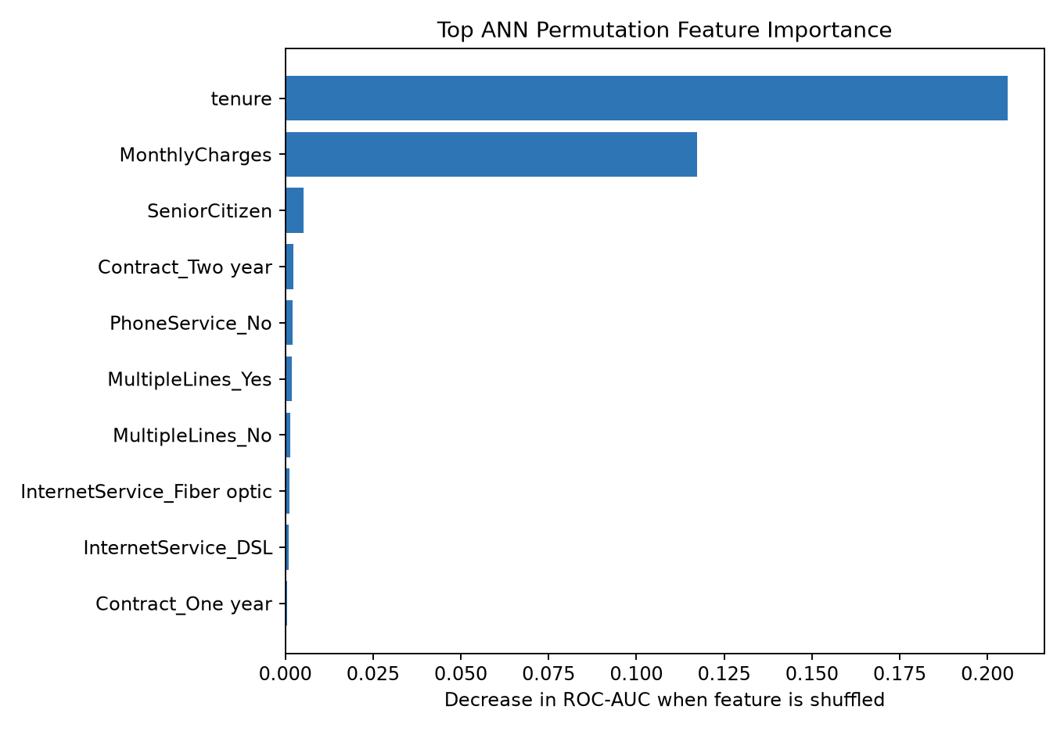
Figure 7. Predictive feature importance; values are not causal effects.

8 Targeted Retention Recommendations
Priority group | Recommended action | Measures
High-risk newer customers | 30, 60 and 90-day onboarding, proactive service checks, issue follow-up and suitable contract-conversion offers | 90-day churn, resolution time, offer acceptance, retained revenue
Higher-value senior customers | Clear bill review, accessible support, plan-value check, price protection or plan right-sizing | Churn, repeat contacts, complaints, plan changes, satisfaction
Loyal long-term customers | Recognition, loyalty benefits, referral options and relevant upgrades rather than blanket discounts | Retention, referrals, upgrade acceptance, margin
Standard service customers | Low-cost digital education and service reminders; escalate only when risk rises | Engagement, churn, intervention cost
ANN high-risk queue | Combine probability, segment and value for human review before offering an incentive | Precision, recall, retained revenue, incentive cost, false-positive rate

Pilot Sequence
- Run a four-week pilot for the two highest-risk segments.
- Use the ANN score as a ranking tool and retain staff review before contact.
- Hold out a comparable group so incremental retention impact can be measured.
- Track churn, retained revenue, offer cost, complaints, false positives and group outcomes.
- Expand only if the pilot improves retention without unacceptable cost or fairness concerns.

9 Limitations and Proposed Solutions
Limitation | Impact | Proposed solution
Only nine customer attributes | Important behaviour and service causes are missing | Add usage, billing, payment, complaints, outages and support-history fields after governance review
No true customer identifier | 302 identical rows cannot be verified | Add a stable anonymised customer key and duplicate-resolution rules
One historical dataset | Future or external performance is unknown | Use a time-based holdout and monitor monthly performance
Class imbalance | Accuracy can hide missed churn cases | Continue class weighting and use recall, F1, balanced accuracy, ROC-AUC and precision-recall evidence
Accuracy and F1 missed target | More false alerts are created while recall is prioritised | Tune threshold and architecture with validation data, collect stronger features and compare simple baselines
Threshold fixed at 0.50 | May not match actual business costs | Choose a threshold using a documented cost-benefit rule
Predictive importance is not causal | Signals do not explain why customers leave | Combine model evidence with customer research, complaint analysis and controlled pilots
No production monitoring | Performance and fairness may drift | Monitor data drift, recall, precision, segment outcomes and retraining triggers

10 Conclusion and Next Steps
The project delivered the required data preparation, customer segmentation, ANN model, prediction evidence, evaluation and business recommendations. Four segments provide an understandable view of customer differences, while the ANN provides useful churn-risk ranking with ROC-AUC 0.807 and recall 0.693.
The evidence supports a controlled retention pilot, not automatic deployment. The company should focus first on newer high-risk customers and higher-value senior customers, apply human review, measure incremental retained revenue and monitor cost, complaints and fairness. Future work should add stronger behavioural data, validate performance over time and select a threshold based on real business costs.

11 Evidence and Repository
Evidence area | Location
Public repository | https://github.com/Ranjit-Mishra/customer-churn-stage2-deliverables
Data preparation | Data_Preparation folder and scripts/01_data_preparation.py
Clustering analysis | Clustering_Analysis folder and scripts/02_clustering_analysis.py
ANN readiness | Predictive_Modeling/docs/ANN_Data_Validation_and_Architecture_Plan.docx
ANN model evidence | Predictive_Modeling/docs/ANN_Model_Architecture_Training_and_Evaluation.docx
Trained ANN | Predictive_Modeling/models/ann_mlp_model.joblib
ANN training code | scripts/07_train_ann_model.py
Predictions and metrics | Predictive_Modeling/results
Final report | Final_Report/Final_Report.docx
Jira progress | https://ranjitmishra757.atlassian.net/issues?jql=project%20%3D%20KAN%20ORDER%20BY%20duedate%20ASC

All reported figures were taken from the saved project outputs. Automated verification scripts check the Stage 2 package, ANN readiness and Stage 3 progress. Private speaking notes are not included in the repository or shared project documentation.

