ANN Model Architecture Training and Evaluation
Stage 3 predictive modelling evidence
Project | Customer Churn Analysis for Advanced Telecommunications Solutions
Technical lead | Muhammad Fahad Nazir
Data validation | Pratima Kandel
Project manager | Ranjit Mishra
Version | Final evidence, 20 October 2026

Purpose and Result
This document records the implemented artificial neural network, its training controls, final test results, saved evidence and limitations. The model is a reproducible decision-support proof of concept for customer churn prediction. It met the project targets for churn recall and ROC-AUC, while accuracy and F1-score remained below target.

Validated Model Inputs
Input item | Final value | Control
Source data | 7,043 rows and 10 columns | Official supplied dataset
Training set | 5,634 rows | 80% stratified split
Testing set | 1,409 rows | 20% reserved test split
Model features | 16 encoded inputs | Same names and order across splits
Target | Churn: No = 0, Yes = 1 | Excluded from input features
Preprocessing | StandardScaler and OneHotEncoder | Fitted on training data only
Missing or infinite values | 0 | Automated validation passed
Training churn rate | 26.54% | Class weighting used

Implemented ANN Architecture
The implementation uses scikit-learn MLPClassifier, which is a feed-forward artificial neural network. The supplied runtime did not expose dropout layers, so the planned dropout control was replaced with L2 regularisation. Early stopping, validation monitoring and balanced sample weights were retained.
Component | Configuration | Purpose
Input | 16 features | Receives validated numeric and encoded categorical attributes
Hidden layer 1 | 32 neurons, ReLU | Learns non-linear customer patterns
Hidden layer 2 | 16 neurons, ReLU | Combines a smaller predictive representation
Output | Binary churn probability | Returns probability used with a 0.50 threshold
Optimiser | Adam, learning rate 0.001 | Supports stable convergence
Regularisation | L2 alpha 0.001 | Reduces overfitting
Validation | 20% of training data | Supports early stopping
Early stopping | Patience 10 | Stops when validation improvement ends
Random seed | 42 | Supports reproducibility

16 inputs -> Dense 32 ReLU -> Dense 16 ReLU -> churn probability

Training and Convergence
The ANN trained on 5,634 records with balanced sample weights and completed 19 epochs before early stopping. Training and validation evidence was saved so the result can be reproduced and reviewed.
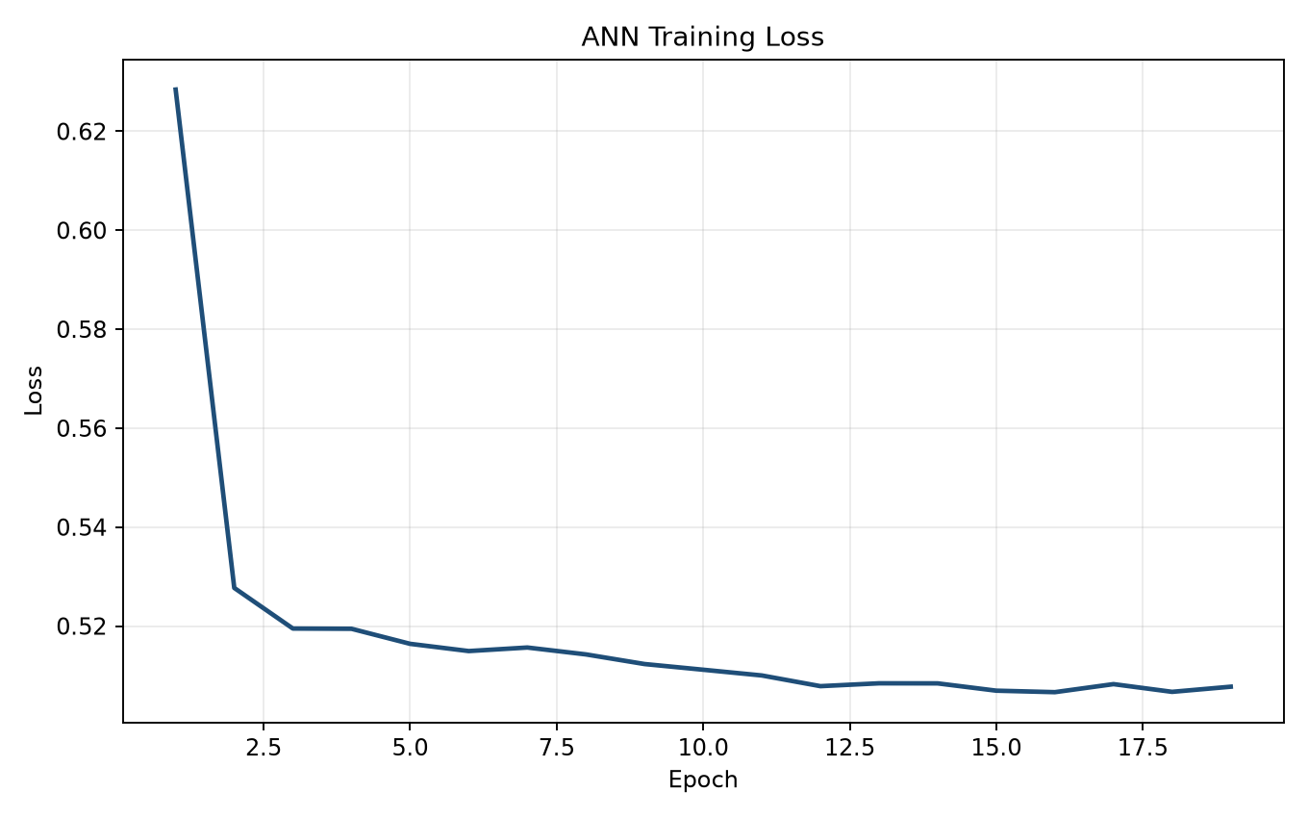
Figure 1. Training and validation loss across the completed epochs.
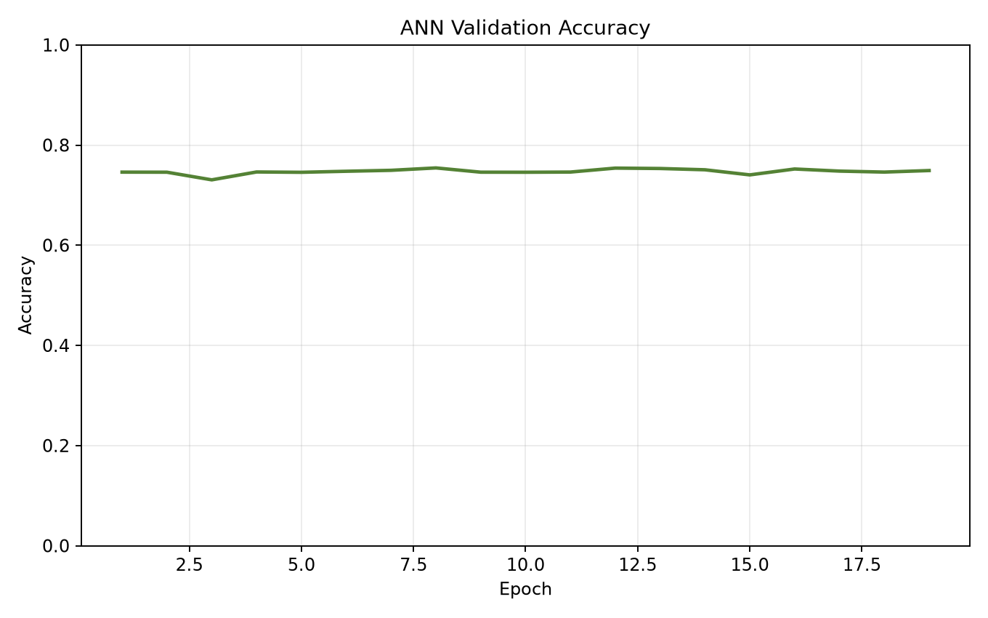
Figure 2. Validation accuracy evidence during training.

Test Performance
Metric | Result | Target | Decision
Accuracy | 0.731 | 0.750 | Not met
Balanced accuracy | 0.719 | Not set | Reported
Churn precision | 0.495 | Not set | Reported
Churn recall | 0.693 | 0.650 | Met
Churn F1-score | 0.578 | 0.600 | Not met
ROC-AUC | 0.807 | 0.750 | Met
Average precision | 0.606 | Not set | Reported

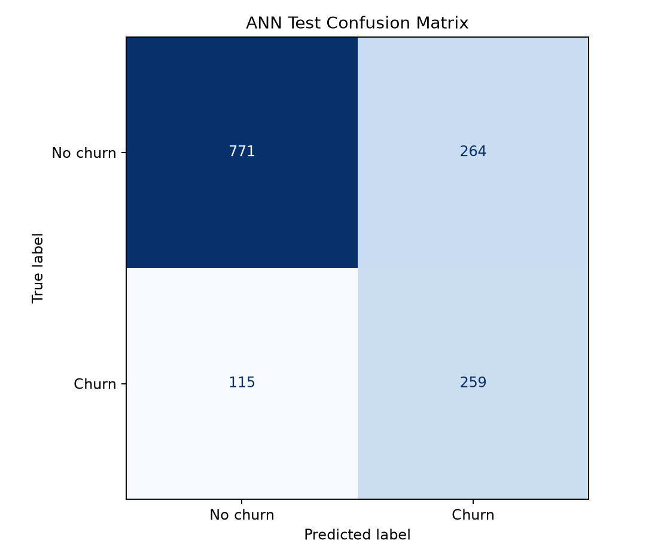
Figure 3. Confusion matrix for the reserved 1,409-record testing set.
The model correctly identified 259 churn cases and missed 115. It also generated 264 false churn warnings. This trade-off supports using the model to rank customers for human review rather than automatically issue offers.
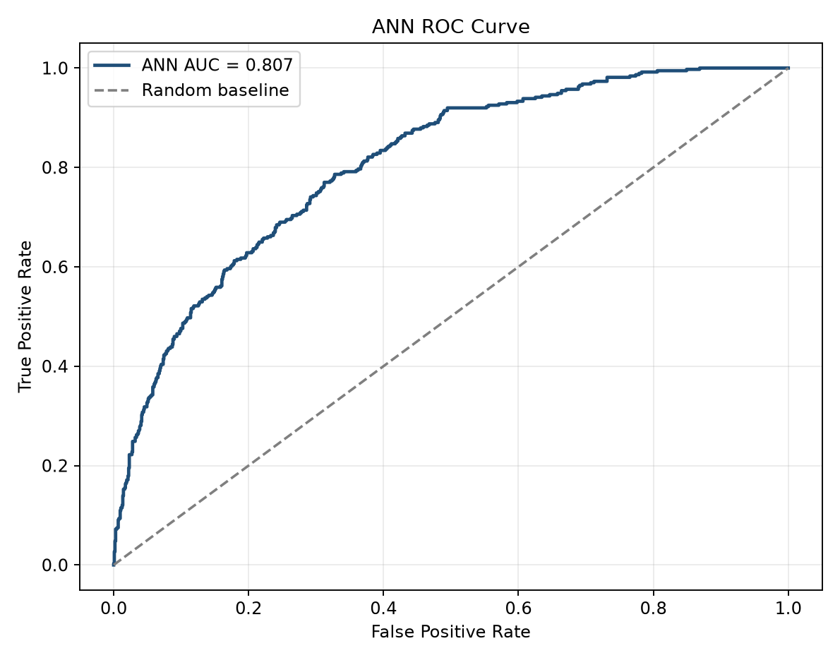
Figure 4. ROC curve with test ROC-AUC of 0.807.
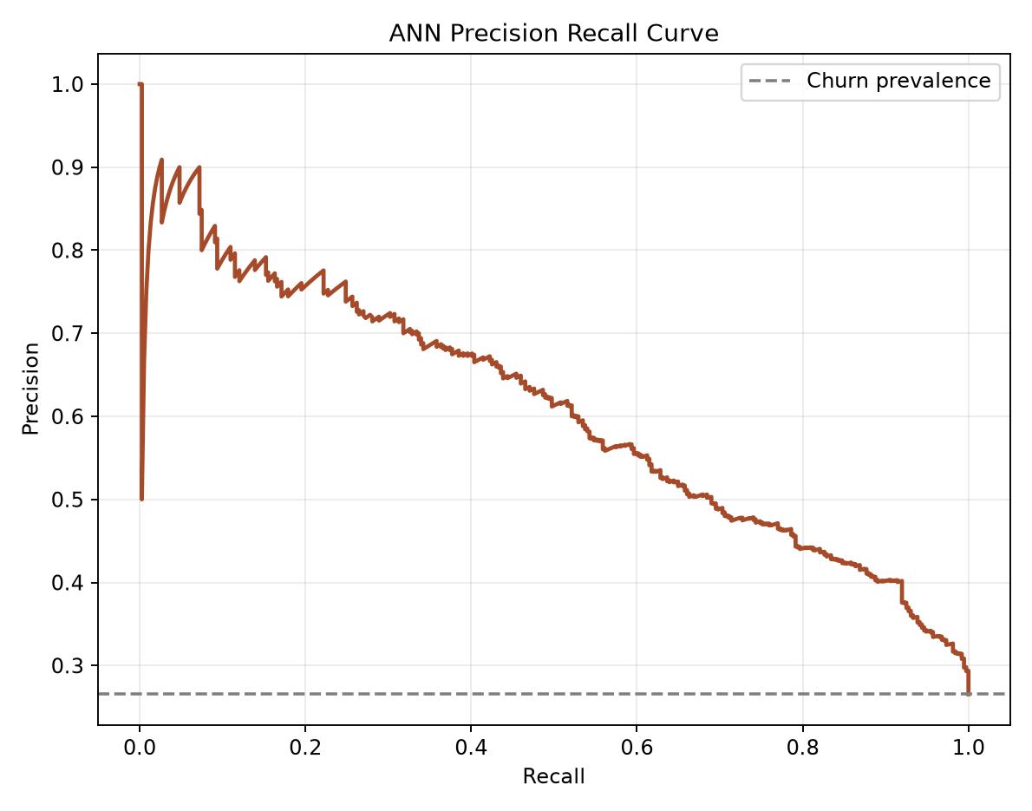
Figure 5. Precision-recall curve for the minority churn class.

Predictive Signals and Interpretation
Permutation importance identified tenure, monthly charges, senior-citizen status, a two-year contract indicator and no phone service as the five strongest test-set signals. Importance measures predictive influence, not causation.
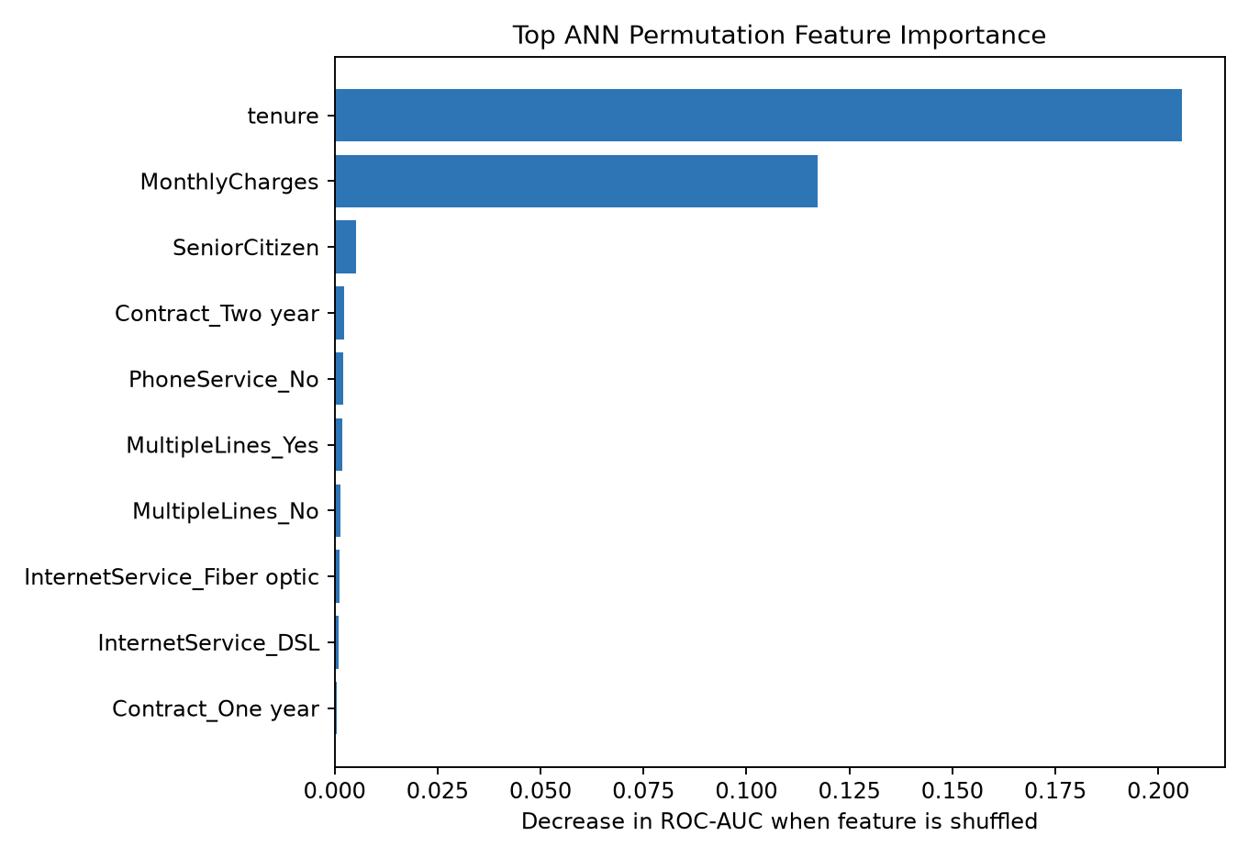
Figure 6. Permutation feature importance measured against test ROC-AUC.

Saved Evidence
Evidence | Repository path
Trained model | Predictive_Modeling/models/ann_mlp_model.joblib
Training script | scripts/07_train_ann_model.py
Test metrics | Predictive_Modeling/results/ann_test_metrics.csv
Confusion matrix | Predictive_Modeling/results/ann_confusion_matrix.csv
Classification report | Predictive_Modeling/results/ann_classification_report.csv
Training history | Predictive_Modeling/results/ann_training_history.csv
Feature importance | Predictive_Modeling/results/ann_permutation_feature_importance.csv
Evaluation summary | Predictive_Modeling/docs/ann_model_evaluation_summary.md

Limitations and Decision
- The source has only nine customer attributes and excludes usage, complaints, payment behaviour and service-quality history.
- The source contains 302 identical rows but no true customer identifier, so the rows cannot be confirmed as accidental duplicates.
- The model has been tested on one supplied dataset and not on future or external customers.
- The default 0.50 threshold is not yet optimised for the financial cost of missed churn and unnecessary offers.
- Predictive importance is not evidence of a causal reason for churn.
The trained ANN is accepted as the Stage 3 predictive-modelling deliverable. It is suitable for risk ranking, pilot testing and further evaluation, but not for automatic production decisions.

