1. What do you get if you take a load balancer and sprinkle a little cloud on it? An application gateway, of course!
2. a load balancer receives your internet and network traffic and, based on an IP address and a port, it will send that data to one of the VMs in the backend pool.
3. But what if you want to route the traffic based on other parameters than simply IP address and port number?

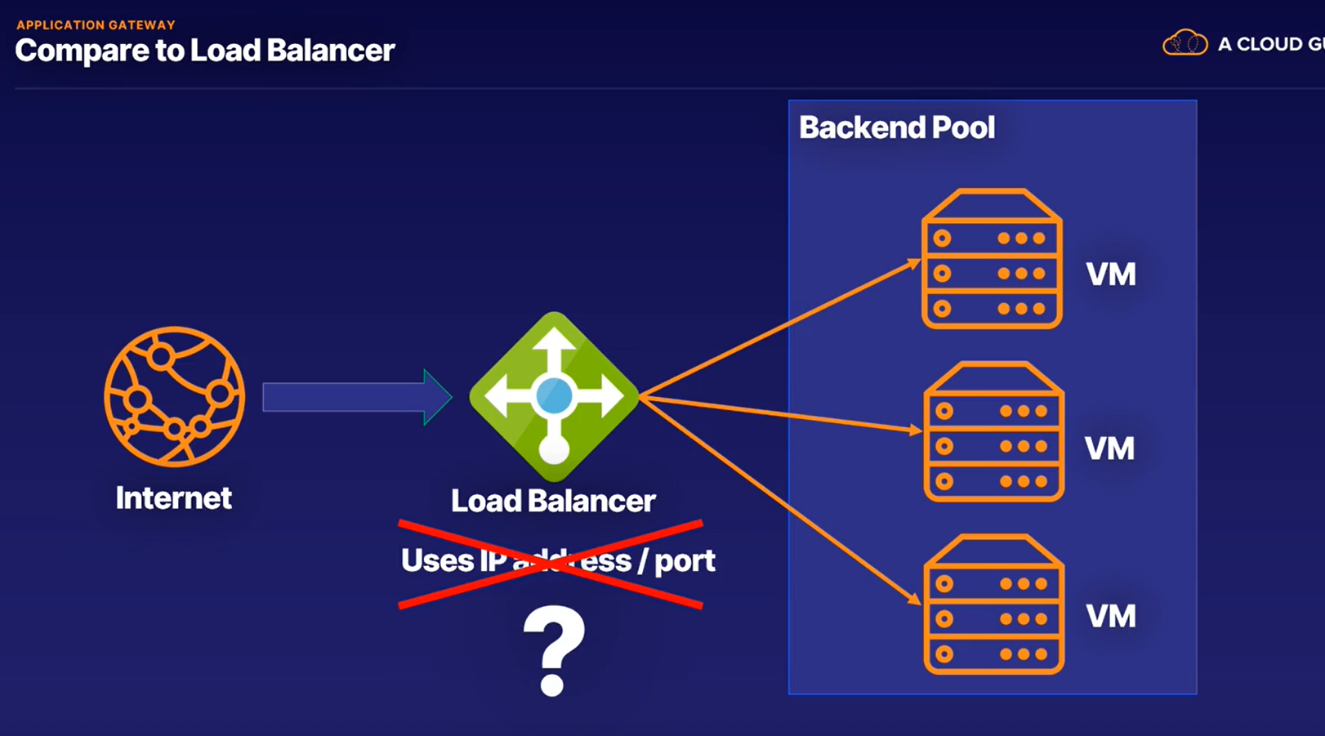

1. With Application Gateway, you can make routing decisions based on additional attributes of an HTTP request, such as URI path or host headers.
2. An HTTP request is the data format that is received from any kind of internet traffic.
3. The URI path is the web address for the request, and a host header is a piece of information that is sent with the request.
4. This means you can send traffic from a specific web address to a specific machine.
5. For example, if you have a request for a URL that is images, you could send that to a specific pool of machines that are better at handling images.

1. The same can be done for videos.

1. One of the great things about a lot of Azure services is that they work so well together, and for the Application Gateway, that is no difference.
2. A few of the benefits for using an application gateway are that an application gateway can scale up or down based on the traffic that comes to it.
3. As always this can cost more, but it also means you don't have to worry about managing the resources needed to serve your application.
4. An application gateway has end-to-end encryption for all traffic, meaning you can comply with any requirements about securing the traffic.
5. If not needed, you can disable secure transfer to the backend pool to improve processing times too.
6. Zone redundancy - this is an application gateway that can span multiple availability zones, offering better fault resiliency, and you don't have to set up more gateways to cater for each zone either.
7. You can use multi-site hosting to use the same application gateway for more than one website.
8. You can, in fact, add up to 100 websites to the same instance of an application gateway.
9. This will both save you on cost and complexity.

1. So, in summary, an application gateway is another type of load balancer that works on a higher level.
2. It works on the HTTP request of the traffic instead of the IP address and port.
3. Traffic from a specific web address, such as an image or video URL, can go to a specific machine in the backend pool.
4. It works well with all the Azure services and can share the same cloud benefits like high availability and pricing.
5. And this supports auto scaling, end-to-end encryption, zone redundancy, and multi-site hosting, among other benefits.

