Name- Ranjit Chavan
PRN- 123B1B103

Assignment no 1
Compilation Steps
- Open Remix IDE
- Create a new file named contract.sol
- Write the smart contract code
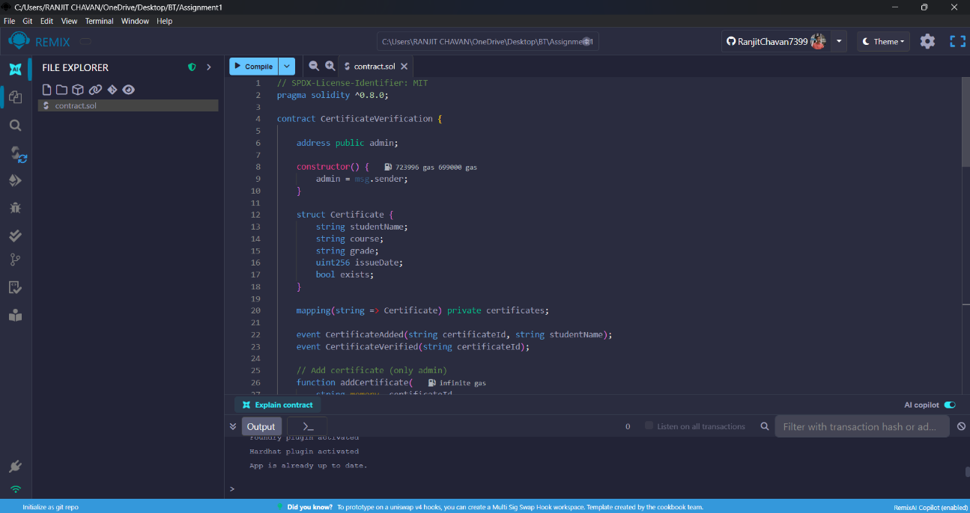
- Go to the Solidity Compiler tab
- Select compiler version 0.8.x
- Click on Compile contract.sol
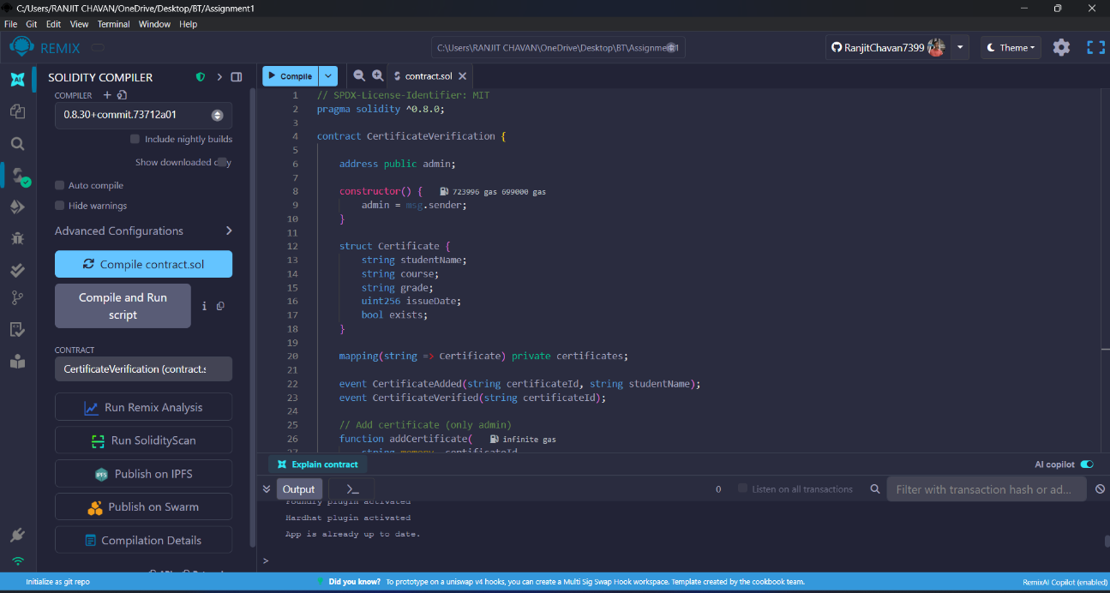
- Check for “Compilation Successful” message
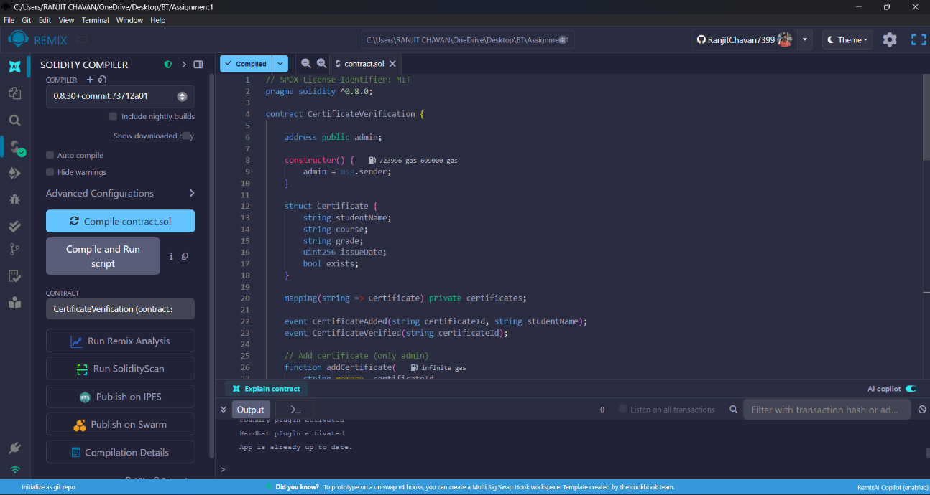

Deployment Steps
- Go to the Deploy & Run Transactions tab in Remix IDE
- Select Environment:
  - Browser Wallet (sepholia testnet) or
  - Remix VM (for testing)
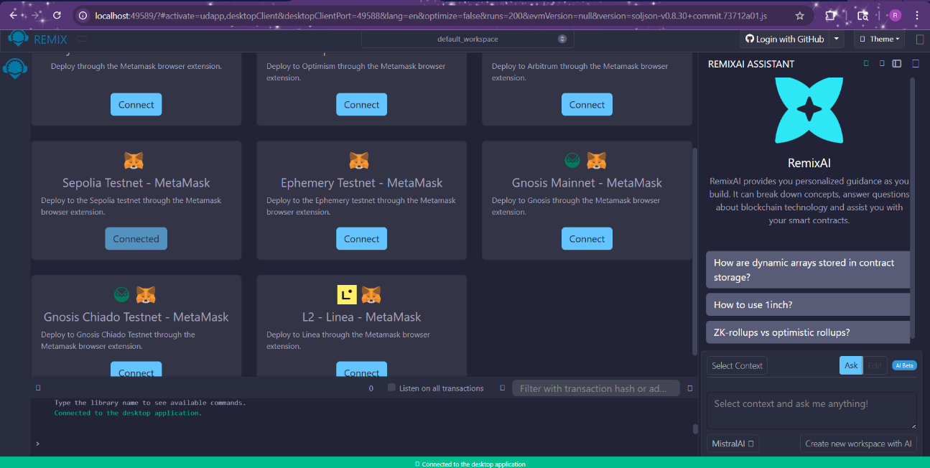
- Select your contract name
- Click on Deploy
- Confirm the transaction (if using MetaMask)
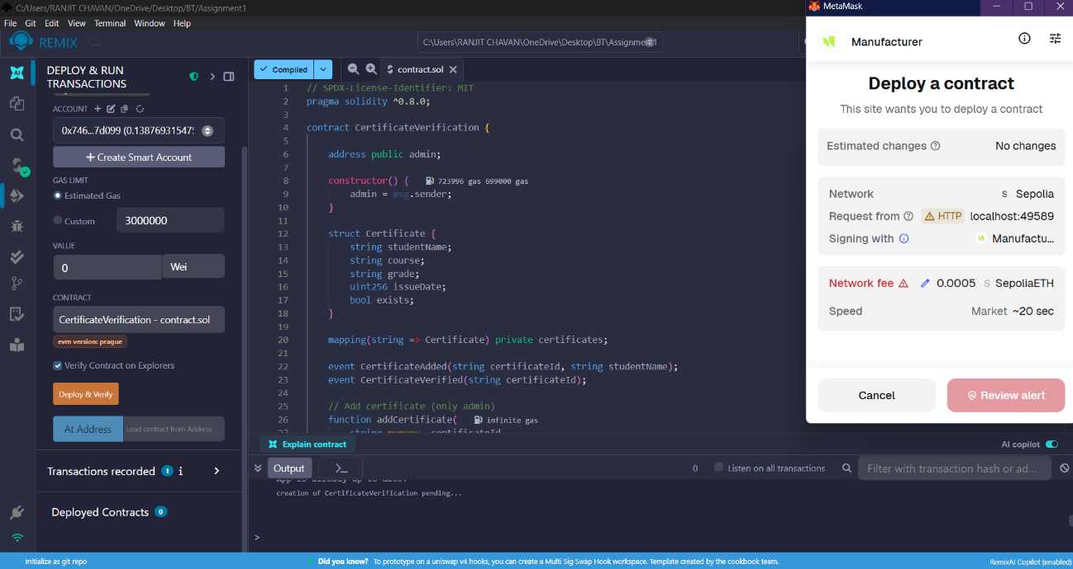
- After deployment, the contract will appear in Deployed Contracts section
- Copy the Contract Address and check on etrescan
