Name: Ranjit Chavan
PRN: 123B1B103
Assignment No 3
Screenshots
1. Wallet Connection using MetaMask
This screenshot shows the process of connecting the web application to the MetaMask wallet. When the user clicks on the “Connect Wallet” button, MetaMask prompts for permission to access the user’s account. The user selects an account and approves the connection. This step establishes a secure connection between the frontend application and the blockchain network.
Home page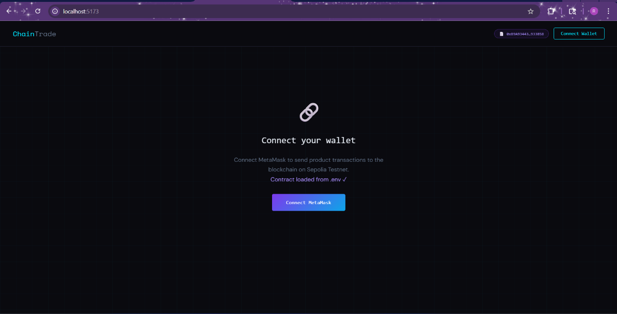
After Click on connect button
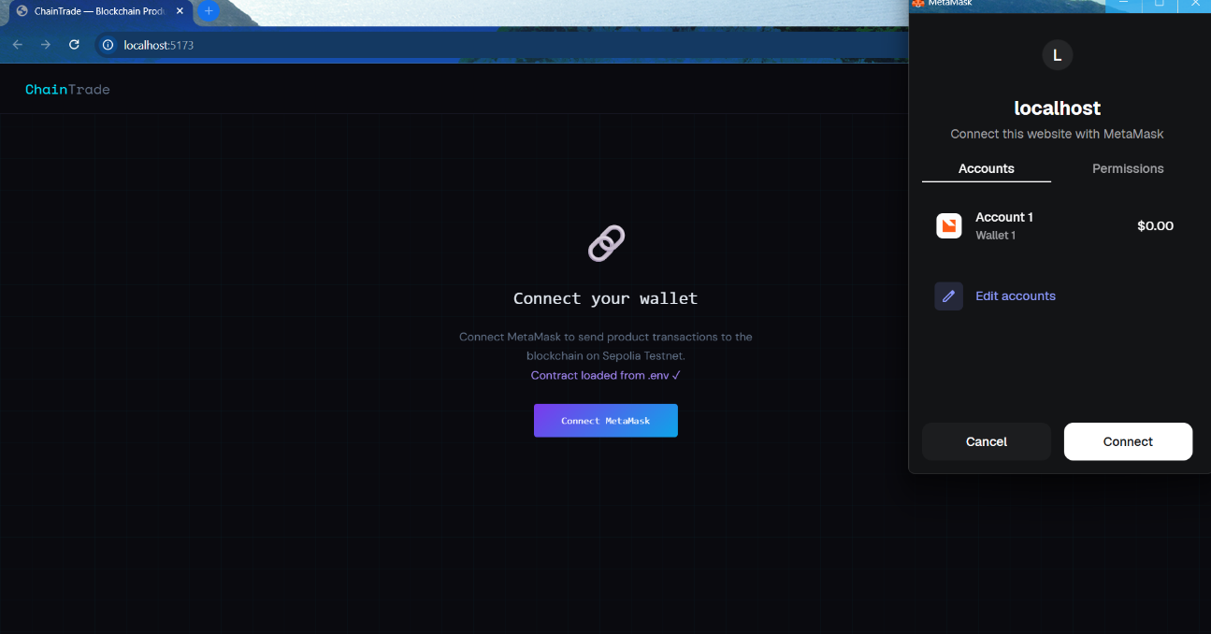
Interface After Connection
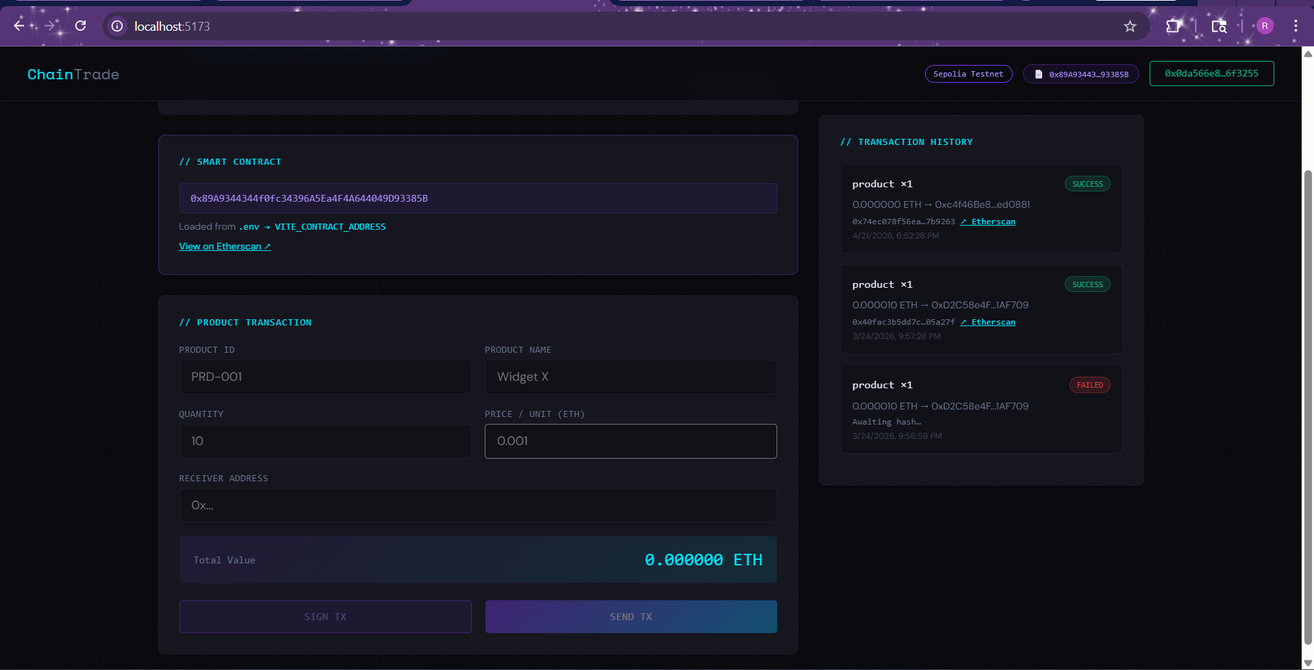

2. Successful Wallet Connection
This screenshot displays the wallet address after a successful connection. It confirms that the frontend application has successfully accessed the user’s Ethereum account using MetaMask. The connection is handled using the window.ethereum object, which allows the application to communicate with the blockchain. This step is essential before performing any transactions.
Account Connected successfully
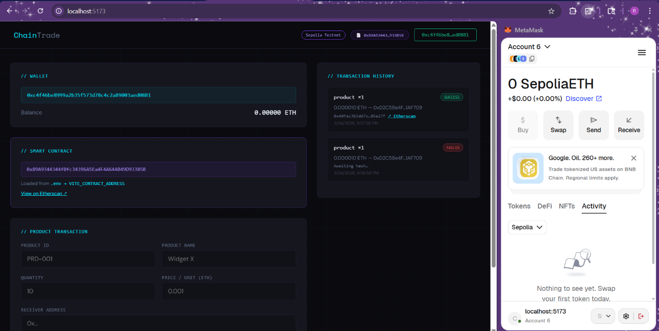

3. Initiating Blockchain Transaction
This screenshot shows the user initiating a blockchain transaction by clicking a button such as “Send Transaction”. At this stage, the frontend prepares the transaction details including sender address, receiver address, and value. A request is then sent to MetaMask for approval. This demonstrates the interaction between the web interface and the blockchain.
Transaction
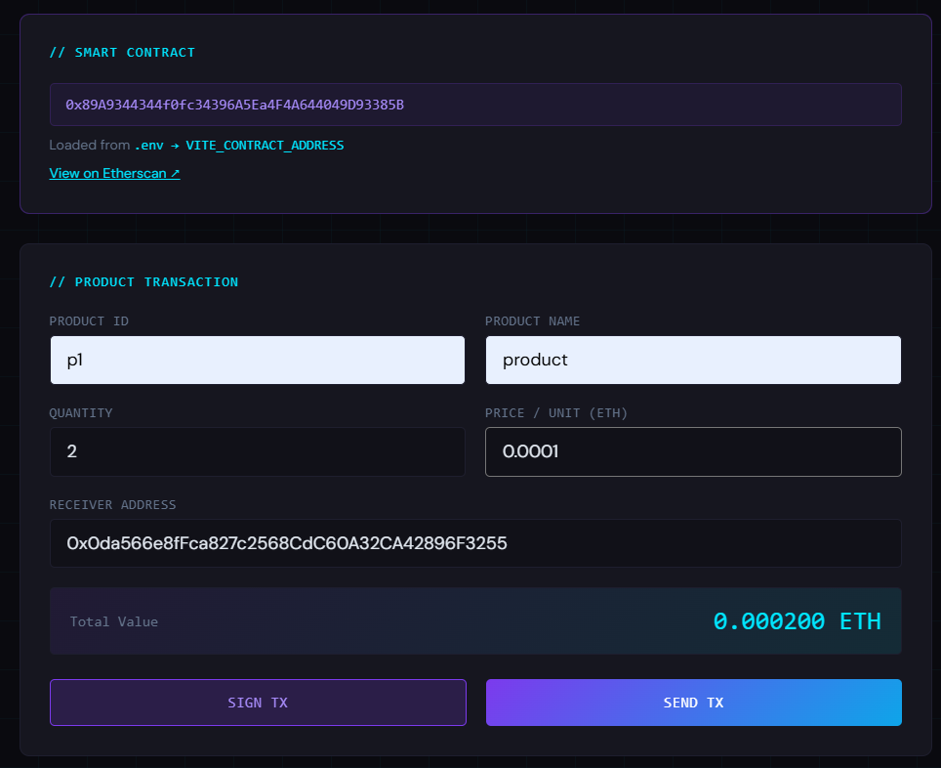

4. MetaMask Transaction Confirmation
This screenshot shows the MetaMask popup for transaction confirmation. It displays important transaction details such as gas fees, transaction amount, and recipient address. The user must review and approve the transaction. MetaMask securely signs the transaction using the user’s private key, ensuring safety and authenticity.
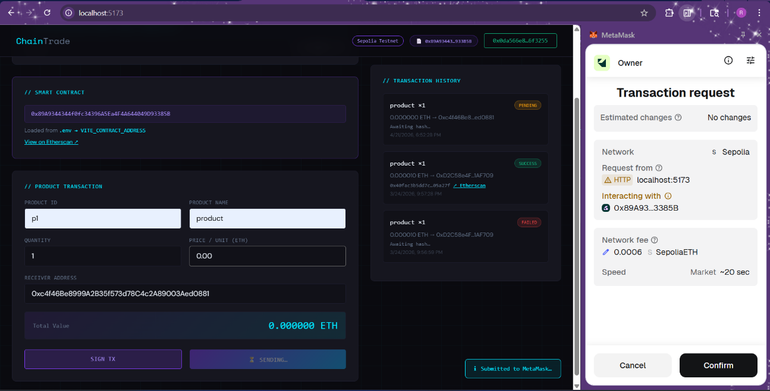
5. Successful Transaction Execution
This screenshot shows the confirmation of a successful transaction. It may include a transaction hash or a success message displayed in the application. The transaction hash is a unique identifier that proves the transaction has been recorded on the blockchain. This step confirms successful execution of the transaction.
Transaction Execution 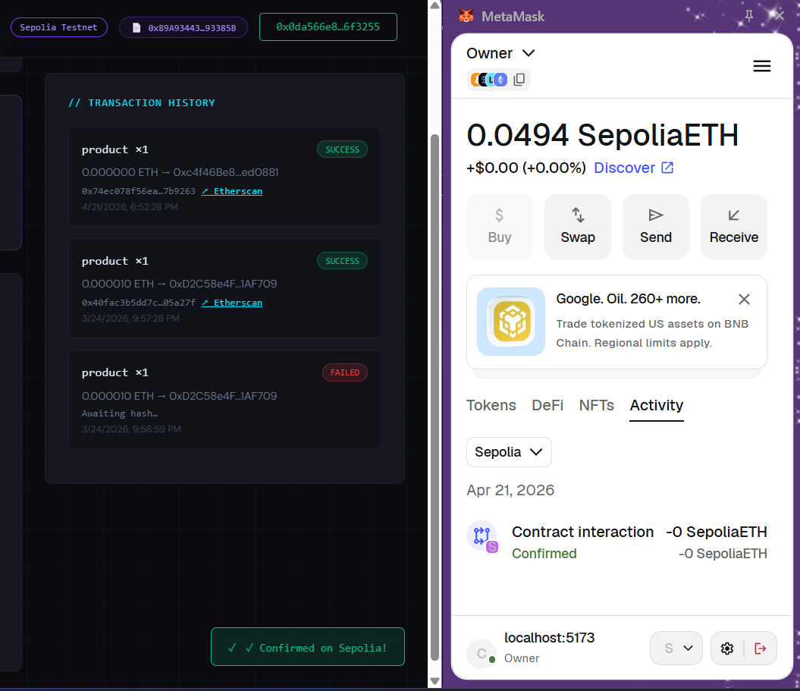
6. Transaction on Blockchain Explorer
This screenshot shows the transaction details on a blockchain explorer such as Etherscan. It includes information like transaction hash, block number, gas used, and transaction status. This provides public proof that the transaction is successfully recorded on the blockchain and ensures transparency.
